|  |  |  |  |  |  |  |  |  |  |
| --- | --- | --- | --- | --- | --- | --- | --- | --- | --- |
|  | | | | | | | | | |
|  | | | | | | | | | |
|  | | | | | | | | | |
|  |  |  |  |  |  |  |  |  |  |
| **student handout**  **classification using naïve bayes algorithm**  **name: ……………………………………….…….. ID:………………..** | | | | | | | | | |

Using the Naïve Bayes classification algorithm with the train dataset, calculate the most likely classification for the following unseen instances:

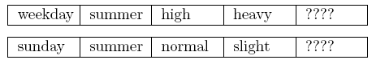

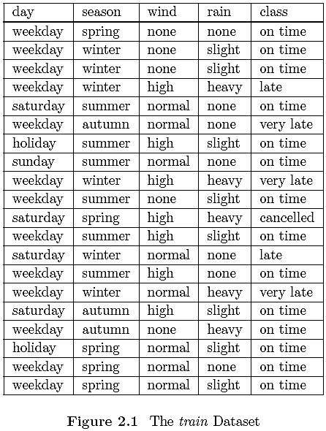

**Step 1:** Define the classes and the possible values for each attribute

………………………………………………………………………………………………………………………………………………

………………………………………………………………………………………………………………………………………………

………………………………………………………………………………………………………………………………………………

………………………………………………………………………………………………………………………………………………

………………………………………………………………………………………………………………………………………………

**Step 2:** Calculate the prior probability of each class. & **Step 3:** Calculate the posterior probability of each attribute given that each class (in a table)

|  |  |  |  |  |  |
| --- | --- | --- | --- | --- | --- |
| **Probabilities** | | **Class=on time** | **Class =late** | **Class=very late** | **Class=cancelled** |
| **Conditional (posterior) probability** | **day=weekday** |  |  |  |  |
| **day=holiday** |  |  |  |  |
| **day=Saturday** |  |  |  |  |
| **day=Sunday** |  |  |  |  |
| **season=spring** |  |  |  |  |
| **season=summer** |  |  |  |  |
| **season=winter** |  |  |  |  |
| **season=autumn** |  |  |  |  |
| **wind=none** |  |  |  |  |
| **wind=high** |  |  |  |  |
| **wind=normal** |  |  |  |  |
| **rain=none** |  |  |  |  |
| **rain=slight** |  |  |  |  |
| **rain=heavy** |  |  |  |  |
|  | **Prior Probability** |  |  |  |  |

**Step 4:** Using the values in each of the columns in the table, calculate the posterior (conditional) probabilities for **each possible classification** for a given unseen (unclassified) instance.



Class = on time : ……………………………………………………………………………………

Class = late : ……………………………………………………………………………………

Class = very late : ……………………………………………………………………………………

Class = cancelled : ……………………………………………………………………………………

**Step 5:** Choose the largest value as a classification of the given unseen instance

……………………………………………………………………………………

**For the second instance:**

**Step 4:** Using the values in each of the columns in the table, calculate the posterior (conditional) probabilities for **each possible classification** for a given unseen (unclassified) instance.



Class = on time : ……………………………………………………………………………………

Class = late : ……………………………………………………………………………………

Class = very late : ……………………………………………………………………………………

Class = cancelled : ……………………………………………………………………………………

**Step 5:** Choose the largest value as a classification of the given unseen instance

……………………………………………………………………………………

Good Luck ☺