|  |  |  |  |  |  |  |  |  |  |
| --- | --- | --- | --- | --- | --- | --- | --- | --- | --- |
|  | | | | | | | | | |
|  |  |  |  |  |  |  |  |  |  |
| **student handout**  **classification using Decision trees: The Degrees Dataset**  **name: ……………………………………….…….. ID:………………..** | | | | | | | | | |

**Using the training set below and the Top-Down Induction of Decision Trees (TDIDT) algorithm, do the following:**

1. **Construct the decision tree from the training set.**
2. **Convert the decision tree into a set of decision/classification rules**

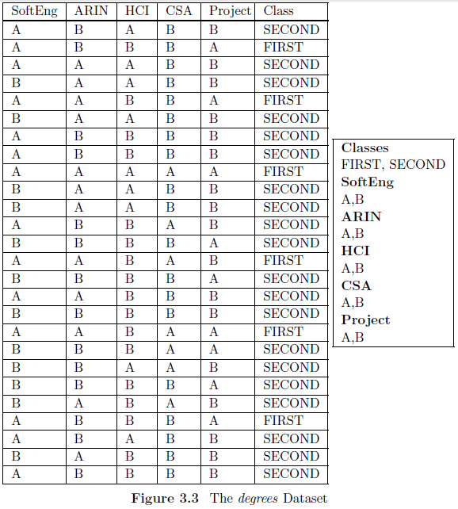

**Step 1:** Select an attribute A to split on*(*NEVER SELECT AN ATTRIBUTE TWICE IN THE SAME BRANCH)*

**Step 2:** Sort the instances in the training set into **subsets**, one for each value of attribute A.

|  |  |  |
| --- | --- | --- |
|  | |  |
|  |  |  |
|  |  |  |
|  |  |  |

**Step 3:** Return a tree with **one branch for each subset,** each branch has either a **child sub-tree**, or a **class**. **Step 4:** Repeat steps 1 to 3 for each sub-tree.