|  |  |  |  |  |  |  |  |  |  |
| --- | --- | --- | --- | --- | --- | --- | --- | --- | --- |
|  | | | | | | | | | |
|  | | | | | | | | | |
|  |  |  |  |  |  |  |  |  |  |
| **student handout**  **inducing modular rules for classification using prism algorithm**  **name: ……………………………………….…….. ID:………………..** | | | | | | | | | |

**Using the training set below and the Prism algorithm, do the following:**

1. **Induce the classification rules for the class = 2.**
2. **Induce the classification rules for the class = 3.**

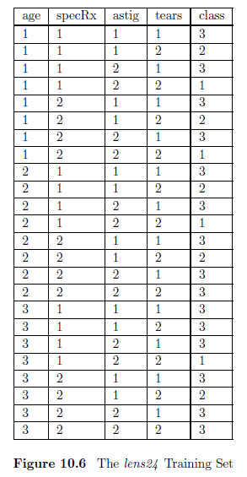

**The Prism Algorithm:**

**Step 1.** Calculate the probability that class = i for each attribute=value.

**Step 2.** Select the pair with the largest probability and create a subset of the training set comprising all the instances with the selected attribute=value combination (for all classifications).

**Step 3.** Repeat 1 and 2 for this subset until a subset is reached that contains only instances of class i. The induced rule is then the conjunction of all the attribute=value pairs selected.

**Step 4.** Remove all instances covered by this rule from the training set.

**Repeat 1–4 until all instances of class i have been removed**