|  |
| --- |
|  |
|  |
| **student handout**  **Clustering using k-means algorithm**  **name: ……………………………………….…….. ID:………………..** |

**1. Using the k-means method, cluster the following data into three clusters.**

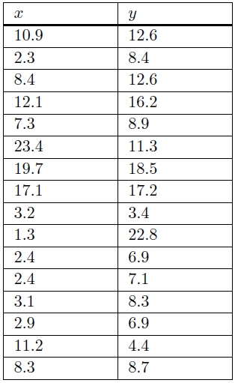

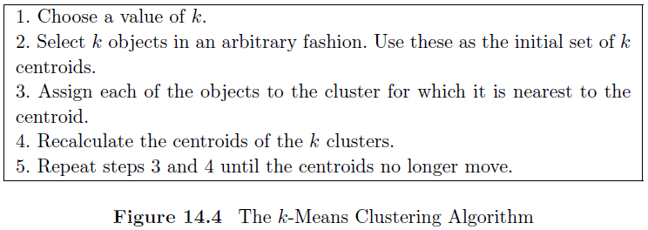

**Solution:**

**Step 1: Set initial k and initial centroids, K=3**

We begin by choosing three of the instances to form the initial centroids. We can select three instances that are fairly far apart. One possible choice is as follows:

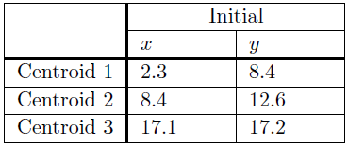

**Step 2: Calculate the Euclidean distance & Step 3: Assign objects to clusters**



|  |  |  |  |
| --- | --- | --- | --- |
| ***d1*** | ***d2*** | ***d3*** | ***Cluster*** |
|  |  |  |  |
|  |  |  |  |
|  |  |  |  |
|  |  |  |  |
|  |  |  |  |
|  |  |  |  |
|  |  |  |  |
|  |  |  |  |
|  |  |  |  |
|  |  |  |  |
|  |  |  |  |
|  |  |  |  |
|  |  |  |  |
|  |  |  |  |
|  |  |  |  |
|  |  |  |  |

**Step 4: Recalcaute the centroids of each cluster**

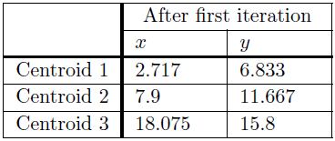

***~Repeat the algorithm~***

**Repeat Step 2 & Step 3: Calculate the Euclidean distance from new centroids, then assign objects to clusters**



|  |  |  |  |
| --- | --- | --- | --- |
| ***d1*** | ***d2*** | ***d3*** | ***Cluster*** |
|  |  |  |  |
|  |  |  |  |
|  |  |  |  |
|  |  |  |  |
|  |  |  |  |
|  |  |  |  |
|  |  |  |  |
|  |  |  |  |
|  |  |  |  |
|  |  |  |  |
|  |  |  |  |
|  |  |  |  |
|  |  |  |  |
|  |  |  |  |
|  |  |  |  |
|  |  |  |  |

**Repeat Step 4: Recalcaute the centroids of each cluster**



**If they are unchanged from the first iteration, the process terminates. The objects in the final three clusters are as follows.**

* **Cluster 1:** 2, 9, 11, 12, 13, 14
* **Cluster 2:** 1, 3, 5, 10, 15, 16
* **Cluster 3:** 4, 6, 7, 8