|  |  |  |  |  |  |  |  |  |  |
| --- | --- | --- | --- | --- | --- | --- | --- | --- | --- |
|  | | | | | | | | | |
|  | | | | | | | | | |
|  |  |  |  |  |  |  |  |  |  |
| **student handout**  **classification using Nearest Neighbour Algorithm**  **name: ……………………………………….…….. ID:………………..** | | | | | | | | | |

Using the training set below and the Euclidean distance measure, calculate the 5-nearest neighbours of the following unseen instance:

|  |  |  |
| --- | --- | --- |
| 9.1 | 11.0 | ??? |

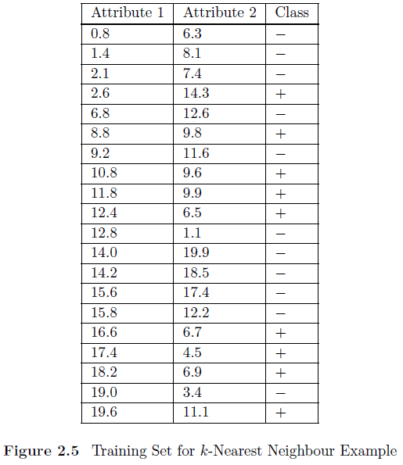

**Step 1:** Define the value of k

**…………………………………………………………………**

**Step 2:** Calculate the similarity between the unseen/unclassified instance and each instance in the training using Euclidean distance & **Step 3:** Find the most k nearest instances to the unseen instance.



|  |  |  |
| --- | --- | --- |
| 9.1 | 11.0 |  |

|  |  |  |  |  |
| --- | --- | --- | --- | --- |
| **Attribute 1** | **Attribute 2** | **Class** | **Euclidean distance** | ***5*-Nearest** |
| 0.8 | 6.3 | - |  |  |
| 1.4 | 8.1 | - |  |  |
| 2.1 | 7.4 | - |  |  |
| 2.6 | 14.3 | + |  |  |
| 6.8 | 12.6 | - |  |  |
| 8.8 | 9.8 | + |  |  |
| 9.2 | 11.6 | - |  |  |
| 10.8 | 9.6 | + |  |  |
| 11.8 | 9.9 | + |  |  |
| 12.4 | 6.5 | + |  |  |
| 12.8 | 1.1 | - |  |  |
| 14.0 | 19.9 | - |  |  |
| 14.2 | 18.5 | - |  |  |
| 15.6 | 17.4 | - |  |  |
| 15.8 | 12.2 | - |  |  |
| 16.6 | 6.7 | + |  |  |
| 17.4 | 4.5 | + |  |  |
| 18.2 | 6.9 | + |  |  |
| 19 | 3.4 | - |  |  |
| 19.6 | 11.1 | + |  |  |

**Step 4:** Use the classification that is used by the majority of nearest instances as a classification for the unseen instance.

**Class = ………………………….**

Good Luck ☺