**Nageena Naaz**

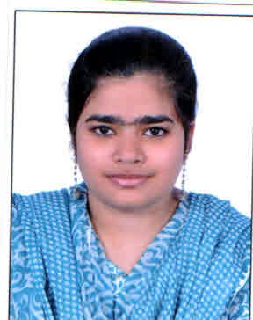Photo

H-No: 3-107, Aditya Nagar

New Hafeezpet, R.R.Dist.

Mobile: +91 8297643349

inageenanaaz@gmail.com

**Career Objective**

A position, which allows substantial valve additional and challenging opportunity that, would groom me to be trusted with complete responsibility.

**Project Details**

**Project Title: Ecommerce**

**Technology Used: Core** Java, J2EE, Angular JS, HTML5, CSS3, Bootstrap, Tomcat, Oracle

**Frame Work:** Spring, Hibernate

**Project Description:**

* Online shopping web sites for retail sales direct to consumers
* Providing or participating in online marketplaces, which process third-party business-to-consumer or consumer-to-consumer sales
* [Business-to-business](https://en.wikipedia.org/wiki/Business-to-business) buying and selling
* Gathering and using demographic data through web contacts and social media

**Educational Qualification**

|  |  |  |  |
| --- | --- | --- | --- |
| **Exam** | **Year of Passing** | **Percentage** | **University/Board** |
| **MSIT** | 2016 | 75% | JNTU KAKINADA |
| **B.TECH** | 2014 | 62% | Shadan Womens College of Engineering and Technology (SWCET) |
| **XII TH** | 2010 | 78.9% | Narayana Junior College |
| **X TH** | 2008 | 65% | Thayal Grammar High School |

**Certification**

I am currently undergoing training from NIIT for .

* Training includes following modules :
* **C++:** Inheritance, polymorphism, encapsulation.
* **Internet Technology :** HTML, JavaScript and XML
* **Core Java:** JVM, packages, Interface, Threads, Applets, Awt, swing, generics.
* **Specialized Technology:** Advanced Java: JSP and Servlets.
* **Database:** Oracle 10g (it includes SQL)
* **Soft Skills:** Training regarding how work in Corporate World with standards, rules, discipline and subject knowledge.

**Technical Skills**

* **Languages:**  Core [java](http://myjobsresumes.blogspot.in/2013/07/cv-for-java-developers.html),J2EE, JavaScript, HTML, XML,  C, C++, SQL,VB 6.0
* **OS Environment:**  Windows 2000/XP/7, 8, 10 DOS.
* **Database:** Oracle 10g,  MS Access
* **Tools:** Eclipse, Net beans
* **Frame Work:** springs, hibernate
* **Web/Application Server**: Tomcat

**Extra-Curricular Activities**

* Participated in College Seminar on ---
* GitHub Link - https://github.com/NageenaNaaz/hello-world

**Personal Strengths and Achievements**

* Strong commutation, Interpersonal, learning and organizing skill matched with the ability to manage stress, time and people effectively.
* Excellent Communication and management skills

**Personal Dossier**

**Father’s Name:** MD. Riyaz Uddin

**DOB:** 29-09-1992

**Marital Status:** Single

**Passport Number:** (Details to be provided)

------------------------------------------------------------------------------------------------------------------------