Name of the Student | N.Jeevan Sai
Reg. No | 192525169
GitHub Link | https://github.com/Nagellajeevansai/MLA0405-Deep-Learning.git

SIMATS ENGINEERING
CO5 - ASSESSMENT TOOL 1
Design Desk
COURSE NAME: Deep Learning COURSE CODE: MLA0405
SLOT : D Faculty : Dr.Arul Raj A.M

COURSE OUTCOME COVERED
CO5: Students will be able to analyze and explain advanced generative deep learning models including Autoencoders, Deep Belief Networks, Boltzmann Machines, Deep Boltzmann Machines, and Generative Adversarial Networks. They will be able to compare their architectures, explain their learning mechanisms, and apply suitable generative models to real-world problems. (BTL-3)
Course Outcome Weightage: 35% Duration: 90 minutes
Assessment Tool Weightage: 30% Mark : 25

Code of Conduct:
I (N.Jeevan Sai / 192525169)certify that this submission is my original work and that I have adhered to the guidelines specified for this assessment.I understand that any violation of academic integrity rules will result in disciplinary action.

Signature of the student: 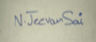 Name of the student: N.Jeevan Sai

Criteria | Subject  Knowledge and  Conceptual  Understanding  (2) | Technical  Accuracy and  Application of  Concepts  (3) | ProblemSolving and Analytical  Thinking (2) | Communication  Skills and Clarity of Explanation  (2) | Confidence,  Presentation and  Professional  Behaviour (1) | Total  (10)
Weightage | 20 % | 30% | 20% | 20 % | 10 % | 100%
Q1
Q2
Q3
Q4
Q5
Total

Faculty Signature : Total Marks:

QUESTIONS: 25 Total Marks:25

- Design an Autoencoder-Based Feature Learning System
Real-world problem: A manufacturing company needs to detect defective products using highdimensional sensor data.
Requirements:
      - Input: 100 sensor features such as temperature, pressure, vibration and voltage.
      - Output: Reconstructed sensor data and a compact feature representation.
      - Constraint: Reduce dimensionality while preserving important information.
Architecture:
100-D Sensor Input → Dense(64) → Dense(32) → Latent(10) → Dense(32) → Dense(64) → 100-D Reconstruction
Design:
      - Encoder: 100 → 64 → 32 → 10 neurons.
      - Latent representation: 10-dimensional feature vector.
      - Decoder: 10 → 32 → 64 → 100 neurons.
      - Hidden activation: ReLU.
      - Output activation: Linear for continuous sensor values.
      - Reconstruction loss: Mean Squared Error (MSE).

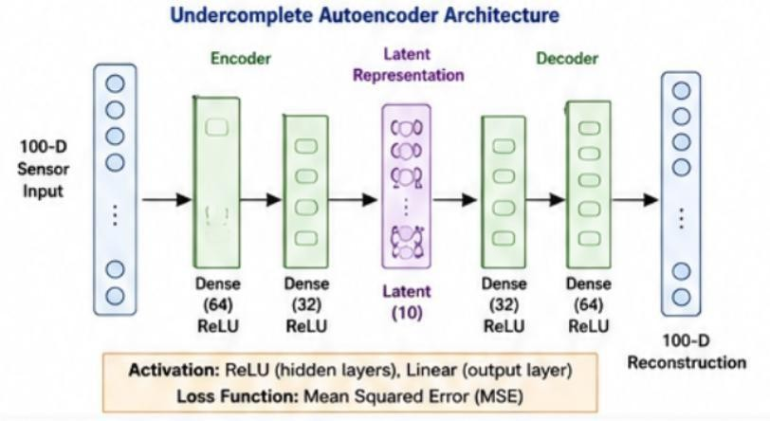
Working: The encoder compresses 100 sensor features into 10 important latent features, while the decoder reconstructs the original sensor data; the latent vector can then be used for defect classification or anomaly detection.
Evaluation: Reconstruction MSE, classification accuracy, precision, recall, F1-score and anomalydetection performance.
Expected outcome: The system reduces data dimensionality by 90% while learning important sensor patterns useful for identifying defective products.
- Design a Robust Regularized Autoencoder
Real-world problem: A healthcare organization has noisy patient-record features and requires robust representations for classification.
Requirements:
    - Input: Patient features such as laboratory values, vital signs and medical-record attributes.
    - Output: Clean reconstruction and robust latent features.
    - Constraint: Reduce noise and prevent overfitting.
Architecture:
Noisy Patient Data → Dense(128) → Dense(64) → Latent(16) → Dense(64) → Dense(128) →
Reconstructed Data
Design:
    - Encoder: 128 → 64 → 16 neurons.
    - Decoder: 16 → 64 → 128 neurons.
    - Hidden activation: ReLU.
    - Output activation: Linear/Sigmoid, depending on data normalization.
    - Regularization: Dropout + L2 weight regularization.
    - Reconstruction loss: MSE.
Training objective:
Total Loss = Reconstruction Loss + λ‖W‖²
Working: Dropout randomly removes neurons during training, while L2 regularization penalizes excessively large weights; together they reduce overfitting and encourage the model to learn useful general features.
Evaluation: Reconstruction error, classification accuracy, precision, recall, F1-score and validation loss.
Expected outcome: The model produces a more stable and noise-resistant representation for downstream patient classification.
- Design a Deep Generative Model
Real-world problem: A recommendation/content-generation system needs to learn complex data distributions and generate new content. Proposed model: Deep Belief Network (DBN)
Architecture:
Visible Layer → Hidden Layer 1 → Hidden Layer 2 → Hidden Layer 3
Example:
100 Input Features → 64 Hidden Units → 32 Hidden Units → 16 Hidden Units
Design:
- Visible layer: Represents input features.
- Hidden Layer 1: 64 neurons.
- Hidden Layer 2: 32 neurons.
- Hidden Layer 3: 16 neurons.
- Activation: Sigmoid for binary/Bernoulli features.
- Latent layer: 16-dimensional representation.
Learning process:
- Train the first Restricted Boltzmann Machine (RBM).
- Freeze its learned representation.
- Train the next RBM using the previous hidden output.
- Continue layer-by-layer.
- Fine-tune the complete network for the desired application.
- Generate new samples by sampling from the learned representation.
Why DBN? A DBN can learn hierarchical features and complex probability distributions from large datasets, making it suitable for recommendation and content-generation tasks.
Evaluation: Reconstruction error, recommendation accuracy, precision@K, recall@K and quality/diversity of generated samples.
4. Design a Stochastic and Contractive Representation Model
Real-world problem: An image-processing system needs representations that remain stable when images contain small changes or noise.
Proposed model: Contractive Autoencoder
Architecture:
Input Image 784 → Dense(256) → Dense(64) → Latent(16) → Dense(64) → Dense(256) → Output Image 784
Design:
  - Input: 28 × 28 grayscale image = 784 features.
  - Encoder: 784 → 256 → 64 → 16.
  - Latent representation: 16 features. • Decoder: 16 → 64 → 256 → 784.
  - Hidden activation: ReLU.
  - Output activation: Sigmoid for normalized image pixels.

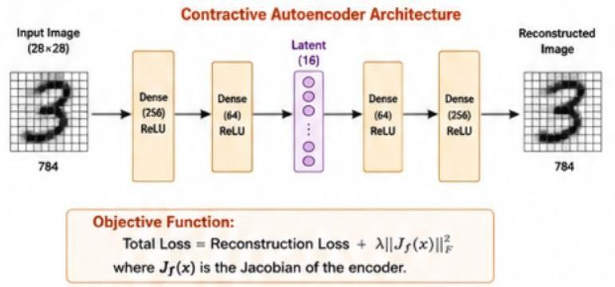
Objective function:
Total Loss = Reconstruction Loss + λ‖Jf(x)‖²F where Jf(x) is the encoder Jacobian.
Robustness mechanism: The contractive penalty minimizes the sensitivity of the latent representation to small changes in the input.
Working: If an image has small pixel-level changes, the encoder produces a similar latent representation, making the learned features stable.
Evaluation: Reconstruction MSE, classification accuracy under noise, robustness to perturbations and latent-feature stability.
Expected outcome: The model learns stable image features and becomes less sensitive to small variations and noise.
5. Design a GAN-Based Data Generation System
Real-world problem: An organization has limited training images and wants realistic synthetic images.
Requirements:
- Input: Random noise vector.
- Output: Realistic synthetic images.
- Constraint: Generated images should be realistic and diverse.
Architecture:
Random Noise z → Generator → Synthetic Image → Discriminator → Real/Fake
Generator
- Input: 100-dimensional random noise vector.
- Dense/upsampling layers.
- ReLU activation in hidden layers.
- Tanh activation at output.
- Output: Synthetic image.
Discriminator
- Input: Real or generated image.
- Convolutional layers.
- Leaky ReLU activation.
- Sigmoid output.
- Output: Probability of Real or Fake.
Adversarial Training:
- Generator creates a synthetic image from random noise.
- Discriminator receives both real and generated images.
- Discriminator learns to distinguish real from fake.
- Generator learns to fool the discriminator.
- Both networks improve through adversarial training.
Loss functions:
  - Discriminator: Binary Cross-Entropy loss.
  - Generator: Adversarial Binary Cross-Entropy loss.
Evaluation:
  - Image quality.
  - Diversity of generated images.
  - FID (Fréchet Inception Distance).
  - Precision and recall for generated distributions.
  - Human visual evaluation.
GAN vs Autoencoder

Feature Autoencoder GAN

Main purpose Reconstruction Data generation
Training Reconstruction loss Adversarial training
Output quality Usually good reconstruction Often highly realistic
Generation Limited Strong
Main components Encoder + Decoder Generator + Discriminator

Justification: A GAN is more suitable because the main requirement is to generate realistic and diverse
synthetic images, rather than simply reconstruct existing image
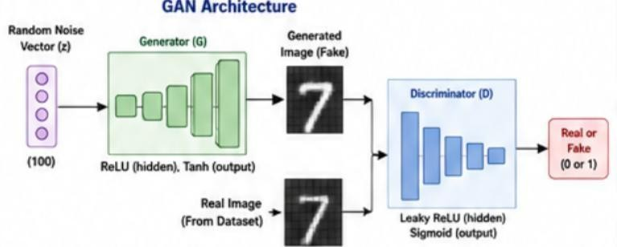
RUBRICS FOR CALCULATION:

Criteria | Weightage | Level 4 Exemplary | Level 3 Proficient | Level 2 Developing | Level 1 Beginning
Understanding of Problem Context | 20 | Clearly understands the problem, requirements, constraints, and expected outcomes. | Good understanding with minor gaps in requirements. | Basic understanding; some requirements are unclear. | Poor understanding or misinterpretation of the problem.
Application of  Concepts | 30 | Accurately applies appropriate generative deep learning concepts and architectures. | Applies relevant concepts correctly with minor errors. | Applies basic concepts with limited accuracy. | Fails to apply appropriate concepts.
Design  Approach | 20 | Innovative, logical, well-structured, feasible, and technically justified design. | Logical and feasible design with minor gaps. | Basic design with some inconsistencies. | Unclear, illogical, or impractical design.
Accuracy of Solution | 20 | Completely correct architecture, process, objectives, and justification. | Mostly correct with minor technical errors. | Partially correct solution with noticeable gaps. | Incorrect or incomplete solution.
Clarity | 10 | Clear, wellorganized diagram and explanation with proper technical labeling. | Understandable with minor clarity issues. | Limited clarity and explanation. | Poorly presented and difficult to understand.

