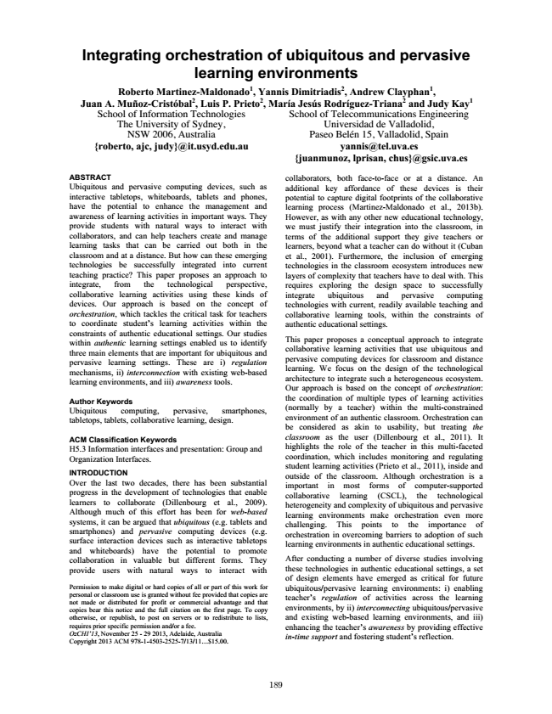

**Integrating orchestration of ubiquitous and pervasive learning environments Roberto Martinez-Maldonado1, Yannis Dimitriadis2, Andrew Clayphan1, Juan School A. Muñoz-Cristóbal2, of Information Technologies**

**Luis P. Prieto2, María Jesús Rodríguez-Triana2 and Judy Kay1**

The University of Sydney, NSW 2006, Australia {roberto, ajc, judy}@it.usyd.edu.au

School of Telecommunications Engineering Universidad de Valladolid, Paseo Belén 15, Valladolid, Spain yannis@tel.uva.es {juanmunoz, lprisan, chus}@gsic.uva.es

ABSTRACT Ubiquitous and pervasive computing devices, such as interactive tabletops, whiteboards, tablets and phones, have the potential to enhance the management and awareness of learning activities in important ways. They provide students with natural ways to interact with collaborators, and can help teachers create and manage learning tasks that can be carried out both in the classroom and at a distance. But how can these emerging technologies be successfully integrated into current teaching practice? This paper proposes an approach to integrate, from the technological perspective, collaborative learning activities using these kinds of devices. Our approach is based on the concept of orchestration, which tackles the critical task for teachers to coordinate student’s learning activities within the constraints of authentic educational settings. Our studies within authentic learning settings enabled us to identify three main elements that are important for ubiquitous and pervasive learning settings. These are i) regulation mechanisms, ii) interconnection with existing web-based learning environments, and iii) awareness tools.

Author Keywords Ubiquitous computing, pervasive, smartphones, tabletops, tablets, collaborative learning, design.

ACM Classification Keywords H5.3 Information interfaces and presentation: Group and Organization Interfaces.

INTRODUCTION Over the last two decades, there has been substantial progress in the development of technologies that enable learners to collaborate (Dillenbourg et al., 2009). Although much of this effort has been for web-based systems, it can be argued that ubiquitous (e.g. tablets and smartphones) and pervasive computing devices (e.g. surface interaction devices such as interactive tabletops and whiteboards) have the potential to promote collaboration in valuable but different forms. They provide users with natural ways to interact with

collaborators, both face-to-face or at a distance. An additional key affordance of these devices is their potential to capture digital footprints of the collaborative learning process (Martinez-Maldonado et al., 2013b). However, as with any other new educational technology, we must justify their integration into the classroom, in terms of the additional support they give teachers or learners, beyond what a teacher can do without it (Cuban et al., 2001). Furthermore, the inclusion of emerging technologies in the classroom ecosystem introduces new layers of complexity that teachers have to deal with. This requires exploring the design space to successfully integrate ubiquitous and pervasive computing technologies with current, readily available teaching and collaborative learning tools, within the constraints of authentic educational settings.

This paper proposes a conceptual approach to integrate collaborative learning activities that use ubiquitous and pervasive computing devices for classroom and distance learning. We focus on the design of the technological architecture to integrate such a heterogeneous ecosystem. Our approach is based on the concept of orchestration: the coordination of multiple types of learning activities (normally by a teacher) within the multi-constrained environment of an authentic classroom. Orchestration can be considered as akin to usability, but treating the classroom as the user (Dillenbourg et al., 2011). It highlights the role of the teacher in this multi-faceted coordination, which includes monitoring and regulating student learning activities (Prieto et al., 2011), inside and outside of the classroom. Although orchestration is a important in most forms of computer-supported collaborative learning (CSCL), the technological heterogeneity and complexity of ubiquitous and pervasive learning environments make orchestration even more challenging. This points to the importance of orchestration in overcoming barriers to adoption of such learning environments in authentic educational settings.

After conducting a number of diverse studies involving these technologies in authentic educational settings, a set of design elements have emerged as critical for future Permission to make digital or hard copies of all or part of this work for personal or classroom use is granted without fee provided that copies are not made or distributed for profit or commercial advantage and that copies bear this notice and the full citation on the first page. To copy otherwise, or republish, to post on servers or to redistribute to lists,

ubiquitous/pervasive learning environments: i) enabling teacher’s regulation of activities across the learning environments, by ii) interconnecting ubiquitous/pervasive and existing web-based learning environments, and iii) requires prior specific permission and/or a fee. OzCHI’13, November 25 - 29 2013, Adelaide, Australia Copyright 2013 ACM 978-1-4503-2525-7/13/11...$15.00.

enhancing the teacher’s awareness by providing effective in-time support and fostering student’s reflection.

189

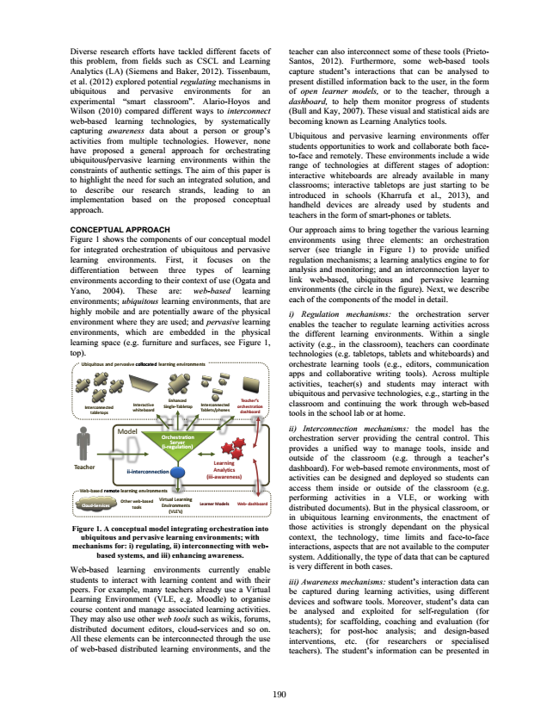

Diverse research efforts have tackled different facets of this problem, from fields such as CSCL and Learning Analytics (LA) (Siemens and Baker, 2012). Tissenbaum, et al. (2012) explored potential regulating mechanisms in ubiquitous and pervasive environments for an experimental “smart classroom”. Alario-Hoyos and Wilson (2010) compared different ways to interconnect web-based learning technologies, by systematically capturing awareness data about a person or group’s activities from multiple technologies. However, none have proposed a general approach for orchestrating ubiquitous/pervasive learning environments within the constraints of authentic settings. The aim of this paper is to highlight the need for such an integrated solution, and to describe our research strands, leading to an implementation based on the proposed conceptual approach.

CONCEPTUAL APPROACH Figure 1 shows the components of our conceptual model for integrated orchestration of ubiquitous and pervasive learning environments. First, it focuses on the differentiation between three types of learning environments according to their context of use (Ogata and Yano, 2004). These are: web-based learning environments; ubiquitous learning environments, that are highly mobile and are potentially aware of the physical environment where they are used; and pervasive learning environments, which are embedded in the physical learning space (e.g. furniture and surfaces, see Figure 1, top).

Model

**Web-­‐based remote learning environments**

**Figure 1. A conceptual model integrating orchestration into ubiquitous and pervasive learning environments; with mechanisms for: i) regulating, ii) interconnecting with web- based systems, and iii) enhancing awareness.**

Web-based learning environments currently enable students to interact with learning content and with their peers. For example, many teachers already use a Virtual Learning Environment (VLE, e.g. Moodle) to organise course content and manage associated learning activities. They may also use other web tools such as wikis, forums, distributed document editors, cloud-services and so on. All these elements can be interconnected through the use of web-based distributed learning environments, and the

**Teacher**

**Ubiquitous and pervasive collocated learning environments**

**Interactive whiteboard**

**Cloud-­‐Services**

**Interconnected tabletops**

**Other web-­‐based tools**

**ii-­‐interconnection**

**Virtual Learning Environments (VLE’s)**

**Orchestration Server (i-­‐regulation)**

**Enhanced Single-­‐Tabletop**

**Teacher’s**

**Tablets/phones Interconnected**

**orchestration dashboard**

**Learning Analytics (iii-­‐awareness)**

**Learner Models**

**Web-­‐ dashboard**

teacher can also interconnect some of these tools (Prieto- Santos, 2012). Furthermore, some web-based tools capture student’s interactions that can be analysed to present distilled information back to the user, in the form of open learner models, or to the teacher, through a dashboard, to help them monitor progress of students (Bull and Kay, 2007). These visual and statistical aids are becoming known as Learning Analytics tools.

Ubiquitous and pervasive learning environments offer students opportunities to work and collaborate both face- to-face and remotely. These environments include a wide range of technologies at different stages of adoption: interactive whiteboards are already available in many classrooms; interactive tabletops are just starting to be introduced in schools (Kharrufa et al., 2013), and handheld devices are already used by students and teachers in the form of smart-phones or tablets.

Our approach aims to bring together the various learning environments using three elements: an orchestration server (see triangle in Figure 1) to provide unified regulation mechanisms; a learning analytics engine to for analysis and monitoring; and an interconnection layer to link web-based, ubiquitous and pervasive learning environments (the circle in the figure). Next, we describe each of the components of the model in detail.

i) Regulation mechanisms: the orchestration server enables the teacher to regulate learning activities across the different learning environments. Within a single activity (e.g., in the classroom), teachers can coordinate technologies (e.g. tabletops, tablets and whiteboards) and orchestrate learning tools (e.g., editors, communication apps and collaborative writing tools). Across multiple activities, teacher(s) and students may interact with ubiquitous and pervasive technologies, e.g., starting in the classroom and continuing the work through web-based tools in the school lab or at home.

ii) Interconnection mechanisms: the model has the orchestration server providing the central control. This provides a unified way to manage tools, inside and outside of the classroom (e.g. through a teacher’s dashboard). For web-based remote environments, most of activities can be designed and deployed so students can access them inside or outside of the classroom (e.g. performing activities in a VLE, or working with distributed documents). But in the physical classroom, or in ubiquitous learning environments, the enactment of those activities is strongly dependant on the physical context, the technology, time limits and face-to-face interactions, aspects that are not available to the computer system. Additionally, the type of data that can be captured is very different in both cases.

iii) Awareness mechanisms: student’s interaction data can be captured during learning activities, using different devices and software tools. Moreover, student’s data can be analysed and exploited for self-regulation (for students); for scaffolding, coaching and evaluation (for teachers); for post-hoc analysis; and design-based interventions, etc. (for researchers or specialised teachers). The student’s information can be presented in

190

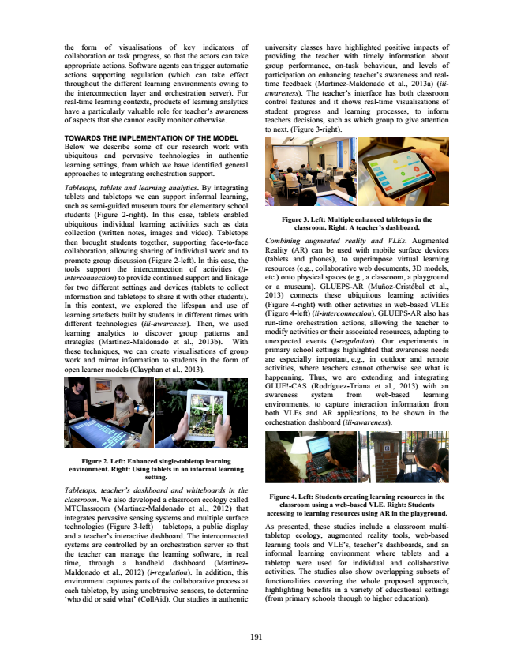

the form of visualisations of key indicators of collaboration or task progress, so that the actors can take appropriate actions. Software agents can trigger automatic actions supporting regulation (which can take effect throughout the different learning environments owing to the interconnection layer and orchestration server). For real-time learning contexts, products of learning analytics have a particularly valuable role for teacher’s awareness of aspects that she cannot easily monitor otherwise.

TOWARDS THE IMPLEMENTATION OF THE MODEL Below we describe some of our research work with ubiquitous and pervasive technologies in authentic learning settings, from which we have identified general approaches to integrating orchestration support.

Tabletops, tablets and learning analytics. By integrating tablets and tabletops we can support informal learning, such as semi-guided museum tours for elementary school students (Figure 2-right). In this case, tablets enabled ubiquitous individual learning activities such as data collection (written notes, images and video). Tabletops then brought students together, supporting face-to-face collaboration, allowing sharing of individual work and to promote group discussion (Figure 2-left). In this case, the tools support the interconnection of activities (ii- interconnection) to provide continued support and linkage for two different settings and devices (tablets to collect information and tabletops to share it with other students). In this context, we explored the lifespan and use of learning artefacts built by students in different times with different technologies (iii-awareness). Then, we used learning analytics to discover group patterns and strategies (Martinez-Maldonado et al., 2013b). With these techniques, we can create visualisations of group work and mirror information to students in the form of open learner models (Clayphan et al., 2013).

**Figure 2. Left: Enhanced single-tabletop learning environment. Right: Using tablets in an informal learning setting.**

Tabletops, teacher’s dashboard and whiteboards in the classroom. We also developed a classroom ecology called MTClassroom (Martinez-Maldonado et al., 2012) that integrates pervasive sensing systems and multiple surface technologies (Figure 3-left) – tabletops, a public display and a teacher’s interactive dashboard. The interconnected systems are controlled by an orchestration server so that the teacher can manage the learning software, in real time, through a handheld dashboard (Martinez- Maldonado et al., 2012) (i-regulation). In addition, this environment captures parts of the collaborative process at each tabletop, by using unobtrusive sensors, to determine ‘who did or said what’ (CollAid). Our studies in authentic

**Figure 4. Left: Students creating learning resources in the classroom using a web-based VLE. Right: Students accessing to learning resources using AR in the playground.**

As presented, these studies include a classroom multi- tabletop ecology, augmented reality tools, web-based learning tools and VLE’s, teacher’s dashboards, and an informal learning environment where tablets and a tabletop were used for individual and collaborative activities. The studies also show overlapping subsets of functionalities covering the whole proposed approach, highlighting benefits in a variety of educational settings (from primary schools through to higher education).

191

university classes have highlighted positive impacts of providing the teacher with timely information about group performance, on-task behaviour, and levels of participation on enhancing teacher’s awareness and real- time feedback (Martinez-Maldonado et al., 2013a) (iii- awareness). The teacher’s interface has both classroom control features and it shows real-time visualisations of student progress and learning processes, to inform teachers decisions, such as which group to give attention to next. (Figure 3-right).

**Figure 3. Left: Multiple enhanced tabletops in the classroom. Right: A teacher’s dashboard.**

Combining augmented reality and VLEs. Augmented Reality (AR) can be used with mobile surface devices (tablets and phones), to superimpose virtual learning resources (e.g., collaborative web documents, 3D models, etc.) onto physical spaces (e.g., a classroom, a playground or a museum). GLUEPS-AR (Muñoz-Cristóbal et al., 2013) connects these ubiquitous learning activities (Figure 4-right) with other activities in web-based VLEs (Figure 4-left) (ii-interconnection). GLUEPS-AR also has run-time orchestration actions, allowing the teacher to modify activities or their associated resources, adapting to unexpected events (i-regulation). Our experiments in primary school settings highlighted that awareness needs are especially important, e.g., in outdoor and remote activities, where teachers cannot otherwise see what is happenning. Thus, we are extending and integrating GLUE!-CAS (Rodríguez-Triana et al., 2013) with an awareness system from web-based learning environments, to capture interaction information from both VLEs and AR applications, to be shown in the orchestration dashboard (iii-awareness).

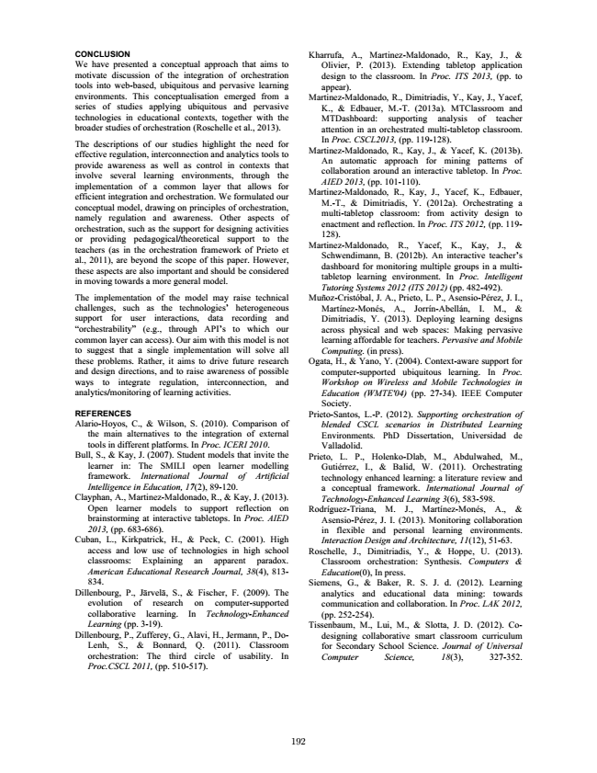

CONCLUSION We have presented a conceptual approach that aims to motivate discussion of the integration of orchestration tools into web-based, ubiquitous and pervasive learning environments. This conceptualisation emerged from a series of studies applying ubiquitous and pervasive technologies in educational contexts, together with the broader studies of orchestration (Roschelle et al., 2013).

The descriptions of our studies highlight the need for effective regulation, interconnection and analytics tools to provide awareness as well as control in contexts that involve several learning environments, through the implementation of a common layer that allows for efficient integration and orchestration. We formulated our conceptual model, drawing on principles of orchestration, namely regulation and awareness. Other aspects of orchestration, such as the support for designing activities or providing pedagogical/theoretical support to the teachers (as in the orchestration framework of Prieto et al., 2011), are beyond the scope of this paper. However, these aspects are also important and should be considered in moving towards a more general model.

The implementation of the model may raise technical challenges, such as the technologies’ heterogeneous support for user interactions, data recording and “orchestrability” (e.g., through API’s to which our common layer can access). Our aim with this model is not to suggest that a single implementation will solve all these problems. Rather, it aims to drive future research and design directions, and to raise awareness of possible ways to integrate regulation, interconnection, and analytics/monitoring of learning activities.

REFERENCES Alario-Hoyos, C., & Wilson, S. (2010). Comparison of the main alternatives to the integration of external tools in different platforms. In Proc. ICERI 2010. Bull, S., & Kay, J. (2007). Student models that invite the learner in: The SMILI open learner modelling framework. International Journal of Artificial Intelligence in Education, 17(2), 89-120. Clayphan, A., Martinez-Maldonado, R., & Kay, J. (2013). Open learner models to support reflection on brainstorming at interactive tabletops. In Proc. AIED 2013, (pp. 683-686). Cuban, L., Kirkpatrick, H., & Peck, C. (2001). High access and low use of technologies in high school classrooms: Explaining an apparent paradox. American Educational Research Journal, 38(4), 813- 834. Dillenbourg, P., Järvelä, S., & Fischer, F. (2009). The evolution of research on computer-supported collaborative learning. In Technology-Enhanced Learning (pp. 3-19). Dillenbourg, P., Zufferey, G., Alavi, H., Jermann, P., Do- Lenh, S., & Bonnard, Q. (2011). Classroom orchestration: The third circle of usability. In Proc.CSCL 2011, (pp. 510-517).

Kharrufa, A., Martinez-Maldonado, R., Kay, J., & Olivier, P. (2013). Extending tabletop application design to the classroom. In Proc. ITS 2013, (pp. to appear). Martinez-Maldonado, R., Dimitriadis, Y., Kay, J., Yacef, K., & Edbauer, M.-T. (2013a). MTClassroom and MTDashboard: supporting analysis of teacher attention in an orchestrated multi-tabletop classroom. In Proc. CSCL2013, (pp. 119-128). Martinez-Maldonado, R., Kay, J., & Yacef, K. (2013b). An automatic approach for mining patterns of collaboration around an interactive tabletop. In Proc. AIED 2013, (pp. 101-110). Martinez-Maldonado, R., Kay, J., Yacef, K., Edbauer, M.-T., & Dimitriadis, Y. (2012a). Orchestrating a multi-tabletop classroom: from activity design to enactment and reflection. In Proc. ITS 2012, (pp. 119- 128). Martinez-Maldonado, R., Yacef, K., Kay, J., & Schwendimann, B. (2012b). An interactive teacher’s dashboard for monitoring multiple groups in a multi- tabletop learning environment. In Proc. Intelligent Tutoring Systems 2012 (ITS 2012) (pp. 482-492). Muñoz-Cristóbal, J. A., Prieto, L. P., Asensio-Pérez, J. I., Martínez-Monés, A., Jorrín-Abellán, I. M., & Dimitriadis, Y. (2013). Deploying learning designs across physical and web spaces: Making pervasive learning affordable for teachers. Pervasive and Mobile Computing. (in press). Ogata, H., & Yano, Y. (2004). Context-aware support for computer-supported ubiquitous learning. In Proc. Workshop on Wireless and Mobile Technologies in Education (WMTE'04) (pp. 27-34). IEEE Computer Society. Prieto-Santos, L.-P. (2012). Supporting orchestration of blended CSCL scenarios in Distributed Learning Environments. PhD Dissertation, Universidad de Valladolid. Prieto, L. P., Holenko-Dlab, M., Abdulwahed, M., Gutiérrez, I., & Balid, W. (2011). Orchestrating technology enhanced learning: a literature review and a conceptual framework. International Journal of Technology-Enhanced Learning 3(6), 583-598. Rodríguez-Triana, M. J., Martínez-Monés, A., & Asensio-Pérez, J. I. (2013). Monitoring collaboration in flexible and personal learning environments. Interaction Design and Architecture, 11(12), 51-63. Roschelle, J., Dimitriadis, Y., & Hoppe, U. (2013). Classroom orchestration: Synthesis. Computers & Education(0), In press. Siemens, G., & Baker, R. S. J. d. (2012). Learning analytics and educational data mining: towards communication and collaboration. In Proc. LAK 2012, (pp. 252-254). Tissenbaum, M., Lui, M., & Slotta, J. D. (2012). Co- designing collaborative smart classroom curriculum for Secondary School Science. Journal of Universal Computer Science, 18(3), 327-352.

192