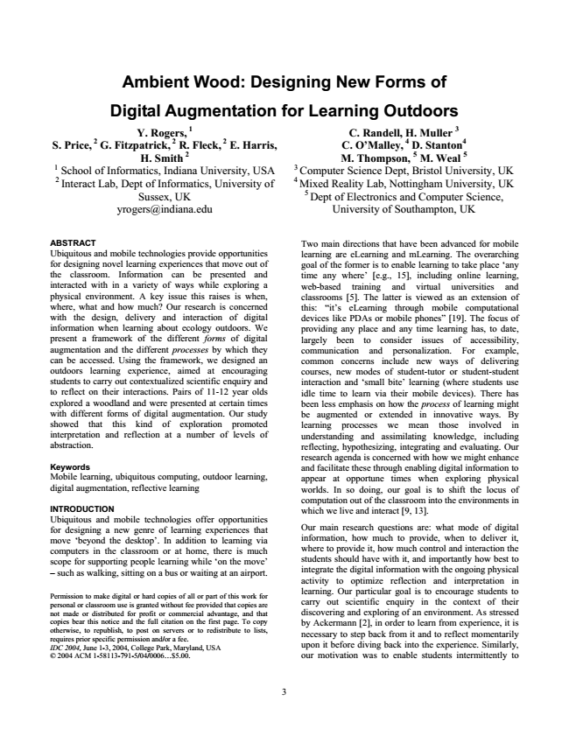

**Ambient Wood: Designing New Forms of**

**Digital Augmentation for Learning Outdoors**

Y. Rogers, 1 S. Price, 2 G. Fitzpatrick, 2 R. Fleck, 2 E. Harris, H. Smith 2 1 School of Informatics, Indiana University, USA 2 Interact Lab, Dept of Informatics, University of Sussex, UK yrogers@indiana.edu

C. Randell, H. Muller 3 C. O’Malley, 4 D. Stanton4 M. Thompson, 5 M. Weal 5 3 Computer Science Dept, Bristol University, UK 4 Mixed Reality Lab, Nottingham University, UK

5

Dept of Electronics and Computer Science,

University of Southampton, UK

ABSTRACT Ubiquitous and mobile technologies provide opportunities for designing novel learning experiences that move out of the classroom. Information can be presented and interacted with in a variety of ways while exploring a physical environment. A key issue this raises is when, where, what and how much? Our research is concerned with the design, delivery and interaction of digital information when learning about ecology outdoors. We present a framework of the different forms of digital augmentation and the different processes by which they can be accessed. Using the framework, we designed an outdoors learning experience, aimed at encouraging students to carry out contextualized scientific enquiry and to reflect on their interactions. Pairs of 11-12 year olds explored a woodland and were presented at certain times with different forms of digital augmentation. Our study showed that this kind of exploration promoted interpretation and reflection at a number of levels of abstraction.

Keywords Mobile learning, ubiquitous computing, outdoor learning, digital augmentation, reflective learning

INTRODUCTION Ubiquitous and mobile technologies offer opportunities for designing a new genre of learning experiences that move ‘beyond the desktop’. In addition to learning via computers in the classroom or at home, there is much scope for supporting people learning while ‘on the move’ – such as walking, sitting on a bus or waiting at an airport.

Permission to make digital or hard copies of all or part of this work for personal or classroom use is granted without fee provided that copies are not made or distributed for profit or commercial advantage, and that copies bear this notice and the full citation on the first page. To copy otherwise, to republish, to post on servers or to redistribute to lists, requires prior specific permission and/or a fee. IDC 2004, June 1-3, 2004, College Park, Maryland, USA © 2004 ACM 1-58113-791-5/04/0006...$5.00.

Two main directions that have been advanced for mobile learning are eLearning and mLearning. The overarching goal of the former is to enable learning to take place ‘any time any where’ [e.g., 15], including online learning, web-based training and virtual universities and classrooms [5]. The latter is viewed as an extension of this: “it’s eLearning through mobile computational devices like PDAs or mobile phones” [19]. The focus of providing any place and any time learning has, to date, largely been to consider issues of accessibility, communication and personalization. For example, common concerns include new ways of delivering courses, new modes of student-tutor or student-student interaction and ‘small bite’ learning (where students use idle time to learn via their mobile devices). There has been less emphasis on how the process of learning might be augmented or extended in innovative ways. By learning processes we mean those involved in understanding and assimilating knowledge, including reflecting, hypothesizing, integrating and evaluating. Our research agenda is concerned with how we might enhance and facilitate these through enabling digital information to appear at opportune times when exploring physical worlds. In so doing, our goal is to shift the locus of computation out of the classroom into the environments in which we live and interact [9, 13].

Our main research questions are: what mode of digital information, how much to provide, when to deliver it, where to provide it, how much control and interaction the students should have with it, and importantly how best to integrate the digital information with the ongoing physical activity to optimize reflection and interpretation in learning. Our particular goal is to encourage students to carry out scientific enquiry in the context of their discovering and exploring of an environment. As stressed by Ackermann [2], in order to learn from experience, it is necessary to step back from it and to reflect momentarily upon it before diving back into the experience. Similarly, our motivation was to enable students intermittently to

3

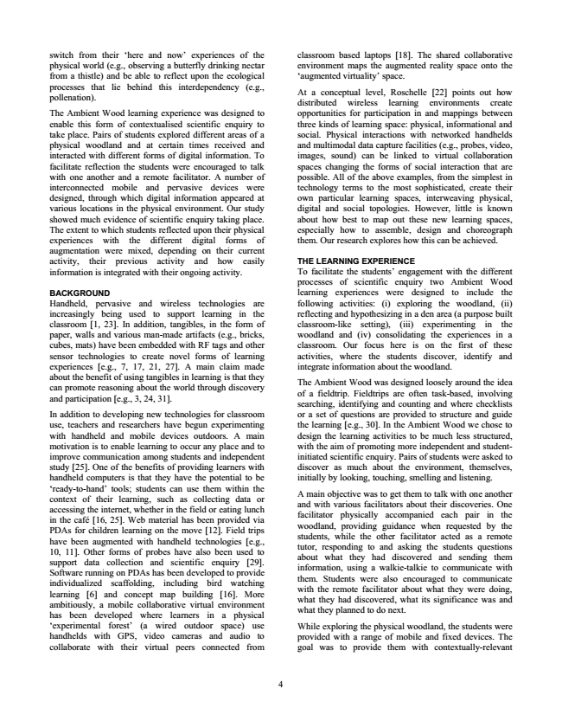

switch from their ‘here and now’ experiences of the physical world (e.g., observing a butterfly drinking nectar from a thistle) and be able to reflect upon the ecological processes that lie behind this interdependency (e.g., pollenation).

The Ambient Wood learning experience was designed to enable this form of contextualised scientific enquiry to take place. Pairs of students explored different areas of a physical woodland and at certain times received and interacted with different forms of digital information. To facilitate reflection the students were encouraged to talk with one another and a remote facilitator. A number of interconnected mobile and pervasive devices were designed, through which digital information appeared at various locations in the physical environment. Our study showed much evidence of scientific enquiry taking place. The extent to which students reflected upon their physical experiences with the different digital forms of augmentation were mixed, depending on their current activity, their previous activity and how easily information is integrated with their ongoing activity.

BACKGROUND Handheld, pervasive and wireless technologies are increasingly being used to support learning in the classroom [1, 23]. In addition, tangibles, in the form of paper, walls and various man-made artifacts (e.g., bricks, cubes, mats) have been embedded with RF tags and other sensor technologies to create novel forms of learning experiences [e.g., 7, 17, 21, 27]. A main claim made about the benefit of using tangibles in learning is that they can promote reasoning about the world through discovery and participation [e.g., 3, 24, 31].

In addition to developing new technologies for classroom use, teachers and researchers have begun experimenting with handheld and mobile devices outdoors. A main motivation is to enable learning to occur any place and to improve communication among students and independent study [25]. One of the benefits of providing learners with handheld computers is that they have the potential to be ‘ready-to-hand’ tools; students can use them within the context of their learning, such as collecting data or accessing the internet, whether in the field or eating lunch in the café [16, 25]. Web material has been provided via PDAs for children learning on the move [12]. Field trips have been augmented with handheld technologies [e.g., 10, 11]. Other forms of probes have also been used to support data collection and scientific enquiry [29]. Software running on PDAs has been developed to provide individualized scaffolding, including bird watching learning [6] and concept map building [16]. More ambitiously, a mobile collaborative virtual environment has been developed where learners in a physical ‘experimental forest’ (a wired outdoor space) use handhelds with GPS, video cameras and audio to collaborate with their virtual peers connected from

4

classroom based laptops [18]. The shared collaborative environment maps the augmented reality space onto the ‘augmented virtuality’ space.

At a conceptual level, Roschelle [22] points out how distributed wireless learning environments create opportunities for participation in and mappings between three kinds of learning space: physical, informational and social. Physical interactions with networked handhelds and multimodal data capture facilities (e.g., probes, video, images, sound) can be linked to virtual collaboration spaces changing the forms of social interaction that are possible. All of the above examples, from the simplest in technology terms to the most sophisticated, create their own particular learning spaces, interweaving physical, digital and social topologies. However, little is known about how best to map out these new learning spaces, especially how to assemble, design and choreograph them. Our research explores how this can be achieved.

THE LEARNING EXPERIENCE To facilitate the students’ engagement with the different processes of scientific enquiry two Ambient Wood learning experiences were designed to include the following activities: (i) exploring the woodland, (ii) reflecting and hypothesizing in a den area (a purpose built classroom-like setting), (iii) experimenting in the woodland and (iv) consolidating the experiences in a classroom. Our focus here is on the first of these activities, where the students discover, identify and integrate information about the woodland.

The Ambient Wood was designed loosely around the idea of a fieldtrip. Fieldtrips are often task-based, involving searching, identifying and counting and where checklists or a set of questions are provided to structure and guide the learning [e.g., 30]. In the Ambient Wood we chose to design the learning activities to be much less structured, with the aim of promoting more independent and student- initiated scientific enquiry. Pairs of students were asked to discover as much about the environment, themselves, initially by looking, touching, smelling and listening.

A main objective was to get them to talk with one another and with various facilitators about their discoveries. One facilitator physically accompanied each pair in the woodland, providing guidance when requested by the students, while the other facilitator acted as a remote tutor, responding to and asking the students questions about what they had discovered and sending them information, using a walkie-talkie to communicate with them. Students were also encouraged to communicate with the remote facilitator about what they were doing, what they had discovered, what its significance was and what they planned to do next.

While exploring the physical woodland, the students were provided with a range of mobile and fixed devices. The goal was to provide them with contextually-relevant

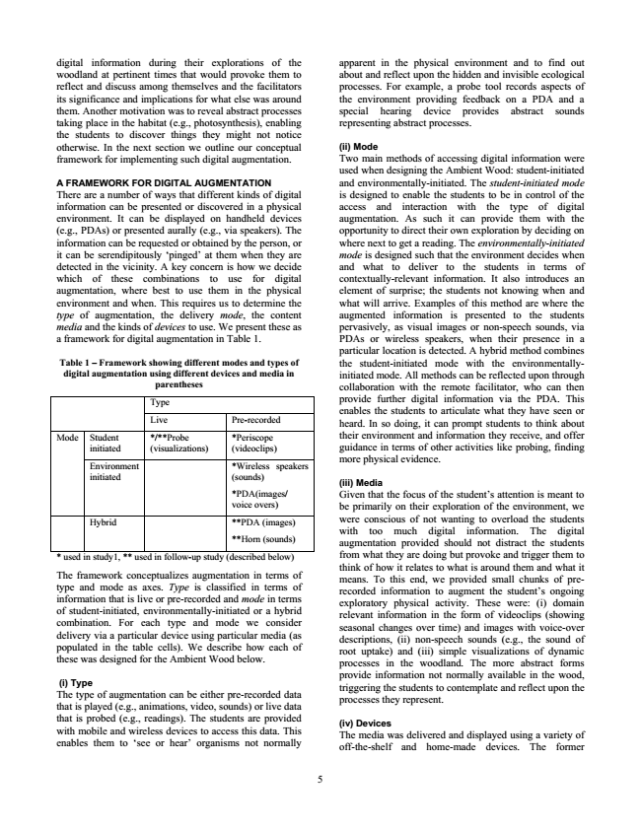

digital information during their explorations of the woodland at pertinent times that would provoke them to reflect and discuss among themselves and the facilitators its significance and implications for what else was around them. Another motivation was to reveal abstract processes taking place in the habitat (e.g., photosynthesis), enabling the students to discover things they might not notice otherwise. In the next section we outline our conceptual framework for implementing such digital augmentation.

A FRAMEWORK FOR DIGITAL AUGMENTATION There are a number of ways that different kinds of digital information can be presented or discovered in a physical environment. It can be displayed on handheld devices (e.g., PDAs) or presented aurally (e.g., via speakers). The information can be requested or obtained by the person, or it can be serendipitously ‘pinged’ at them when they are detected in the vicinity. A key concern is how we decide which of these combinations to use for digital augmentation, where best to use them in the physical environment and when. This requires us to determine the type of augmentation, the delivery mode, the content media and the kinds of devices to use. We present these as a framework for digital augmentation in Table 1.

**Table 1 – Framework showing different modes and types of digital augmentation using different devices and media in parentheses**

Type

Live Pre-recorded

Student initiated Mode

*/**Probe

*Periscope (visualizations)

(videoclips)

Environment initiated

*Wireless speakers (sounds)

*PDA(images/ voice overs)

Hybrid **PDA (images)

**Horn (sounds)

* used in study1, ** used in follow-up study (described below)

The framework conceptualizes augmentation in terms of type and mode as axes. Type is classified in terms of information that is live or pre-recorded and mode in terms of student-initiated, environmentally-initiated or a hybrid combination. For each type and mode we consider delivery via a particular device using particular media (as populated in the table cells). We describe how each of these was designed for the Ambient Wood below.

(i) Type The type of augmentation can be either pre-recorded data that is played (e.g., animations, video, sounds) or live data that is probed (e.g., readings). The students are provided with mobile and wireless devices to access this data. This enables them to ‘see or hear’ organisms not normally

5

apparent in the physical environment and to find out about and reflect upon the hidden and invisible ecological processes. For example, a probe tool records aspects of the environment providing feedback on a PDA and a special hearing device provides abstract sounds representing abstract processes.

(ii) Mode Two main methods of accessing digital information were used when designing the Ambient Wood: student-initiated and environmentally-initiated. The student-initiated mode is designed to enable the students to be in control of the access and interaction with the type of digital augmentation. As such it can provide them with the opportunity to direct their own exploration by deciding on where next to get a reading. The environmentally-initiated mode is designed such that the environment decides when and what to deliver to the students in terms of contextually-relevant information. It also introduces an element of surprise; the students not knowing when and what will arrive. Examples of this method are where the augmented information is presented to the students pervasively, as visual images or non-speech sounds, via PDAs or wireless speakers, when their presence in a particular location is detected. A hybrid method combines the student-initiated mode with the environmentally- initiated mode. All methods can be reflected upon through collaboration with the remote facilitator, who can then provide further digital information via the PDA. This enables the students to articulate what they have seen or heard. In so doing, it can prompt students to think about their environment and information they receive, and offer guidance in terms of other activities like probing, finding more physical evidence.

(iii) Media Given that the focus of the student’s attention is meant to be primarily on their exploration of the environment, we were conscious of not wanting to overload the students with too much digital information. The digital augmentation provided should not distract the students from what they are doing but provoke and trigger them to think of how it relates to what is around them and what it means. To this end, we provided small chunks of pre- recorded information to augment the student’s ongoing exploratory physical activity. These were: (i) domain relevant information in the form of videoclips (showing seasonal changes over time) and images with voice-over descriptions, (ii) non-speech sounds (e.g., the sound of root uptake) and (iii) simple visualizations of dynamic processes in the woodland. The more abstract forms provide information not normally available in the wood, triggering the students to contemplate and reflect upon the processes they represent.

(iv) Devices The media was delivered and displayed using a variety of off-the-shelf and home-made devices. The former

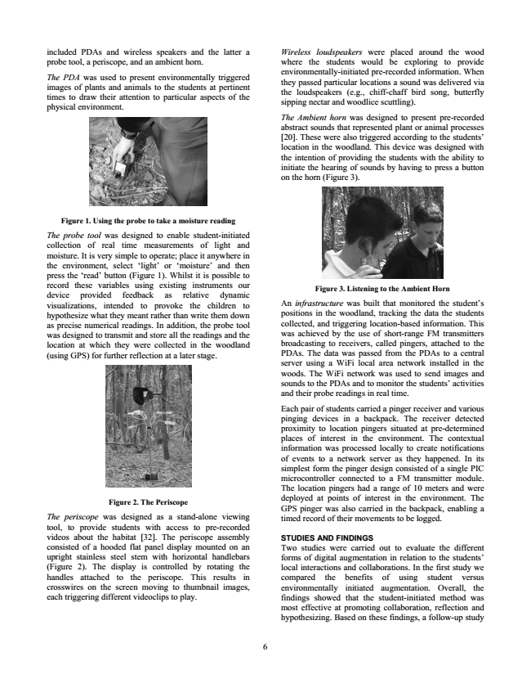

included PDAs and wireless speakers and the latter a probe tool, a periscope, and an ambient horn.

The PDA was used to present environmentally triggered images of plants and animals to the students at pertinent times to draw their attention to particular aspects of the physical environment.

**Figure 1. Using the probe to take a moisture reading**

The probe tool was designed to enable student-initiated collection of real time measurements of light and moisture. It is very simple to operate; place it anywhere in the environment, select ‘light’ or ‘moisture’ and then press the ‘read’ button (Figure 1). Whilst it is possible to record these variables using existing instruments our device provided feedback as relative dynamic visualizations, intended to provoke the children to hypothesize what they meant rather than write them down as precise numerical readings. In addition, the probe tool was designed to transmit and store all the readings and the location at which they were collected in the woodland (using GPS) for further reflection at a later stage.

**Figure 2. The Periscope**

The periscope was designed as a stand-alone viewing tool, to provide students with access to pre-recorded videos about the habitat [32]. The periscope assembly consisted of a hooded flat panel display mounted on an upright stainless steel stem with horizontal handlebars (Figure 2). The display is controlled by rotating the handles attached to the periscope. This results in crosswires on the screen moving to thumbnail images, each triggering different videoclips to play.

6

Wireless loudspeakers were placed around the wood where the students would be exploring to provide environmentally-initiated pre-recorded information. When they passed particular locations a sound was delivered via the loudspeakers (e.g., chiff-chaff bird song, butterfly sipping nectar and woodlice scuttling).

The Ambient horn was designed to present pre-recorded abstract sounds that represented plant or animal processes [20]. These were also triggered according to the students’ location in the woodland. This device was designed with the intention of providing the students with the ability to initiate the hearing of sounds by having to press a button on the horn (Figure 3).

**Figure 3. Listening to the Ambient Horn**

An infrastructure was built that monitored the student’s positions in the woodland, tracking the data the students collected, and triggering location-based information. This was achieved by the use of short-range FM transmitters broadcasting to receivers, called pingers, attached to the PDAs. The data was passed from the PDAs to a central server using a WiFi local area network installed in the woods. The WiFi network was used to send images and sounds to the PDAs and to monitor the students’ activities and their probe readings in real time.

Each pair of students carried a pinger receiver and various pinging devices in a backpack. The receiver detected proximity to location pingers situated at pre-determined places of interest in the environment. The contextual information was processed locally to create notifications of events to a network server as they happened. In its simplest form the pinger design consisted of a single PIC microcontroller connected to a FM transmitter module. The location pingers had a range of 10 meters and were deployed at points of interest in the environment. The GPS pinger was also carried in the backpack, enabling a timed record of their movements to be logged.

STUDIES AND FINDINGS Two studies were carried out to evaluate the different forms of digital augmentation in relation to the students’ local interactions and collaborations. In the first study we compared the benefits of using student versus environmentally initiated augmentation. Overall, the findings showed that the student-initiated method was most effective at promoting collaboration, reflection and hypothesizing. Based on these findings, a follow-up study

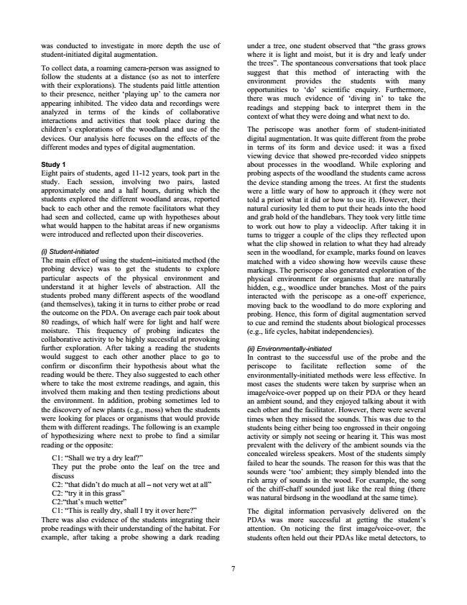

was conducted to investigate in more depth the use of student-initiated digital augmentation.

To collect data, a roaming camera-person was assigned to follow the students at a distance (so as not to interfere with their explorations). The students paid little attention to their presence, neither ‘playing up’ to the camera nor appearing inhibited. The video data and recordings were analyzed in terms of the kinds of collaborative interactions and activities that took place during the children’s explorations of the woodland and use of the devices. Our analysis here focuses on the effects of the different modes and types of digital augmentation.

Study 1 Eight pairs of students, aged 11-12 years, took part in the study. Each session, involving two pairs, lasted approximately one and a half hours, during which the students explored the different woodland areas, reported back to each other and the remote facilitators what they had seen and collected, came up with hypotheses about what would happen to the habitat areas if new organisms were introduced and reflected upon their discoveries.

(i) Student-initiated The main effect of using the student–initiated method (the probing device) was to get the students to explore particular aspects of the physical environment and understand it at higher levels of abstraction. All the students probed many different aspects of the woodland (and themselves), taking it in turns to either probe or read the outcome on the PDA. On average each pair took about 80 readings, of which half were for light and half were moisture. This frequency of probing indicates the collaborative activity to be highly successful at provoking further exploration. After taking a reading the students would suggest to each other another place to go to confirm or disconfirm their hypothesis about what the reading would be there. They also suggested to each other where to take the most extreme readings, and again, this involved them making and then testing predictions about the environment. In addition, probing sometimes led to the discovery of new plants (e.g., moss) when the students were looking for places or organisms that would provide them with different readings. The following is an example of hypothesizing where next to probe to find a similar reading or the opposite:

C1: “Shall we try a dry leaf?” They put the probe onto the leaf on the tree and discuss C2: “that didn’t do much at all – not very wet at all” C2: “try it in this grass” C2:“that’s much wetter” C1: “This is really dry, shall I try it over here?” There was also evidence of the students integrating their probe readings with their understanding of the habitat. For example, after taking a probe showing a dark reading

7

under a tree, one student observed that “the grass grows where it is light and moist, but it is dry and leafy under the trees”. The spontaneous conversations that took place suggest that this method of interacting with the environment provides the students with many opportunities to ‘do’ scientific enquiry. Furthermore, there was much evidence of ‘diving in’ to take the readings and stepping back to interpret them in the context of what they were doing and what next to do.

The periscope was another form of student-initiated digital augmentation. It was quite different from the probe in terms of its form and device used: it was a fixed viewing device that showed pre-recorded video snippets about processes in the woodland. While exploring and probing aspects of the woodland the students came across the device standing among the trees. At first the students were a little wary of how to approach it (they were not told a priori what it did or how to use it). However, their natural curiosity led them to put their heads into the hood and grab hold of the handlebars. They took very little time to work out how to play a videoclip. After taking it in turns to trigger a couple of the clips they reflected upon what the clip showed in relation to what they had already seen in the woodland, for example, marks found on leaves matched with a video showing how weevils cause these markings. The periscope also generated exploration of the physical environment for organisms that are naturally hidden, e.g., woodlice under branches. Most of the pairs interacted with the periscope as a one-off experience, moving back to the woodland to do more exploring and probing. Hence, this form of digital augmentation served to cue and remind the students about biological processes (e.g., life cycles, habitat independencies).

(ii) Environmentally-initiated In contrast to the successful use of the probe and the periscope to facilitate reflection some of the environmentally-initiated methods were less effective. In most cases the students were taken by surprise when an image/voice-over popped up on their PDA or they heard an ambient sound, and they enjoyed talking about it with each other and the facilitator. However, there were several times when they missed the sounds. This was due to the students being either being too engrossed in their ongoing activity or simply not seeing or hearing it. This was most prevalent with the delivery of the ambient sounds via the concealed wireless speakers. Most of the students simply failed to hear the sounds. The reason for this was that the sounds were ‘too’ ambient; they simply blended into the rich array of sounds in the wood. For example, the song of the chiff-chaff sounded just like the real thing (there was natural birdsong in the woodland at the same time).

The digital information pervasively delivered on the PDAs was more successful at getting the student’s attention. On noticing the first image/voice-over, the students often held out their PDAs like metal detectors, to

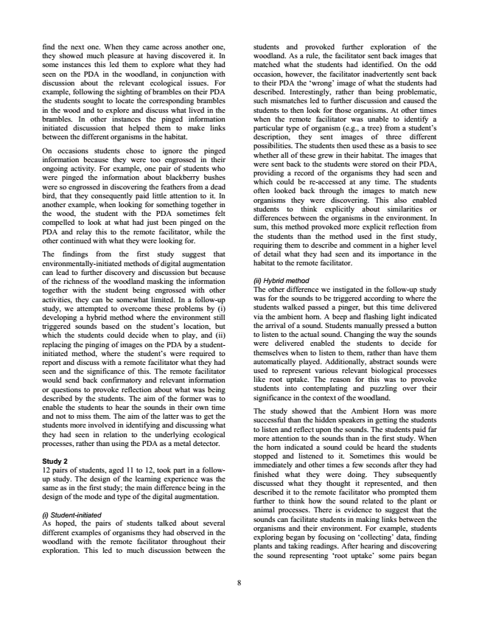

find the next one. When they came across another one, they showed much pleasure at having discovered it. In some instances this led them to explore what they had seen on the PDA in the woodland, in conjunction with discussion about the relevant ecological issues. For example, following the sighting of brambles on their PDA the students sought to locate the corresponding brambles in the wood and to explore and discuss what lived in the brambles. In other instances the pinged information initiated discussion that helped them to make links between the different organisms in the habitat.

On occasions students chose to ignore the pinged information because they were too engrossed in their ongoing activity. For example, one pair of students who were pinged the information about blackberry bushes were so engrossed in discovering the feathers from a dead bird, that they consequently paid little attention to it. In another example, when looking for something together in the wood, the student with the PDA sometimes felt compelled to look at what had just been pinged on the PDA and relay this to the remote facilitator, while the other continued with what they were looking for.

The findings from the first study suggest that environmentally-initiated methods of digital augmentation can lead to further discovery and discussion but because of the richness of the woodland masking the information together with the student being engrossed with other activities, they can be somewhat limited. In a follow-up study, we attempted to overcome these problems by (i) developing a hybrid method where the environment still triggered sounds based on the student’s location, but which the students could decide when to play, and (ii) replacing the pinging of images on the PDA by a student- initiated method, where the student’s were required to report and discuss with a remote facilitator what they had seen and the significance of this. The remote facilitator would send back confirmatory and relevant information or questions to provoke reflection about what was being described by the students. The aim of the former was to enable the students to hear the sounds in their own time and not to miss them. The aim of the latter was to get the students more involved in identifying and discussing what they had seen in relation to the underlying ecological processes, rather than using the PDA as a metal detector.

Study 2 12 pairs of students, aged 11 to 12, took part in a follow- up study. The design of the learning experience was the same as in the first study; the main difference being in the design of the mode and type of the digital augmentation.

(i) Student-initiated As hoped, the pairs of students talked about several different examples of organisms they had observed in the woodland with the remote facilitator throughout their exploration. This led to much discussion between the

8

students and provoked further exploration of the woodland. As a rule, the facilitator sent back images that matched what the students had identified. On the odd occasion, however, the facilitator inadvertently sent back to their PDA the ‘wrong’ image of what the students had described. Interestingly, rather than being problematic, such mismatches led to further discussion and caused the students to then look for those organisms. At other times when the remote facilitator was unable to identify a particular type of organism (e.g., a tree) from a student’s description, they sent images of three different possibilities. The students then used these as a basis to see whether all of these grew in their habitat. The images that were sent back to the students were stored on their PDA, providing a record of the organisms they had seen and which could be re-accessed at any time. The students often looked back through the images to match new organisms they were discovering. This also enabled students to think explicitly about similarities or differences between the organisms in the environment. In sum, this method provoked more explicit reflection from the students than the method used in the first study, requiring them to describe and comment in a higher level of detail what they had seen and its importance in the habitat to the remote facilitator.

(ii) Hybrid method The other difference we instigated in the follow-up study was for the sounds to be triggered according to where the students walked passed a pinger, but this time delivered via the ambient horn. A beep and flashing light indicated the arrival of a sound. Students manually pressed a button to listen to the actual sound. Changing the way the sounds were delivered enabled the students to decide for themselves when to listen to them, rather than have them automatically played. Additionally, abstract sounds were used to represent various relevant biological processes like root uptake. The reason for this was to provoke students into contemplating and puzzling over their significance in the context of the woodland.

The study showed that the Ambient Horn was more successful than the hidden speakers in getting the students to listen and reflect upon the sounds. The students paid far more attention to the sounds than in the first study. When the horn indicated a sound could be heard the students stopped and listened to it. Sometimes this would be immediately and other times a few seconds after they had finished what they were doing. They subsequently discussed what they thought it represented, and then described it to the remote facilitator who prompted them further to think how the sound related to the plant or animal processes. There is evidence to suggest that the sounds can facilitate students in making links between the organisms and their environment. For example, students exploring began by focusing on ‘collecting’ data, finding plants and taking readings. After hearing and discovering the sound representing ‘root uptake’ some pairs began

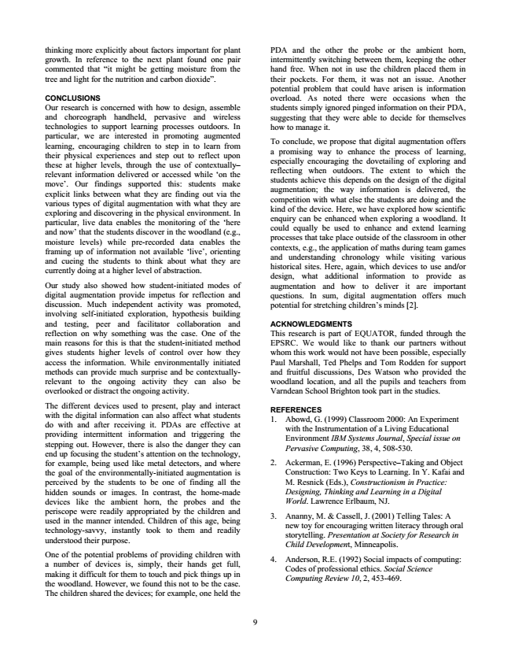

thinking more explicitly about factors important for plant growth. In reference to the next plant found one pair commented that “it might be getting moisture from the tree and light for the nutrition and carbon dioxide”.

CONCLUSIONS Our research is concerned with how to design, assemble and choreograph handheld, pervasive and wireless technologies to support learning processes outdoors. In particular, we are interested in promoting augmented learning, encouraging children to step in to learn from their physical experiences and step out to reflect upon these at higher levels, through the use of contextually– relevant information delivered or accessed while ‘on the move’. Our findings supported this: students make explicit links between what they are finding out via the various types of digital augmentation with what they are exploring and discovering in the physical environment. In particular, live data enables the monitoring of the ‘here and now’ that the students discover in the woodland (e.g., moisture levels) while pre-recorded data enables the framing up of information not available ‘live’, orienting and cueing the students to think about what they are currently doing at a higher level of abstraction.

Our study also showed how student-initiated modes of digital augmentation provide impetus for reflection and discussion. Much independent activity was promoted, involving self-initiated exploration, hypothesis building and testing, peer and facilitator collaboration and reflection on why something was the case. One of the main reasons for this is that the student-initiated method gives students higher levels of control over how they access the information. While environmentally initiated methods can provide much surprise and be contextually- relevant to the ongoing activity they can also be overlooked or distract the ongoing activity.

The different devices used to present, play and interact with the digital information can also affect what students do with and after receiving it. PDAs are effective at providing intermittent information and triggering the stepping out. However, there is also the danger they can end up focusing the student’s attention on the technology, for example, being used like metal detectors, and where the goal of the environmentally-initiated augmentation is perceived by the students to be one of finding all the hidden sounds or images. In contrast, the home-made devices like the ambient horn, the probes and the periscope were readily appropriated by the children and used in the manner intended. Children of this age, being technology-savvy, instantly took to them and readily understood their purpose.

One of the potential problems of providing children with a number of devices is, simply, their hands get full, making it difficult for them to touch and pick things up in the woodland. However, we found this not to be the case. The children shared the devices; for example, one held the

9

PDA and the other the probe or the ambient horn, intermittently switching between them, keeping the other hand free. When not in use the children placed them in their pockets. For them, it was not an issue. Another potential problem that could have arisen is information overload. As noted there were occasions when the students simply ignored pinged information on their PDA, suggesting that they were able to decide for themselves how to manage it.

To conclude, we propose that digital augmentation offers a promising way to enhance the process of learning, especially encouraging the dovetailing of exploring and reflecting when outdoors. The extent to which the students achieve this depends on the design of the digital augmentation; the way information is delivered, the competition with what else the students are doing and the kind of the device. Here, we have explored how scientific enquiry can be enhanced when exploring a woodland. It could equally be used to enhance and extend learning processes that take place outside of the classroom in other contexts, e.g., the application of maths during team games and understanding chronology while visiting various historical sites. Here, again, which devices to use and/or design, what additional information to provide as augmentation and how to deliver it are important questions. In sum, digital augmentation offers much potential for stretching children’s minds [2].

ACKNOWLEDGMENTS This research is part of EQUATOR, funded through the EPSRC. We would like to thank our partners without whom this work would not have been possible, especially Paul Marshall, Ted Phelps and Tom Rodden for support and fruitful discussions, Des Watson who provided the woodland location, and all the pupils and teachers from Varndean School Brighton took part in the studies.

REFERENCES 1. Abowd, G. (1999) Classroom 2000: An Experiment

with the Instrumentation of a Living Educational Environment IBM Systems Journal, Special issue on Pervasive Computing, 38, 4, 508-530.

2. Ackerman, E. (1996) Perspective–Taking and Object Construction: Two Keys to Learning. In Y. Kafai and M. Resnick (Eds.), Constructionism in Practice: Designing, Thinking and Learning in a Digital World. Lawrence Erlbaum, NJ.

3. Ananny, M. & Cassell, J. (2001) Telling Tales: A

new toy for encouraging written literacy through oral storytelling. Presentation at Society for Research in Child Development, Minneapolis.

4. Anderson, R.E. (1992) Social impacts of computing:

Codes of professional ethics. Social Science Computing Review 10, 2, 453-469.

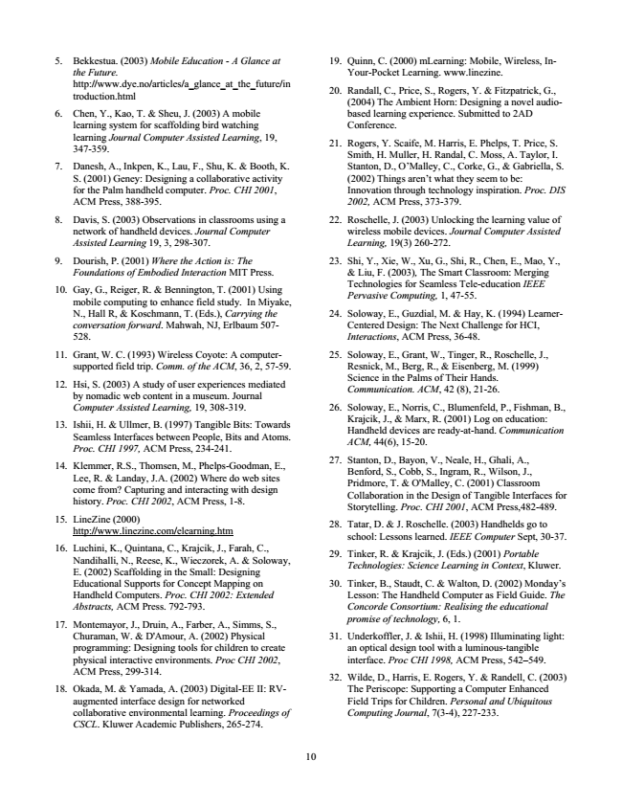

*5. Bekkestua. (2003) Mobile Education - A Glance at*

the Future. http://www.dye.no/articles/a_glance_at_the_future/in troduction.html

6. Chen, Y., Kao, T. & Sheu, J. (2003) A mobile learning system for scaffolding bird watching learning Journal Computer Assisted Learning, 19, 347-359.

7. Danesh, A., Inkpen, K., Lau, F., Shu, K. & Booth, K.

S. (2001) Geney: Designing a collaborative activity for the Palm handheld computer. Proc. CHI 2001, ACM Press, 388-395.

8. Davis, S. (2003) Observations in classrooms using a network of handheld devices. Journal Computer Assisted Learning 19, 3, 298-307.

*9. Dourish, P. (2001) Where the Action is: The*

*Foundations of Embodied Interaction MIT Press.*

10. Gay, G., Reiger, R. & Bennington, T. (2001) Using

mobile computing to enhance field study. In Miyake, N., Hall R, & Koschmann, T. (Eds.), Carrying the conversation forward. Mahwah, NJ, Erlbaum 507- 528.

11. Grant, W. C. (1993) Wireless Coyote: A computer-

supported field trip. Comm. of the ACM, 36, 2, 57-59.

12. Hsi, S. (2003) A study of user experiences mediated

by nomadic web content in a museum. Journal Computer Assisted Learning, 19, 308-319.

13. Ishii, H. & Ullmer, B. (1997) Tangible Bits: Towards Seamless Interfaces between People, Bits and Atoms. Proc. CHI 1997, ACM Press, 234-241.

14. Klemmer, R.S., Thomsen, M., Phelps-Goodman, E.,

Lee, R. & Landay, J.A. (2002) Where do web sites come from? Capturing and interacting with design history. Proc. CHI 2002, ACM Press, 1-8.

15. LineZine (2000)

http://www.linezine.com/elearning.htm

16. Luchini, K., Quintana, C., Krajcik, J., Farah, C.,

Nandihalli, N., Reese, K., Wieczorek, A. & Soloway, E. (2002) Scaffolding in the Small: Designing Educational Supports for Concept Mapping on Handheld Computers. Proc. CHI 2002: Extended Abstracts, ACM Press. 792-793.

17. Montemayor, J., Druin, A., Farber, A., Simms, S.,

Churaman, W. & D'Amour, A. (2002) Physical programming: Designing tools for children to create physical interactive environments. Proc CHI 2002, ACM Press, 299-314.

18. Okada, M. & Yamada, A. (2003) Digital-EE II: RV-

augmented interface design for networked collaborative environmental learning. Proceedings of CSCL. Kluwer Academic Publishers, 265-274.

10

19. Quinn, C. (2000) mLearning: Mobile, Wireless, In-

Your-Pocket Learning. www.linezine.

20. Randall, C., Price, S., Rogers, Y. & Fitzpatrick, G.,

(2004) The Ambient Horn: Designing a novel audio- based learning experience. Submitted to 2AD Conference.

21. Rogers, Y. Scaife, M. Harris, E. Phelps, T. Price, S. Smith, H. Muller, H. Randal, C. Moss, A. Taylor, I. Stanton, D., O’Malley, C., Corke, G., & Gabriella, S. (2002) Things aren’t what they seem to be: Innovation through technology inspiration. Proc. DIS 2002, ACM Press, 373-379.

22. Roschelle, J. (2003) Unlocking the learning value of wireless mobile devices. Journal Computer Assisted Learning, 19(3) 260-272.

23. Shi, Y., Xie, W., Xu, G., Shi, R., Chen, E., Mao, Y.,

& Liu, F. (2003), The Smart Classroom: Merging Technologies for Seamless Tele-education IEEE Pervasive Computing, 1, 47-55.

24. Soloway, E., Guzdial, M. & Hay, K. (1994) Learner-

Centered Design: The Next Challenge for HCI, Interactions, ACM Press, 36-48.

25. Soloway, E., Grant, W., Tinger, R., Roschelle, J.,

Resnick, M., Berg, R., & Eisenberg, M. (1999) Science in the Palms of Their Hands. Communication. ACM, 42 (8), 21-26.

26. Soloway, E., Norris, C., Blumenfeld, P., Fishman, B., Krajcik, J., & Marx, R. (2001) Log on education: Handheld devices are ready-at-hand. Communication ACM, 44(6), 15-20.

27. Stanton, D., Bayon, V., Neale, H., Ghali, A.,

Benford, S., Cobb, S., Ingram, R., Wilson, J., Pridmore, T. & O'Malley, C. (2001) Classroom Collaboration in the Design of Tangible Interfaces for Storytelling. Proc. CHI 2001, ACM Press,482-489.

28. Tatar, D. & J. Roschelle. (2003) Handhelds go to

school: Lessons learned. IEEE Computer Sept, 30-37.

29. Tinker, R. & Krajcik, J. (Eds.) (2001) Portable

*Technologies: Science Learning in Context, Kluwer.*

30. Tinker, B., Staudt, C. & Walton, D. (2002) Monday’s Lesson: The Handheld Computer as Field Guide. The Concorde Consortium: Realising the educational promise of technology, 6, 1.

31. Underkoffler, J. & Ishii, H. (1998) Illuminating light:

an optical design tool with a luminous-tangible interface. Proc CHI 1998, ACM Press, 542–549.

32. Wilde, D., Harris, E. Rogers, Y. & Randell, C. (2003) The Periscope: Supporting a Computer Enhanced Field Trips for Children. Personal and Ubiquitous Computing Journal, 7(3-4), 227-233.