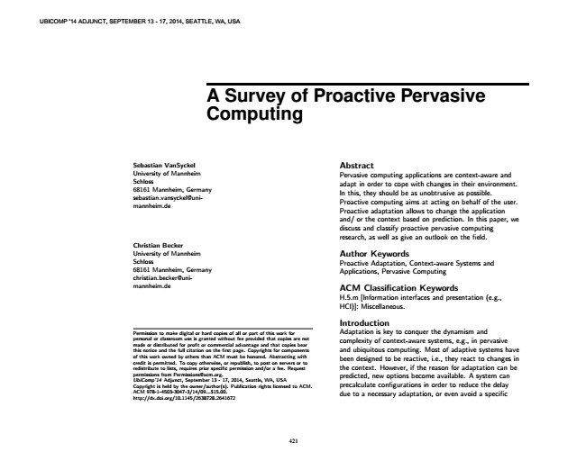

UBICOMP '14 ADJUNCT, SEPTEMBER 13 - 17, 2014, SEATTLE, WA, USA

**A Survey of Proactive Pervasive Computing**

Sebastian VanSyckel University of Mannheim Schloss 68161 Mannheim, Germany sebastian.vansyckel@uni- mannheim.de

Christian Becker University of Mannheim Schloss 68161 Mannheim, Germany christian.becker@uni- mannheim.de

Permission to make digital or hard copies of all or part of this work for personal or classroom use is granted without fee provided that copies are not made or distributed for profit or commercial advantage and that copies bear this notice and the full citation on the first page. Copyrights for components of this work owned by others than ACM must be honored. Abstracting with credit is permitted. To copy otherwise, or republish, to post on servers or to redistribute to lists, requires prior specific permission and/or a fee. Request permissions from Permissions@acm.org. UbiComp’14 Adjunct, September 13 - 17, 2014, Seattle, WA, USA Copyright is held by the owner/author(s). Publication rights licensed to ACM. ACM 978-1-4503-3047-3/14/09...$15.00. http://dx.doi.org/10.1145/2638728.2641672

Abstract Pervasive computing applications are context-aware and adapt in order to cope with changes in their environment. In this, they should be as unobtrusive as possible. Proactive computing aims at acting on behalf of the user. Proactive adaptation allows to change the application and/ or the context based on prediction. In this paper, we discuss and classify proactive pervasive computing research, as well as give an outlook on the field.

Author Keywords Proactive Adaptation, Context-aware Systems and Applications, Pervasive Computing

ACM Classification Keywords H.5.m [Information interfaces and presentation (e.g., HCI)]: Miscellaneous.

Introduction Adaptation is key to conquer the dynamism and complexity of context-aware systems, e.g., in pervasive and ubiquitous computing. Most of adaptive systems have been designed to be reactive, i.e., they react to changes in the context. However, if the reason for adaptation can be predicted, new options become available. A system can precalculate configurations in order to reduce the delay due to a necessary adaptation, or even avoid a specific

421

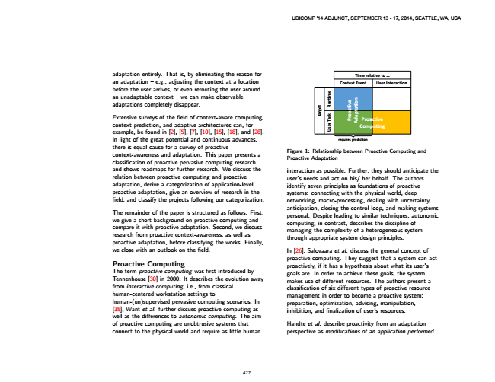

adaptation entirely. That is, by eliminating the reason for an adaptation – e.g., adjusting the context at a location before the user arrives, or even rerouting the user around an unadaptable context – we can make observable adaptations completely disappear.

Extensive surveys of the field of context-aware computing, context prediction, and adaptive architectures can, for example, be found in [2], [5], [7], [10], [15], [18], and [28]. In light of the great potential and continuous advances, there is equal cause for a survey of proactive context-awareness and adaptation. This paper presents a classification of proactive pervasive computing research and shows roadmaps for further research. We discuss the relation between proactive computing and proactive adaptation, derive a categorization of application-level proactive adaptation, give an overview of research in the field, and classify the projects following our categorization.

The remainder of the paper is structured as follows. First, we give a short background on proactive computing and compare it with proactive adaptation. Second, we discuss research from proactive context-awareness, as well as proactive adaptation, before classifying the works. Finally, we close with an outlook on the field.

Proactive Computing The term proactive computing was first introduced by Tennenhouse [30] in 2000. It describes the evolution away from interactive computing, i.e., from classical human-centered workstation settings to human-(un)supervised pervasive computing scenarios. In [35], Want et al. further discuss proactive computing as well as the differences to autonomic computing. The aim of proactive computing are unobtrusive systems that connect to the physical world and require as little human

**n**

**Proactive Computing**

**requires prediction**

Figure 1: Relationship between Proactive Computing and Proactive Adaptation

interaction as possible. Further, they should anticipate the user’s needs and act on his/ her behalf. The authors identify seven principles as foundations of proactive systems: connecting with the physical world, deep networking, macro-processing, dealing with uncertainty, anticipation, closing the control loop, and making systems personal. Despite leading to similar techniques, autonomic computing, in contrast, describes the discipline of managing the complexity of a heterogeneous system through appropriate system design principles.

In [26], Salovaara et al. discuss the general concept of proactive computing. They suggest that a system can act proactively, if it has a hypothesis about what its user’s goals are. In order to achieve these goals, the system makes use of different resources. The authors present a classification of six different types of proactive resource management in order to become a proactive system: preparation, optimization, advising, manipulation, inhibition, and finalization of user’s resources.

Handte et al. describe proactivity from an adaptation perspective as modifications of an application performed

422

**t e**

**Time relative to ...**

**Context Event User Interaction**

**g r a T**

**e v i t c a o r P**

**o i t a t p a d A**

UBICOMP '14 ADJUNCT, SEPTEMBER 13 - 17, 2014, SEATTLE, WA, USA

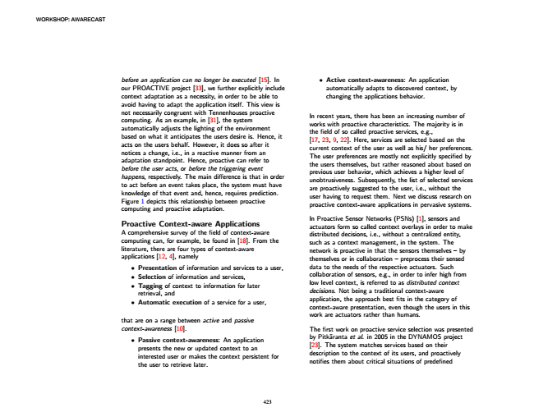

WORKSHOP: AWARECAST

• before an application can no longer be executed [15]. In

Active context-awareness: An application our PROACTIVE project [33], we further explicitly include

automatically adapts to discovered context, by context adaptation as a necessity, in order to be able to

changing the applications behavior. avoid having to adapt the application itself. This view is not necessarily congruent with Tennenhouses proactive computing. As an example, in [31], the system automatically adjusts the lighting of the environment based on what it anticipates the users desire is. Hence, it acts on the users behalf. However, it does so after it notices a change, i.e., in a reactive manner from an adaptation standpoint. Hence, proactive can refer to before the user acts, or before the triggering event happens, respectively. The main difference is that in order to act before an event takes place, the system must have knowledge of that event and, hence, requires prediction. Figure 1 depicts this relationship between proactive computing and proactive adaptation.

In recent years, there has been an increasing number of works with proactive characteristics. The majority is in the field of so called proactive services, e.g., [17, 23, 9, 22]. Here, services are selected based on the current context of the user as well as his/ her preferences. The user preferences are mostly not explicitly specified by the users themselves, but rather reasoned about based on previous user behavior, which achieves a higher level of unobtrusiveness. Subsequently, the list of selected services are proactively suggested to the user, i.e., without the user having to request them. Next we discuss research on proactive context-aware applications in pervasive systems.

Proactive Context-aware Applications A comprehensive survey of the field of context-aware computing can, for example, be found in [18]. From the literature, there are four types of context-aware applications [12, 4], namely

In Proactive Sensor Networks (PSNs) [1], sensors and actuators form so called context overlays in order to make distributed decisions, i.e., without a centralized entity, such as a context management, in the system. The network is proactive in that the sensors themselves – by themselves or in collaboration – preprocess their sensed

• Presentation of information and services to a user,

• Selection of information and services,

• Tagging of context to information for later retrieval, and

• Automatic execution of a service for a user,

data to the needs of the respective actuators. Such collaboration of sensors, e.g., in order to infer high from low level context, is referred to as distributed context decisions. Not being a traditional context-aware application, the approach best fits in the category of context-aware presentation, even though the users in this

that are on a range between active and passive

work are actuators rather than humans.

context-awareness [10].

The first work on proactive service selection was presented

• Passive context-awareness: An application presents the new or updated context to an interested user or makes the context persistent for the user to retrieve later.

by Pitkäranta et al. in 2005 in the DYNAMOS project [23]. The system matches services based on their description to the context of its users, and proactively notifies them about critical situations of predefined

423

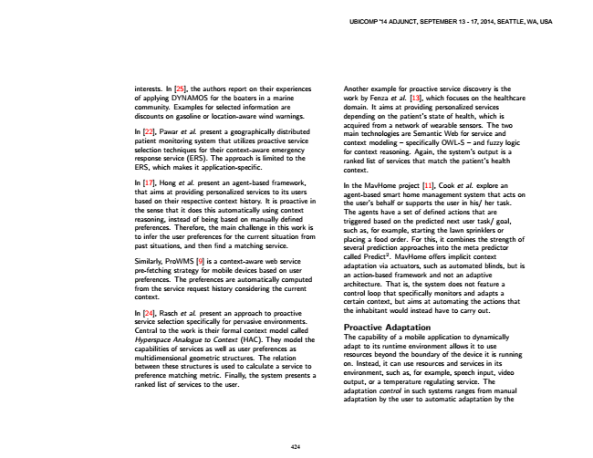

Another interests. In [25], the authors report on their experiences

example for proactive service discovery is the of applying DYNAMOS for the boaters in a marine

work by Fenza et al. [13], which focuses on the healthcare community. Examples for selected information are

domain. It aims at providing personalized services discounts on gasoline or location-aware wind warnings.

depending on the patient’s state of health, which is

In [22], Pawar et al. present a geographically distributed patient monitoring system that utilizes proactive service selection techniques for their context-aware emergency response service (ERS). The approach is limited to the ERS, which makes it application-specific.

acquired from a network of wearable sensors. The two main technologies are Semantic Web for service and context modeling – specifically OWL-S – and fuzzy logic for context reasoning. Again, the system’s output is a ranked list of services that match the patient’s health context.

In [17], Hong et al. present an agent-based framework, that aims at providing personalized services to its users based on their respective context history. It is proactive in the sense that it does this automatically using context reasoning, instead of being based on manually defined preferences. Therefore, the main challenge in this work is to infer the user preferences for the current situation from past situations, and then find a matching service.

In the MavHome project [11], Cook et al. explore an agent-based smart home management system that acts on the user’s behalf or supports the user in his/ her task. The agents have a set of defined actions that are triggered based on the predicted next user task/ goal, such as, for example, starting the lawn sprinklers or placing a food order. For this, it combines the strength of several prediction approaches into the meta predictor

Similarly, ProWMS [9] is a context-aware web service pre-fetching strategy for mobile devices based on user preferences. The preferences are automatically computed from the service request history considering the current context.

called Predict2. MavHome offers implicit context adaptation via actuators, such as automated blinds, but is an action-based framework and not an adaptive architecture. That is, the system does not feature a control loop that specifically monitors and adapts a certain context, but aims at automating the actions that In [24], Rasch et al. present an approach to proactive

the inhabitant would instead have to carry out. service selection specifically for pervasive environments. Central to the work is their formal context model called Hyperspace Analogue to Context (HAC). They model the capabilities of services as well as user preferences as multidimensional geometric structures. The relation between these structures is used to calculate a service to preference matching metric. Finally, the system presents a ranked list of services to the user.

Proactive Adaptation The capability of a mobile application to dynamically adapt to its runtime environment allows it to use resources beyond the boundary of the device it is running on. Instead, it can use resources and services in its environment, such as, for example, speech input, video output, or a temperature regulating service. The adaptation control in such systems ranges from manual adaptation by the user to automatic adaptation by the

424

UBICOMP '14 ADJUNCT, SEPTEMBER 13 - 17, 2014, SEATTLE, WA, USA

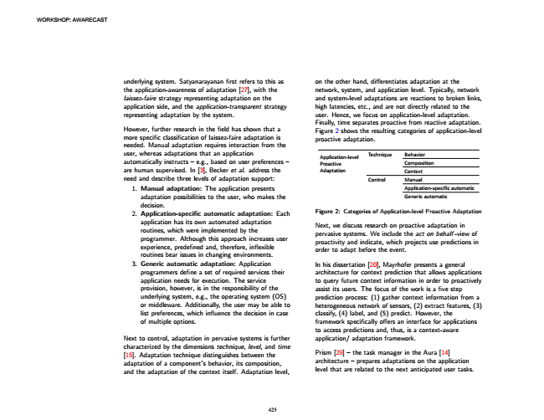

WORKSHOP: AWARECAST

on underlying system. Satyanarayanan first refers to this as

the other hand, differentiates adaptation at the the application-awareness of adaptation [27], with the

network, system, and application level. Typically, network laissez-faire strategy representing adaptation on the

and system-level adaptations are reactions to broken links, application side, and the application-transparent strategy

high latencies, etc., and are not directly related to the representing adaptation by the system.

user. Hence, we focus on application-level adaptation.

However, further research in the field has shown that a more specific classification of laissez-faire adaptation is needed. Manual adaptation requires interaction from the

Finally, time separates proactive from reactive adaptation. Figure 2 shows the resulting categories of application-level proactive adaptation.

user, whereas adaptations that an application automatically instructs – e.g., based on user preferences – are human supervised. In [3], Becker et al. address the

Application-level Proactive Adaptation need and describe three levels of adaptation support: 1. Manual adaptation: The application presents

adaptation possibilities to the user, who makes the decision. 2. Application-specific automatic adaptation: Each

application has its own automated adaptation routines, which were implemented by the programmer. Although this approach increases user experience, predefined and, therefore, inflexible routines bear issues in changing environments. 3. Generic automatic adaptation: Application

programmers define a set of required services their application needs for execution. The service provision, however, is in the responsibility of the underlying system, e.g., the operating system (OS) or middleware. Additionally, the user may be able to list preferences, which influence the decision in case of multiple options.

Next to control, adaptation in pervasive systems is further characterized by the dimensions technique, level, and time [15]. Adaptation technique distinguishes between the adaptation of a component’s behavior, its composition, and the adaptation of the context itself. Adaptation level,

Technique Behavior

Composition Context Control Manual

Application-specific automatic Generic automatic

Figure 2: Categories of Application-level Proactive Adaptation

Next, we discuss research on proactive adaptation in pervasive systems. We include the act on behalf -view of proactivity and indicate, which projects use predictions in order to adapt before the event.

In his dissertation [20], Mayrhofer presents a general architecture for context prediction that allows applications to query future context information in order to proactively assist its users. The focus of the work is a five step prediction process: (1) gather context information from a heterogeneous network of sensors, (2) extract features, (3) classify, (4) label, and (5) predict. However, the framework specifically offers an interface for applications to access predictions and, thus, is a context-aware application/ adaptation framework.

Prism [29] – the task manager in the Aura [14] architecture – prepares adaptations on the application level that are related to the next anticipated user tasks.

425

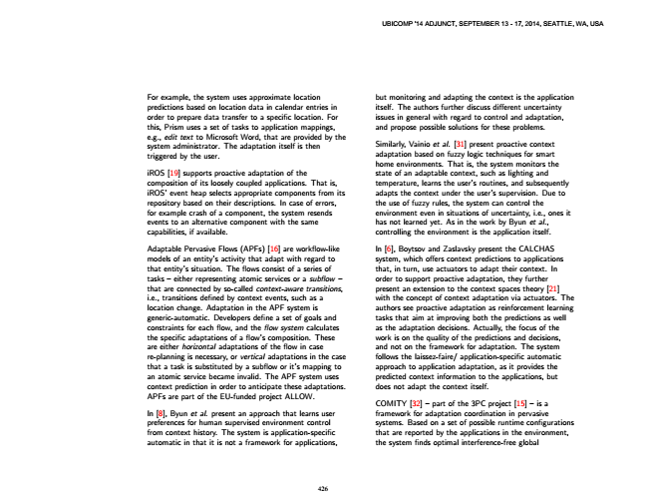

but For example, the system uses approximate location

monitoring and adapting the context is the application predictions based on location data in calendar entries in

itself. The authors further discuss different uncertainty order to prepare data transfer to a specific location. For

issues in general with regard to control and adaptation, this, Prism uses a set of tasks to application mappings,

and propose possible solutions for these problems. e.g., edit text to Microsoft Word, that are provided by the system administrator. The adaptation itself is then triggered by the user.

Similarly, Vainio et al. [31] present proactive context adaptation based on fuzzy logic techniques for smart home environments. That is, the system monitors the iROS [19] supports proactive adaptation of the

state of an adaptable context, such as lighting and composition of its loosely coupled applications. That is,

temperature, learns the user’s routines, and subsequently iROS’ event heap selects appropriate components from its

adapts the context under the user’s supervision. Due to repository based on their descriptions. In case of errors,

the use of fuzzy rules, the system can control the for example crash of a component, the system resends

environment even in situations of uncertainty, i.e., ones it events to an alternative component with the same

has not learned yet. As in the work by Byun et al., capabilities, if available.

controlling the environment is the application itself.

Adaptable Pervasive Flows (APFs) [16] are workflow-like

In [6], Boytsov and Zaslavsky present the CALCHAS models of an entity’s activity that adapt with regard to

system, which offers context predictions to applications that entity’s situation. The flows consist of a series of

that, in turn, use actuators to adapt their context. In tasks – either representing atomic services or a subfiow –

order to support proactive adaptation, they further that are connected by so-called context-aware transitions,

present an extension to the context spaces theory [21] i.e., transitions defined by context events, such as a

with the concept of context adaptation via actuators. The location change. Adaptation in the APF system is

authors see proactive adaptation as reinforcement learning generic-automatic. Developers define a set of goals and

tasks that aim at improving both the predictions as well constraints for each flow, and the fiow system calculates

as the adaptation decisions. Actually, the focus of the the specific adaptations of a flow’s composition. These

work is on the quality of the predictions and decisions, are either horizontal adaptations of the flow in case

and not on the framework for adaptation. The system re-planning is necessary, or vertical adaptations in the case

follows the laissez-faire/ application-specific automatic that a task is substituted by a subflow or it’s mapping to

approach to application adaptation, as it provides the an atomic service became invalid. The APF system uses

predicted context information to the applications, but context prediction in order to anticipate these adaptations.

does not adapt the context itself. APFs are part of the EU-funded project ALLOW.

COMITY [32] – part of the 3PC project [15] – is a In [8], Byun et al. present an approach that learns user

framework for adaptation coordination in pervasive preferences for human supervised environment control

systems. Based on a set of possible runtime configurations from context history. The system is application-specific

that are reported by the applications in the environment, automatic in that it is not a framework for applications,

the system finds optimal interference-free global

426

UBICOMP '14 ADJUNCT, SEPTEMBER 13 - 17, 2014, SEATTLE, WA, USA

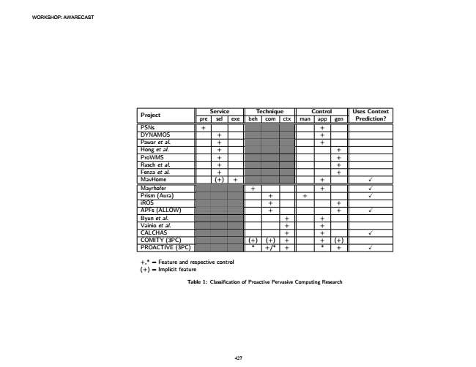

WORKSHOP: AWARECAST

Service Project

Technique Control Uses Context pre sel exe beh com ctx man app gen Prediction? PSNs + + DYNAMOS + + Pawar et al. + + Hong et al. + + ProWMS + + Rasch et al. + + Fenza et al. + + MavHome (+) + + Mayrhofer + + Prism (Aura) + + iROS + + APFs (ALLOW) + + Byun et al. + + Vainio et al. + + CALCHAS + + COMITY (3PC) (+) (+) + + (+) PROACTIVE (3PC) * +/* + * +

+,* = Feature and respective control (+) = Implicit feature

Table 1: Classification of Proactive Pervasive Computing Research

427

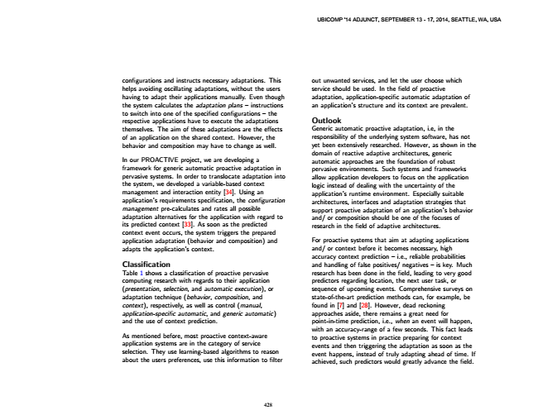

out configurations and instructs necessary adaptations. This

unwanted services, and let the user choose which helps avoiding oscillating adaptations, without the users

service should be used. In the field of proactive having to adapt their applications manually. Even though

adaptation, application-specific automatic adaptation of the system calculates the adaptation plans – instructions

an application’s structure and its context are prevalent. to switch into one of the specified configurations – the respective applications have to execute the adaptations

Outlook themselves. The aim of these adaptations are the effects

Generic automatic proactive adaptation, i.e, in the of an application on the shared context. However, the

responsibility of the underlying system software, has not behavior and composition may have to change as well.

yet been extensively researched. However, as shown in the

In our PROACTIVE project, we are developing a framework for generic automatic proactive adaptation in

domain of reactive adaptive architectures, generic automatic approaches are the foundation of robust pervasive environments. Such systems and frameworks pervasive systems. In order to translocate adaptation into

allow application developers to focus on the application the system, we developed a variable-based context

logic instead of dealing with the uncertainty of the management and interaction entity [34]. Using an application’s requirements specification, the configuration management pre-calculates and rates all possible

application’s runtime environment. Especially suitable architectures, interfaces and adaptation strategies that support proactive adaptation of an application’s behavior adaptation alternatives for the application with regard to

and/ or composition should be one of the focuses of its predicted context [33]. As soon as the predicted

research in the field of adaptive architectures. context event occurs, the system triggers the prepared application adaptation (behavior and composition) and

For proactive systems that aim at adapting applications adapts the application’s context.

and/ or context before it becomes necessary, high

Classification

accuracy context prediction – i.e., reliable probabilities and handling of false positives/ negatives – is key. Much Table 1 shows a classification of proactive pervasive

research has been done in the field, leading to very good computing research with regards to their application

predictors regarding location, the next user task, or (presentation, selection, and automatic execution), or

sequence of upcoming events. Comprehensive surveys on adaptation technique (behavior, composition, and

state-of-the-art prediction methods can, for example, be context), respectively, as well as control (manual,

found in [7] and [28]. However, dead reckoning application-specific automatic, and generic automatic)

approaches aside, there remains a great need for and the use of context prediction.

point-in-time prediction, i.e., when an event will happen,

As mentioned before, most proactive context-aware application systems are in the category of service selection. They use learning-based algorithms to reason about the users preferences, use this information to filter

with an accuracy-range of a few seconds. This fact leads to proactive systems in practice preparing for context events and then triggering the adaptation as soon as the event happens, instead of truly adapting ahead of time. If achieved, such predictors would greatly advance the field.

428

UBICOMP '14 ADJUNCT, SEPTEMBER 13 - 17, 2014, SEATTLE, WA, USA

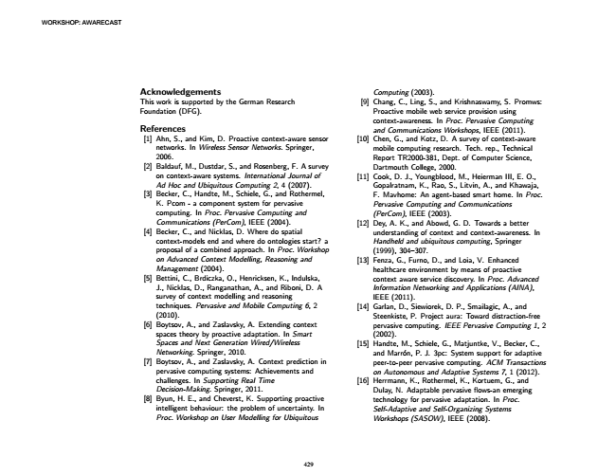

WORKSHOP: AWARECAST

Acknowledgements This work is supported by the German Research Foundation (DFG).

References

[1] Ahn, S., and Kim, D. Proactive context-aware sensor networks. In Wireless Sensor Networks. Springer, 2006. [2] Baldauf, M., Dustdar, S., and Rosenberg, F. A survey

on context-aware systems. International Journal of Ad Hoc and Ubiquitous Computing 2, 4 (2007). [3] Becker, C., Handte, M., Schiele, G., and Rothermel,

K. Pcom - a component system for pervasive computing. In Proc. Pervasive Computing and Communications (PerCom), IEEE (2004). [4] Becker, C., and Nicklas, D. Where do spatial

context-models end and where do ontologies start? a proposal of a combined approach. In Proc. Workshop on Advanced Context Modelling, Reasoning and Management (2004). [5] Bettini, C., Brdiczka, O., Henricksen, K., Indulska,

J., Nicklas, D., Ranganathan, A., and Riboni, D. A survey of context modelling and reasoning techniques. Pervasive and Mobile Computing 6, 2 (2010). [6] Boytsov, A., and Zaslavsky, A. Extending context

spaces theory by proactive adaptation. In Smart Spaces and Next Generation Wired/Wireless Networking. Springer, 2010. [7] Boytsov, A., and Zaslavsky, A. Context prediction in pervasive computing systems: Achievements and challenges. In Supporting Real Time Decision-Making. Springer, 2011. [8] Byun, H. E., and Cheverst, K. Supporting proactive intelligent behaviour: the problem of uncertainty. In Proc. Workshop on User Modelling for Ubiquitous

Computing (2003). [9] Chang, C., Ling, S., and Krishnaswamy, S. Promws:

Proactive mobile web service provision using context-awareness. In Proc. Pervasive Computing and Communications Workshops, IEEE (2011). [10] Chen, G., and Kotz, D. A survey of context-aware

mobile computing research. Tech. rep., Technical Report TR2000-381, Dept. of Computer Science, Dartmouth College, 2000. [11] Cook, D. J., Youngblood, M., Heierman III, E. O.,

Gopalratnam, K., Rao, S., Litvin, A., and Khawaja, F. Mavhome: An agent-based smart home. In Proc. Pervasive Computing and Communications (PerCom), IEEE (2003). [12] Dey, A. K., and Abowd, G. D. Towards a better

understanding of context and context-awareness. In Handheld and ubiquitous computing, Springer (1999), 304–307. [13] Fenza, G., Furno, D., and Loia, V. Enhanced

healthcare environment by means of proactive context aware service discovery. In Proc. Advanced Information Networking and Applications (AINA), IEEE (2011). [14] Garlan, D., Siewiorek, D. P., Smailagic, A., and

Steenkiste, P. Project aura: Toward distraction-free pervasive computing. IEEE Pervasive Computing 1, 2 (2002). [15] Handte, M., Schiele, G., Matjuntke, V., Becker, C.,

and Marrón, P. J. 3pc: System support for adaptive peer-to-peer pervasive computing. ACM Transactions on Autonomous and Adaptive Systems 7, 1 (2012). [16] Herrmann, K., Rothermel, K., Kortuem, G., and

Dulay, N. Adaptable pervasive flows-an emerging technology for pervasive adaptation. In Proc. Self-Adaptive and Self-Organizing Systems Workshops (SASOW), IEEE (2008).

429

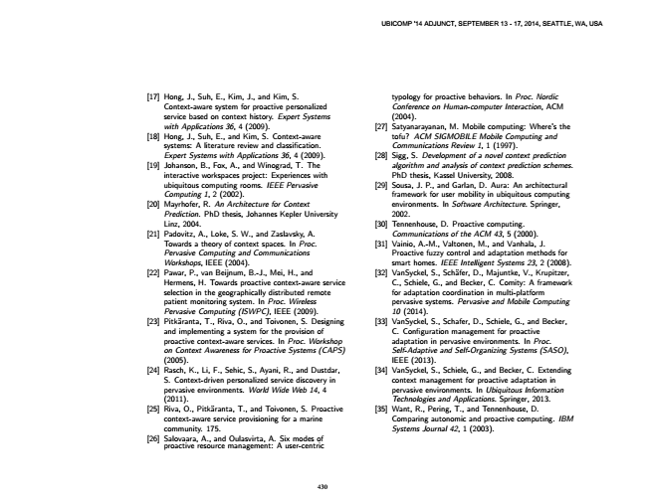

typology [17] Hong, J., Suh, E., Kim, J., and Kim, S.

for proactive behaviors. In Proc. Nordic Context-aware system for proactive personalized

Conference on Human-computer Interaction, ACM service based on context history. Expert Systems

(2004). with Applications 36, 4 (2009).

[27] Satyanarayanan, M. Mobile computing: Where’s the [18] Hong, J., Suh, E., and Kim, S. Context-aware

tofu? ACM SIGMOBILE Mobile Computing and systems: A literature review and classification.

Communications Review 1, 1 (1997). Expert Systems with Applications 36, 4 (2009).

[28] Sigg, S. Development of a novel context prediction [19] Johanson, B., Fox, A., and Winograd, T. The

algorithm and analysis of context prediction schemes. interactive workspaces project: Experiences with

PhD thesis, Kassel University, 2008. ubiquitous computing rooms. IEEE Pervasive

[29] Sousa, J. P., and Garlan, D. Aura: An architectural Computing 1, 2 (2002).

framework for user mobility in ubiquitous computing [20] Mayrhofer, R. An Architecture for Context

environments. In Software Architecture. Springer, Prediction. PhD thesis, Johannes Kepler University

2002. Linz, 2004.

[30] Tennenhouse, D. Proactive computing. [21] Padovitz, A., Loke, S. W., and Zaslavsky, A.

Communications of the ACM 43, 5 (2000). Towards a theory of context spaces. In Proc.

[31] Vainio, A.-M., Valtonen, M., and Vanhala, J. Pervasive Computing and Communications

Proactive fuzzy control and adaptation methods for Workshops, IEEE (2004).

smart homes. IEEE Intelligent Systems 23, 2 (2008). [22] Pawar, P., van Beijnum, B.-J., Mei, H., and

[32] VanSyckel, S., Schäfer, D., Majuntke, V., Krupitzer, Hermens, H. Towards proactive context-aware service

C., Schiele, G., and Becker, C. Comity: A framework selection in the geographically distributed remote

for adaptation coordination in multi-platform patient monitoring system. In Proc. Wireless

pervasive systems. Pervasive and Mobile Computing Pervasive Computing (ISWPC), IEEE (2009).

10 (2014). [23] Pitkäranta, T., Riva, O., and Toivonen, S. Designing

[33] VanSyckel, S., Schafer, D., Schiele, G., and Becker, and implementing a system for the provision of

C. Configuration management for proactive proactive context-aware services. In Proc. Workshop

adaptation in pervasive environments. In Proc. on Context Awareness for Proactive Systems (CAPS)

Self-Adaptive and Self-Organizing Systems (SASO), (2005).

IEEE (2013). [24] Rasch, K., Li, F., Sehic, S., Ayani, R., and Dustdar,

[34] VanSyckel, S., Schiele, G., and Becker, C. Extending S. Context-driven personalized service discovery in

context management for proactive adaptation in pervasive environments. World Wide Web 14, 4

pervasive environments. In Ubiquitous Information (2011).

Technologies and Applications. Springer, 2013. [25] Riva, O., Pitkäranta, T., and Toivonen, S. Proactive

[35] Want, R., Pering, T., and Tennenhouse, D. context-aware service provisioning for a marine

Comparing autonomic and proactive computing. IBM community. 175.

Systems Journal 42, 1 (2003). [26] Salovaara, proactive resource A., and management: Oulasvirta, A. A Six user-centric modes of

430

UBICOMP '14 ADJUNCT, SEPTEMBER 13 - 17, 2014, SEATTLE, WA, USA