**Assignment-2** Malaykumar Sorathiya

Install Tomcat, Up and running

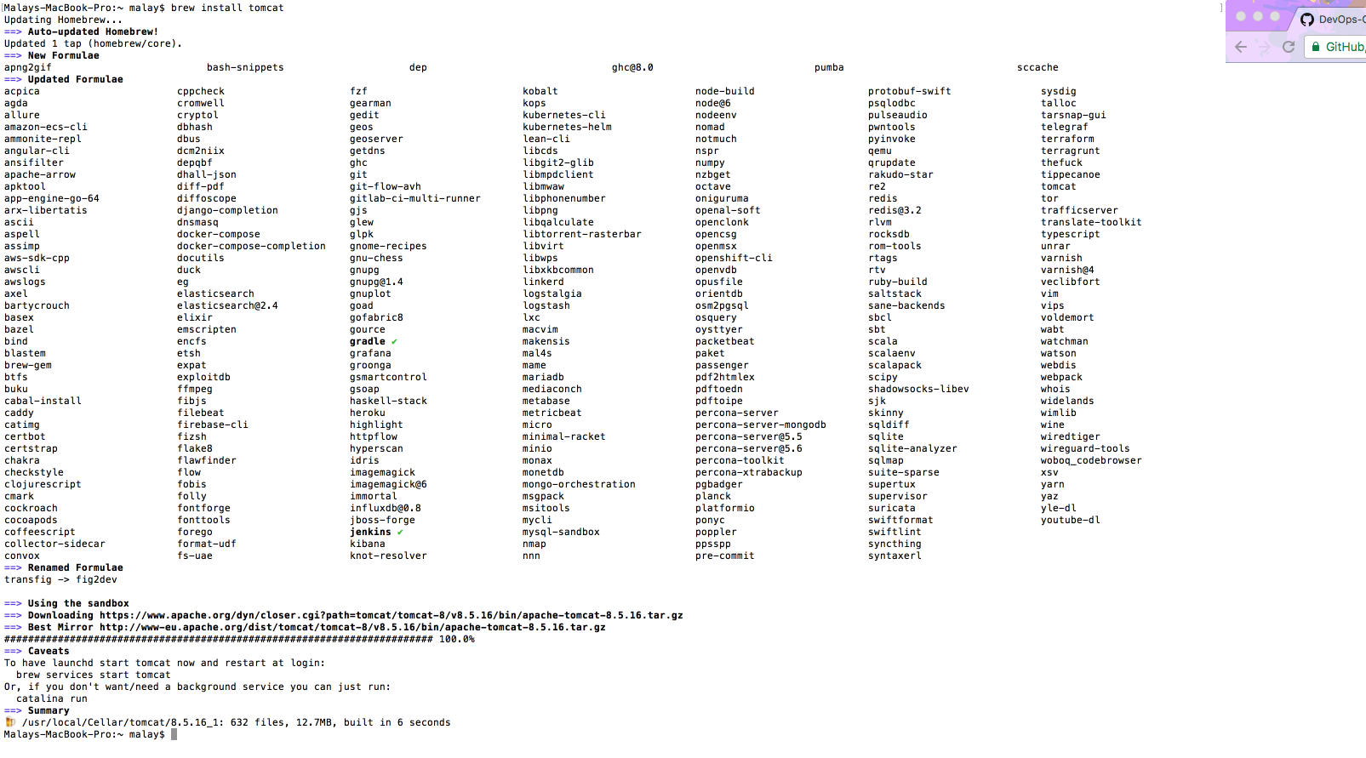

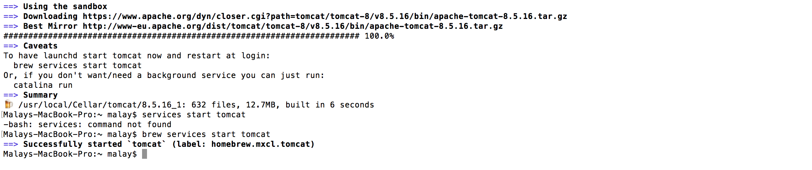

Install Jenkins, Up and running

