**Assignment-3**

**Anitha Gandu**

**Installation of JDK, Tomcat and Jenkins:**

**Steps for Installing Git on Ubuntu:**

1. sudo apt-get update
2. sudo apt-get install git

Now the git will install on Ubuntu machine.

If we try to install again we get a message that already installed as below screenshot.

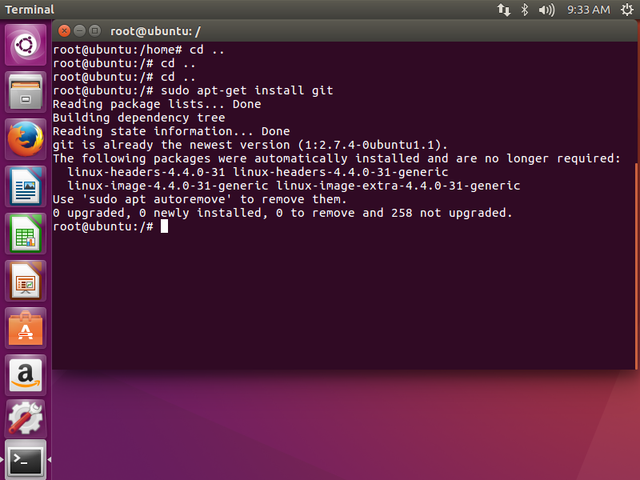

**JDK Installation:**

sudo apt-get install default-jdk –y

**Tomcat Installation:**

sudo wget <http://www-eu.apache.org/dist/tomcat/tomcat-9/v9.0.0.M21/bin/apache-tomcat-9.0.0.M21.tar.gz>

**Jenkins Installation:**

Step1: sudo wget -q -o - <https://pkg.jenkins.io/debian/jenkins-ci.org.key>

Step2: sudo apt-key add jenkins-ci.org.key

(ok)

Step3: echo deb <http://pkg.jenkins.io/debian-stable> binary/ | sudo tee /etc/apt/sources.list.d/jenkins.list

(deb <http://pkg.jenkins.io/debian-stable> binary/)

Step 4: sudo apt-get update

Step 5: sudo apt-get install jenkins

Step 6: sudo systemctl enable jenkins

Step 7: sudo systemctl start jenkins

Step 8: sudo systemctl status jenkins

(output: jenkins.service - LSB: ....)

(type q to go back to command prompt)

Step 9: sudo ufw allow 8080

(Rules updated Rules updated (v6))

Step 10: sudo ufw enable

(Firewall is active and enabled on system startup)

Step 11: sudo ufw status

Gives the status(Status: active)

Step 12: Note: open a browser in your virtual machine (don't open the browser on the host machine) and type the following

localhost:8080 And hit 'enter'

Step 13: sudo cat /var/lib/jenkins/secrets/initialAdminPassword

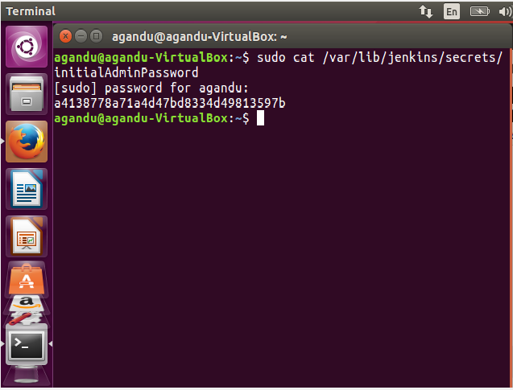

(Copy the 32-character password and paste it on the browser's password field)

(Click on 'Install suggested plugins)

Step14: Enter username, password, re-enter password and email.

Finally click on the ‘start’ button and you can now see the user interface for Jenkins as shown below.

