Assignment-5

Anitha Gandu

**Installation of Docker:**

1. Sudo apt-get install

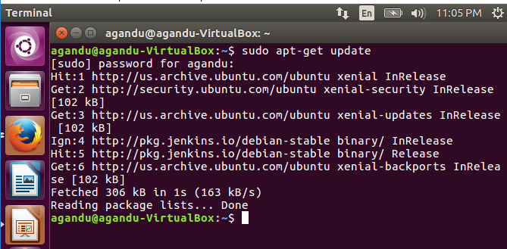

1. * Install packages to allow apt to use a repository over HTTPS:

$ **sudo apt-get install apt-transport-https ca-certificates curl software-properties-common**

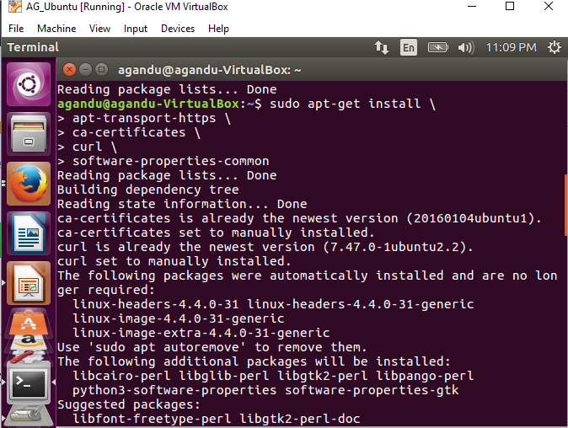

1. Add Docker’s official GPG key:

$ **curl -fsSL https://download.docker.com/linux/ubuntu/gpg | sudo apt-key add –**

1. Verify that the key fingerprint is:

9DC8 5822 9FC7 DD38 854A E2D8 8D81 803C 0EBF CD88

**sudo apt-key fingerprint 0EBFCD88**



1. Use the following command to set up the **stable** repository:

$ sudo add-apt-repository “deb [arch=amd64] [https://download.docker.com/linux/ubuntu \](https://download.docker.com/linux/ubuntu%20/)

$(lsb_release -cs) Stable”

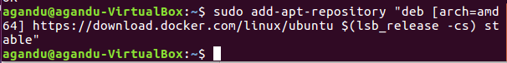

1. * Update the apt package index. $ sudo apt-get update

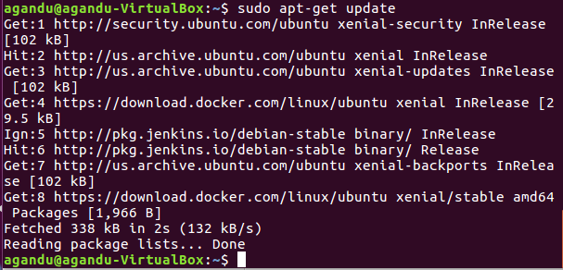

1. Install the latest version of Docker CE:

$ sudo apt-get install docker-ce

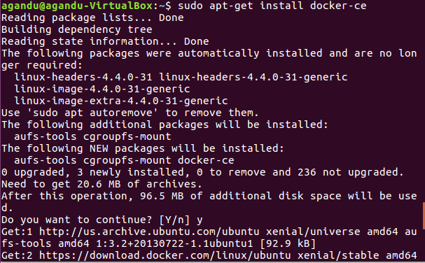

1. Sudo systemctl status Docker

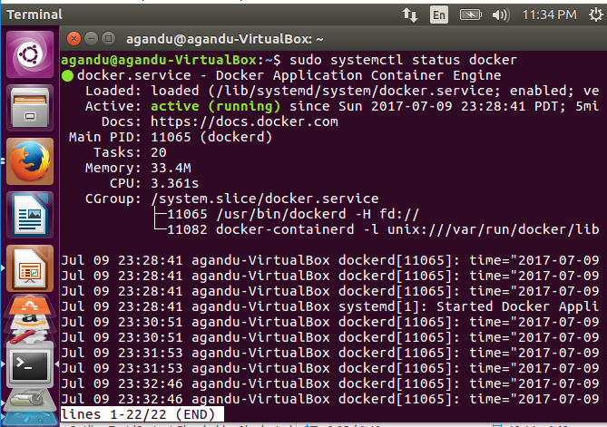

1. Verify that Docker CE is installed correctly by running the hello-world image.

$ sudo docker run hello-world

