Assignment-6: Docker-II

Anitha Gandu

1. cd ~
2. mkdir mongodb
3. cd mongodb
4. vi Dockerfile
5. docker build -t my_mongodb .

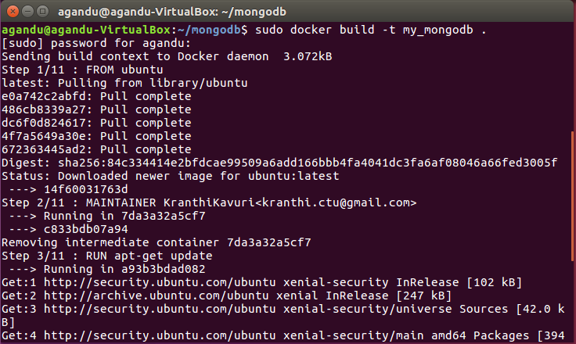

1. sudo docker run -name my_first_mdb_instance -i -t my_mongodb

