**Installation of Maven**

* wget <http://www-us.apache.org/dist/maven/maven-3/3.5.0/binaries/apache-maven-3.5.0-bin.tar.gz>

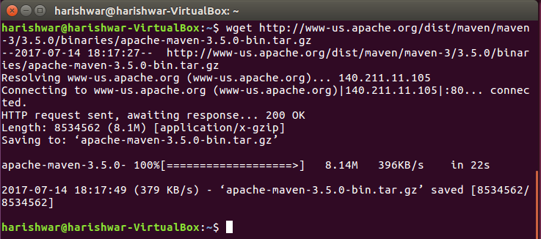

* chmod 755 [apache-maven-3.5.0-bin.tar.gz](http://www-us.apache.org/dist/maven/maven-3/3.5.0/binaries/apache-maven-3.5.0-bin.tar.gz)



* tar -xvf [apache-maven-3.5.0-bin.tar.gz](http://www-us.apache.org/dist/maven/maven-3/3.5.0/binaries/apache-maven-3.5.0-bin.tar.gz)
* ln -s [apache-maven-3.5.0 maven350](http://www-us.apache.org/dist/maven/maven-3/3.5.0/binaries/apache-maven-3.5.0-bin.tar.gz)
* export PATH=~/[apache-maven-3.5.0/bin:$PATH](http://www-us.apache.org/dist/maven/maven-3/3.5.0/binaries/apache-maven-3.5.0-bin.tar.gz)
* mvn -v

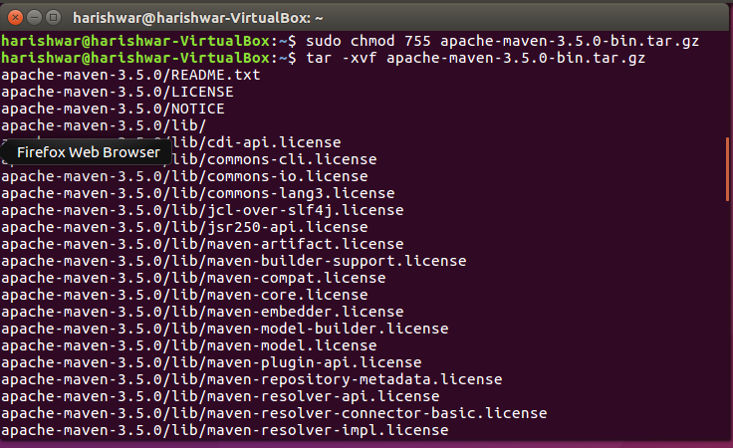



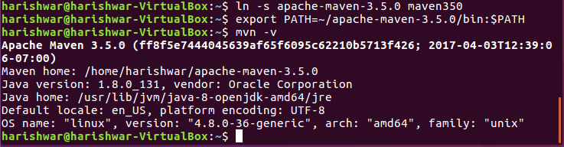

mvn archetype:generate -DgroupId=com.mycompany.app -DartifactId=my-app -DarchetypeArtifactId=maven-archetype-quickstart -DinteractiveMode=false

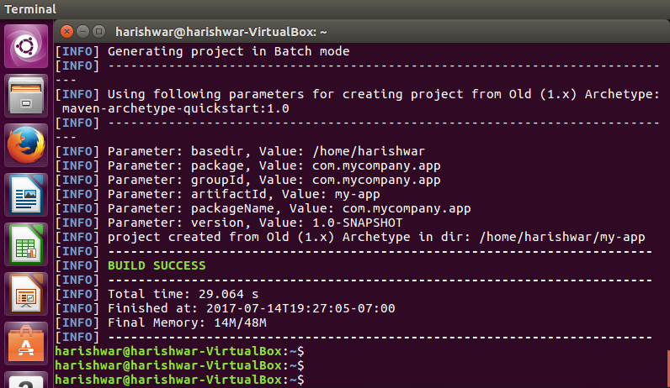

mvn package

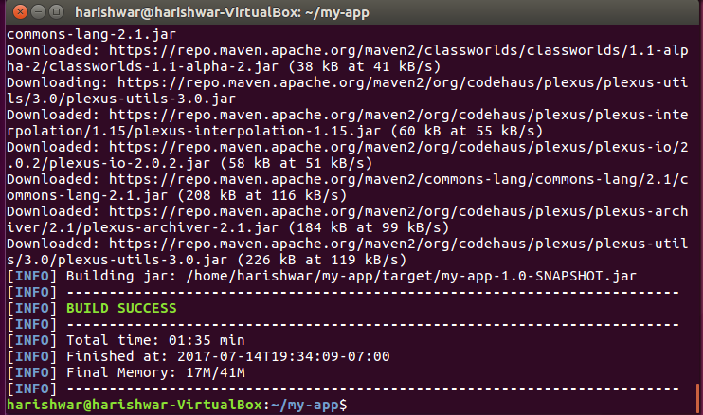

java -cp target/my-app-1.0-SNAPSHOT.jar com.mycompany.app.App

