**Ubuntu installation**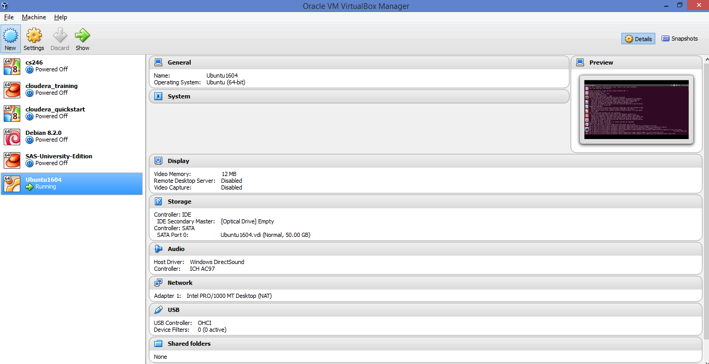

**Java JDK**

sudo apt-get install default-jdk -y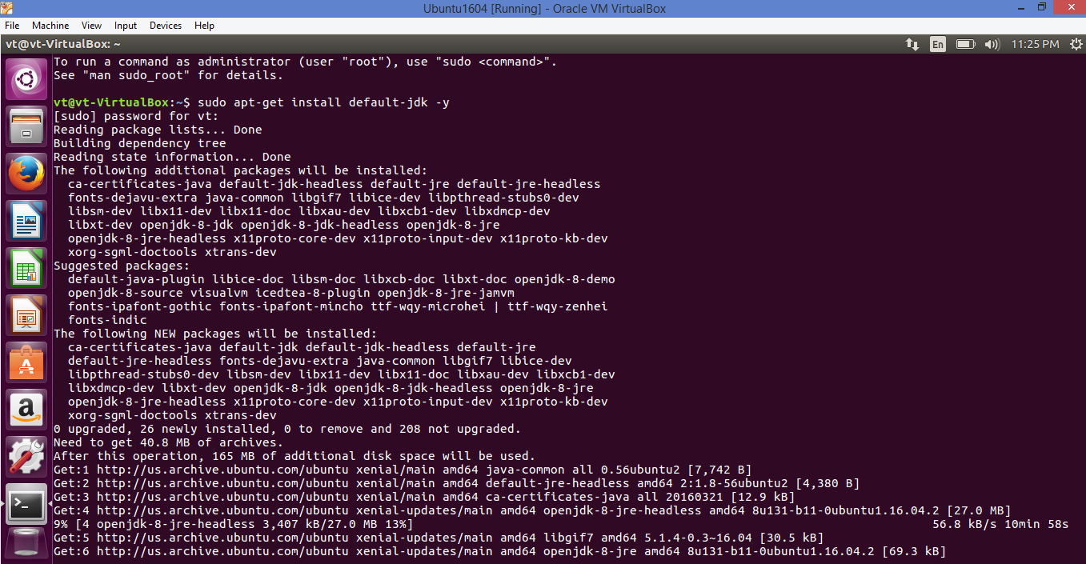

**Git**

Sudo apt-getinstall git -y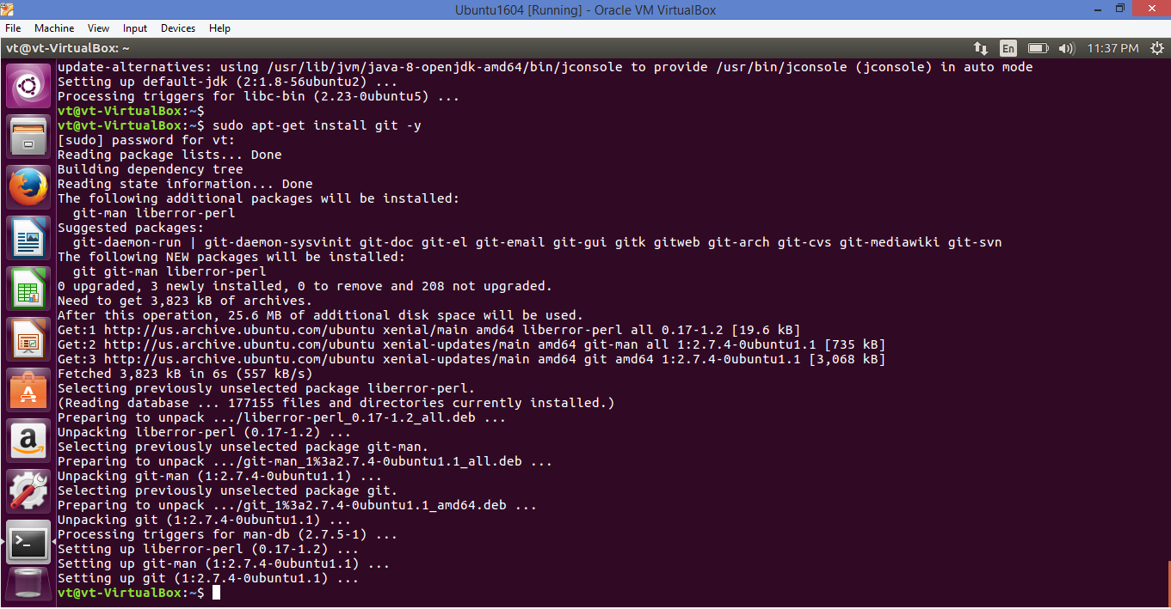

**Tomcat9**

sudo wget [http://www-eu.apache.org/dist/tomcat/tomcat-9/v9.0.0.M21/bin/apache-tomcat-9.0.0.M21.tar.gz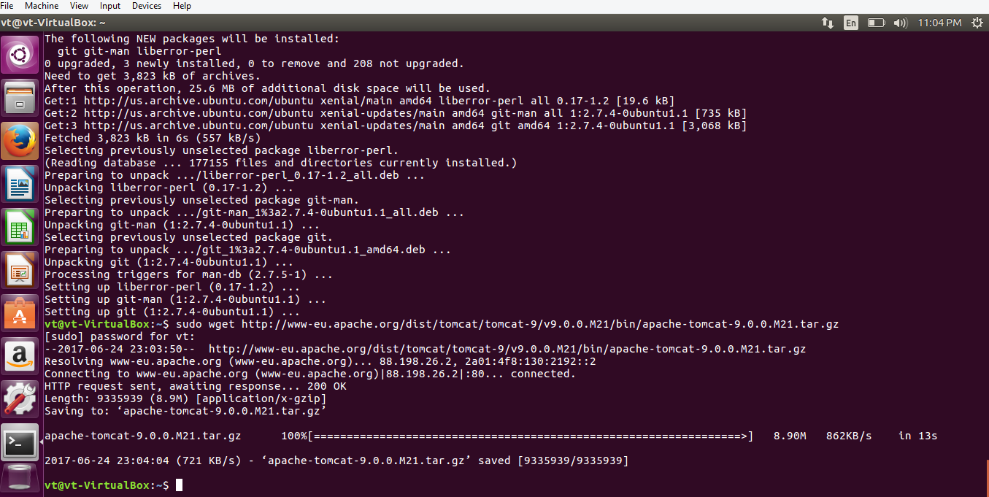](http://www-eu.apache.org/dist/tomcat/tomcat-9/v9.0.0.M21/bin/apache-tomcat-9.0.0.M21.tar.gz#)

**Jenkins**

sudo wget -q -o - <https://pkg.jenkins.io/debian/jenkins-ci.org.key>

sudo apt-key add jenkins-ci.org.key

echo deb <http://pkg.jenkins.io/debian-stable> binary/ | sudo tee /etc/apt/sources.list.d/jenkins.list

sudo apt-get update

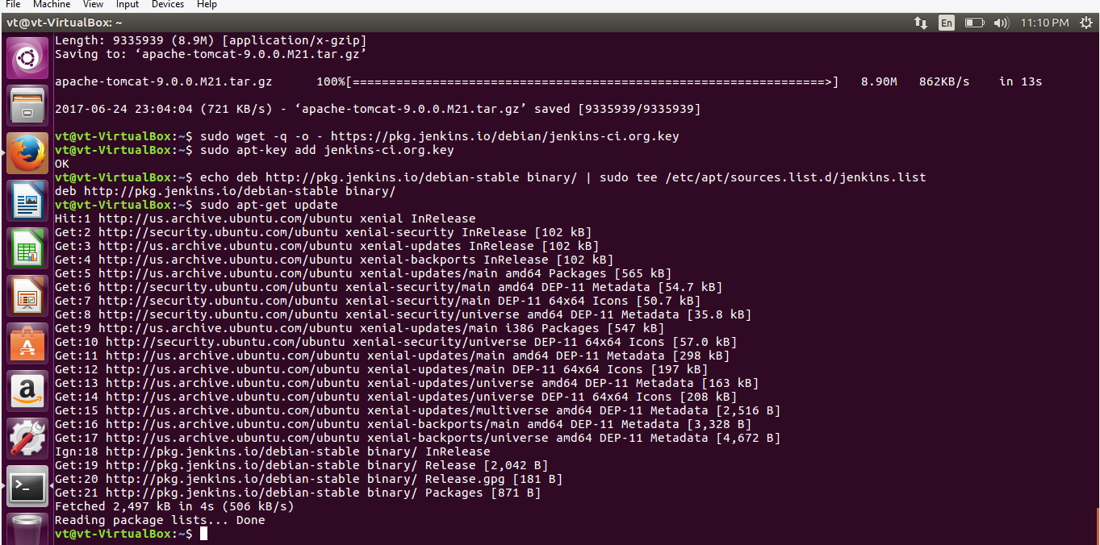

sudo apt-get install Jenkins

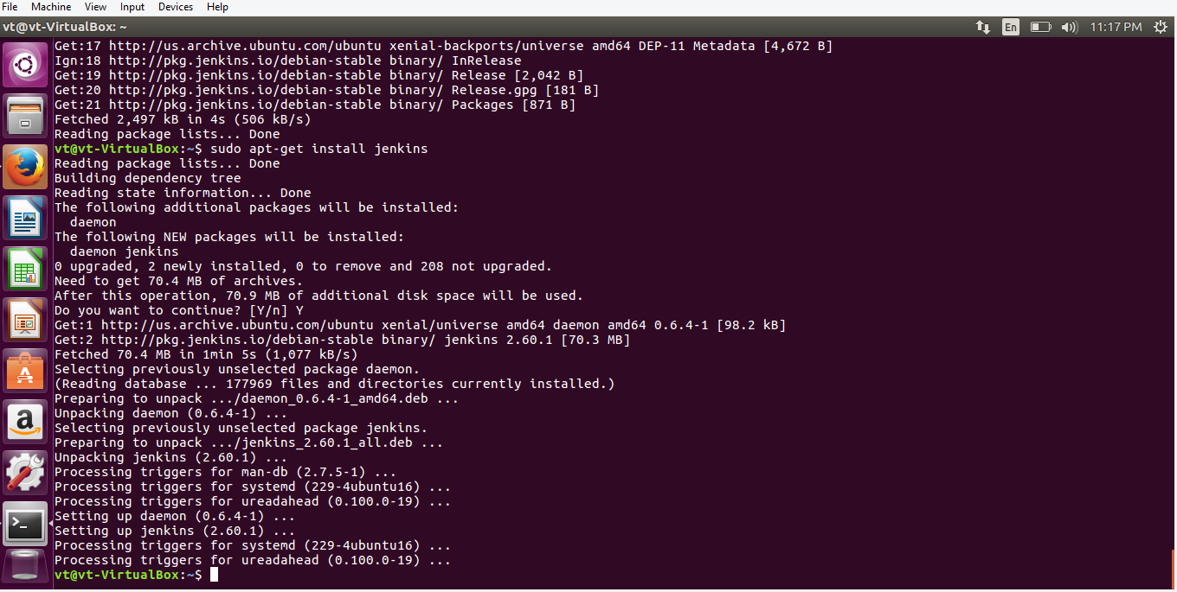

sudo systemctl enable Jenkins

sudo systemctl start Jenkins

sudo systemctl status Jenkins

sudo ufw allow 8080

sudo ufw enable

sudo ufw status

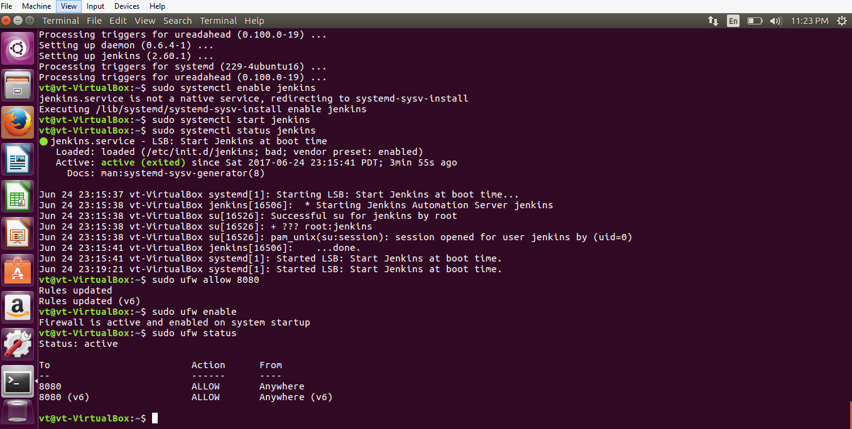

Open browser in virtual machine and type below:

localhost:8080 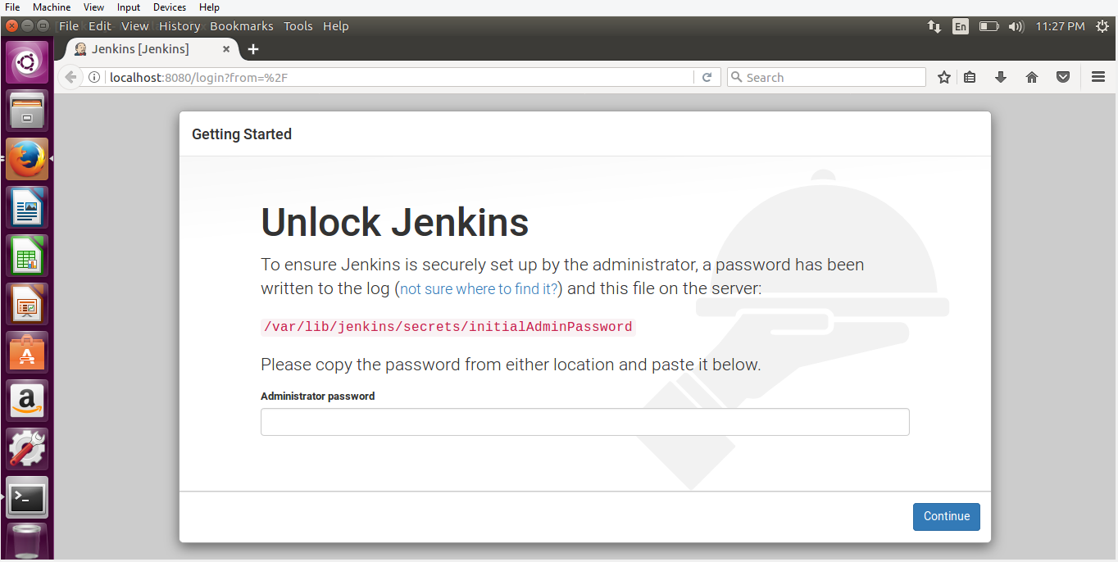

sudo cat /var/lib/jenkins/secrets/initialAdminPassword 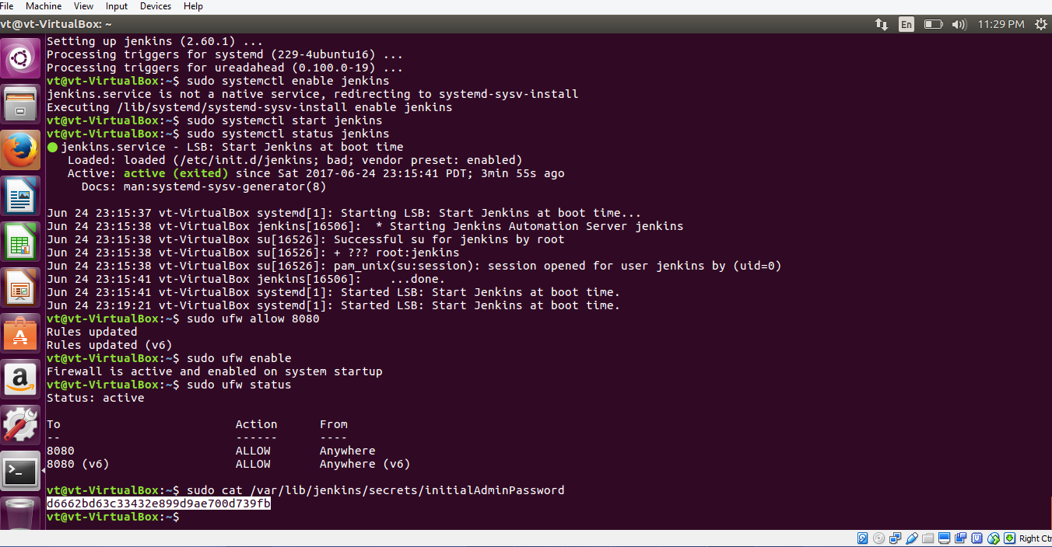

copy the password and paste it on browser’s password field 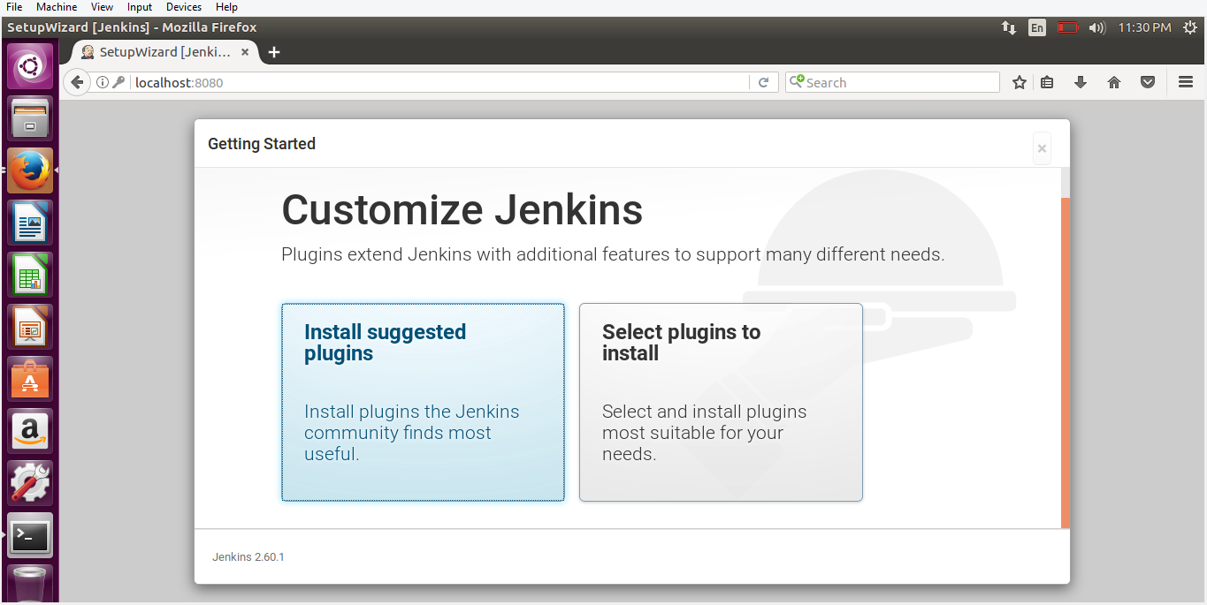

Click on Install suggested plugins, give username password and email 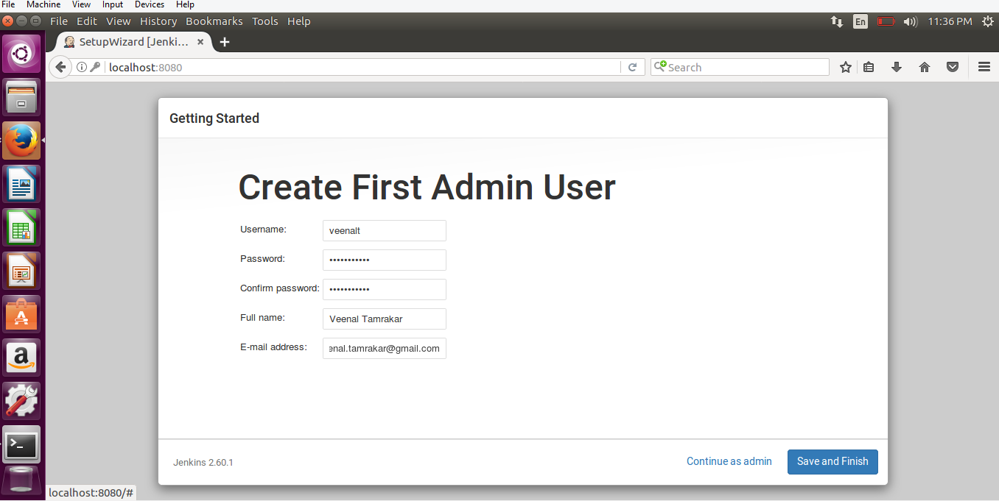

Start using Jenkins 