**MAVEN**

wget<http://www-us.apache.org/dist/maven/maven-3/3.5.0/binaries/apache-maven-3.5.0-bin.tar.gz>

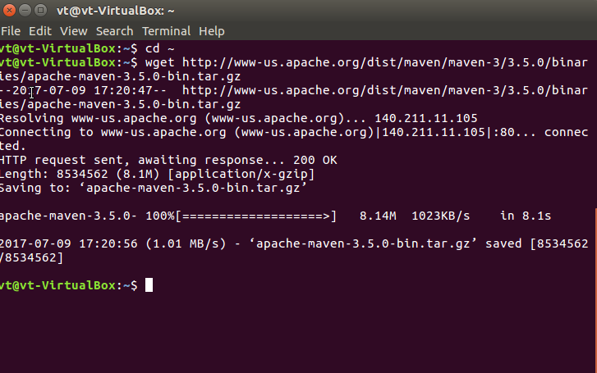

sudo chmod 755[apache-maven-3.5.0-bin.tar.gz](http://www-us.apache.org/dist/maven/maven-3/3.5.0/binaries/apache-maven-3.5.0-bin.tar.gz)

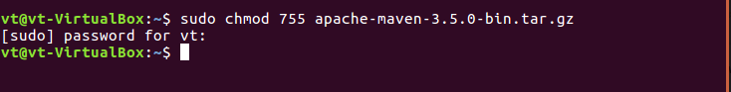

tar -xvf [apache-maven-3.5.0-bin.tar.gz](http://www-us.apache.org/dist/maven/maven-3/3.5.0/binaries/apache-maven-3.5.0-bin.tar.gz)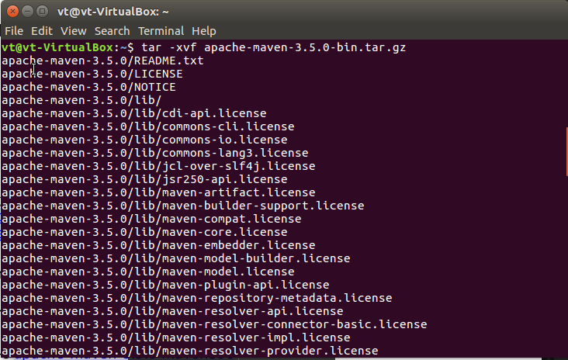

ln -s [apache-maven-3.5.0 maven350](http://www-us.apache.org/dist/maven/maven-3/3.5.0/binaries/apache-maven-3.5.0-bin.tar.gz)

export PATH=~/[apache-maven-3.5.0/bin:$PATH](http://www-us.apache.org/dist/maven/maven-3/3.5.0/binaries/apache-maven-3.5.0-bin.tar.gz)

mvn -v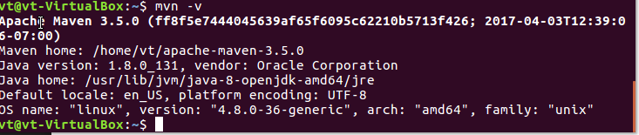

mvn archetype:generate -DgroupId=com.mycompany.app -DartifactId=my-app1 -DarchetypeArtifactId=maven-archetype-quickstart -DinteractiveMode=false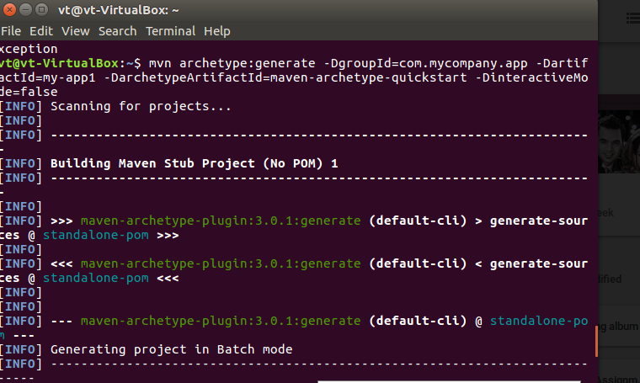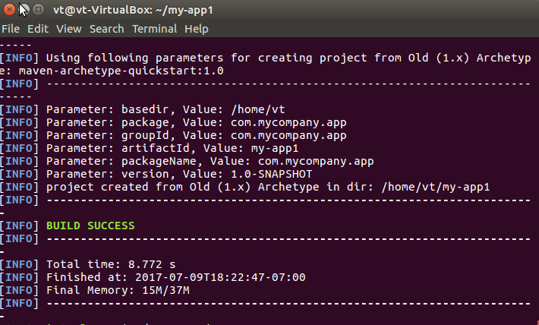

cd my-app1/

mvn package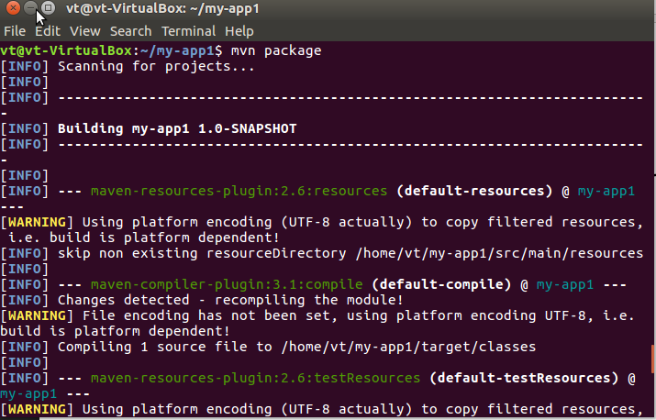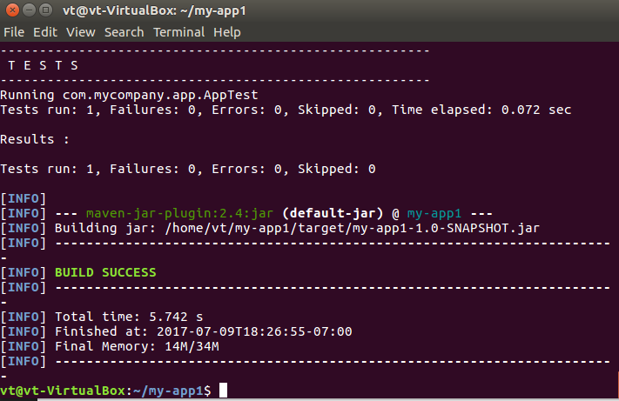

java -cp target/my-app1-1.0-SNAPSHOT.jar com.mycompany.app.App

mvn clean dependency:copy-dependencies package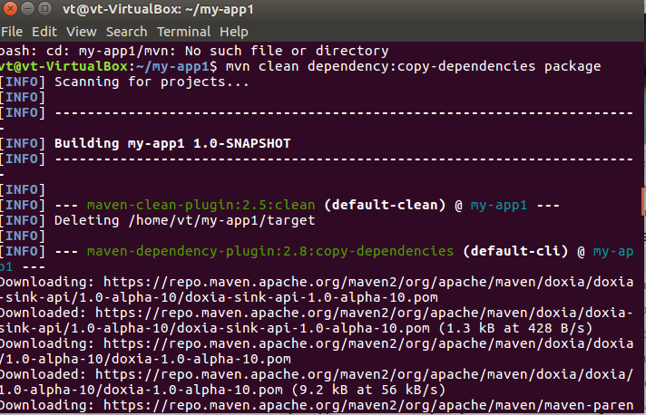

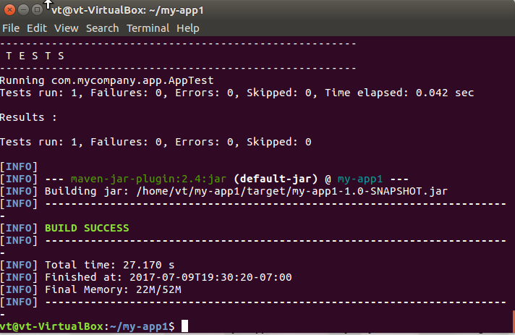

mvn site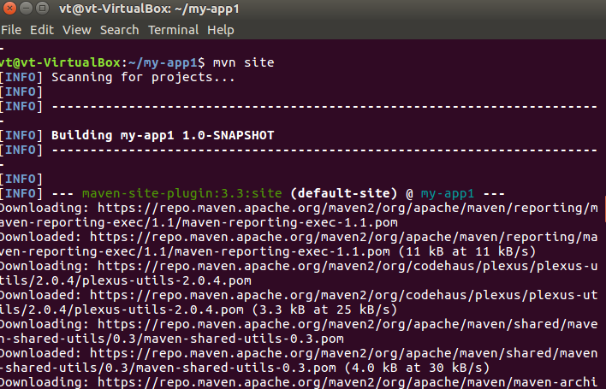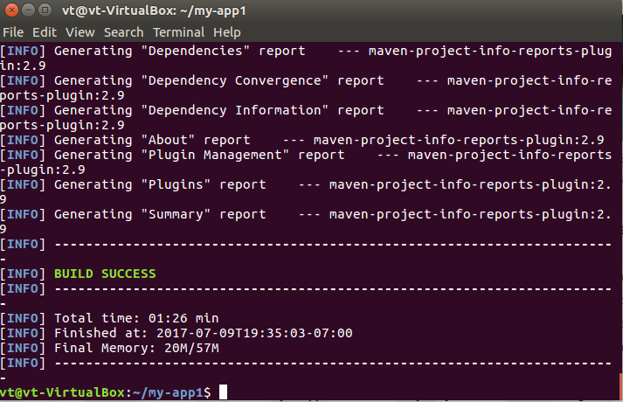

env