**DOCKER**

1. Update the apt package index

sudo apt-get update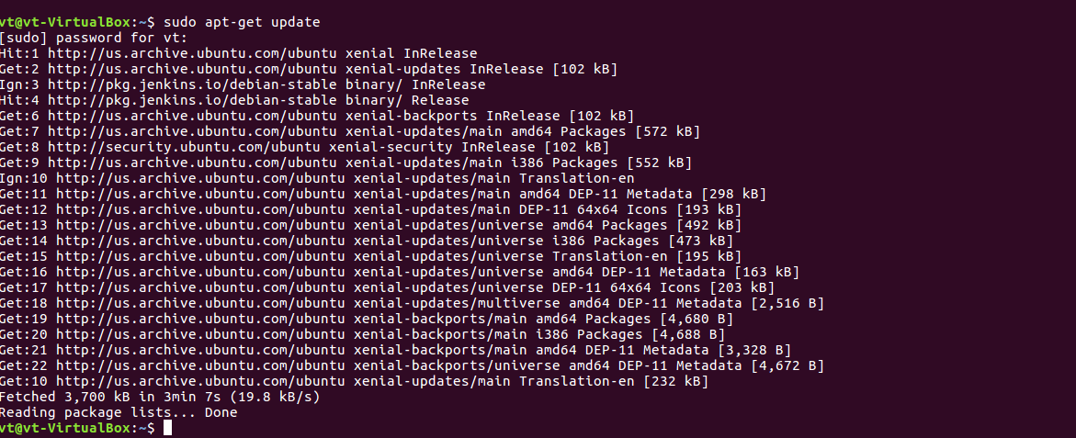

1. Add Docker’s official GPG key

curl -fsSL https://download.docker.com/linux/ubuntu/gpg | sudo apt-key add -

1. Set up stable repository

sudo add-apt-repository “deb [arch=amd64] [https://download.docker.com/linux/ubuntu](https://download.docker.com/linux/ubuntu%20/) $(lsb_release -cs) stable”

sudo apt-get update

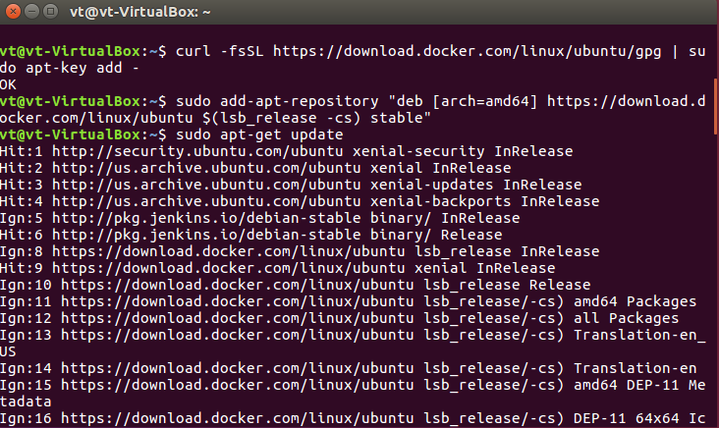

1. Update the apt package index.

sudo apt-get update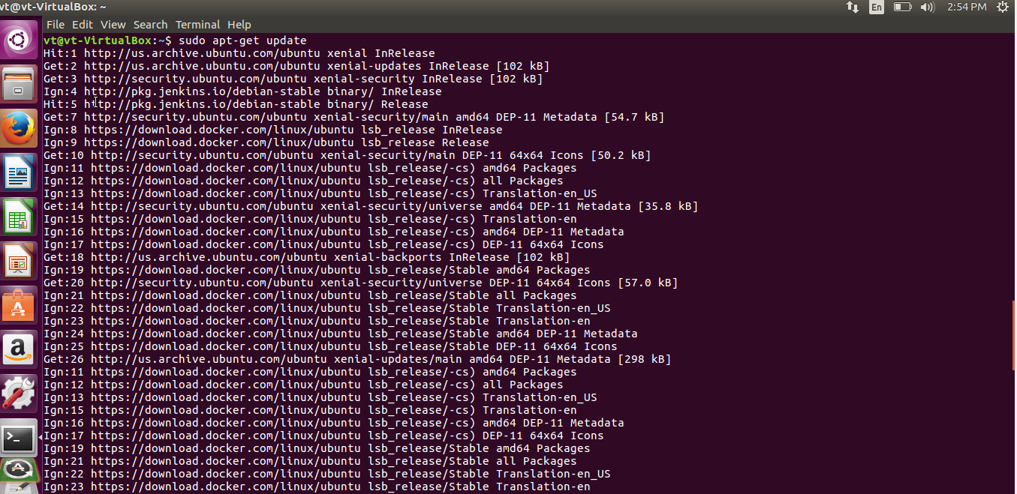

1. Install the latest version of Docker CE:

sudo apt-get install docker-ce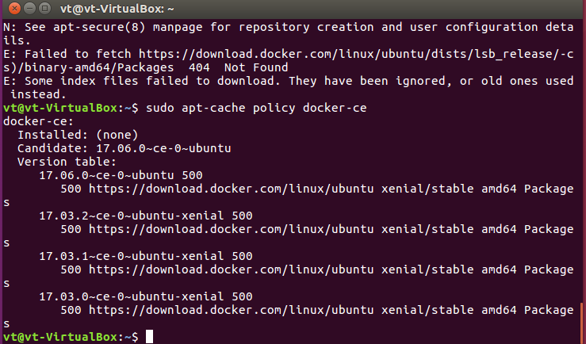

1. Check the docker version

docker -- version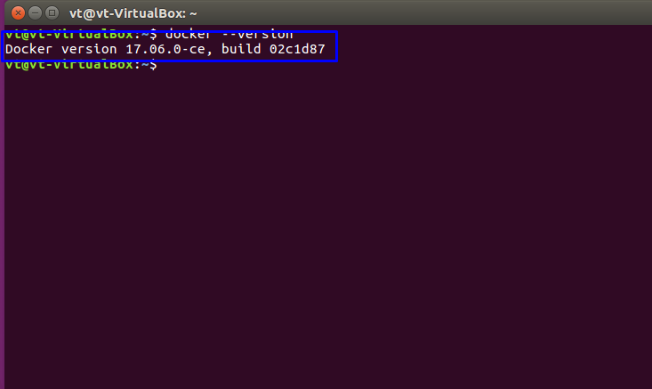

1. Check

sudo systemctl status docker

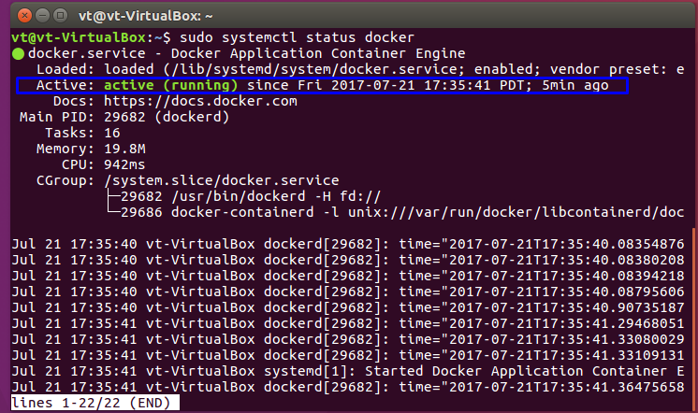

1. Verify that Docker CE is installed correctly by running the hello-world image.

sudo docker run hello-world