1. Created directory mongodb and copy paste the given lines in Docker file.

sudo vim dockerfile

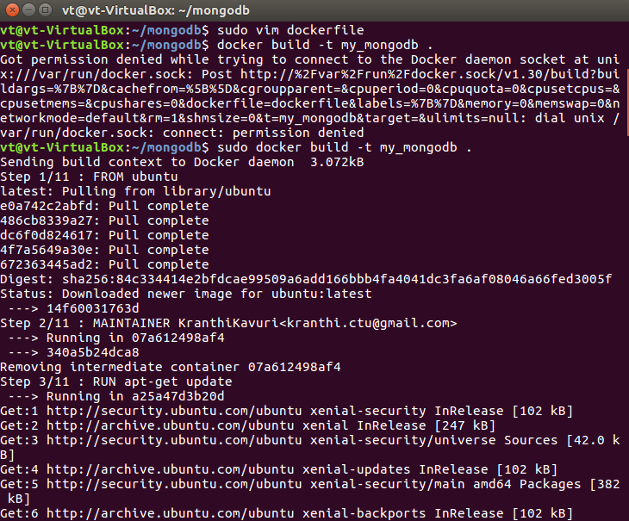

**Build the docker image :** sudo docker build -t my_mongodb .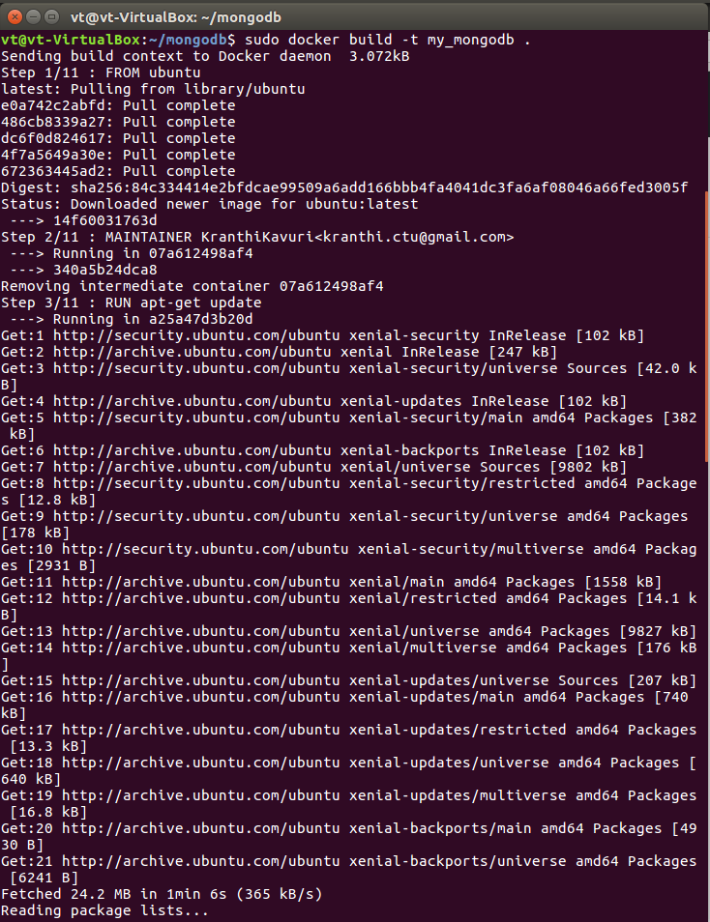

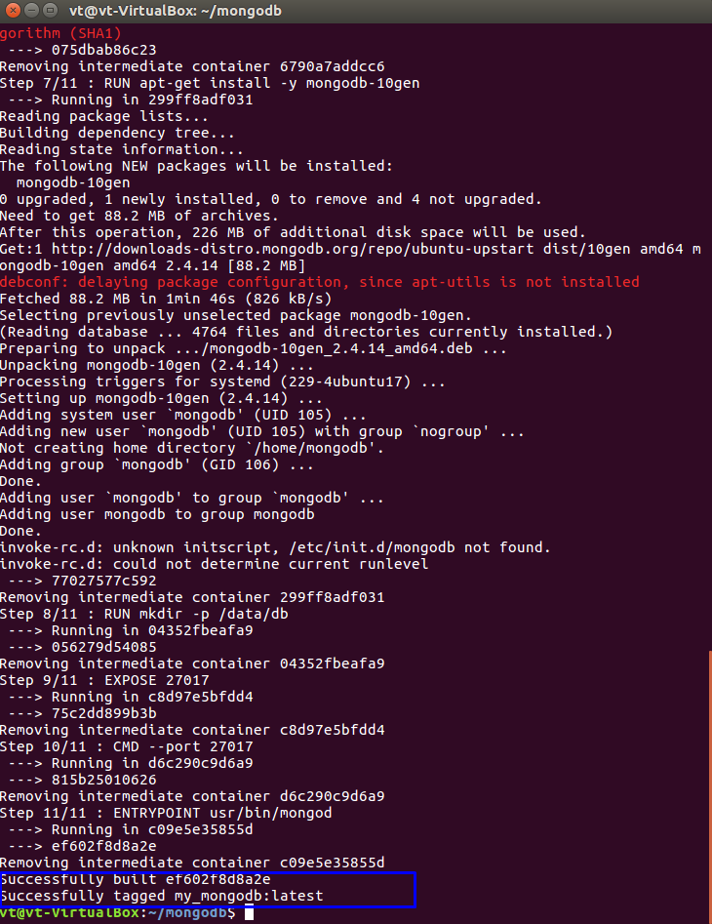

sudo docker run -name my_first_mdb_instance -i -t my_mongodb