**KUBERNETES**

* Kubernetes is an open source container management tool which automates container deployment,scaling,load balancing
* If schedules runs and manages isolated containers which are running on cloud machiens
* if is introduced by google in form of open source platfrom and it uses the Go language

some features of K8s

* orchestration
* Auto scaling
* Load balancing
* Roll back
* Self healing

Kubernetes Architecture

1-master node

2-worker node

The master node in a Kubernetes architecture is used to manage the states of a cluster. It is actually an entry point for all types of administrative tasks. In the Kubernetes cluster, more than one master node is present for checking the fault tolerance.

The master node consistes of different components

1.**Api server**: in k8s api server recives all the command form the user .after reciving it validates the requests ,process ,and then excutes them .after the execution of commands, the resulting state of cluster is saved in **ectd** as distributed key-valve store

2.**Scheduler:** the schedular schedules the tasks to worker nodes and for every worker node it is used to store the resoures usage info. And it is a process that is responsible for assigning pods to the available worker nodes.

**3.Controller Manager:** he controllers in a master node perform a task and manage the state of the cluster. In the Kubernetes, the controller manager executes the various types of controllers for handling the nodes, endpoints, etc.

4.**ETCD:** It is an open-source, simple, distributed key-value storage which is used to store the cluster data. It is a part of a master node which is written in a GO programming language.

Worker node consists of

1**.kubelet:** This component is an agent service that executes on each worker node in a cluster. It ensures that the pods and their containers are running smoothly. Every **kubelet** in each worker node communicates with the master node. It also starts, stops, and maintains the containers which are organized into pods directly by the master node.

**2.Kube-proxy**

It is a proxy service of Kubernetes, which is executed simply on each worker node in the cluster. The main aim of this component is request forwarding. Each node interacts with the Kubernetes services through **Kube-proxy**.

**3.Pods**

A **pod** is a combination of one or more containers which logically execute together on nodes. One worker node can easily execute multiple pods.

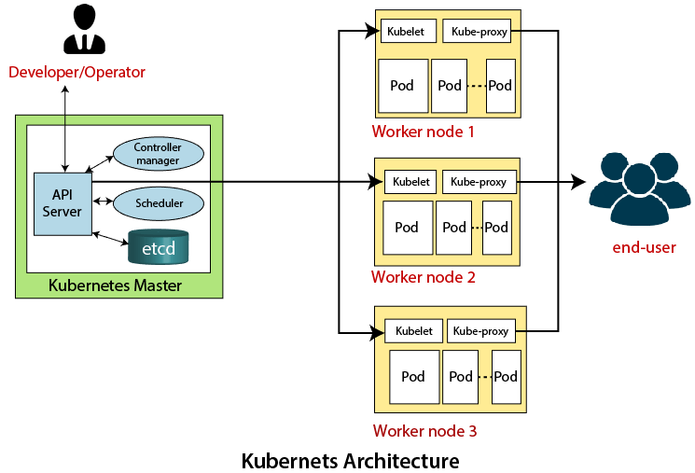

com