Hypothesis Testing

1. A F&B manager wants to determine whether there is any significant difference in the diameter of the cutlet between two units. A randomly selected sample of cutlets was collected from both units and measured? Analyze the data and draw inferences at 5% significance level. Please state the assumptions and tests that you carried out to check validity of the assumptions.

Minitab File : **Cutlets.mtw**

Ans:- Given, Null hypothesis: *μ1=μ2*

Alternate hypothesis: *μ1* not equal *μ2*

Significance level=5%

Alpha=0.05

Alpha/2=0.025

Conditions: If the P value is < alpha reject the Null hypothesis

If the P value> alpha accept the null hypothesis.

If the P value< alpha reject the null hypothesis.

p_value= 0.4722394724599501

alpha **=** 0.025

print('Significance=%.3f, p=%.3f' **%** (alpha, p_value))

**if** p_value **<=** alpha:

print('We reject Null Hypothesis there is a significance difference between two Units A and B')

**else**:

print('We fail to reject Null hypothesis')

Significance=0.025, p=0.472

We fail to reject Null hypothesis

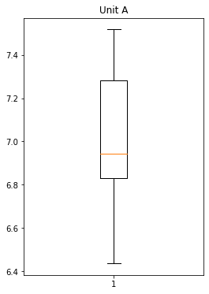

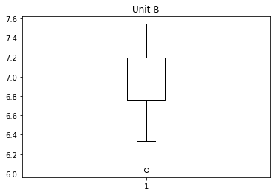

1. A hospital wants to determine whether there is any difference in the average Turn Around Time (TAT) of reports of the laboratories on their preferred list. They collected a random sample and recorded TAT for reports of 4 laboratories. TAT is defined as sample collected to report dispatch.

Analyze the data and determine whether there is any difference in average TAT among the different laboratories at 5% significance level.

Minitab File: **LabTAT.mtw**

Ans:- Null hypothesis: *μ1=μ2=μ3=μ4*

Alternative Hypothesis: At least one of them is different

Significance level=5%

Alpha=0.05

p_value = 2.1156708949992414e-57

alpha **=** 0.05

print('Significance=%.3f, p=%.3f' **%** (alpha, p_value))

**if** p_value **<=** alpha:

print('We reject Null Hypothesis there is a significance difference between TAT of reports of the laboratories')

**else**:

print('We fail to reject Null hypothesis')

Significnace=0.050, p=0.000

We reject Null Hypothesis there is a significance difference between TAT of reports of the laboratories

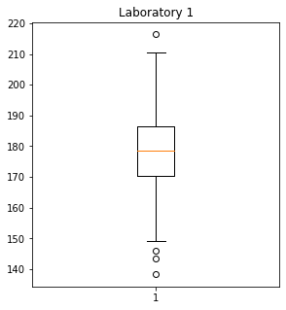

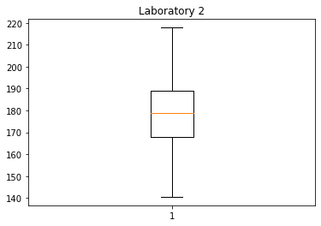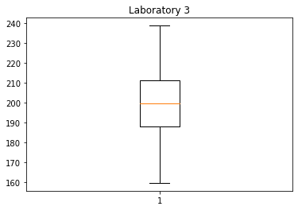

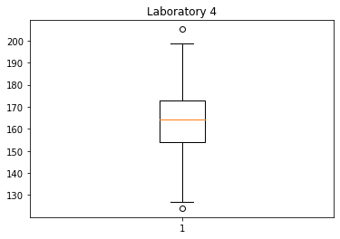

1. Sales of products in four different regions is tabulated for males and females. Find if male-female buyer rations are similar across regions.

Ans:- Null hypothesis= There is no dependency between the male and female ratio

Alternate Hypothesis= There is a dependency between the male and female ratio.

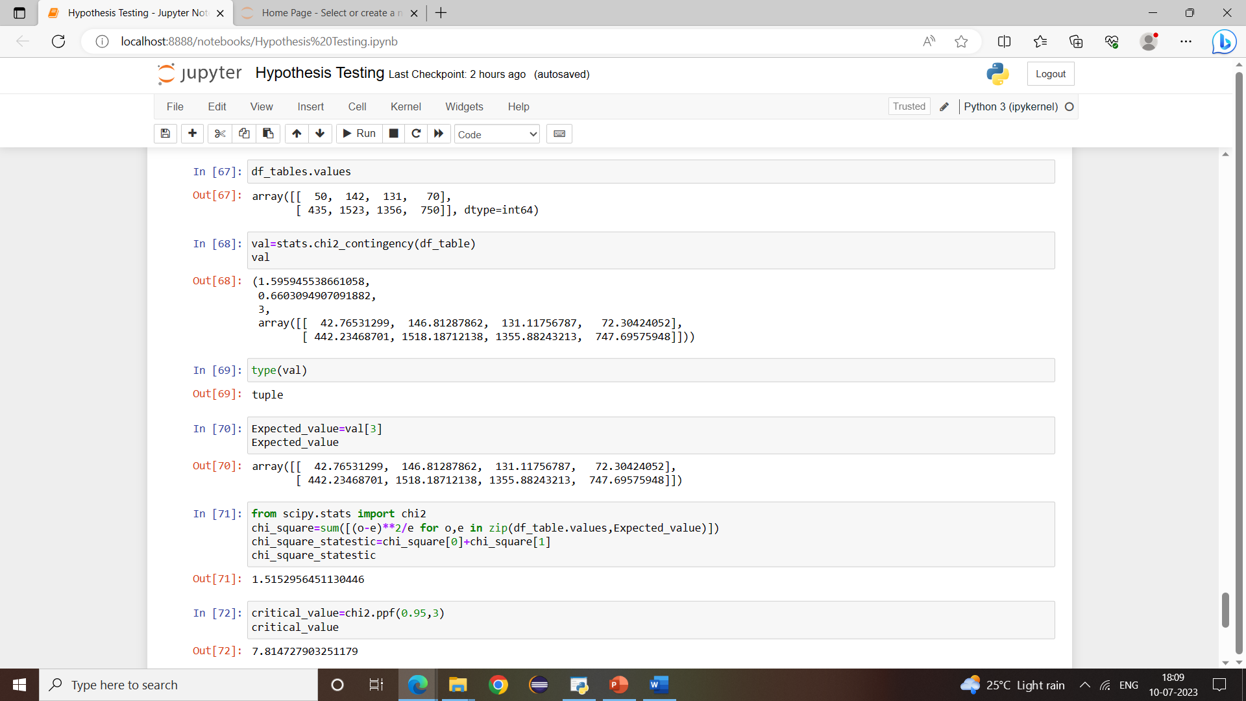

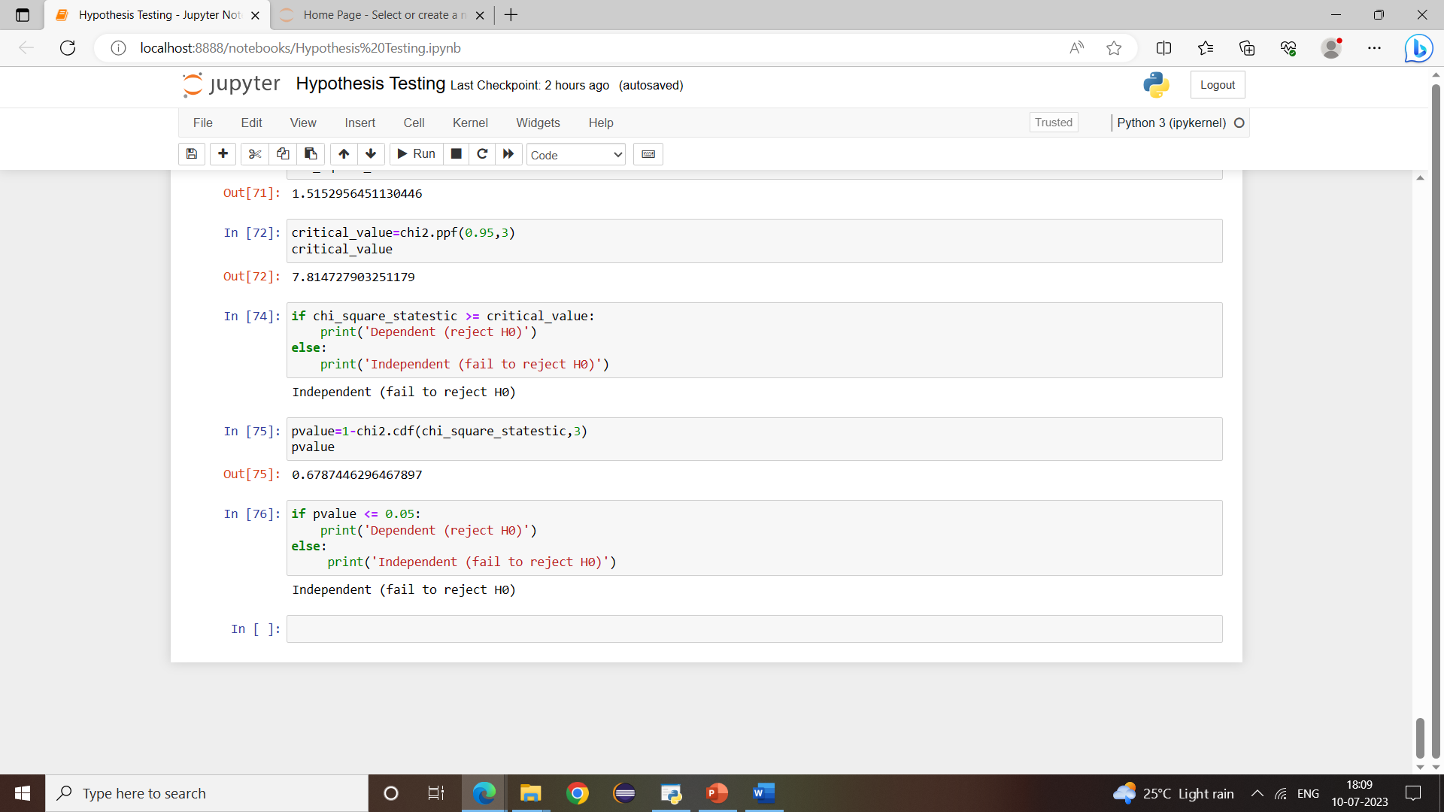

Statistics = 1.5959455390914483

P_Value = 0.8095206646905712

alpha **=** 0.05

print('Significnace=%.3f, p=%.3f' **%** (alpha, p_value))

**if** p_value **<=** alpha:

print('We reject Null Hypothesis there is a significance difference between TAT of reports of the laboratories')

**else**:

print('We fail to reject Null hypothesis')

Significnace=0.050, p=0.810

We fail to reject Null hypothesis

1. TeleCall uses 4 centers around the globe to process customer order forms. They audit a certain % of the customer order forms. Any error in order form renders it defective and has to be reworked before processing. The manager wants to check whether the defective % varies by centre. Please analyze the data at *5%* significance level and help the manager draw appropriate inferences

Minitab File: **CustomerOrderForm.mtw**

Ans:- Null hypothesis: *μ1=μ2=μ3=μ4*

Alternative Hypothesis: At least one of them is different

Significance level=5%

Alpha=0.05

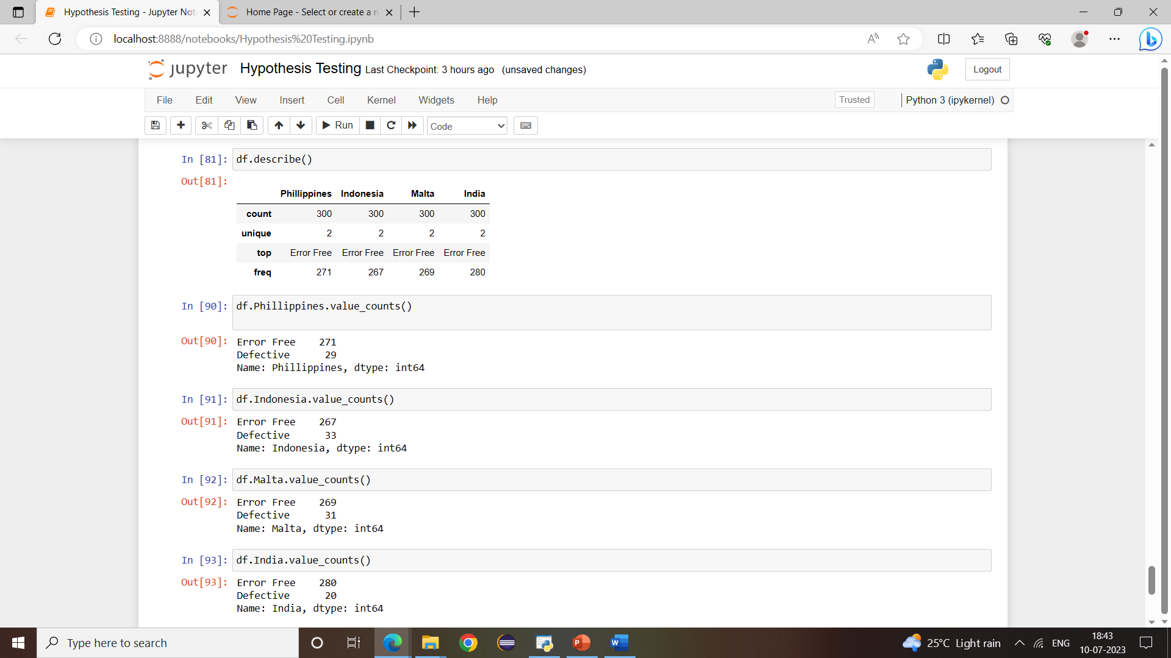

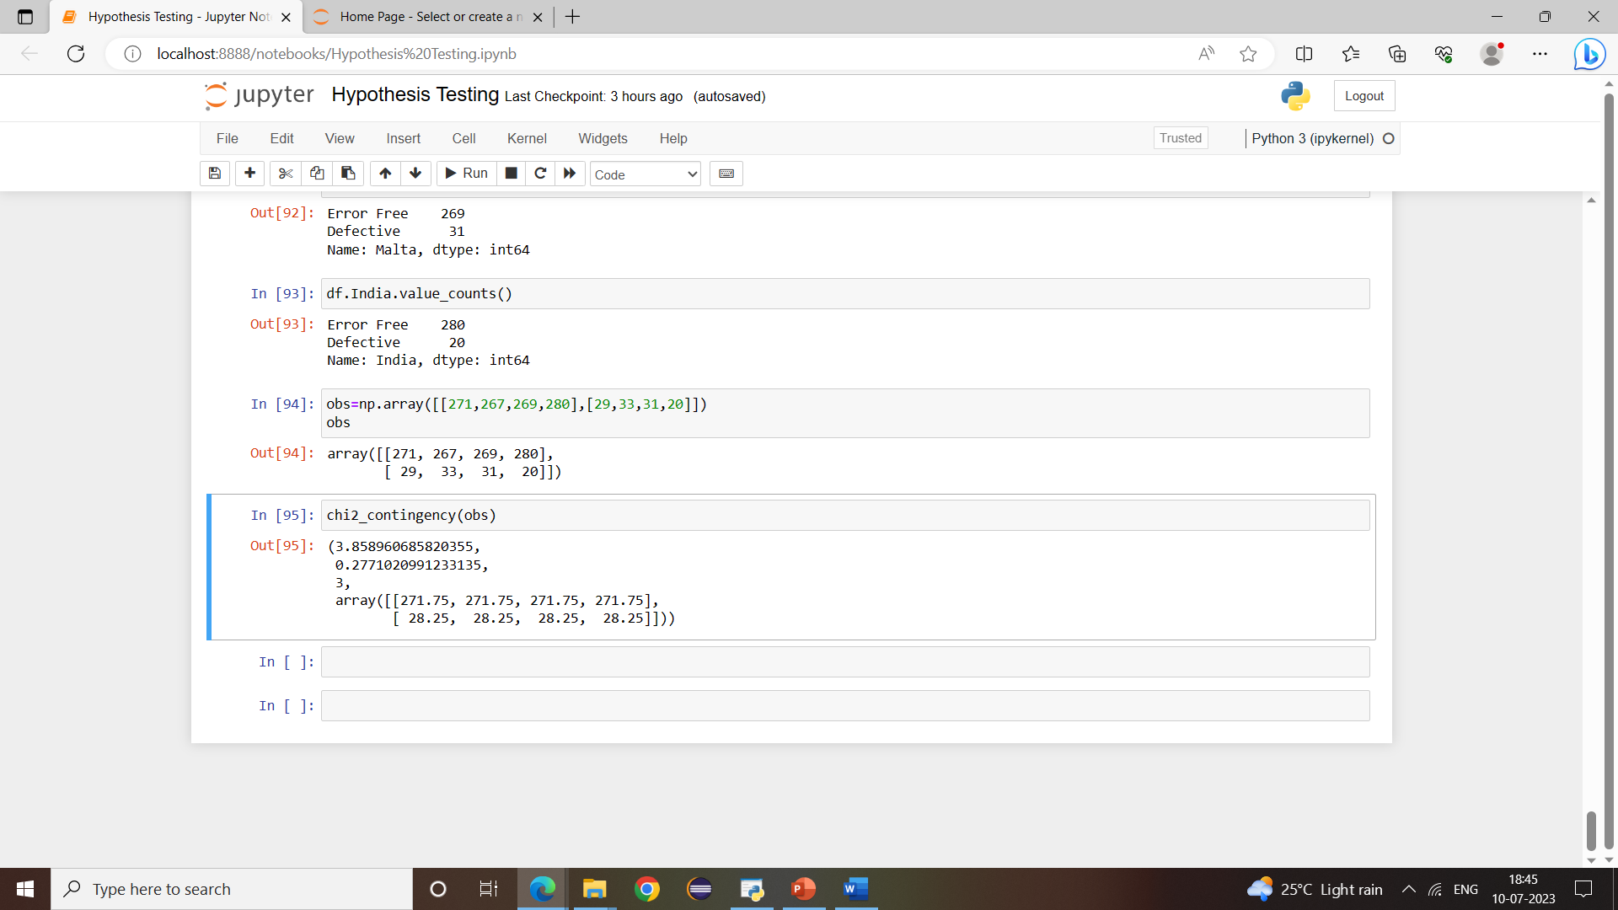

Test Statistic = 3.858960685820355

p_value = 0.4254298144535761

alpha **=** 0.05

print('Significnace=%.3f, p=%.3f' **%** (alpha, p_value))

**if** p_value **<=** alpha:

print('We reject Null Hypothesis there is a significance difference between TAT of reports of the laboratories')

**else**:

print('We fail to reject Null hypothesis')

Significnace=0.050, p=0.810

We fail to reject Null hypothesis