**Project Documentation Format**

# 1. Introduction

Project Title:

HematoVision: Transfer Learning-Based Blood Cell Classification for Medical Imaging

Team Members:

* Tean Leader - P Nagendra
* Team Member – Golkonda Thilak
* Team Member - A Anudeep
* Team Member - Manoj Kumar

# 2. Project Overview

Purpose:

To develop an AI-based system that detects and classifies blood cells using image classification via a pretrained MobileNetV2 model. The goal is to assist healthcare workers and researchers in identifying blood cell types for improved medical diagnostics.

Key Features:

* Upload blood cell images using a web interface
* Predict cell type using pretrained MobileNetV2
* Display cell name and confidence score
* Lightweight, fast and user-friendly UI
* No database used; all processing is in-memory

# 3. Architecture

Frontend:

* HTML and CSS (via Flask templates)

Backend:

* Flask for web framework and routing
* TensorFlow/Keras to load and run the MobileNetV2 model (Blood_Cell.h5)
* OpenCV for image processing
* Prediction logic in a separate utils.py script

Database:

* Not used; images and predictions are processed in-memory.

# 4. Setup Instructions

1. Install dependencies:

pip install -r requirements.txt

1. Place the model file (Blood_Cell.h5) in the root directory.
2. Run: python app.py
3. Open your browser at http://127.0.0.1:5000/

# 5. Folder Structure

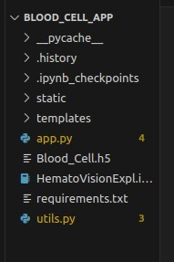

# 6. Running the Application

Run the Flask application locally with: python app.py

Then visit http://127.0.0.1:5000 in your browser.

# 7. API Documentation

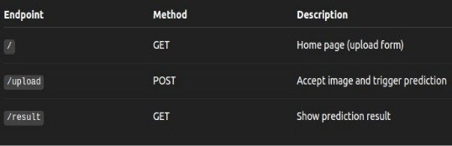

## 8. Authentication

* No authentication is used.
* The application runs locally and is accessible via http://127.0.0.1:5000.

# 🖥️ 9. User Interface

* Clean web interface built with HTML, CSS, and Flask templates.
* Simple image upload form for blood cell images.
* Results page displays predicted blood cell type along with the image preview.
* Proper error handling for invalid or missing image files.

## 10. Testing

***Testing Strategy:***

* Manual testing was performed to ensure that each feature behaves as expected.
* Each functionality, including file upload, prediction, and error handling, was tested individually.
* Focus was on functional accuracy, UI clarity, and robustness under edge cases.

***Test Cases Included:***

|  |  |  |
| --- | --- | --- |
| **Test Case** | **Expected Result** | **Status** |
| Upload valid blood cell image | Displays correct cell type prediction | ✅ Pass |
| Upload invalid file (.txt) | Displays error message | ✅ Pass |
| Upload very large image | Processes and predicts without crashing | ✅ Pass |
| Submit with no image | Prompts user to select an image | ✅ Pass |
| Model response time | Returns prediction within 2–3 seconds ✅ Pass | |

***Tools Used:***

* Web browser (Chrome/Firefox) for testing the user interface.
* Python print statements and logging for backend debugging.
* Manual uploads and form submissions to simulate user actions.

# 11. Screenshots or Demo

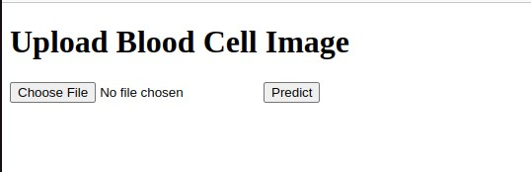

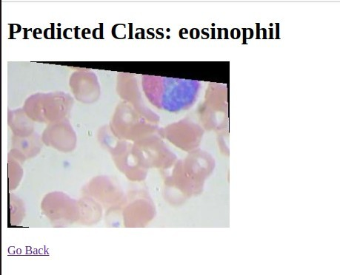

1. **Known Issues**
   * No webcam or real-time camera support.
   * Only supports the four trained blood cell classes: eosinophil, lymphocyte, monocyte, and neutrophil.
   * No feedback mechanism or prediction logging.
   * No user login system or prediction history tracking.
2. **Future Enhancements**
   * ✅ Add mobile version or responsive UI for better accessibility.
   * ✅ Integrate webcam for real-time blood cell detection.
   * ✅ Expand dataset to improve prediction accuracy and generalization.
   * ✅ Enable multilingual interface for broader usability in diverse regions.
   * ✅ Add cloud database to store user feedback and analytics.
   * ✅ Support classification of additional blood cell categories beyond the current four.