BVC ENGINEERING COLLEGE

Name: G. Nagendra Kumar Dept: CSE(AI&DS)

Roll: 23225a4502 Lab: Machine Learning Lab

Tasks

1. Task to download data set from the kaggle website.

Steps:

* 1. Open Web browser (Google chrome, Edge, Firefox …)

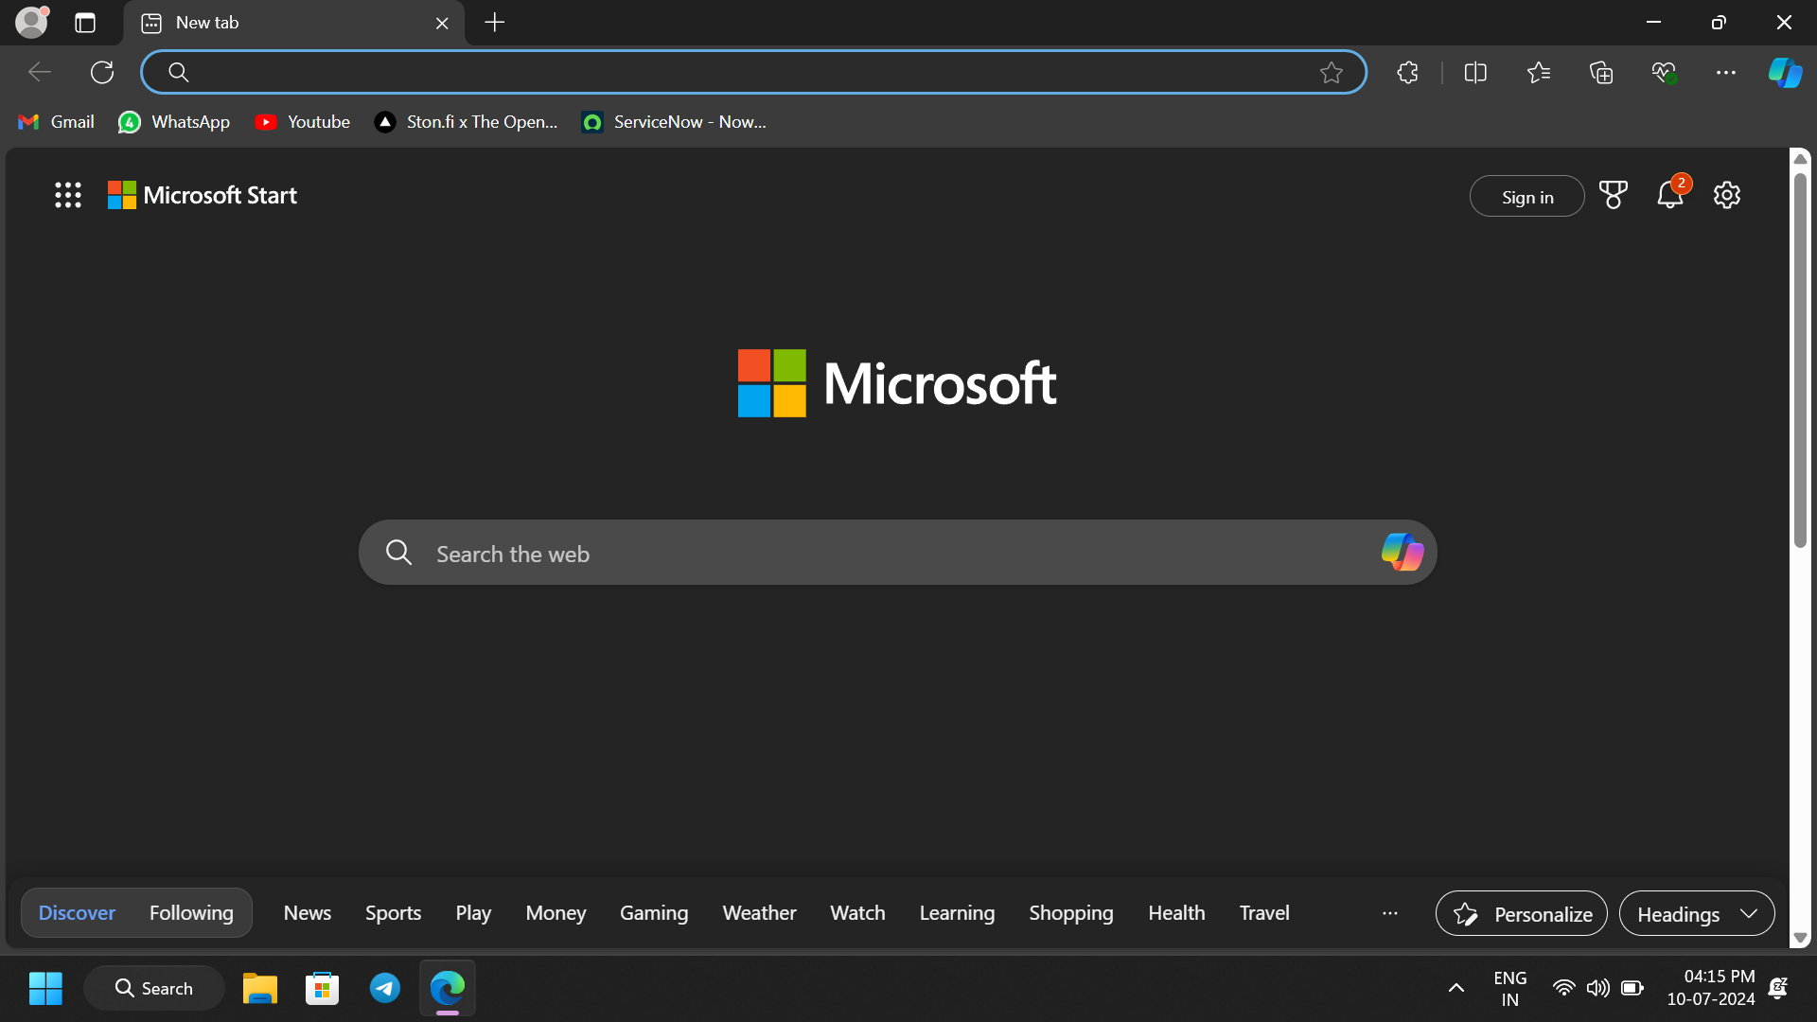

* 1. Search for www.kaggle.com in Google.

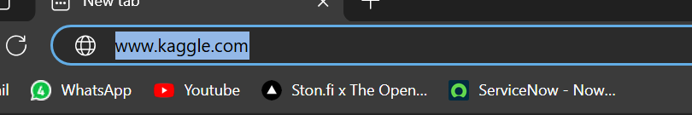

* 1. Kaggle Website appears as below.

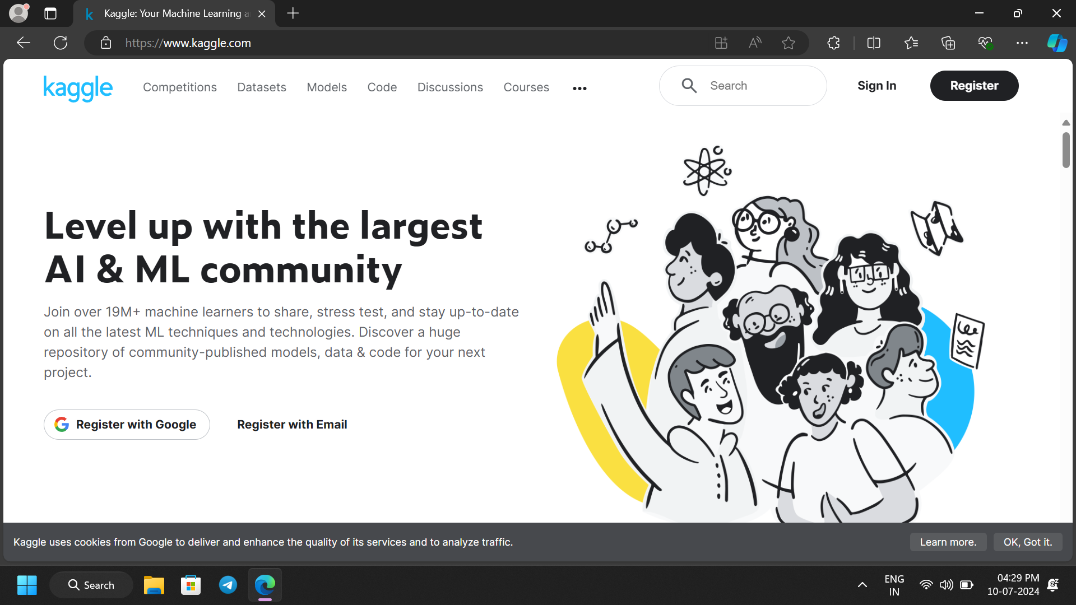

* 1. Sign In with your credentials.

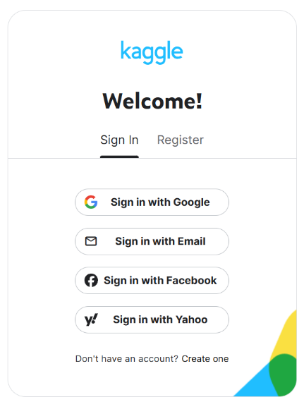

* 1. Search for