1. Why are functions advantageous to have in your programs?

The advantages of using functions are:

* Reducing duplication of code.
* Decomposing complex problems into simpler pieces.
* Improving clarity of the code.
* Reusability of code.
* Information hiding.

2. When does the code in a function run: when it's specified or when it's called?

The code inside function will be run when it is called.

#declaration or defination

def add():

pass

#Calling Function

add()

3. What statement creates a function?

A function is created with the **def** keyword. The statements in the block of the function must be indented. The def keyword is followed by the function name with round brackets and a colon.

Ex:

def nothing():

pass

4. What is the difference between a function and a function call?

Function is a piece of code for some specific functionality whereas function call is calling that function inorder to execute that piece of code.

5. How many global scopes are there in a Python program? How many local scopes?

There are 4 scopes in Python:

**Local :** Whenever you define a variable within a function, its scope lies ONLY within the function. It is accessible from the point at which it is defined until the end of the function and exists for as long as the function is executing. Which means its value cannot be changed or even accessed from outside the function.

Ex:

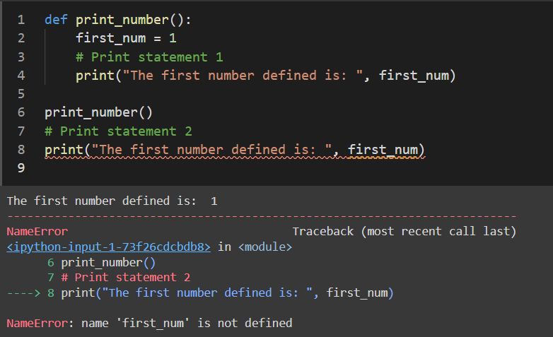

Explanation: We were able to print the first_num variable by calling the function print_number() (# Print statement 1). But when trying to access and then print the same variable from outside the function (# Print statement 2), it raised a NameError. This is because first_num is "local" to the function - thus, it cannot be reached from outside the function body.

**Enclosing:** This type of scope is generally seen nested functions.

Ex:

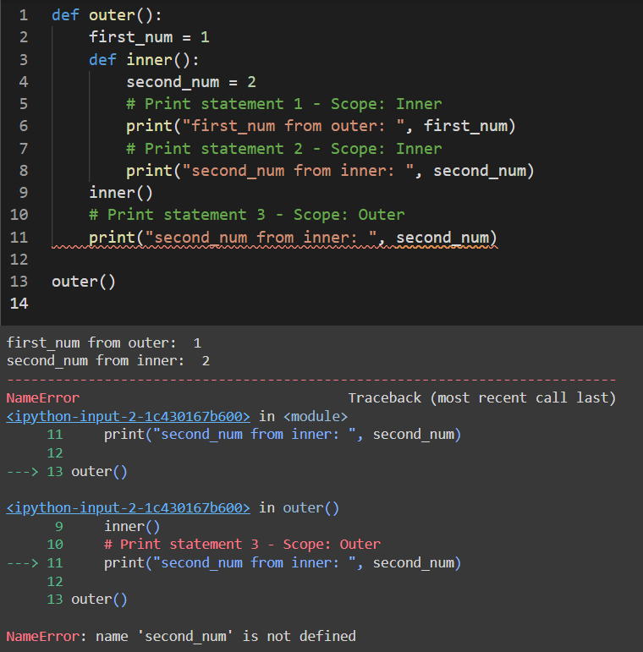

Explanation: This is because you cannot access second_num from outer() (# Print statement 3). It is not defined within that function. However, you can access first_num from inner() (# Print statement 1), because the scope of first_num is larger, it is within outer(). This is an enclosing scope. Outer's variables have a larger scope and can be accessed from the enclosed function inner().

**Global:** Whenever a variable is defined outside any function, it becomes a global variable, and its scope is anywhere within the program. Which means it can be used by any function.

Ex:

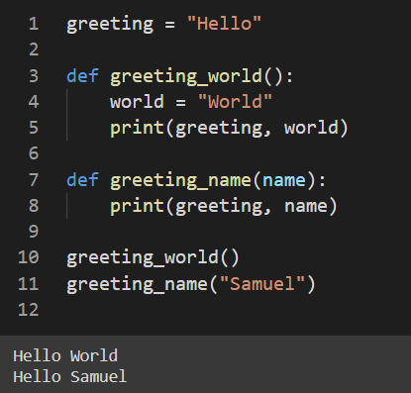

**Builtin:** This is the widest scope that exists! All the special reserved keywords fall under this scope. We can call the keywords anywhere within our program without having to define them before use.

These are the keywords in Python:

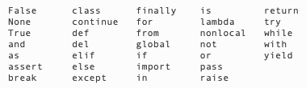

6. What happens to variables in a local scope when the function call returns?

All **local variables are destroyed** in memory after the function call returns and comes out of scope of function.

7. What is the concept of a return value? Is it possible to have a return value in an expression?

return keyword in python is used to return some value outside the function by calling that function. This return statement will terminate the function execution and get out of the function by returning some value outside. we will have expressions as return but expressions should not contain return in it.

This is possible:

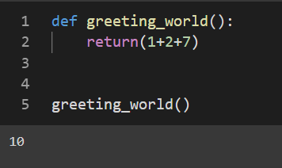

But this is not:

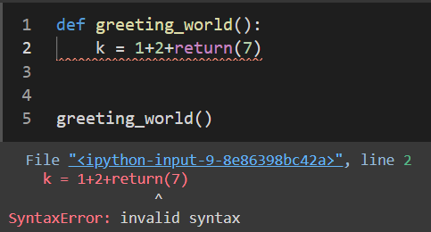

8. If a function does not have a return statement, what is the return value of a call to that function?

A function with no return statement will return **None**.

9. How do you make a function variable refer to the global variable?

By using **global** keyword before that variable within function.

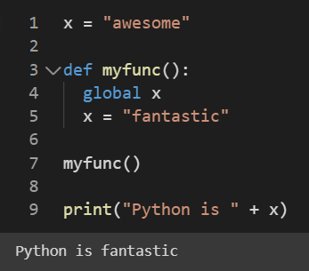

10. What is the data type of None?

It is **NoneType.**

11. What does the sentence import areallyourpetsnamederic do?

It will throw ModuleNotFoundError: No module named 'areallyourpetsnamederic'. Because there is nothing like areallyourpetsnamederic in python.

12. If you had a bacon() feature in a spam module, what would you call it after importing spam?

This function can be called with spam.bacon().

13. What can you do to save a programme from crashing if it encounters an error?

We can use Exception Handling handle known exceptioto stop our program from crashing

14. What is the purpose of the try clause? What is the purpose of the except clause?