**QUESTION:-**



**Explanation:-**

Initially the file named **emp_details.txt** is loaded in **local machine** under the path **‘/home/acadgild/hive’.** You can see the contents of file named ‘emp_details.txt’ below.

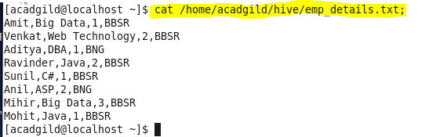

First we are starting mysql service to start hive.

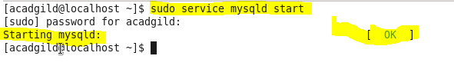

Now we are **starting hive** as shown in the below screenshot.

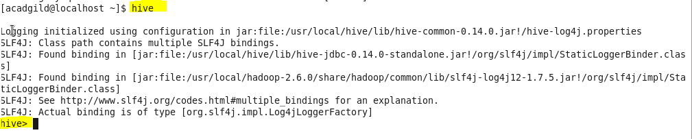

We have checked whether database named **“Demo”** exists. As shown in below screenshot, there are no database named “**Demo”** exists. So we need to create database named **“Demo”.**

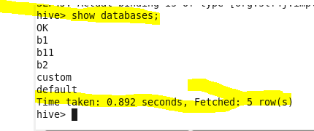

We have created database named **“Demo”** as shown in the below screenshot.

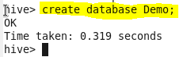

Now we are **using Database named “Demo”.**

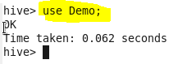

There are **no tables under Database “Demo”** as shown in the below Screenshot.

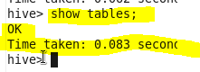

Now we created the table named **“Employee” under database “Demo”.** The **file that has separator as comma (‘,’)** will be **loaded into table named Employee.**

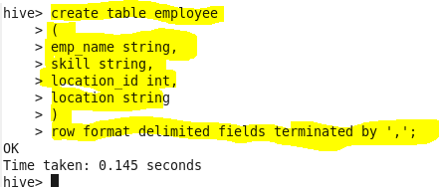

Now we are loading file from local machine to HDFS under the table **employee**.

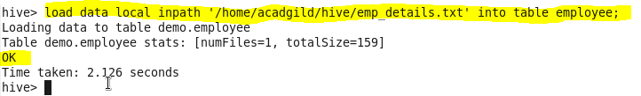

After loading the file, **since we have created internal or managed table, the file named employee.txt will be saved under location ‘/user/hive/warehouse’.**

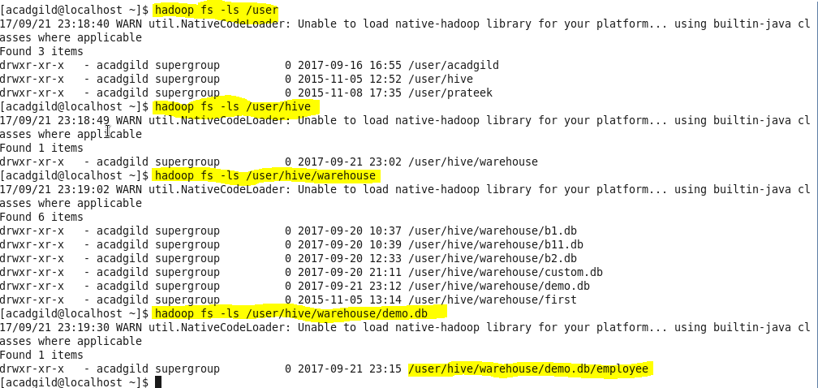

Now let’s come back to employee table. We have d**isplayed the loaded contents of employee table.**

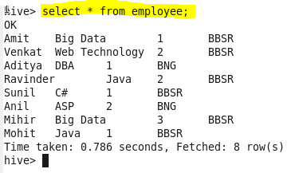

**Described** the employee table.

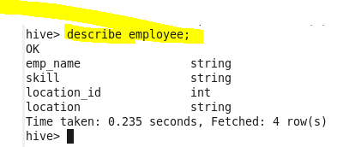

**FINAL QUERY AND OUTPUT:-**

As per the need, we have counted the no of employees for each skill using **“Group By”.** We have highlighted the output.

