**Problem Statement**

Write a Hive program to find the number of medals won by each country in swimming.

Write a Hive program to find the number of medals that India won year wise.

Write a Hive Program to find the total number of medals each country won.

Write a Hive program to find the number of gold medals each country won.

Sample records:

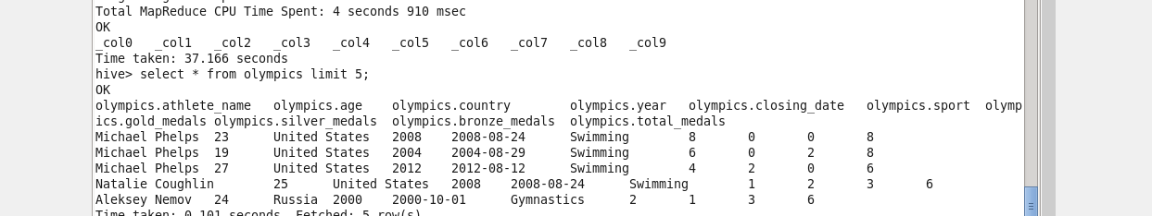

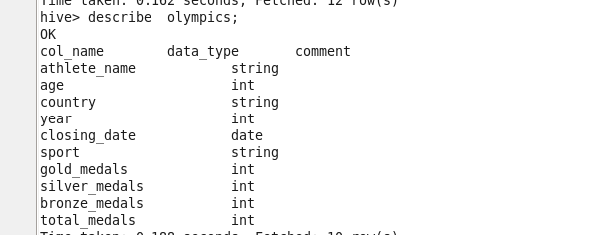

**Problem 1: Write a Hive program to find the number of medals won by each country in swimming.**

Creating a temporary table for loading data

CREATE DATABASE IF NOT EXISTS GAMES;

USE GAMES;

CREATE TABLE IF NOT EXISTS olympics_stg

(

Athlete_Name string,

Age int,

Country string,

Year int,

Closing_Date string,

Sport string,

Gold_Medals int,

Silver_Medals int,

Bronze_Medals int,

Total_Medals int

)

ROW FORMAT SERDE 'org.apache.hadoop.hive.serde2.OpenCSVSerde'

WITH SERDEPROPERTIES (

"separatorChar" = "\t",

"quoteChar" = "\"",

"escapeChar" = "\\"

)

STORED AS TEXTFILE;

**Loading staging table:**

LOAD DATA LOCAL INPATH '/home/acadgild/sridhar/hive/assignment7/olympix_data.csv' INTO TABLE olympics_stg

**Final table with changing closing_date to Data type;**

CREATE TABLE IF NOT EXISTS olympics

(

Athlete_Name string,

Age int,

Country string,

Year int,

Closing_Date date,

Sport string,

Gold_Medals int,

Silver_Medals int,

Bronze_Medals int,

Total_Medals int

);

**Loading into table**

INSERT INTO TABLE olympics

SELECT

Athlete_Name,

Age,

Country,

Year,

to_date(from_unixtime(unix_timestamp(Closing_Date,'MM-dd-yy'))) ,

Sport,

Gold_Medals,

Silver_Medals,

Bronze_Medals,

Total_Medals

FROM olympics_stg;

**Problem 1 output**

select DISTINCT Country, No_of_medals FROM

(

SELECT

Country,

COUNT(Total_Medals) OVER (PARTITION by(Country)) as No_of_medals,

sport

FROM olympics

)temp

WHERE Sport='Swimming';

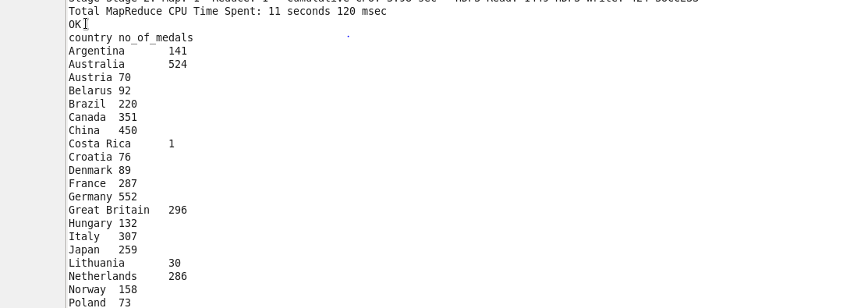

**Problem 2: Write a Hive program to find the number of medals that India won year wise.**

select DISTINCT Year, No_of_medals FROM

(

SELECT

Year,

COUNT(Total_Medals) OVER (PARTITION by(Year)) as No_of_medals,

Country

FROM olympics

)temp

WHERE Country='India';

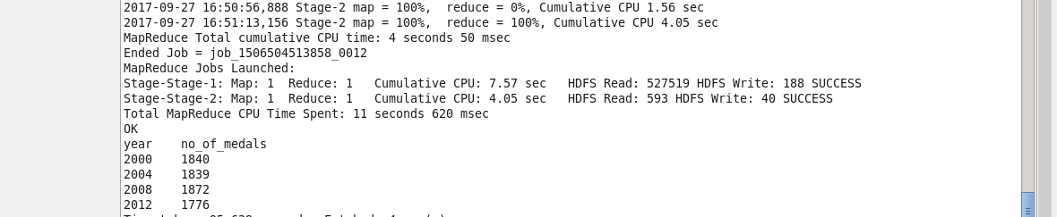

**Problem 3: Write a Hive Program to find the total number of medals each country won.**

select DISTINCT Country, No_of_medals FROM

(

SELECT

Country,

COUNT(Total_Medals) OVER (PARTITION by(Country)) as No_of_medals

FROM olympics

)temp;

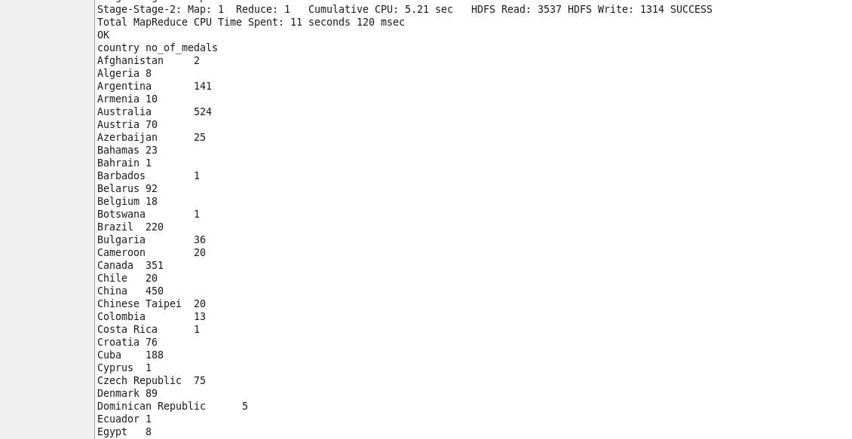

**Problem 4: Write a Hive program to find the number of gold medals each country won.**

select DISTINCT Country, No_of_medals FROM

(

SELECT

Country,

COUNT(Gold_Medals) OVER (PARTITION by(Country)) as No_of_medals

FROM olympics

)temp;

