**Spring Cloud Pivotal**

**Cloud Foundry:**

It is a [PaaS service](https://en.wikipedia.org/wiki/Platform_as_a_service) where we can easily deploy and manage our applications and the Cloud Foundry will take care of the rest of the cloud based offerings like scalability, high availability etc.

**What is Cloud Foundry?**

Cloud foundry is an open source platform as service offering provided by pivotal

Let’s discuss what is platform as service offering?

We have several cloud platform like Google cloud, Amazon Cloud and Spring Cloud and pivotal Cloud where we can deploy our micro services Or any application but each cloud factory have their own patterns to configure, deploy, managing etc.

So each of them offering service us to deploy application.

So let’s see what are the service they providing and how they categorized, normally it divided in 3 types

1. Infrastructure

2. Platform

3. Software.

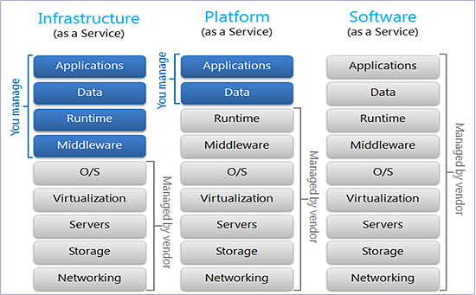

So discuss one by one.  
As per architecture normally we required few support to deploy our application in any environment

1.    Application  
2.    Data  
3.    Runtime  
4.    Middleware  
5.    Operating system  
6.    Virtualization  
7.    Servers  
8.    Storage  
9.    Networking

Now let’s see what each service offering

**Infrastructure Service Offering**

1.    Application  
2.    Data  
3.    Runtime  
4.    Middleware  
5.    Operating system  
6.    Virtualization  
7.    Servers  
8.    Storage  
9.    Networking

Infrastructure provides only green mark fields Rest all we need to manually configure in that cloud environment

Like: workspace, runtime environment and API related configure that we need to do manually

The Best Example is AWS (Amazon Web service) if any one worked on AWS they marked everything we need to set there like Virtual box

**Platform Service Offering**

1.    Application  
2.    Data  
3.    Runtime  
4.    Middleware  
5.    Operating system  
6.    Virtualization  
7.    Servers  
8.    Storage  
9.    Networking

Platform provides only green mark fields Rest all we need to manually configure in that cloud environment

So here you need to bother about only your application set up and data set rest all inbuilt by platform service provider like you can choose your own platform like java, python or any tech they have multi environment supports

The best Example is GCP and Pivotal Cloud Foundry and Cloud Foundry have to great support to Our Spring Cloud

**Software Service Offering**

1.    Application  
2.    Data  
3.    Runtime  
4.    Middleware  
5.    Operating system  
6.    Virtualization  
7.    Servers  
8.    Storage  
9.    Networking

Software service provides all the required environment   
Best Example is Google docs

So now in this article am going to explain Platform Offering Service that with Pivotal Cloud Foundry So what we need to manage for this only our application and data. Rest all will provide by Cloud Foundry

https://javagyanmantra.wixsite.com/website/single-post/2018/02/14/Pivotal-Cloud-Foundry