**Ansible**

**What is Ansible?**

Ansible is a simple configuration management tool that automates IT orchestration, app deployment, or cloud provisioning etc. It promotes deployment because it does not use any complex security infrastructure or agents.

Ansible is an open source automation platform. It can help us with configuration management, application deployment or task automation. It can deploy an application using SSH without any downtime. Ansible is developed or written in [Python](https://www.educba.com/course/web-application-development-pyramid-micro-framework-python/) language.

### What Are The Advantages and use Of Ansible?

* Ansible has a huge number of benefits:  
  No Agent: Agent is not required for setting up Ansible. If Box can support ssh and it has python, then no issue to set up Ansible.
* Idempotent: Architecture of Ansible is totally structured around the concept of idempotency. The main or core idea is that only those things need to be added which are needed, and those things will be repeatable without side effects.
* Declarative not procedural: a Normal attitude of other configuration tools of following a procedural process, means do this then do that and so on. But Ansible normally writes the description of the state of machine what we want and it takes proper steps toward fulfilling that description.
* Very Easy to learn and low overhead.

### How Ansible Works?

Answer:  
Ansible mainly categorized into two types of server: controlling machine and Nodes.  
Ansible will install on the controlling machine and nodes are managed inside this controlling machine by SSH. Nodes location are specified by controlling machine through its inventory.

Ansible deploys modules to nodes using SSH protocol, these modules are mainly stored temporarily in remote nodes and communicate with the Ansible machine through a [JSON](https://www.educba.com/course/json-training/)connection over the standard output.  
Agent installation in remote nodes is not required for Ansible as it is agentless. So any background process or demon process not running for Ansible when it’s not managing any nodes.

Ansible can able to handle more than 100 of nodes in a single system over SSH connection and only one single command ‘ansible’ can be handled entire operation. But some scenarios we can build ‘playbooks’ where we require to execute multiple commands for a deployment.  
Playbooks are actually holding all the sequential command needs to be executed for performing multiple tasks. Playbooks are in YAML file format.

### What’s the use of Ansible?

Ansible mainly used in IT infrastructure to manage or deploy applications to remote nodes. Suppose we want to deploy one application in 100 nodes by just executing one command, then Ansible is actually coming into the picture, but should need some knowledge on Ansible script to understand or execute the same.

It uses playbook to deploy, manage, build, test and configure anything from full server environment to

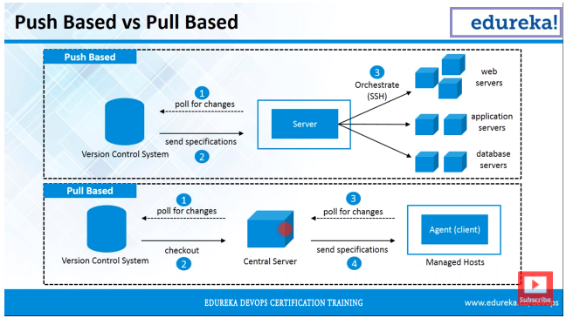

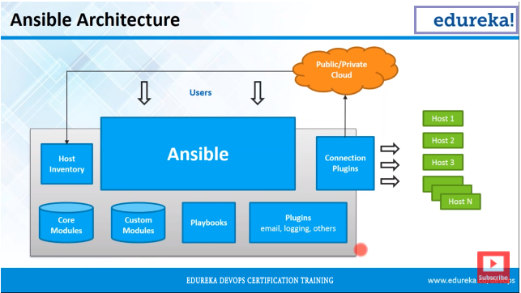

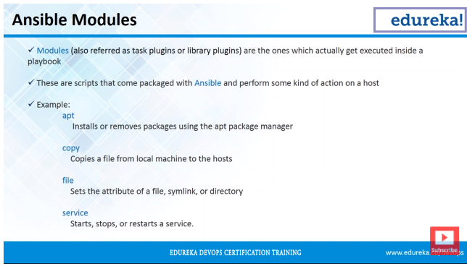

**Ansible Terms:**

* **Controller Machine:** The machine where Ansible is installed, responsible for running the provisioning on the servers you are managing.
* **Inventory:** An initialization file that contains information about the servers you are managing.

It contains list of your hosts, grouped together.

Default location is etc/ansible/hosts

* **Playbook:** The entry point for Ansible provisioning, where the automation is defined through tasks using YAML format.

Playbook contains plays, a play contains different tasks and taks contains module, modules are executed hosts, it contains some takes,

Ex: install package , run and restart server.

* **Task:** A block that defines a single procedure to be executed, e.g. Install a package.
* **Module:** A module typically abstracts a system task, like dealing with packages or creating and changing files. Ansible has a multitude of built-in modules, but you can also create custom ones.
* **Role:** A pre-defined way for organizing playbooks and other files in order to facilitate sharing and reusing portions of a provisioning.
* **Play:** A provisioning executed from start to finish is called a play. In simple words, execution of a playbook is called a play.
* **Facts:** Global variables containing information about the system, like network interfaces or operating system.
* **Handlers:** Used to trigger service status changes, like restarting or stopping a service.

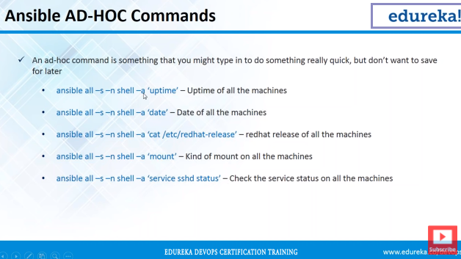

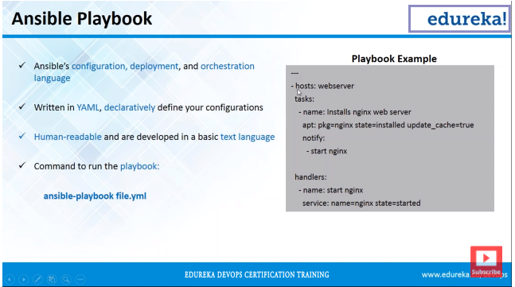

**SSH** (**Secure SHELL**) is an open source and most trusted network protocol that is used to login into remote servers for execution of commands and programs. It is also used to transfer files from one computer to another computer over the network using secure copy (**SCP**) Protocol.