**Programming Project 1**

**Library Management System**

(Venkata Nagendra Kumar Pasupula-vxp142130)

**Technical Specifications:**

1. Programming Language: Java (Swings)
2. Tools: Eclipse
3. Database Language: MySQL

1. **Design decisions and justifications:**

GUI is simple and created by using Java Swings.

It contains a tabbed pane of library which contains library main page as shown below.

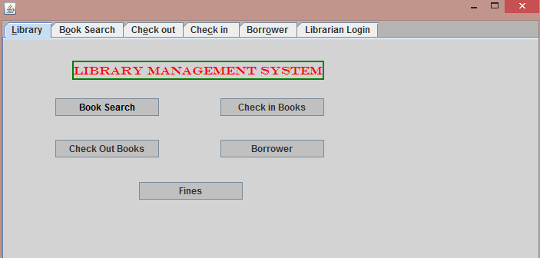

It is provided with buttons for a particular function.

1. **Book Search** – Navigates to Book Search tab to search for a particular book as below.

Provide at least one of the below fields and click on search button.

It will show the resulted books lists as shown below.

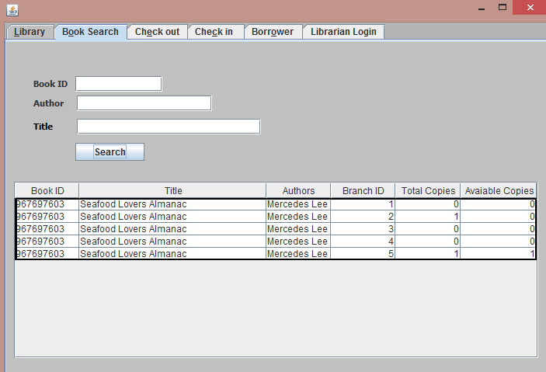

1. **Check Out Books:**

Navigates to check out books tab where you can check out the books.

Provide all the three fields and click on check out button to check out the particular book.

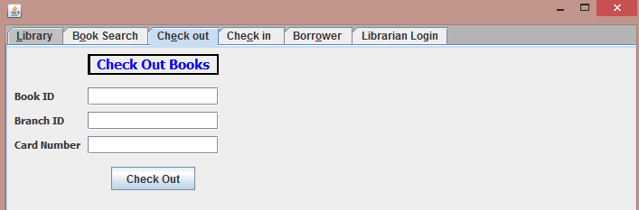

1. **Check in Books:**

Navigates to check in books tab where you can check in a book that has been checked out.

Provide at least one of the below fields Book ID/Card Number/Borrower Name and click on Get Books button.

It will return all the books matching the criterion given and you need to select one of the resulted books and click on check in.(Note: Do not check multiple rows to check in as it will check in only first row).

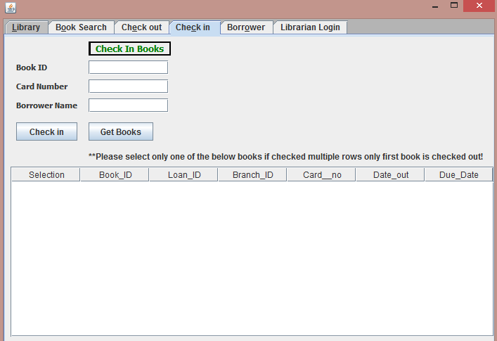

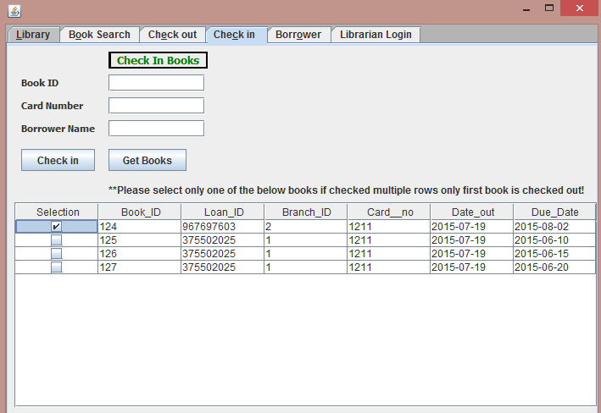

1. **Borrower:**

It will navigate to borrower creation page.

Please enter all required fields as provided * and click on Create Borrower button.

It will not create borrower if the First Name, Last Name and Address fields(except Phone) matches with already existing user.

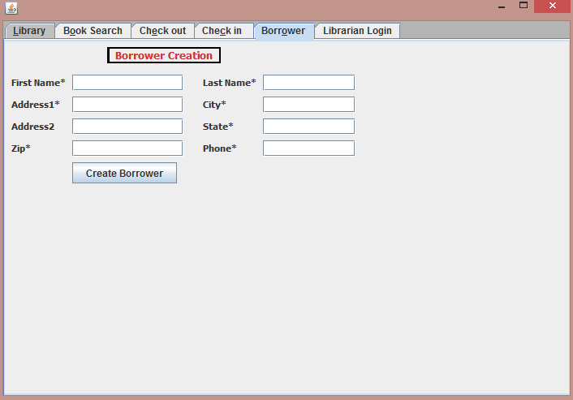

1. **Fines:**

**User Instructions for Librarians:**

* 1. 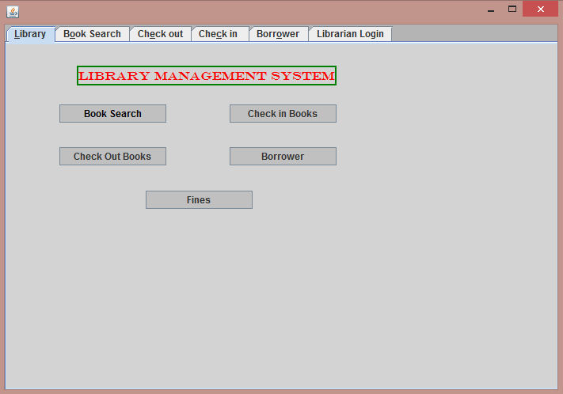Click on Library main page and click on Fines button to view login page.
  2. It will route to below login page and enter the username and password

Username: Librarian

Password: Library

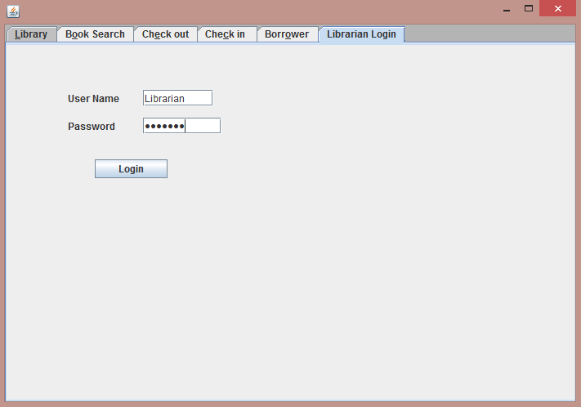

* 1. After entering correct user name and password it will route to fees & fines page to update the fine amount and payment.

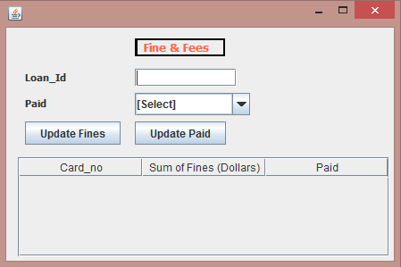

* 1. Click on Update fines to update the fines whose fine amount is sum of fine amount for a borrower.

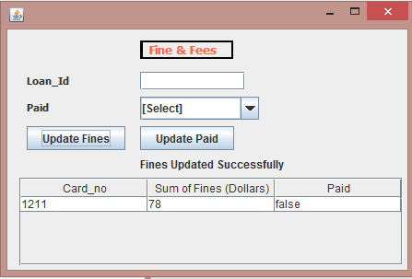

* 1. Provide Loan_ID and Paid as Yes/No and click on Update Paid to update the payment of fine amount.