Project Title:
E-Commerce Sales Performance Analysis for Business Decision Making
Problem Statement:
The business wants to analyze its e-commerce sales data to understand sales and profit performance across products, categories, regions, and time. The objective is to identify growth opportunities and improve overall profitability through data-driven insights.
Business Objectives:
- Analyze overall sales, profit, and quantity performance
- Identify top-performing and low-performing products and categories
- Compare region-wise sales and profitability
- Study monthly sales trends over time
- Provide actionable business recommendations
Dataset Description:
The dataset contains approximately 3,500 sales transactions with 7 columns.
It includes the following fields:
- Order Date
- Product Name
- Category
- Region
- Quantity
- Sales
- Profit
Tools & Technologies Used:
- Microsoft Excel - Data cleaning and pivot table analysis
- Power BI - Data visualization and dashboard creation
- Microsoft Word - Project documentation
Data Cleaning & Preprocessing:
Data cleaning was performed using Microsoft Excel to ensure data accuracy and consistency.
The following steps were carried out:
- Removed duplicate records
- Corrected data types for date and numeric columns
- Ensured consistency in category and region values
- Verified sales, profit, and quantity fields

Power BI Dashboard Overview:
Figure: Interactive Power BI dashboard showing sales, profit, and quantity analysis by category, region, and month.
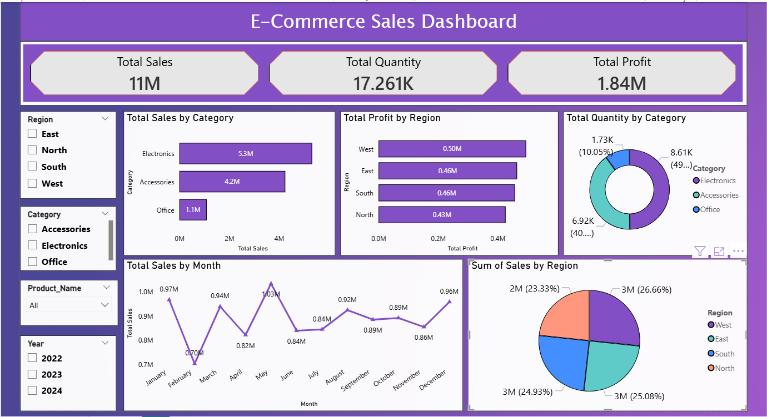
Key Insights & Business Recommendations:
Key Insights:
- The business achieved total sales of 11M with a total profit of 1.84M, indicating strong overall performance.
- Electronics is the highest-performing category, contributing the largest share of sales and quantity.
- The West region generates the highest profit, while the North region shows comparatively lower profitability.
- Monthly sales show seasonal variation, with peak sales in May and lower performance in February.
- Sales are fairly distributed across regions, indicating diversified market presence.
Business Recommendations:
- Focus marketing and inventory planning on high-performing categories such as Electronics.
- Investigate cost and pricing strategies in the North region to improve profitability.
- Launch promotions during low-performing months to stabilize sales.
- Explore opportunities to improve the performance of the Office category.

Conclusion:
This project involved analyzing an e-commerce sales dataset to understand overall business performance and identify key trends. The data was cleaned and prepared, and an interactive Power BI dashboard was developed to analyze sales, profit, and quantity across categories, regions, and time periods.
The analysis helped identify top-performing categories and regions, seasonal sales patterns, and areas with lower profitability. These insights can support data-driven decision-making in areas such as marketing, inventory planning, and regional strategy.
Overall, this project demonstrates the practical application of data analysis skills using Excel and Power BI, along with the ability to convert raw data into meaningful business insights.

