**Experiment-1.1**

Student Name: Nagesh Kumar UID: 23BCS10608

Branch: B.E-C.S.E Section/Group: 23KRG-2A

Semester: 5th Date of Performance: 15/08/2025

Subject Name: DAA Subject Code: 23CSH-301

1. **Aim:** Create Java programs to manage product details, library systems, and student information using classes, inheritance, and abstraction.
2. **Objective:** To understand stacks.
3. **Input/Apparatus Used:** Stack are implemented using templates.
4. **Procedure:**Step1: Create stack.

Step2: Check underflow and overflow condition.

Step3: Increment top to store element in stack.

Step4: Decrement top after removing element form stack.

Step5: Check is stack empty or not.

1. **Code:**

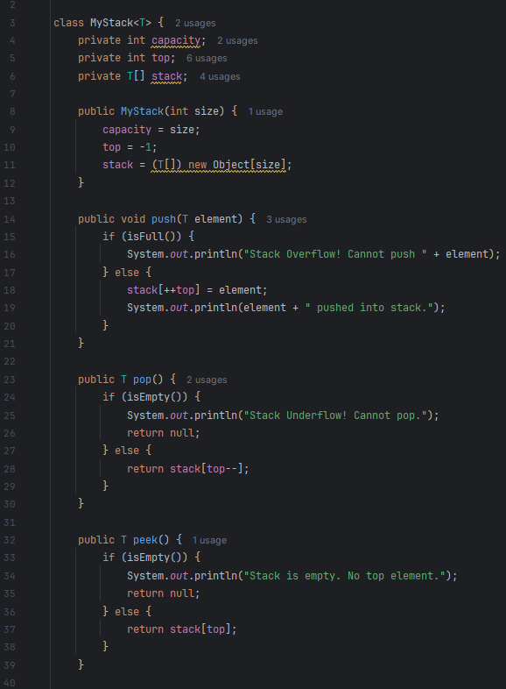

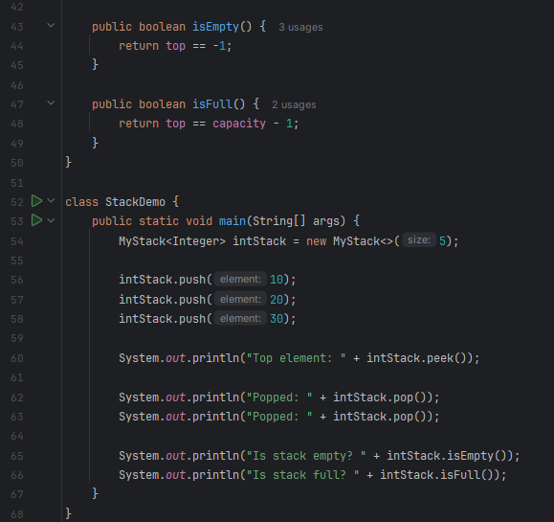

1. **Output:**

