**Experiment-1.2**

Student Name: Nagesh Kumar UID: 23BCS10608

Branch: B.E-C.S.E Section/Group: 23KRG-2A

Semester: 5th Date of Performance: 15/08/2025

Subject Name: DAA Subject Code: 23CSH-301

1. **Aim:** Code implement power function in O(logn) time complexity.
2. **Objective:** To implement power function in O(logn) time complexity.
3. **Input/Apparatus Used:** In this program , power is divided by 2 in order to get complexity in log.
4. **Procedure/Algorithm: Pseudocode:**

if(y==0):

return 1;

temp = power(x,y/2); if(y%2==0):

return temp*temp; else

return x*temp*temp;

**Various possible cases**

1)The power value can be 0

2)The power value can be negative.

3)The power value can be even.

4)The power value can be odd.

1. **Code:**

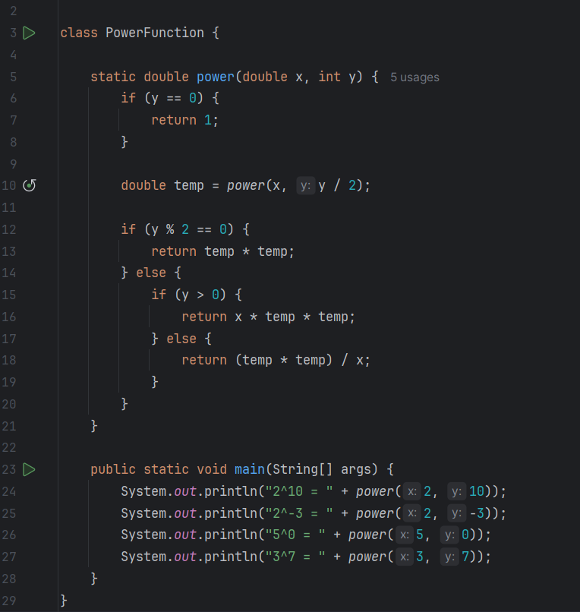

1. **Output:**

