**Experiment-1.3**

Student Name: Nagesh Kumar UID: 23BCS10599

Branch: B.E-C.S.E Section/Group: 23KRG-2A

Semester: 5th Date of Performance: 19/08/2025

Subject Name: DAA Subject Code: 23CSH-301

1. **Aim:**  Code to find frequency of elements in a given array in O(n) time complexity.
2. **Objective:** To find frequency of elements in a given array in O(n) time complexity.
3. **Input/Apparatus Used:**  In this program, HashMap concept is used in order to get less complexity.
4. **Procedure/Algorithm: Pseudocode:**

 Algorithm to find the frequency of each element of an array :

• Input the number of elements of an array.

• Input the array elements.

• Create another array to store the frequency of elements.

• Traverse the input array and update the count of the elements in the frequency array.

• Print the frequency array which displays the frequency of all the elements of the array.

Algorithm to find the frequency of each element of an array using hashing

• Input the number of elements of the array.

• Input the array elements.

• Create a hash table and update the element in one column and its frequency in the other column.

• Print the element along with its frequency.

**Algorithm :**

1.     Create an extra space of size n (hm), use it as a HashMap.

2.     Traverse the array from start to end.

3.     For every element update hm[array[i]-1], i.e. hm[array[i]-1]++

4.     Run a loop from 0 to n and print hm[array[i]-1] along with the index i

**Sample Input:**

1). arr[] = {10, 20, 20, 10, 10, 20, 5, 20}

2). arr[] = {10, 20, 20}

**Sample Output:**

1). 10   3

      20    4

      5      1

2). 10     1

      20     2

1. **Code:**

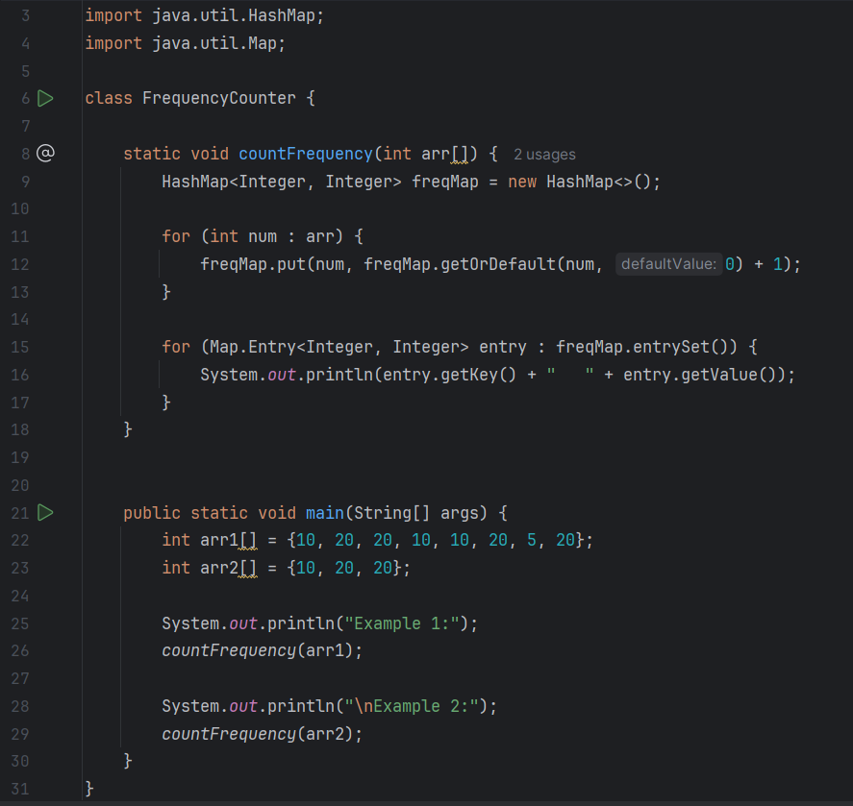

1. **Output:**

