**Experiment-1.4**

Student Name: Nagesh Kumar UID: 23BCS10608

Branch: B.E-C.S.E Section/Group: 23KRG-2A

Semester: 5th Date of Performance: 19/08/2025

Subject Name: DAA Subject Code: 23CSH-301

1. **Aim:**  Apply the concept of Linked list and write code to Insert and Delete an element at the beginning and atend in Doubly and Circular Linked List.
2. **Objective:** To understand doubly and circular linked list
3. **Input/Apparatus Used:**  Doubly and circular Linked List is used.
4. **Procedure/Algorithm: Pseudocode:**

**Procedure for beginning of circular linked list:**

Step1. Create the new node

Step2. Set the new node‟s next to itself (circular) Step3. If the list is empty,return new node.

Step4. Set our new node‟s next to the front. Step5. Set tail‟s next to our new node.

Step6. Return the end of the list.

**Procedure for end of circular linked list:**

Step1. Create the new node

Step2. Set the new node‟s next to itself (circular) Step3. If the list is empty,return new node.

Step4. Set our new node‟s next to the front. Step5. Set tail‟s next to our new node.

Step6. Return the end of the list.

1. **Code:**

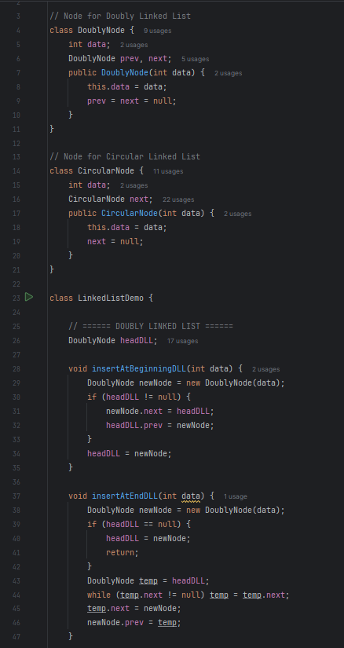

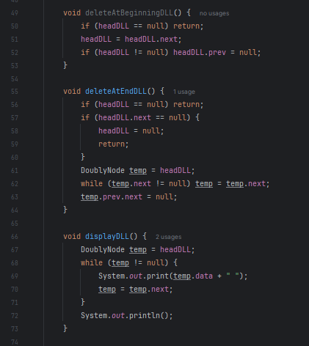

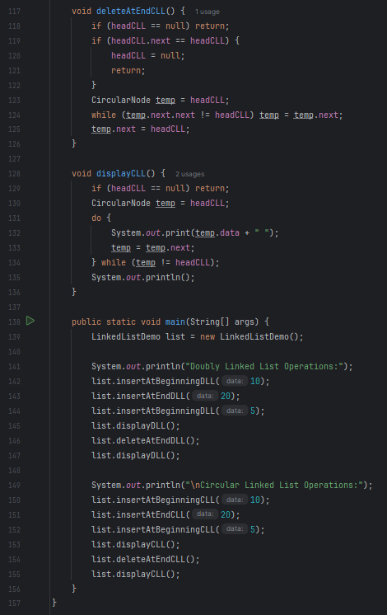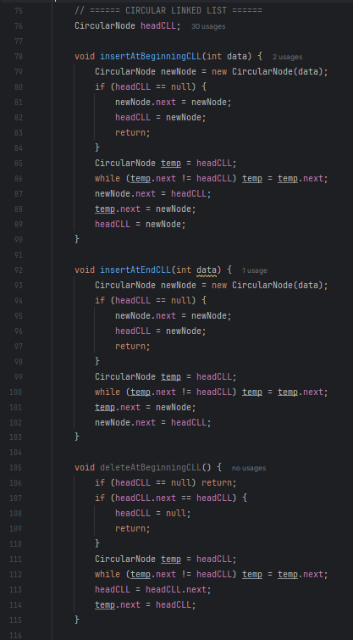

1. **Output:**

