Name : Kulkarni Pranjal

Roll No. 265

Practical No. 12

MOCROSOFT AZURE
Step 1: Open browser and search for “Microsoft Azure” and log in /Sign up
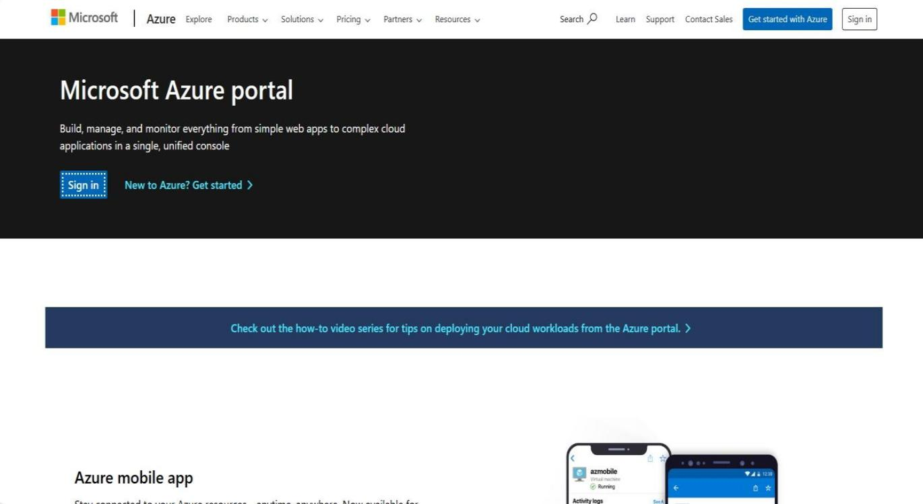

Step 2: Click on 3 lines on left corner of “Microsoft Azure” and then click on “Virtual Machine”.

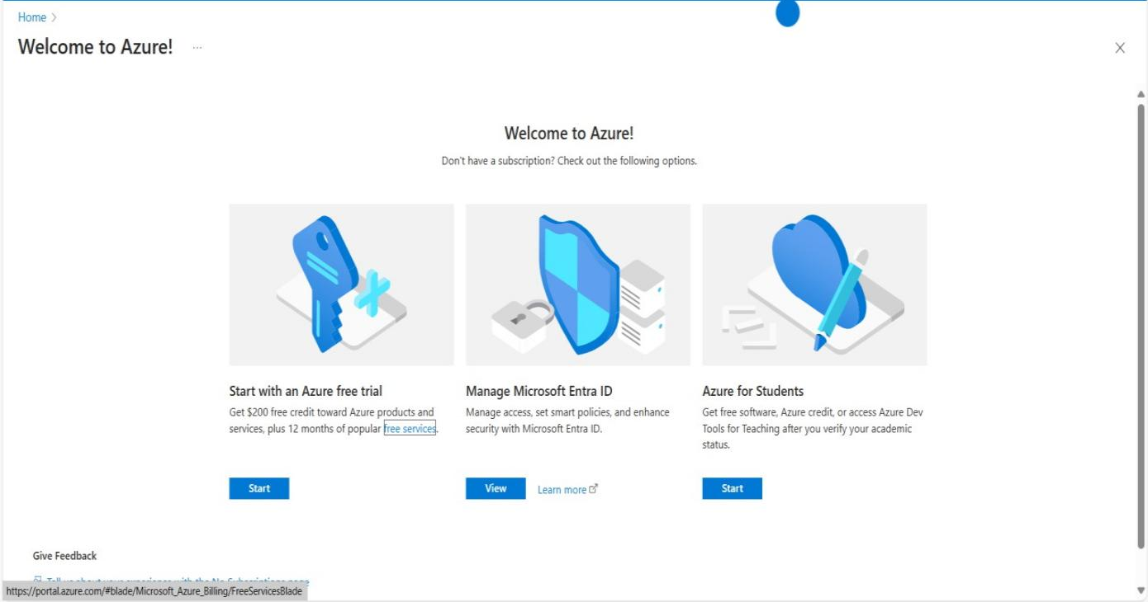
Step 3: And click on “Get Started”

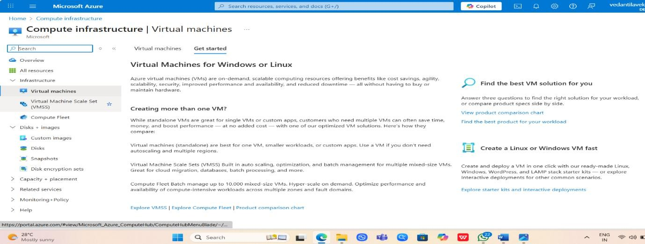

Step 4: Then Click on “Create a Standalone VM”

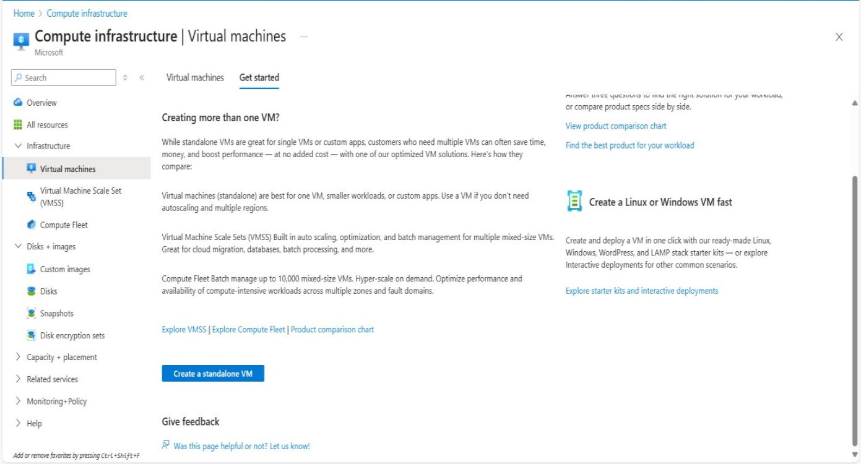
Step 5: Fill all the details required for creating Virtual machine.

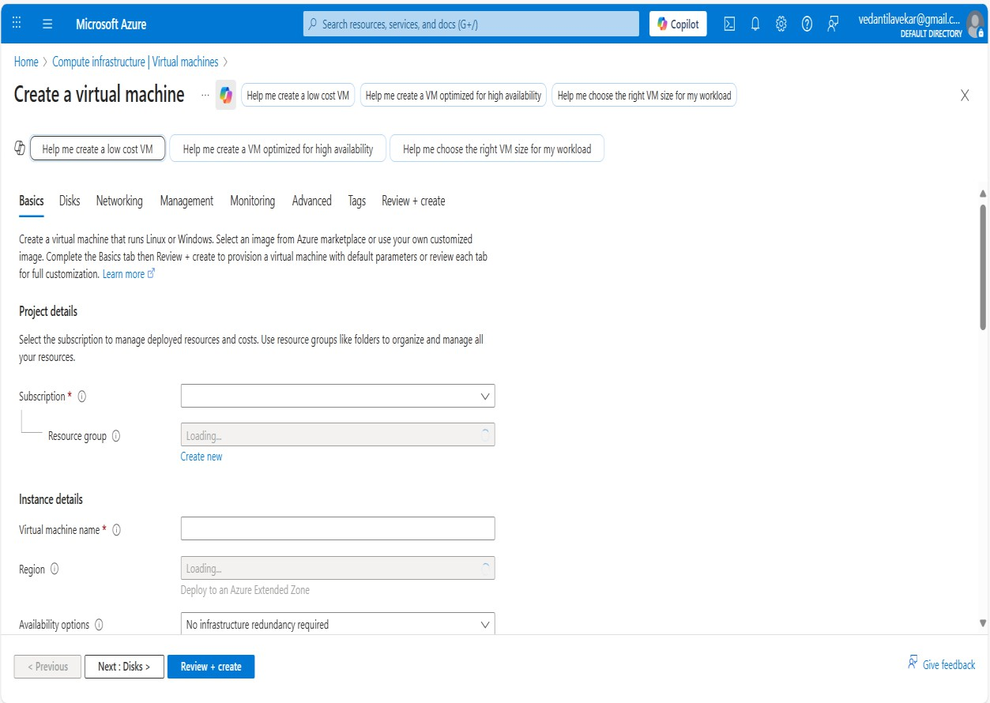
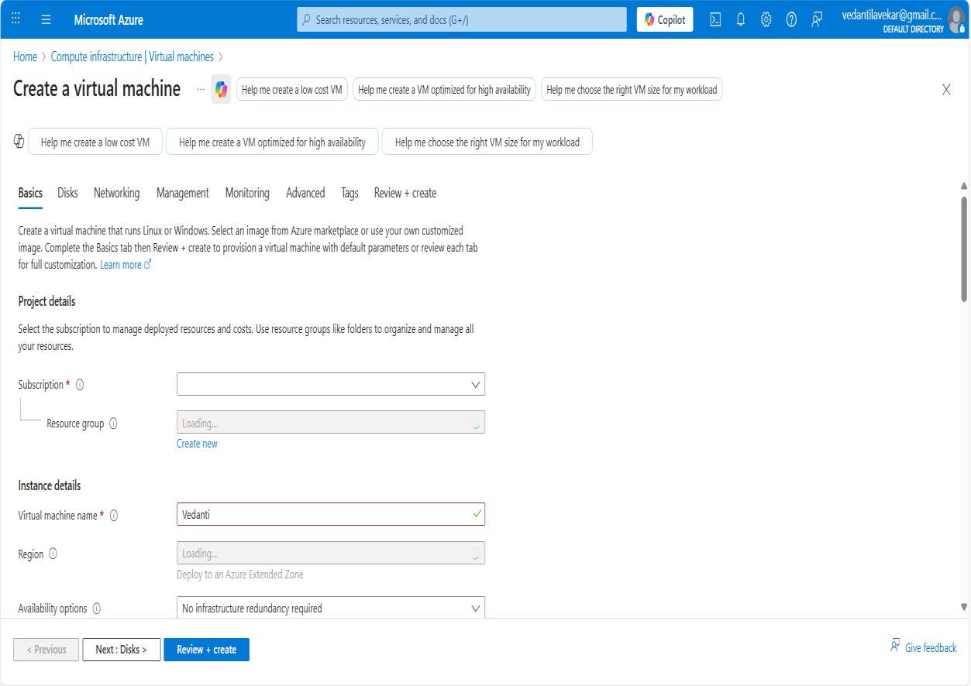

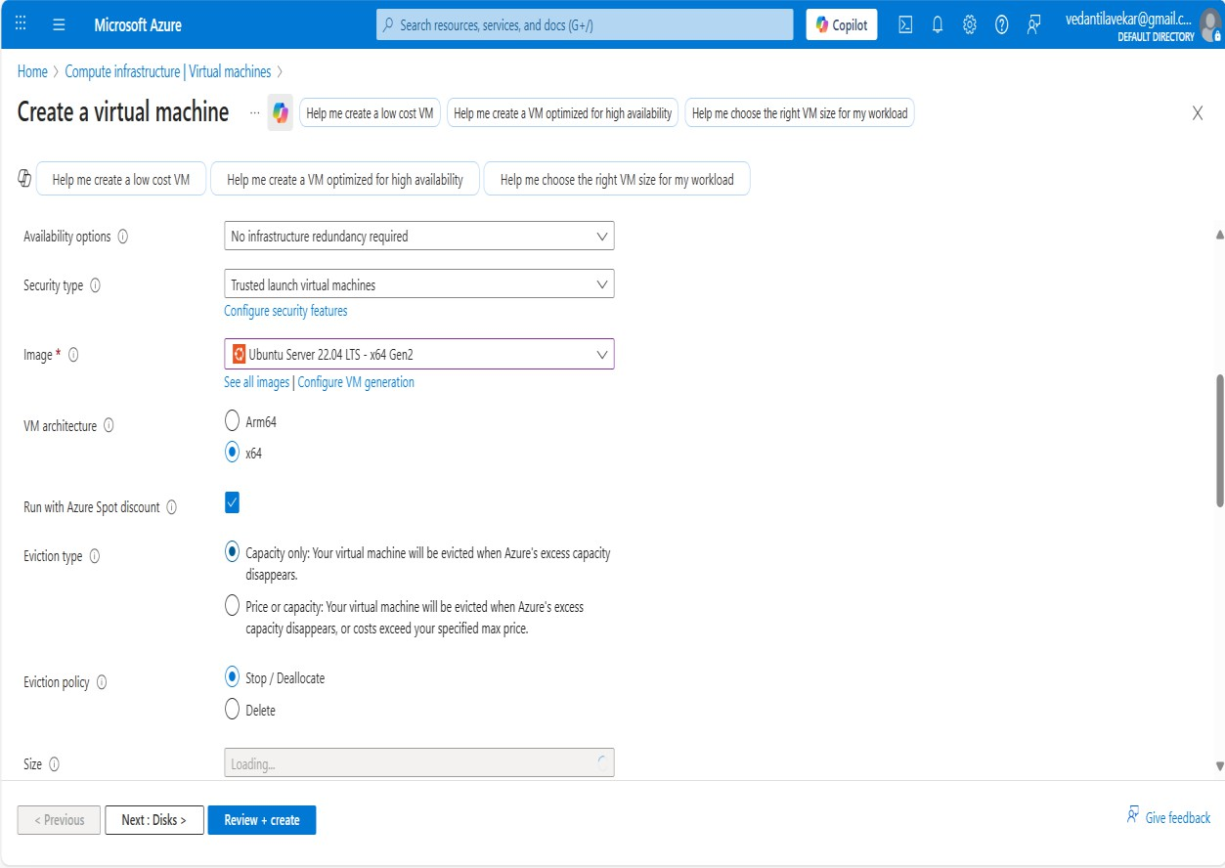

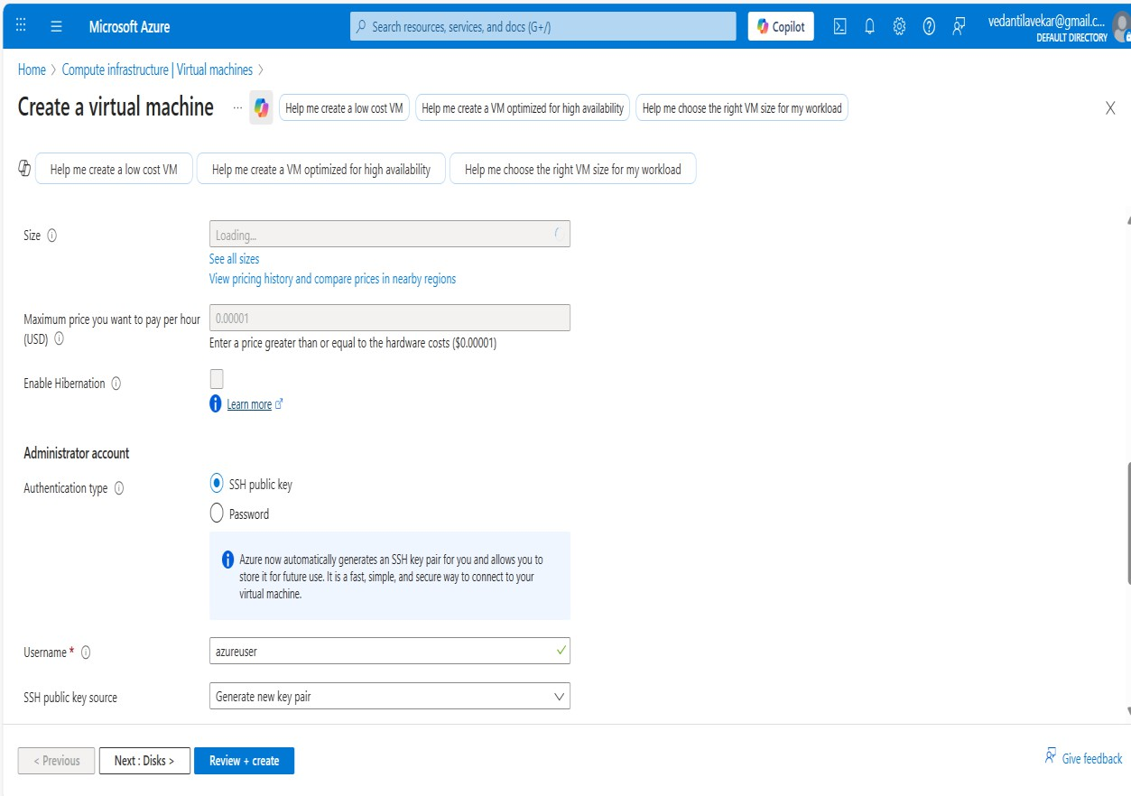
After Filling all the details click on “Review + Create”.

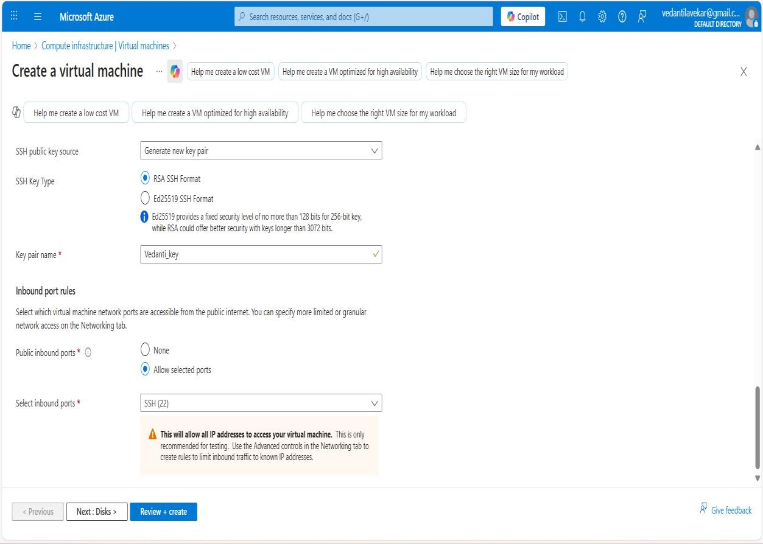

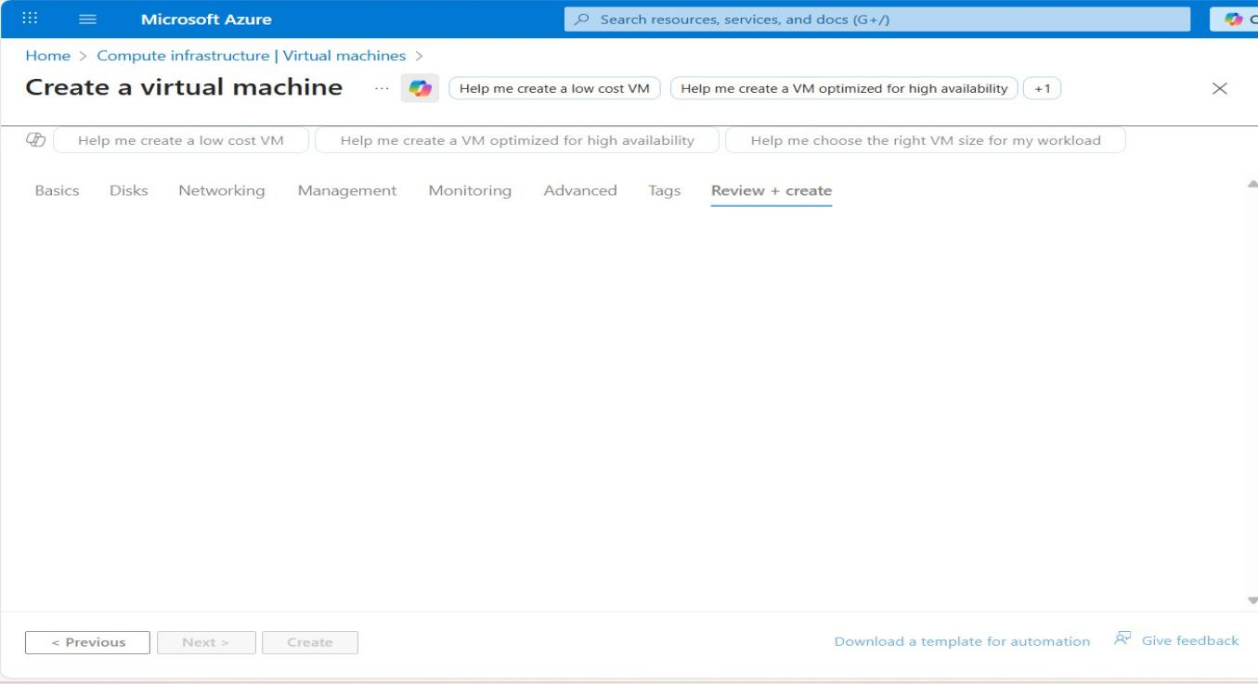

GOOGLE CLOUD
Step 1: Open Browser and search for https://cloud.google.com .Sign in and start free trial.

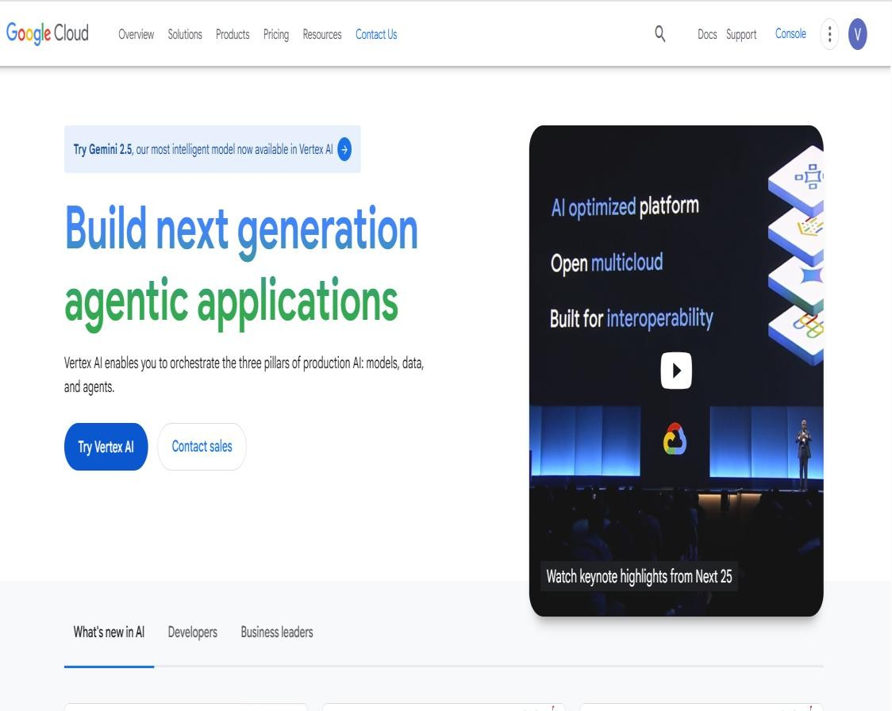
Step 2: Open Google Cloud Console and select Compute Engine.
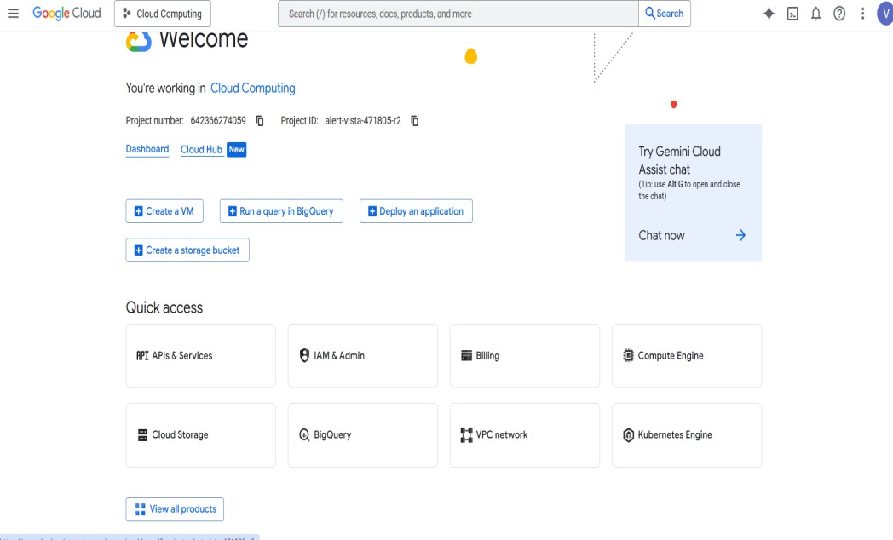

After selecting Compute Engine select VM instances
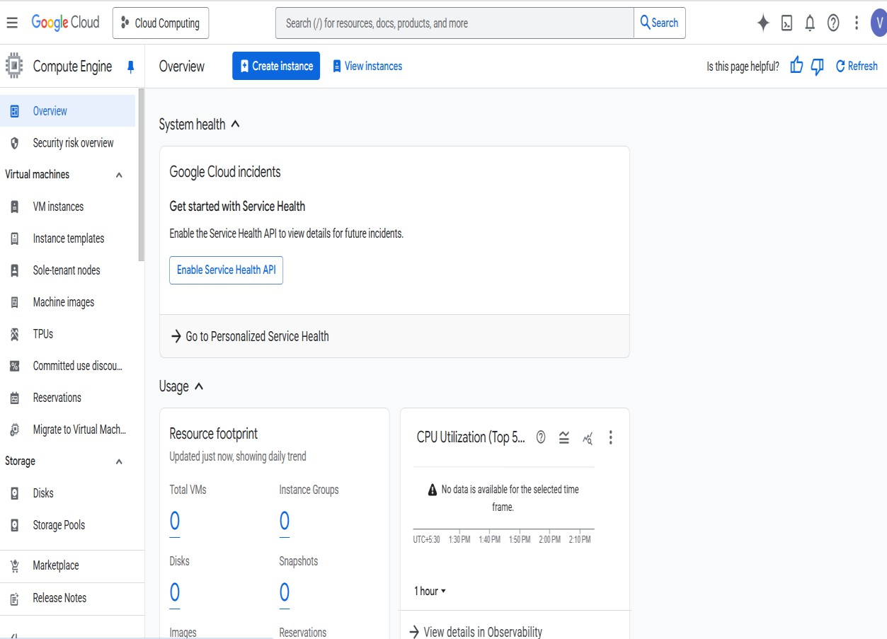
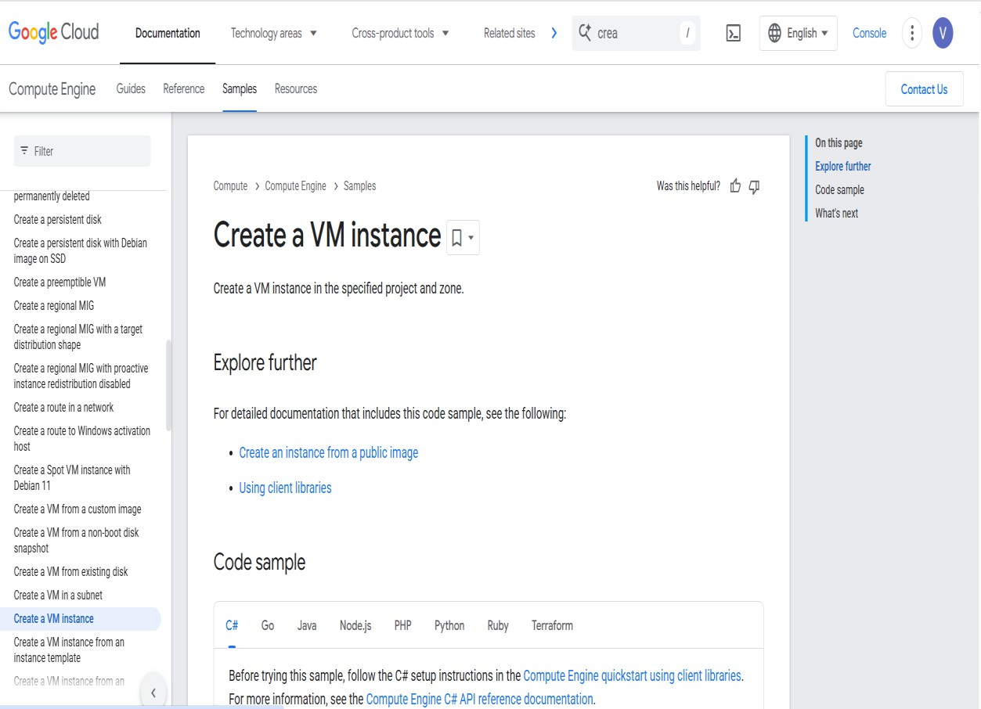

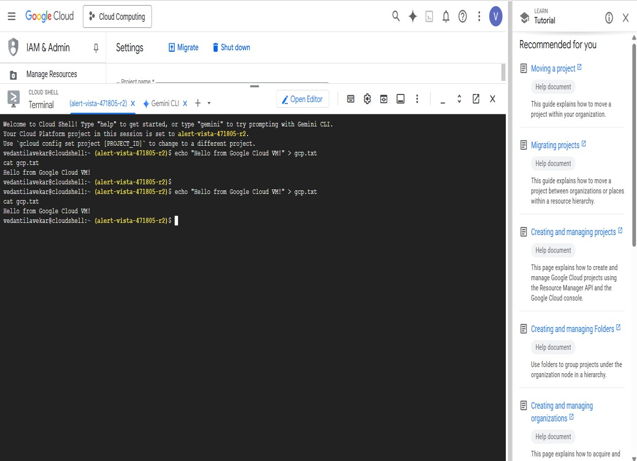

Amazon Web Service
Step 1: Open browser and search for aws.amazon.com.
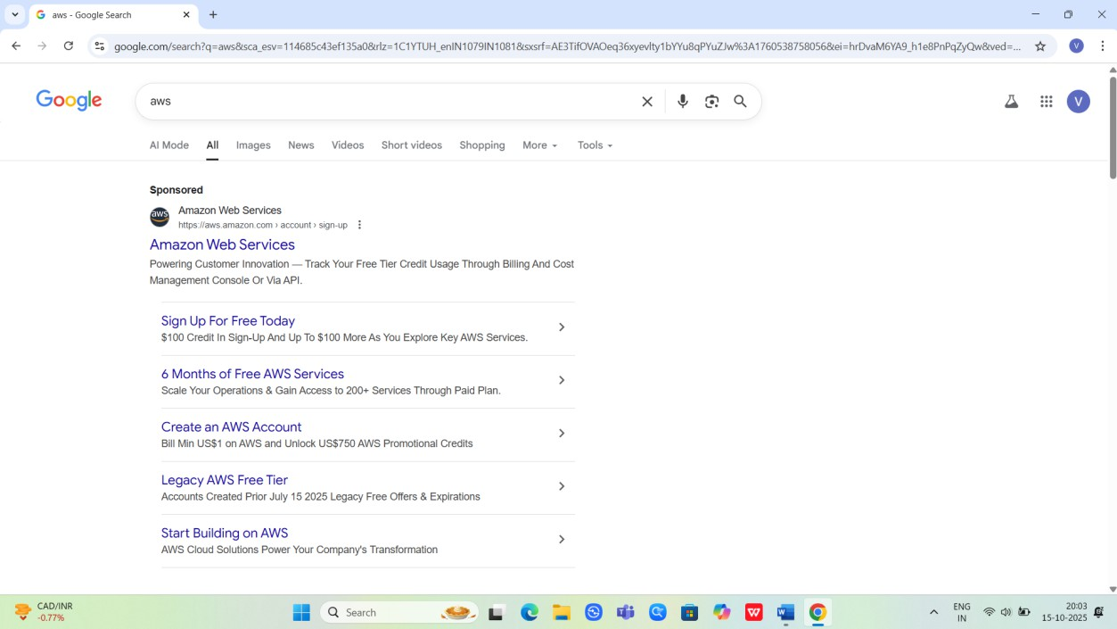
Step 2: Click on “Amazon Web Services.”

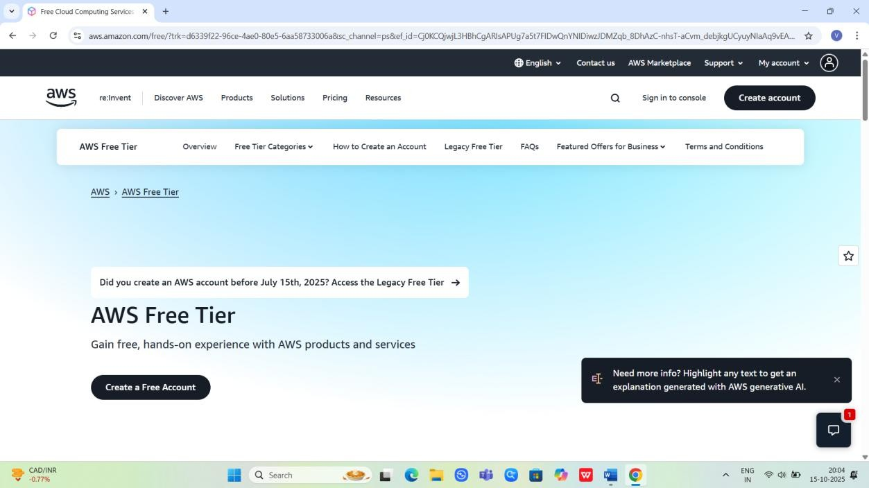
Step 3: Login and sign up
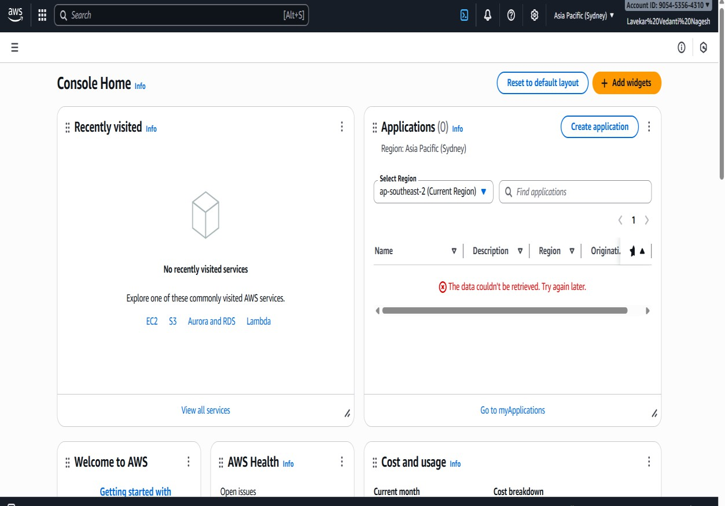
Step 4: Click on EC2 and Sign in using root user

