**Image Processing and Computer Vision- MATLAB**

**UE19CS333**

**6th Semester, Academic Year 2021-22**

Date: 29-01-2022

**Team : ASHWA**

|  |  |  |
| --- | --- | --- |
| **Name:**  LAKSHMI M A  NAGESH B S  ARCHIT RAJ  DEGALA GAGAN | **SRN:**  PES1UG20CS813  PES1UG20CS816  PES1UG19CS598  PES1UG19CS135 | **Section:**  I  C  B  C |

**ASSIGNMENT:1**

1. **Read an image (cm=imread(‘cameraman.tif’);) and display the image (figure; imshow(cm1);) and understand coordinate conventions**

>>cm1=imread('cameraman.tif');

>>figure(1);imshow(cm1);

>> r1=imread('rice.png');

>> figure(2);imshow(r1);

>>figure(1);imshow(cmf);hold on;title('cameraman.tif');

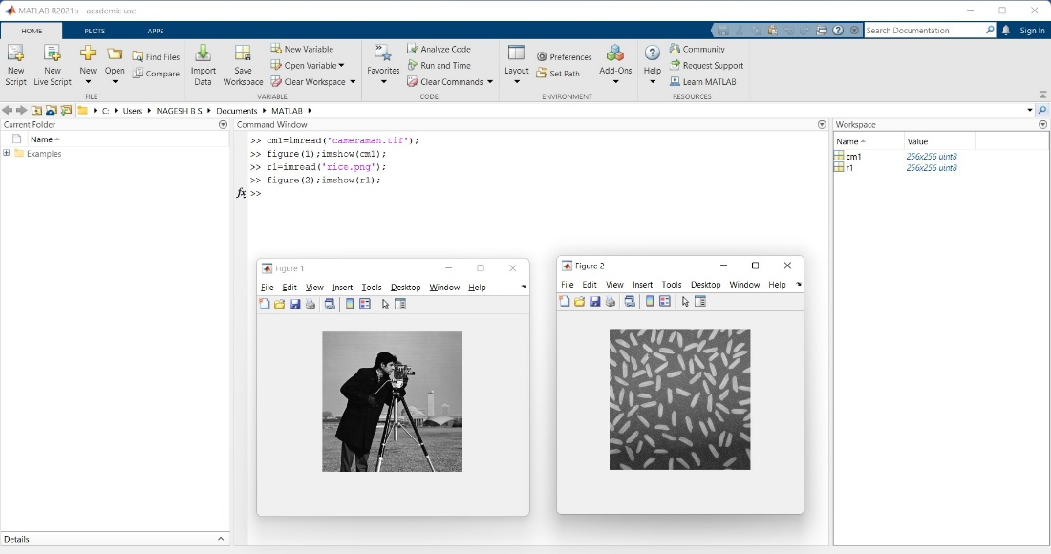

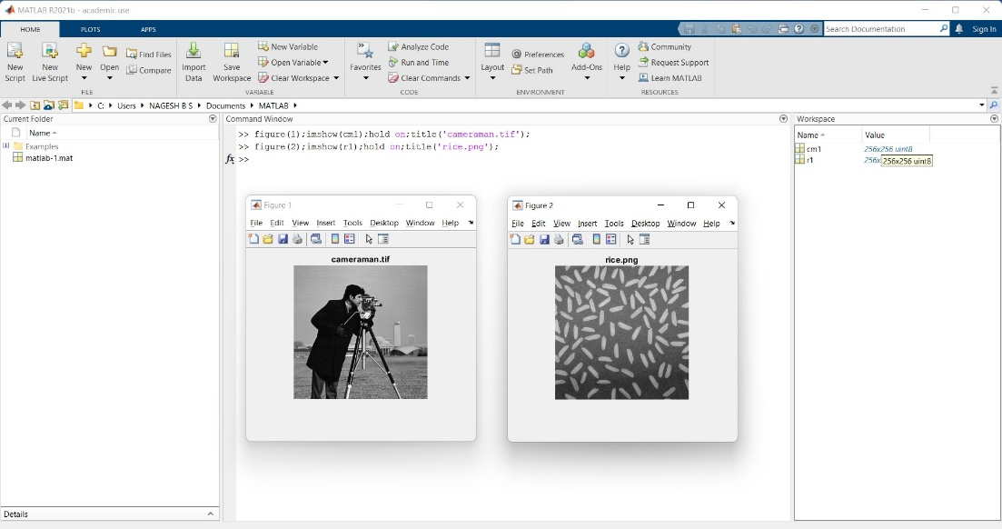

* 1. **What is the origin of the image?**

>>cmf(1,1)

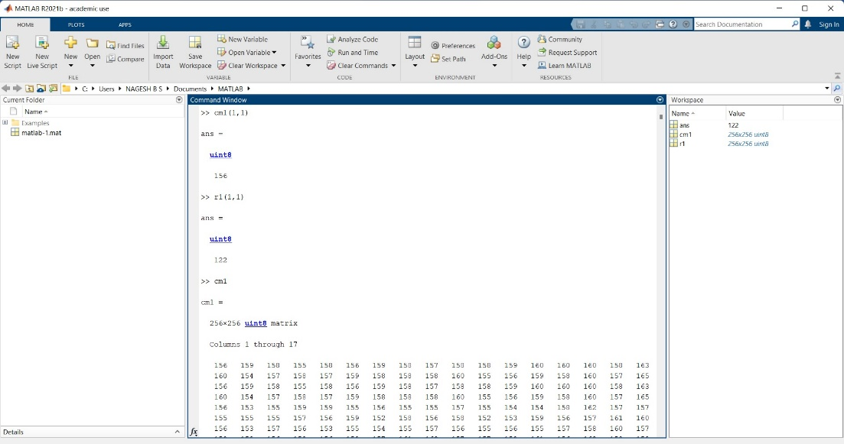

* 1. **What is the intensity value at the center of the image?**

>> cmf(end/2,end/2)

OR

>>a1=cmf(end/2,end/2);

>> figure(3);imshow(a1);

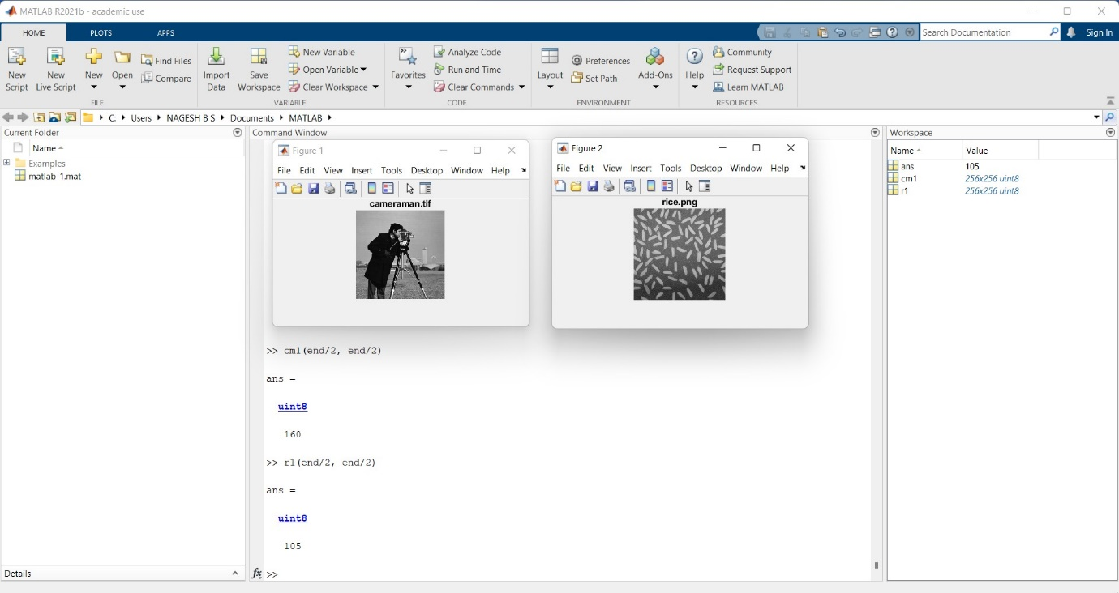

* 1. **accessing one row – 150**

**>>** onerow=cmf(150,:)

**>>** figure(3);plot(onerow,'b+'); hold on;title('row 150 of cameramam');

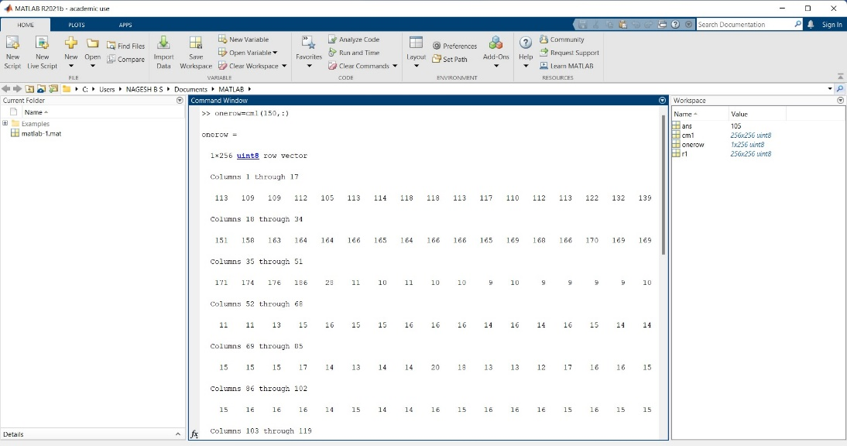

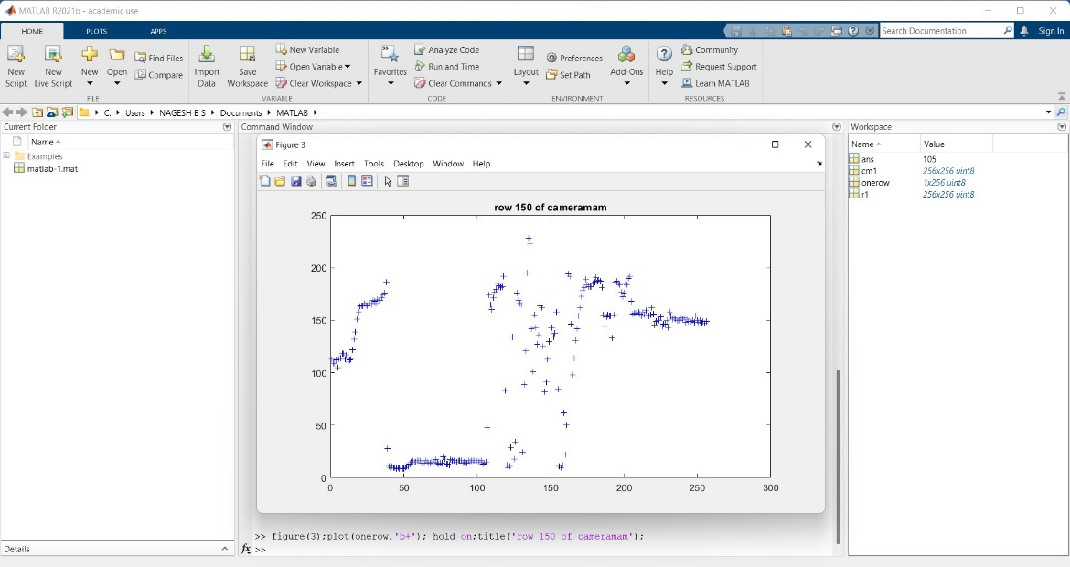

* 1. **accessing one column – 170**

>>oneColumn=cmf(:,170);

>>figure(4);plot(oneColumn,'b+');hold on;title('column 170 of cameraman');

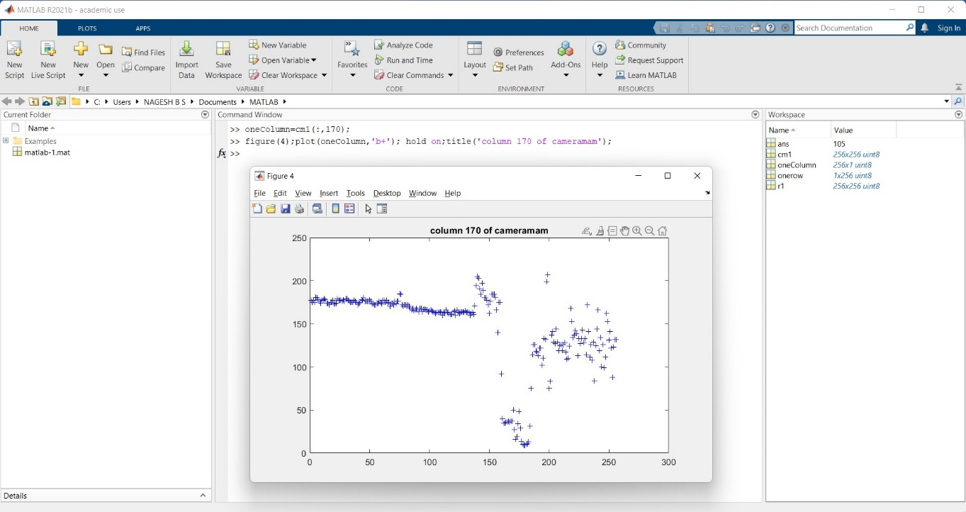

* 1. **accessing a subset of rows and columns (50x50 subimage from the center)**

**>>** cm2 = cm1((end/2)-25:(end/2)+24, (end/2)-25:(end/2)+24);

>> figure(4); imshow(cm2);

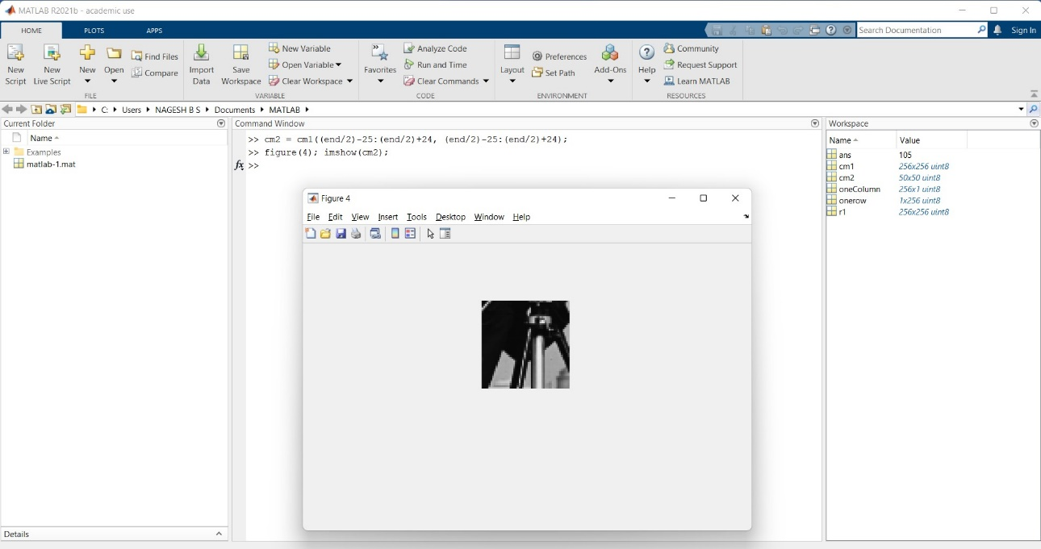

1. **What happens (a) when we multiply cameraman by 2 and (b) divide cameraman by 2?**

a) **when we multiply cameraman by 2?**

>> double=2.*cmf;

>> figure(6);imshow(double);

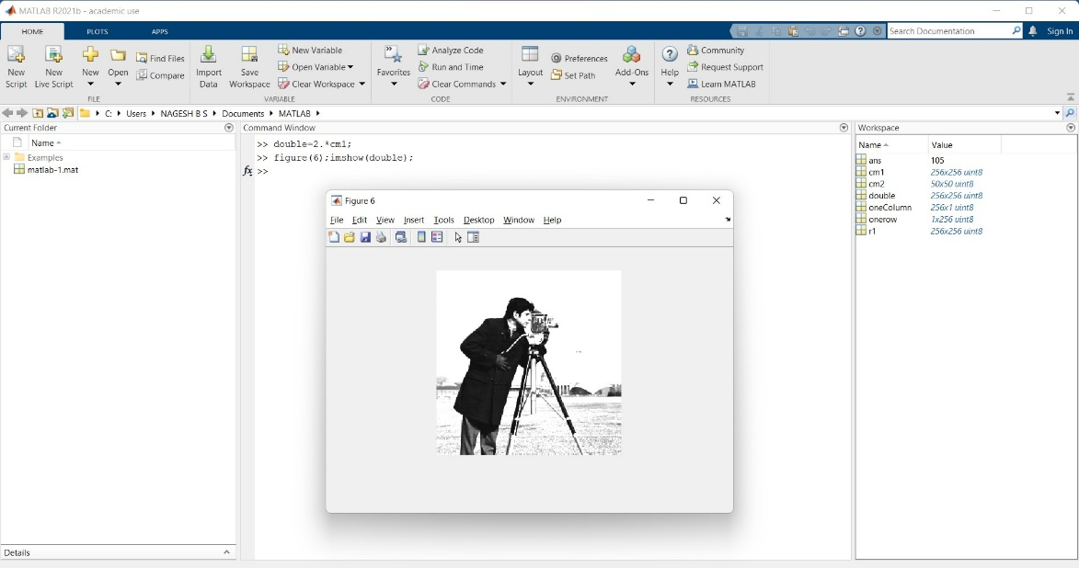

The image's brightness has increased, as can be seen. This effect can be noticed more clearly in the image's lighter areas. Because many pixels are clipped at 255, there is a lot of saturation evident.

b) **divide cameraman by 2?**

>> divide=cmf/2.;

>> figure(8);imshow(divide);

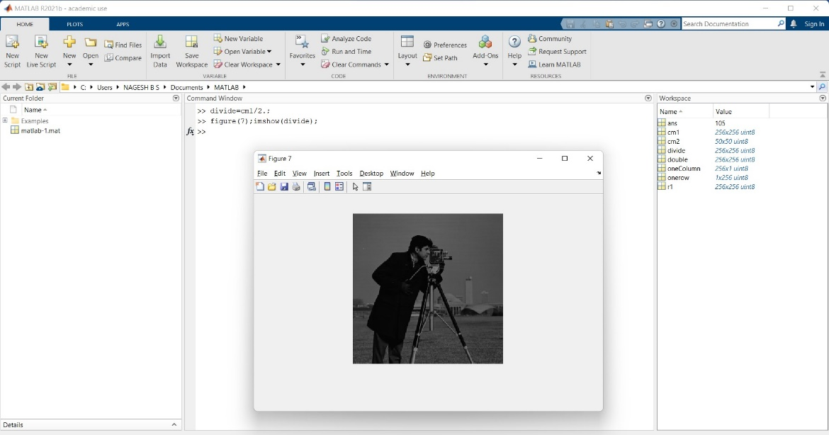

The image's brightness has diminished, as can be seen. Because there is a higher decrease in pixel values in the lighter regions of the original image, this impact is more noticeable.

1. **To the original cameraman image, what happens if we add rice.tif?**

>> cl=imread('cameraman.tif');

>>r2=imread('rice.png');

>> avgadcamrice=0.5.*cl+0.5.*r2;

>>figure(10);imshow(avgadcamrice);

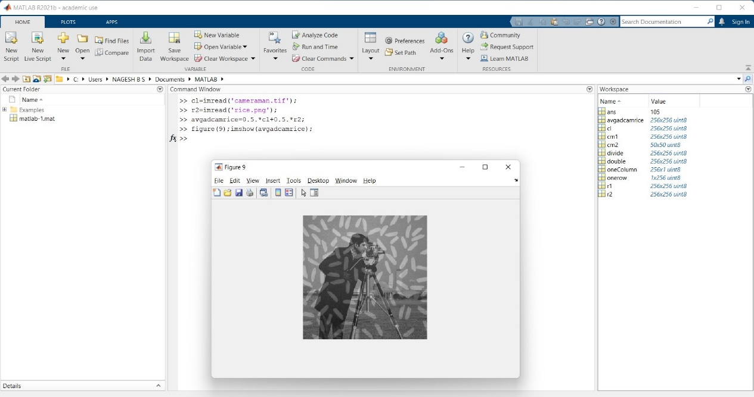

1. **What is the result of averaging cameraman and rice?**

>> avgaddriceandcm1 = 0.5.*cm1+0.5.*r1;

>> figure(7); imshow(avgaddriceandcm1);

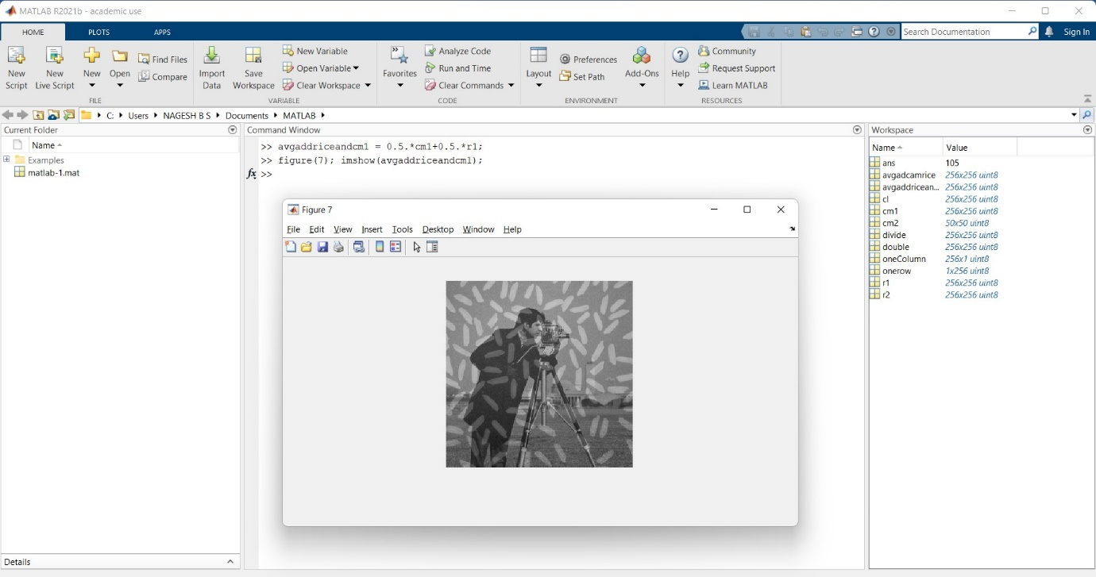

When the averages are computed, it appears that both photos are blended. No signs of saturation can be found. Due to their high pixel values, all of the rice grains are visible, but they appear dimmer. The dark background of the rice image has reduced the brightness of the cameraman image's background.

1. **What is the result of subtracting rice from cameraman?**

>> subriceandcm1 = cm1-r1;

>> figure(8); imshow(subriceandcm1);

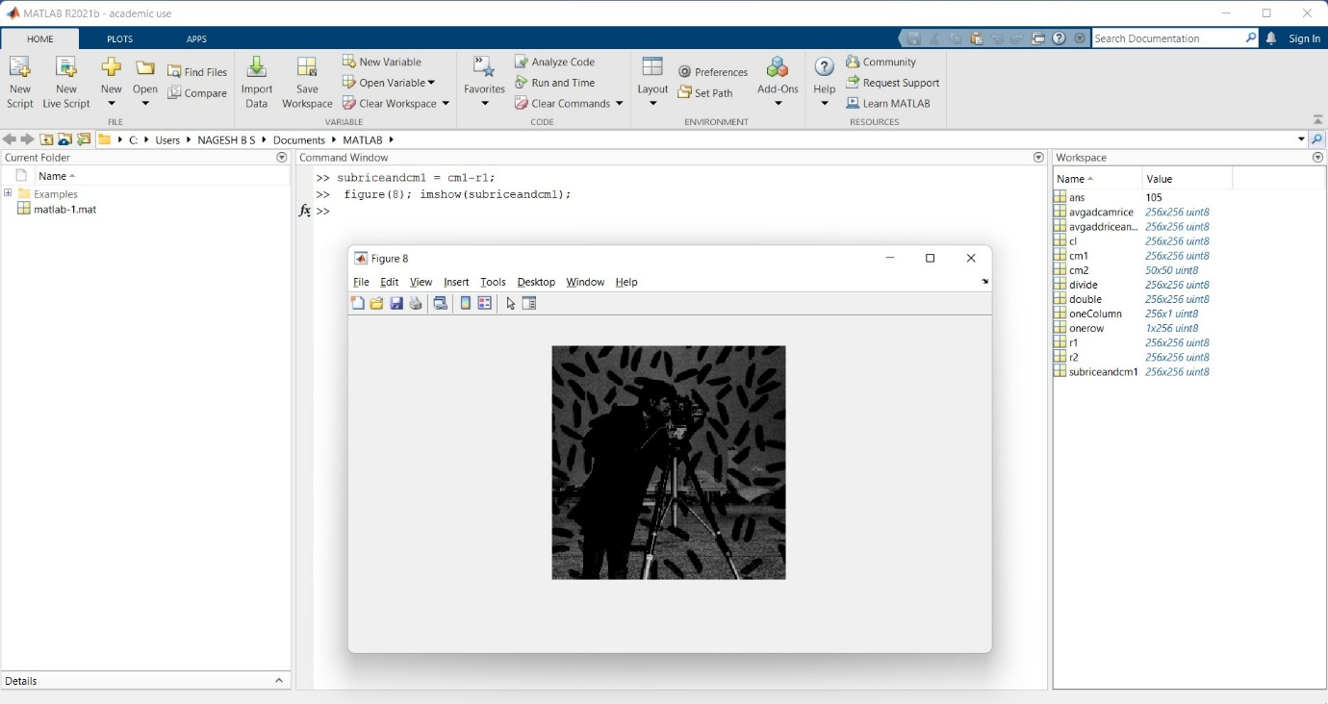

Adding the negative picture of rice to cameraman is the same thing. The rice grains in the original image with high pixel values darken out the region where they are located.

1. **What are the minimum and maximum intensity values in the resulting image above?** 
   1. **Where are they found?**

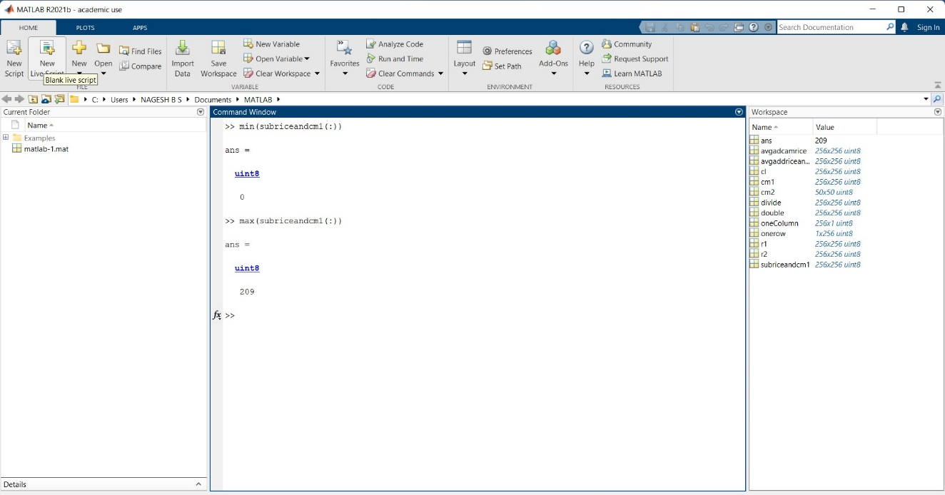

* 1. **Is the min(min(cameraman)) the same as minimum value of intensity found in cameraman?**

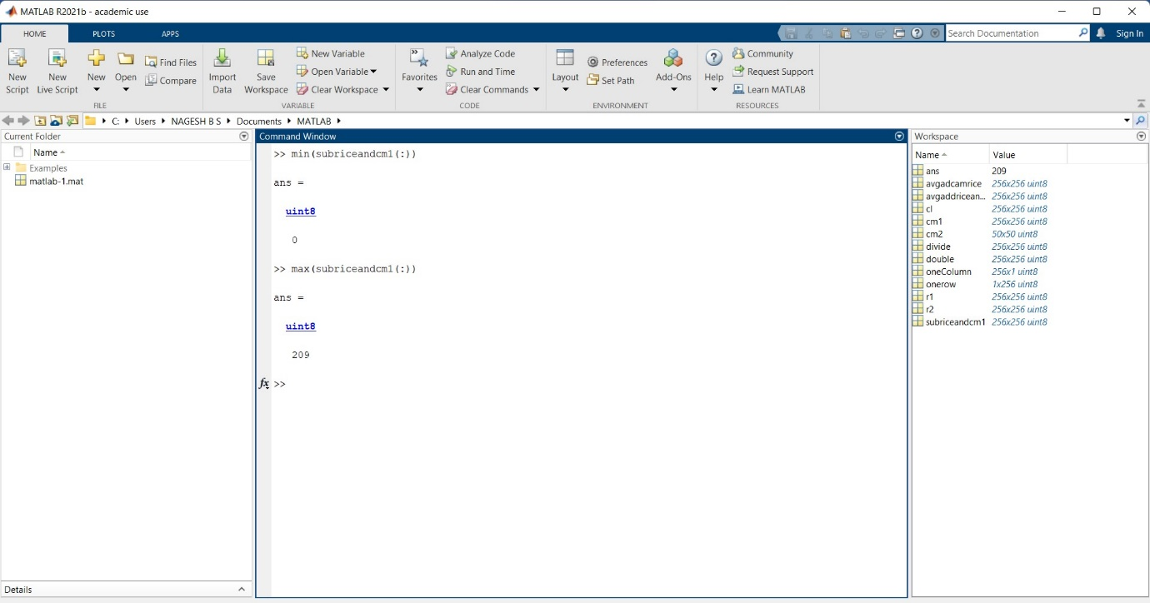

* 1. **How do you find the position of the minimum value in 2D array terms (row, column)?**
  2. **How do you find every instance of the minimum intensity value in the image?**

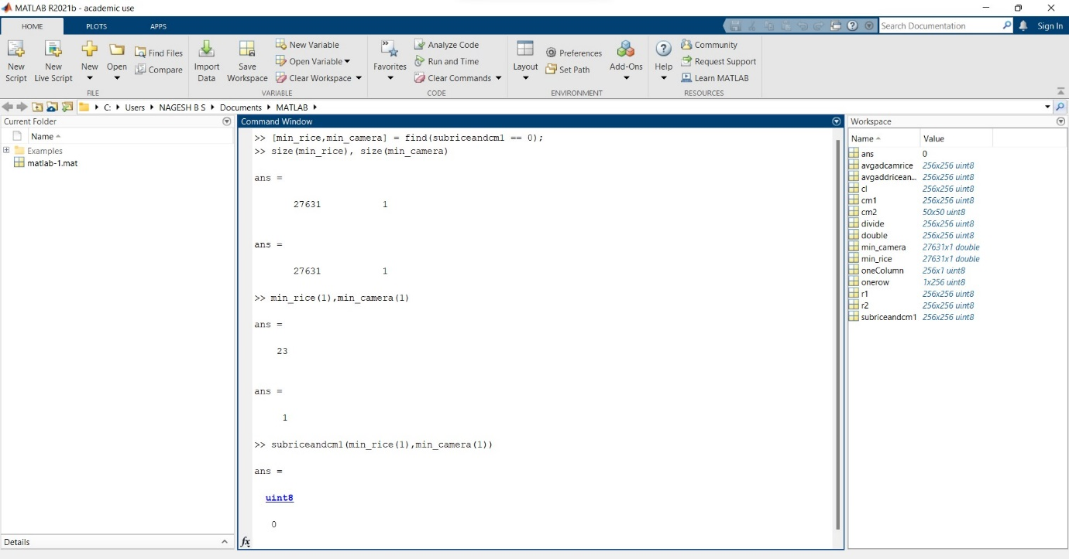

This process can be repeated for all the different coordinates that has been obtained.

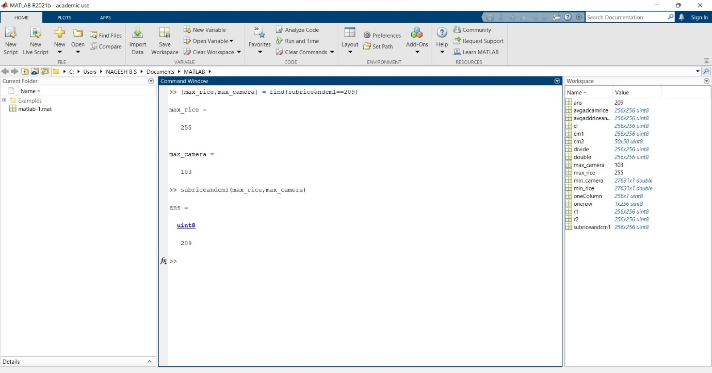

Maximum is also taken similarly and in this case only one occurrence of maximum value is found and that is at (255, 203).

1. **Reset the minimum to 0 and maximum to 255 in the resulting image in Question 4. What do you see now?**

>> avgaddriceandcm1(avgaddriceandcm1==min(avgaddriceandcm1(:)))=0;

>> avgaddriceandcm1(avgaddriceandcm1==max(avgaddriceandcm1(:)))=255;

>> figure(10); imshow(avgaddriceandcm1);

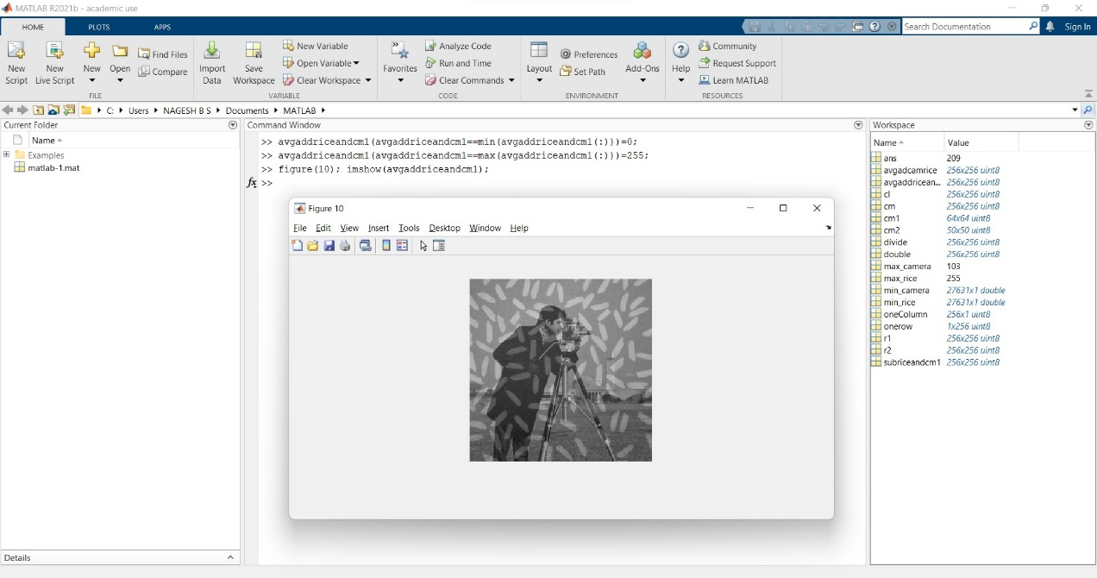

As we can see some pixels have become white as they have become max i.e. 255.

1. **Downsample cameraman by 2 – at what stage does it start to appear pixelated?**

>> cm = imread('cameraman.tif');

>> cm1 = cm(1:2:end, 1:2:end);

>> figure(9); imshow(cm1);

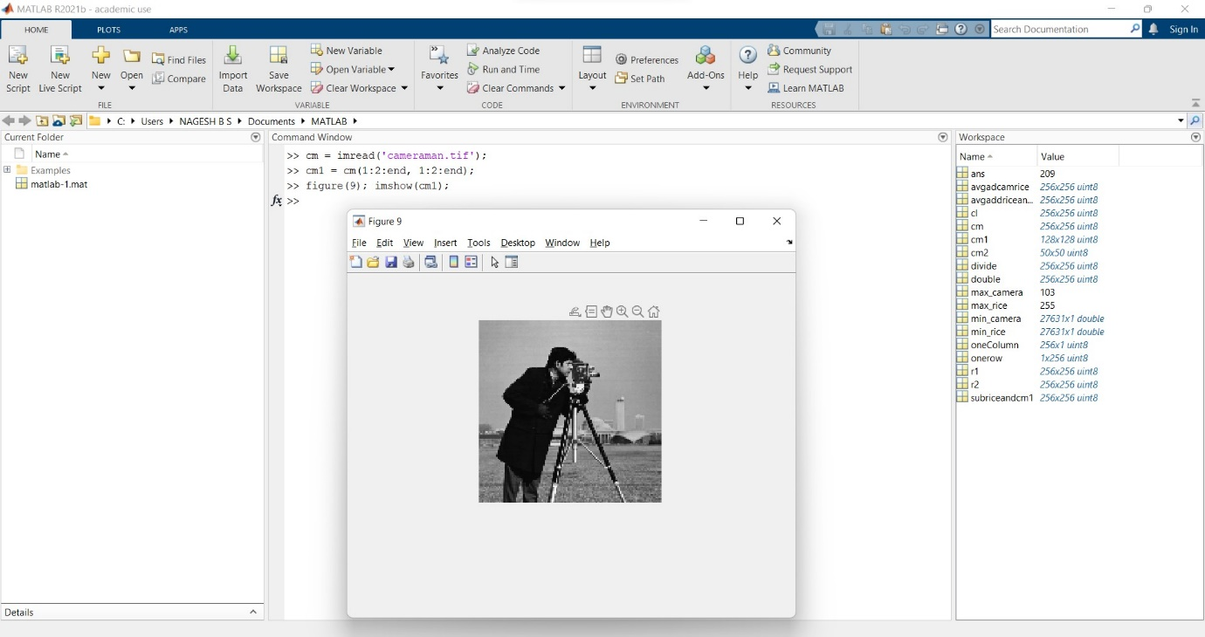

>> cm = imread('cameraman.tif');

>> cm1 = cm(1:4:end, 1:4:end);

>> figure(9); imshow(cm1);

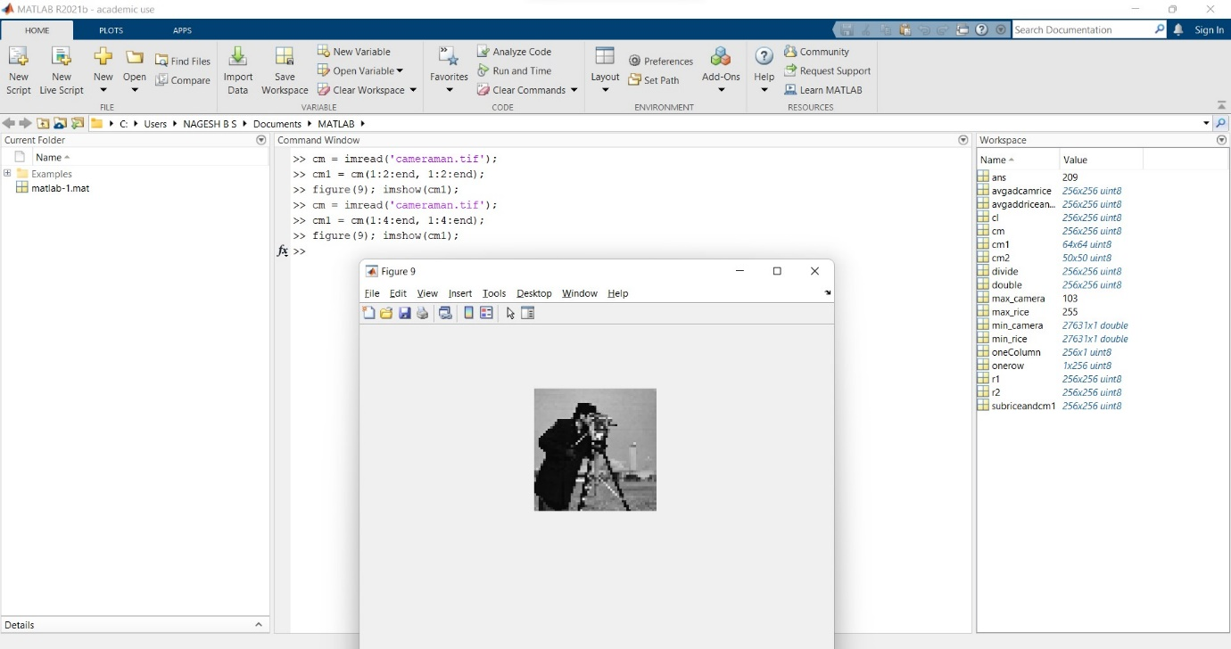

1. **Is there a way to get rid of the ‘jagged edges’ in Cameraman?**

>> cm = imread('cameraman.tif');

>> cm1 = cm(1:2:end, 1:2:end);

>> figure(9); imshow(cm1);

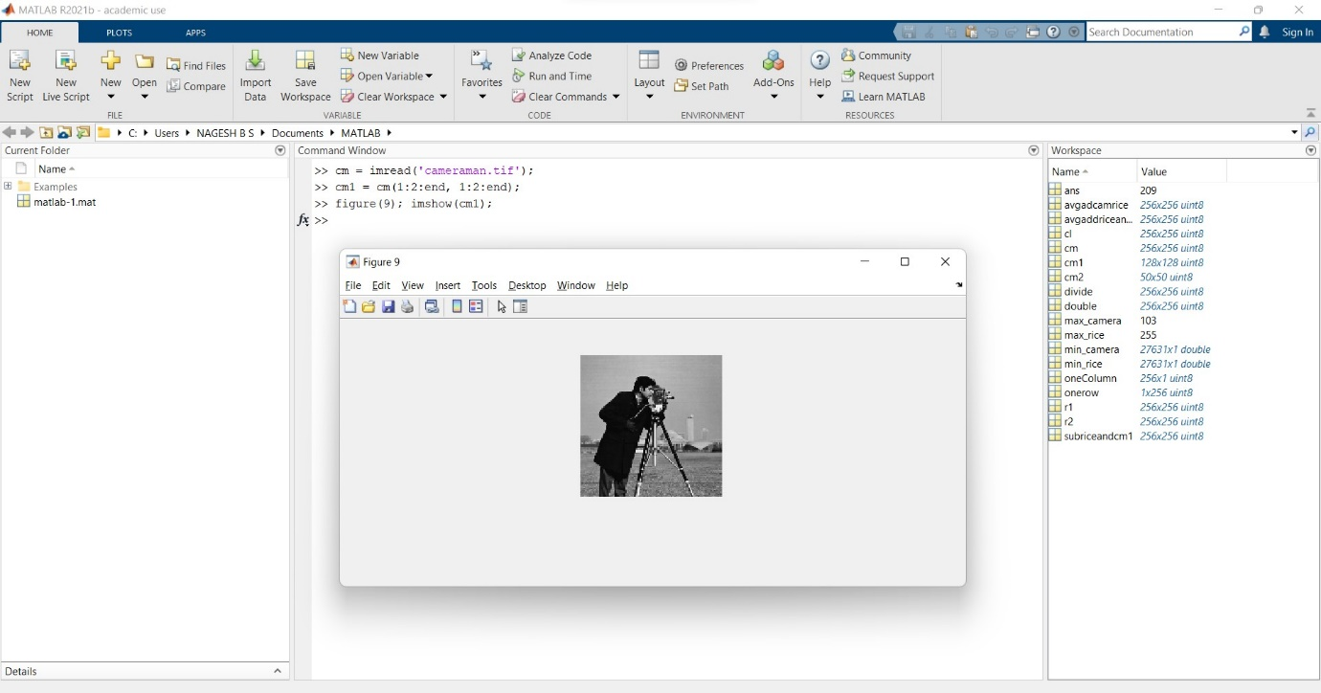

After downsampling the image, we may use interpolation to enlarge it (nearest neighbour, bilinear, bicubic). This, however, does not totally eliminate the rough edges. We can use the gaussian filter to smooth it out at this stage, but the image will be blurred. Another option is to blur the image first and then downscale it. We then use interpolation techniques to upscale it.

1. **To the original cameraman image, apply uniform quantization (set every two gray levels to one gray level) all the way from 8 bits to 1 bit.**

>> cm = imread('cameraman.tif');

>> quants = floor(0.5.*cm);

>> quants = (cm+1)/2-1;

>> quants64 = (quants+1)/2-1;

>> quants32 = (quants64+1)/2-1;

>> quants16 = (quants32+1)/2-1;

>> quants8 = (quants16+1)/2-1;

>> quants4 = (quants8+1)/2-1;

>> quants2 = (quants4+1)/2-1;

>> min(quants2(:))

>>max(quants2(:))

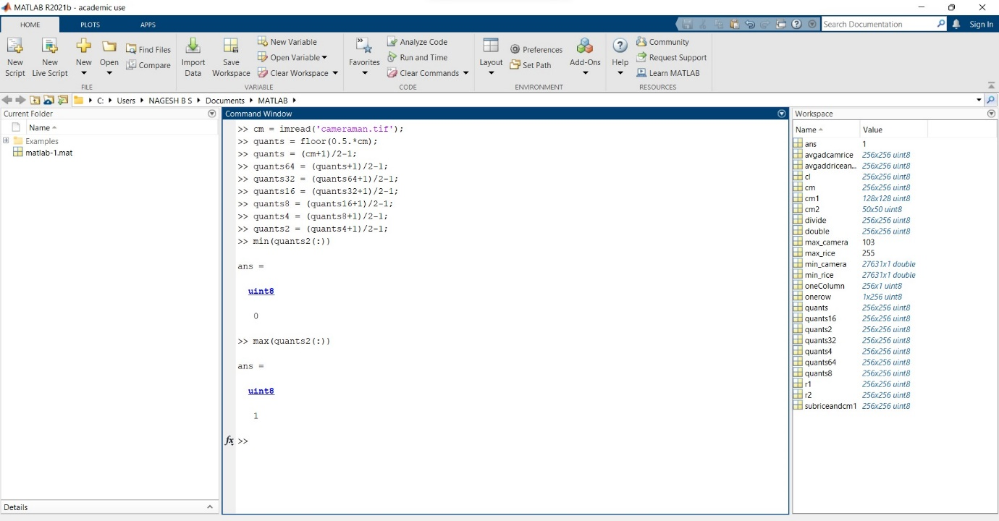

We have to reduce pixel value to their half progressively as shown in the fig.

Plotting the image in gray we get a black and white image

1. **What is the average intensity of the cameraman image? Apply a threshold to compute a binary image. Compare this image with the 1 bit representation in 10. (That is, find the ‘difference image’ and compute the sum of the difference.)**

>> cm = imread('cameraman.tif');

>> mean(cm(:))

>> cm_bin = (cm > (mean(cm(:))));

>> sum(quants2(:))

>> sum(cm_bin(:))

>> figure(1); imshow(cm_bin);

>> diff = imabsdiff(uint8(cm_bin), quants2); sum(diff(:))

>> imagesc(diff); colormap(gray);

>> figure(1); imshow(cm_bin);

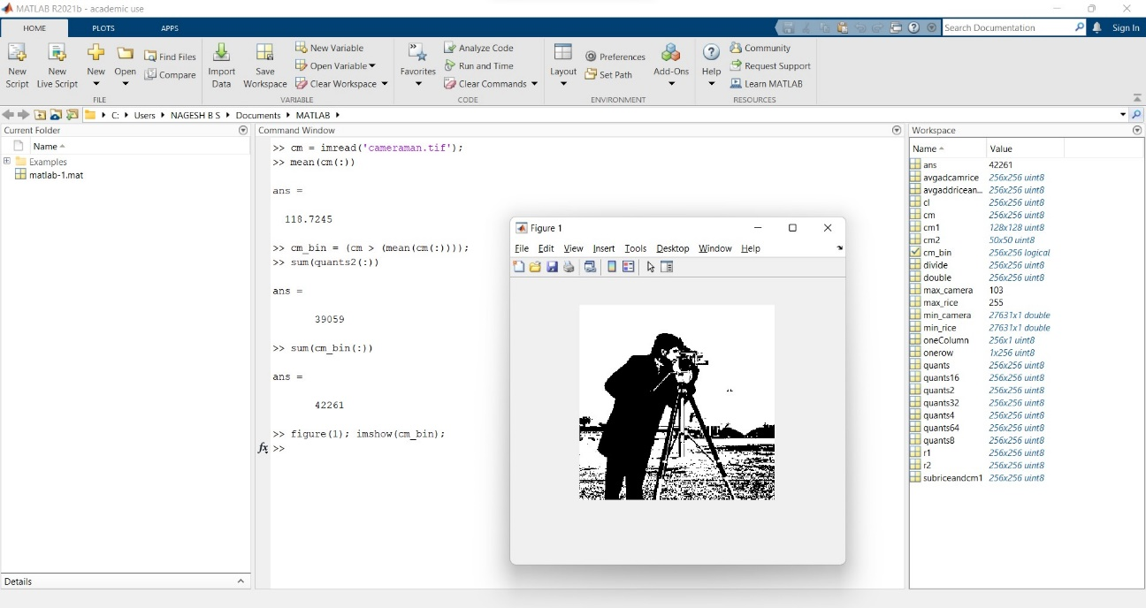

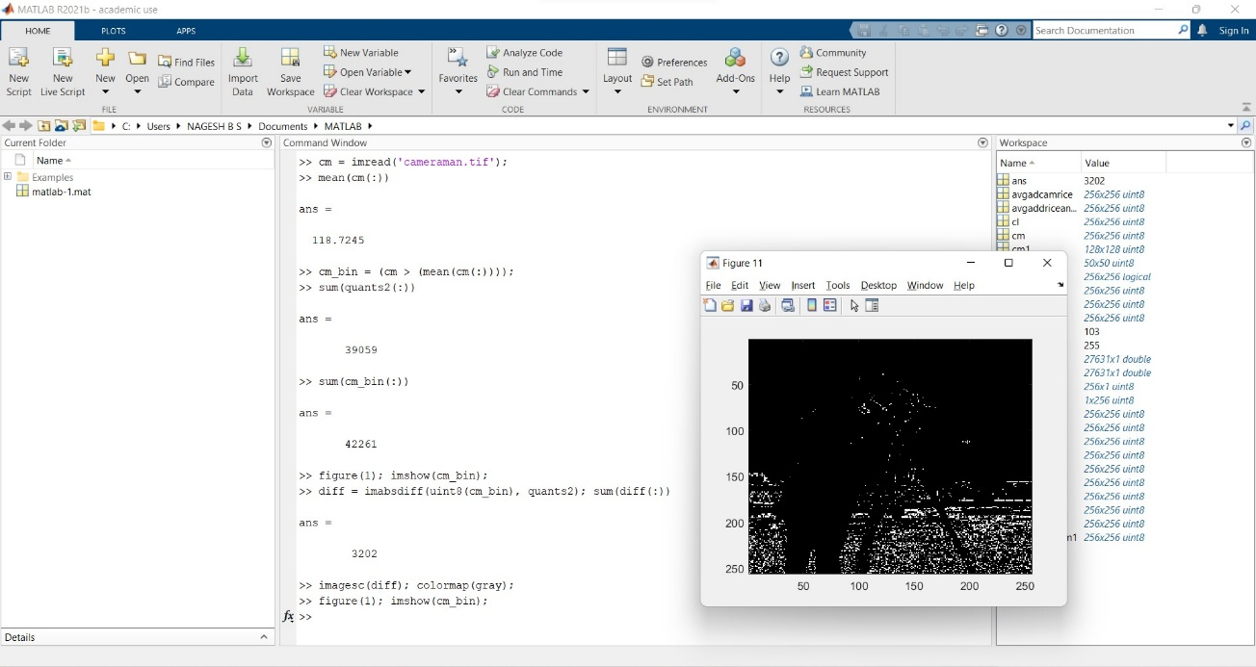

The cameraman image has an average intensity of 118.7245. The binary image, as can be seen, is nearly identical to the image in question 10, i.e., a black and white representation of the cameraman. The difference between the two, however, is still 3202, showing that the two are not the same, as the difference image shows.

1. **Use the binary of version of cameraman to select intensity values from the original image. What is the average of the gray level intensity values in this masked image?**

>> cmbinary=(cm1>119);

>>figure(13);imshow(cmbinary);

>>cmselect=cmbinary.*double(cm1);

>>mean(cmselect(:))

>>mean(cmselect(cmselect~=0))

