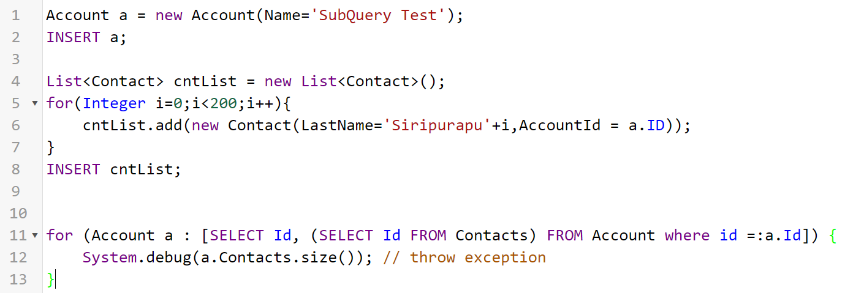



**Explanation**

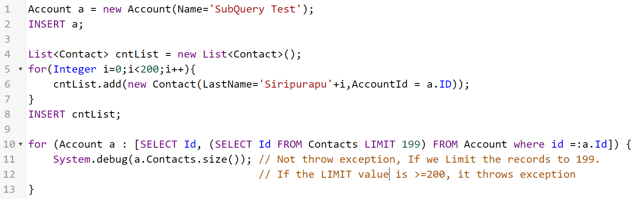

**Solution**

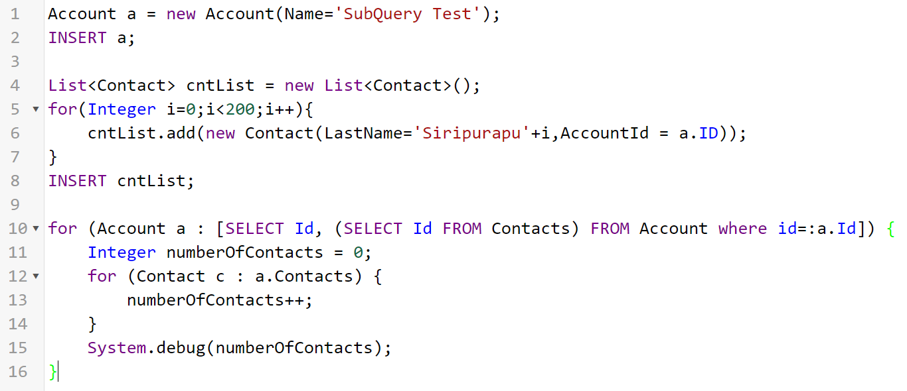

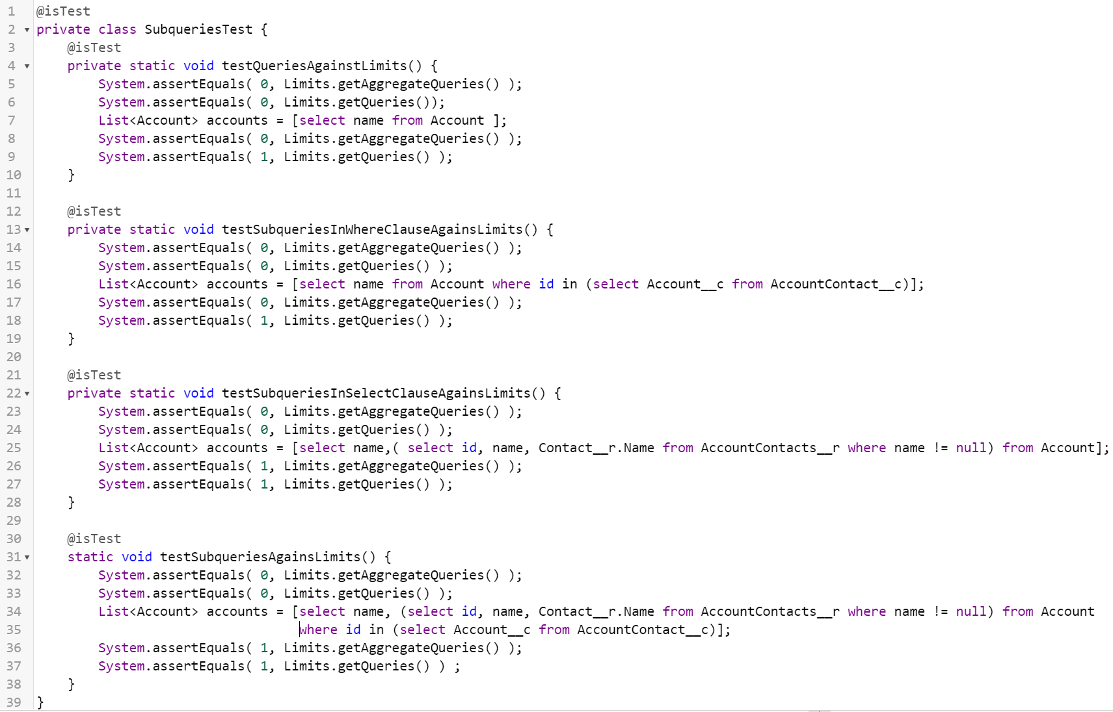

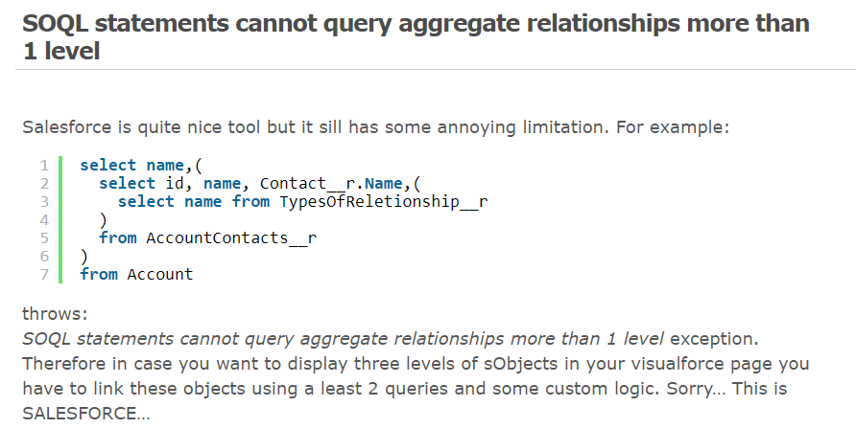

Aggregates are not allowed in sub-queries. Instead, you can aggregate the child records. Note that parents with no children will not include a row in the results.