1a) Explain
- Principle of Transmissibility of forces
- Principle of Superposition of forces
- Principle of Physical Independence of forces
Sol^{n}: i) This principle states that a force can be transmitted from one point to another point
along the same line of action such that the effect produced by the force on a body
remains unchanged.
Let us consider a rigid body subjected to a force of F at point O as shown in figure.
According to the principle of transmissibility, the force can be transmitted to a new
point O’ along the same line of action such that the net effect remains unchanged.
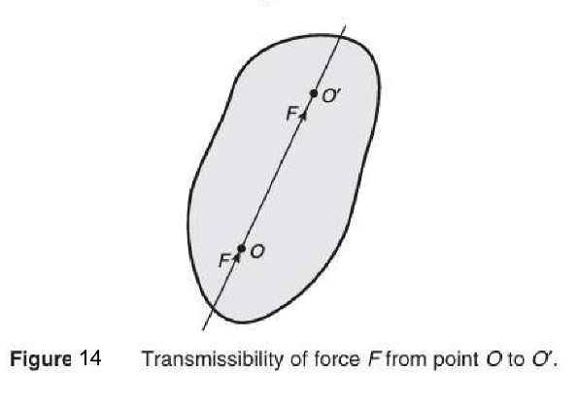
ii) The principle stateds that the net effect of a system of forces on a body is same as
that of the combined effect of individual forces on the body.
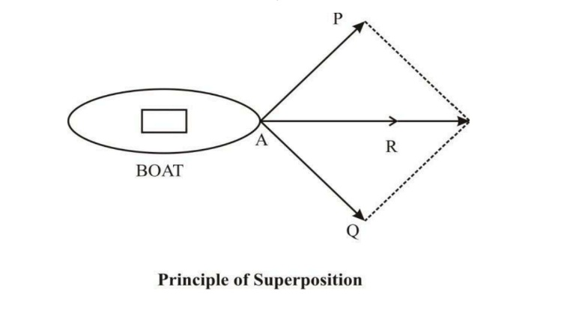
iii) This principle states that the action of a force on a body is not affected by the action
of any other force on the body.
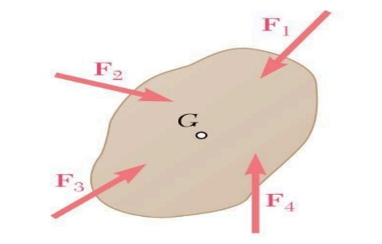

1b) Solve for the magnitude and direction of the force system shown in Fig 1(b)
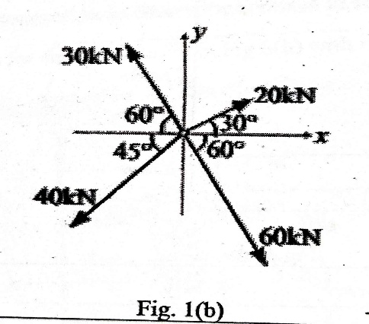
Sol^{n}:

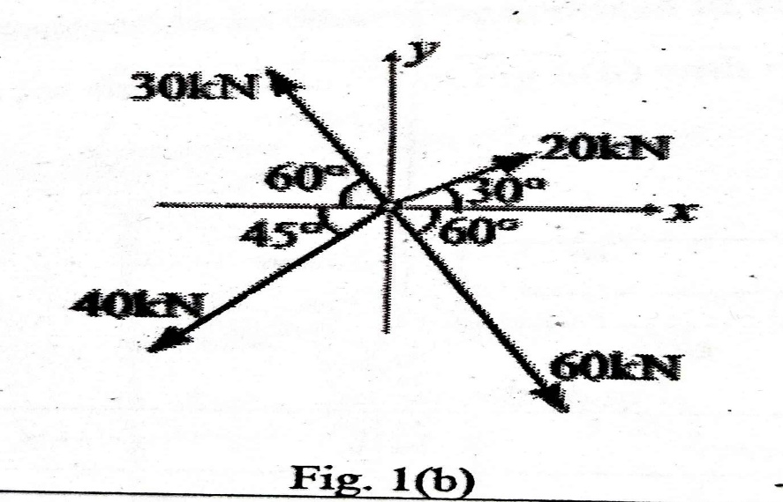
$\sum{f_{x}}$ = $20cos30+60cos60-30cos60-40cos45=4.036kN$
$\sum{f_{y}}$ = $20sin30-60sin60+30sin60-40sin45= -44.265kN$
We know that,
$$R= \sqrt{{\left(\sum{f_{x}}\right)}^{2}+{\left(\sum{f_{y}}\right)}^{2}}$$
$$R= \sqrt{{\left(4.036\right)}^{2}+{\left(-44.265\right)}^{2}}$$
$$R= 44.449kN$$
$$θ=\tan^{(-1)}\left(\frac{\sum{f_{y}}}{\sum{f_{x}}}\right)$$
$$θ=\tan^{(-1)}\left(\frac{-44.265}{4.036}\right)$$
$$θ=-84.79°$$

2a) Explain
- Coplanar concurrent force systems
- Non coplanar force system
- Like parallel force system
- Collinear force system
Sol^{n}: i) If two or more forces are acting in a single plane and their lines of action pass
through a single point, then it is said to be a coplanar concurrent force system.
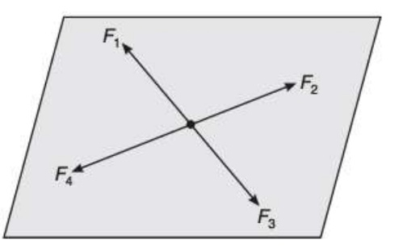
ii) If two or more forces are acting in different planes, the forces constitute a non –
coplanar force system.
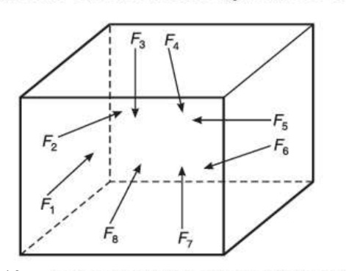

iii) All the forces act parallel to one another and are in the same direction.
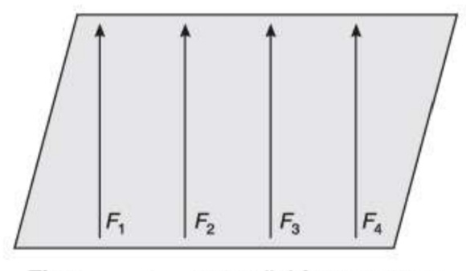
iv) If the lines of action of two or more forces coincide with one another, it is called a
collinear force system.
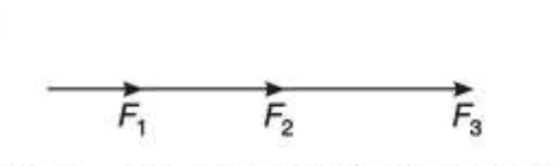

2b) Four forces acting on a hook are shown in Figure 2(b). Determine the direction of the force 125N such that the hook is pulled in the x – direction. Determine the resultant force in the x – direction.
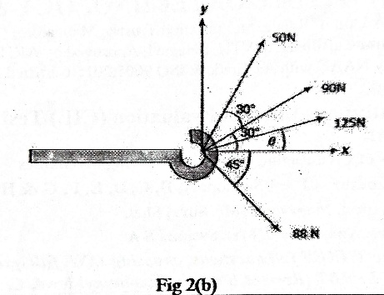
Sol^{n}:
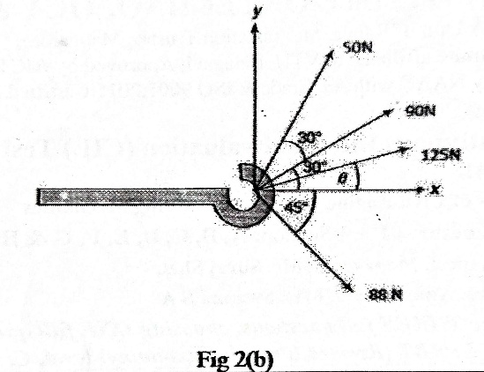
$\sum{f_{y}}$ is zero in this case because the entire resultant force is acting in x – direction not in y – direction, so we equate $\sum{f_{y}}$ as 0 we get θ, hence we can write the equation as,
$$\sum{f_{y}=90sin30+50sin60+125sinθ-88sin45 =0}$$
By re-arranging the equation to sinθ we get,
$$sinθ=\frac{88sin45-90sin30-50sin60}{125}$$
$$sinθ=-0.208$$
Now,
$$θ=\sin^{\left(-1\right)}(-0.208)$$
We get,
$$θ=-12.005°$$

Now take $\sum{f_{x}}$ as “R” (Resultant)
$$\sum{f_{x}=90cos30+50cos60+125cos⁡(-12.005)+88cos45 =R}$$
$$R=90cos30+50cos60+125cos⁡(-12.005)+88cos45$$
$$R=287.434N$$

3a) Explain
- Free body Diagram with a neat sketch
- Moment of a force
- Composition of forces
Sol^{n}: i) A free body diagram is a sketch of a body, a portion of a body, or two or more bodies
completely isolated or free from all other bodies, showing the forces exerted by all
other bodies on the one being considered.
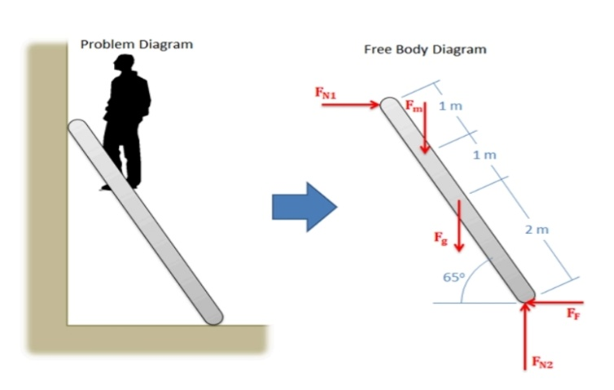
ii) Moment of force is the measure of the capacity or ability to the force to produce
twisting or turning effect about an axis. The axis is perpendicular to the plane
containing the line of action of the force. The magnitude of moment is equal to the
product of the force and the perpendicular distance from the axis to the line of action of
the force. The intersection of the plane and the axis is commonly called the moment
centre, and perpendicular distance from the moment centre to the line of action of the
force is called moment arm.
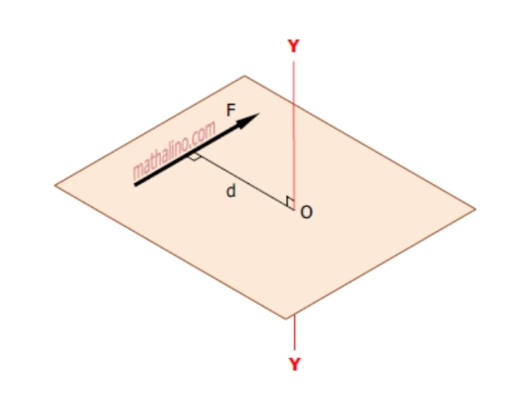
iii) It is the process of combining a number of forces into a single forces such that the net
effect produced by single force is equal to the algebraic sum of effects produced by
the individual forces.
$\sum{f_{x}}=algebraic sum of the components of the forces along the x-axis$
$\sum{f_{x}}=f_{4}+f_{1}cosθ_{1}-f_{3}sinθ_{2}$
$\sum{f_{y}}=algebraic sum of the components of the forces along the y-axis$
$\sum{f_{y}}={-f}_{2}-f_{1}sinθ_{1}-f_{3}cosθ_{2}$
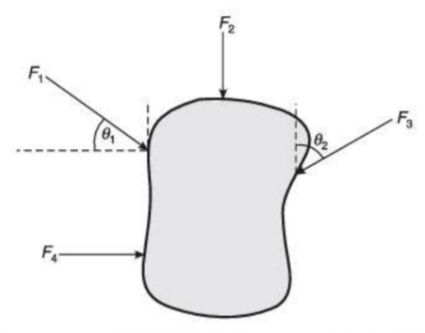
3b) Solve for the centroid for the area shown in the fig 3(b) with respect to the axis shown.
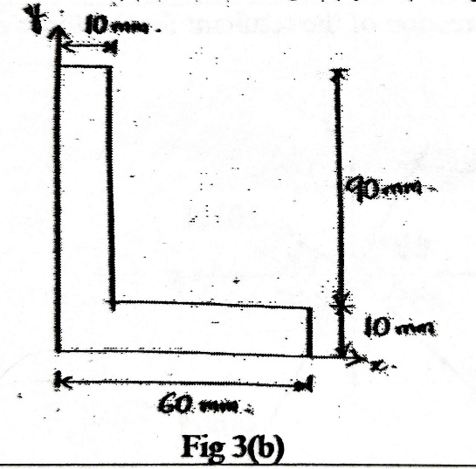
Sol^{n}:
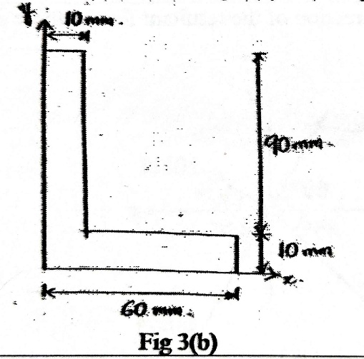
Components | Area  (mm²)  (A) | Centroidal Axis from y – axis  (mm)  (x) | Centroidal Axis from x – axis  (mm)  (y) | A.x  (mm³) | A.y  (mm³)
Rectangle 1 | $$10×90$$ | $$\frac{10}{2}$$ | $$\frac{90}{2}+10$$ | 4500 | 49500
Rectangle 2 | $$60×10$$ | $$\frac{60}{2}$$ | $$\frac{10}{2}$$ | 18000 | 3000
 | $$\sum{A=}1500$$ |  |  | $$\sum{A.x=22500}$$ | $$\sum{A.y=52500}$$
$$\overline{x}= \frac{\sum{A.x}}{\sum{A}}= \frac{22500}{1500}=15mm$$
$$\overline{y}= \frac{\sum{A.y}}{\sum{A}}= \frac{52500}{1500}=35mm$$
4a) Explain
- Characteristics of force
- Resolution of force
Sol^{n}: i) Characteristics of force are:
- Magnitude: The length of the vector represents the magnitude of force, as shon in figure.
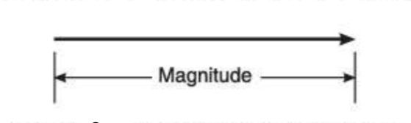
- Direction: the direction of a force can be represented by an arrow head.
- Line of action: It is the line along which force acts.
- Point of application: It is the point at which the force acts.
ii) The process of splitting of a force into its two rectangular components (horizontal and
vertical) is known as resolution of the forces, as shown in the Figure. In this figure, F is
the force which makes an angle θ with the horizontal axis, and has been resolved into
2 components, namely $F_{x}$ and $F_{y}$, along the x – axis and y – axis respectively.
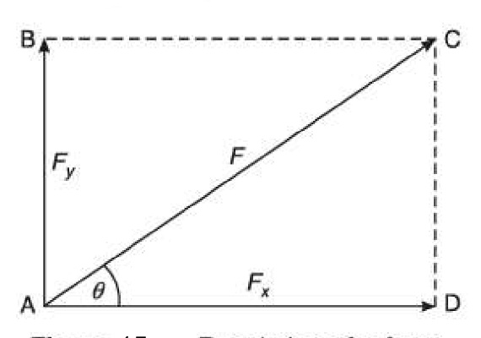
$cosθ=\frac{AD}{AC}⇒\frac{F_{X}}{F}⇒ F_{x}=Fcosθ$
$$sinθ=\frac{AB}{AC}⇒\frac{F_{y}}{F}⇒ F_{y}=Fsinθ$$
If, on the other hand, θ is the angle made by the force F with the vertical axis, then
$$F_{y}=Fcosθ; F_{x}=Fsinθ$$

4b) Solve for the centroid for the area shown in the figure 4(b) with respect to the centroidal axis.
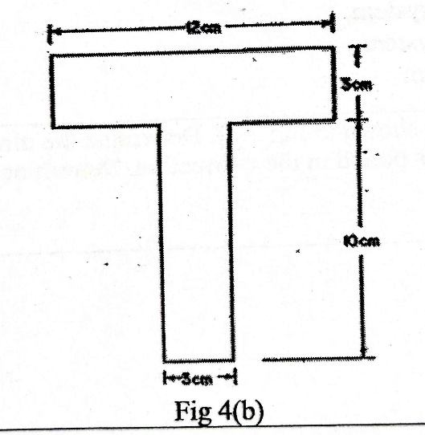

Sol^{n}:

Components | Area  (cm²)  (A) | Centroidal Axis from y – axis  (cm)  (x) | Centroidal Axis from x – axis  (cm)  (y) | A.x  (cm³) | A.y  (cm³)
Rectangle 1 | $$12×3$$ | $$\frac{12}{2}$$ | $$\frac{3}{2}+10$$ | 216 | 414
Rectangle 2 | $$10×3$$ | $$\frac{12}{2}$$ | $$\frac{10}{2}$$ | 180 | 150
 | $$\sum{A=}66$$ |  |  | $$\sum{A.x=396}$$ | $$\sum{A.y=564}$$

$$\overline{x}= \frac{\sum{A.x}}{\sum{A}}= \frac{396}{66}=6cm$$
$$\overline{y}= \frac{\sum{A.y}}{\sum{A}}= \frac{564}{66}=8.545cm$$

5a) Apply the method of integration to derive the centroid of semicircle.
Sol^{n}:
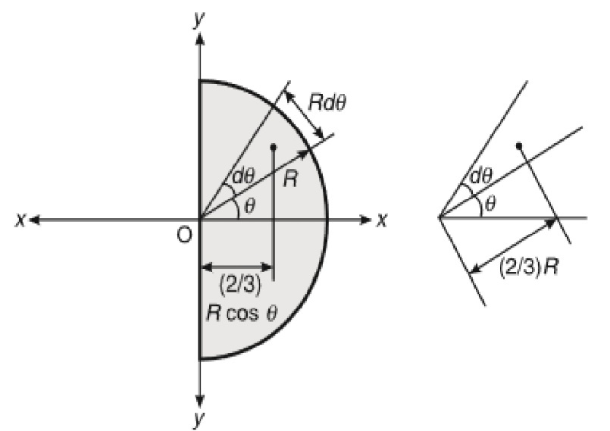
Consider a semicircular lamina of area $\frac{πr^{2}}{2}$ as shown in figure. Now consider a triangular elementary strip of area $\frac{1}{2}×R×R×dθ$ at an angle of θ from the x – axis, whose centre of gravity is at a distance of $\frac{2}{3}R$ from O and its projection on the
x – axis = $\left(\frac{2}{3}\right)Rcosθ$
Moment of area of elementary strip about the y – axis = $\frac{1}{2}×R^{2}×dθ×\left(\frac{2}{3}\right)×Rcosθ$
= $\frac{R^{3}.cosθ.dθ}{3}$
Sum of moment of such elementary strips about the y – axis, = $\int_{{-π}/2}^{π/2}{\frac{R^{3}}{3}cos.dθ}$
= $\frac{R^{3}}{3}{\left[sinθ\right]}_{{-π}/2}^{π/2}$
= $\frac{R^{3}}{3}\left(sin\frac{π}{2}+sin\frac{π}{2}\right)= \frac{{2R}^{3}}{3}$
Moment of total area about the y – axis = $\frac{πR^{2}}{2}×\overline{x}$
Using the principle of moments,

$$\frac{{2R}^{3}}{3}=\frac{πR^{2}}{2}×\overline{x}$$
$$\overline{x}=\frac{2R{.R}^{2}×2}{3R^{2}π}$$
$$\overline{x}=\frac{4R}{3π}$$
But in this case there is no base in x – direction,
Therefore,
$$\overline{y}=0$$
5b) Solve for the centroid for the area shown in the fig 5(b) with respect to the axis shown.
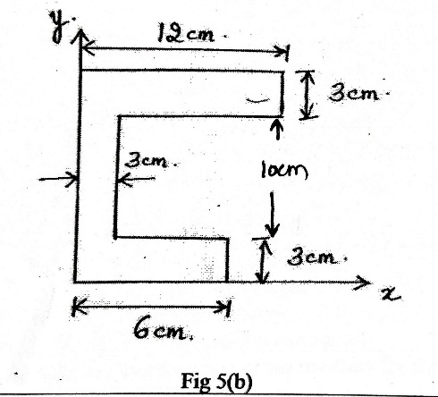
Sol^{n}:
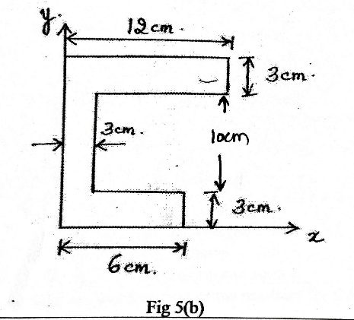

Components | Area  (cm²)  (A) | Centroidal Axis from y – axis  (cm)  (x) | Centroidal Axis from x – axis  (cm)  (y) | A.x  (cm³) | A.y  (cm³)
Rectangle 1 | $$12×3$$ | $$\frac{12}{2}$$ | $$\frac{3}{2}+10+3$$ | 216 | 522
Rectangle 2 | $$10×3$$ | $$\frac{3}{2}$$ | $$\frac{10}{2}+3$$ | 45 | 240
Rectangle 3 | $$3×6$$ | $$\frac{6}{2}$$ | $$\frac{3}{2}$$ | 54 | 27
 | $$\sum{A=}84$$ |  |  | $$\sum{A.x=315}$$ | $$\sum{A.y=789}$$

$$\overline{x}= \frac{\sum{A.x}}{\sum{A}}= \frac{315}{84}=3.75cm$$
$$\overline{y}= \frac{\sum{A.y}}{\sum{A}}= \frac{789}{84}=9.392cm$$

6a) Apply the method of integration to derive the centroid of rectangle.
Sol^{n}:
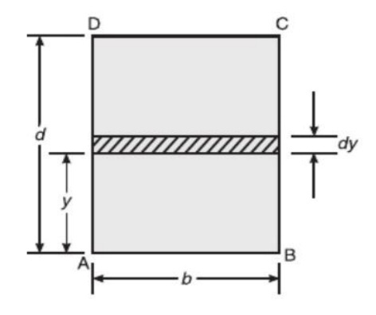
Let us consider a rectangular lamina of area b $×$ d as shown in figure. Now consider a horizontal elementary strip of area $b × dy$, which is at a distance y from the reference axis AB.
Moment of area of elementary strip about AB = $b ×dy×y$
Sum of moments of such elementary strips about AB is given by,
= $\int_{0}^{d}{b×dy×y}$
=$b\int_{0}^{d}{y.dy}$
= $b×{\left[\frac{y^{2}}{2}\right]}_{0}^{d}$
= $\frac{bd^{2}}{2}$
Moment of total area about AB = b.d$×\overline{y}$
Apply the principle of moments about AB,
$\frac{bd^{2}}{2}= b.d×\overline{y} ⇒ \overline{y}= \frac{d}{2}$
By considering a vertical strip, similarly, we can prove that,
$$\overline{x}= \frac{b}{2}$$

6b) Solve for the centroid for the area shown in fig 6(b) with respect to the centroidal axis.
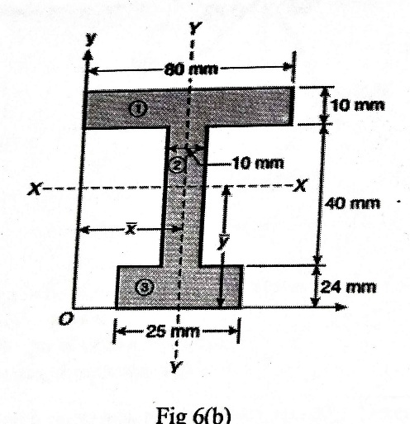
Sol^{n}:
Components | Area  (mm²)  (A) | Centroidal Axis from y – axis  (mm)  (x) | Centroidal Axis from x – axis  (mm)  (y) | A.x  (mm³) | A.y  (mm³)
Rectangle 1 | $$80×10$$ | $$\frac{80}{2}$$ | $$\frac{10}{2}+40+24$$ | 32000 | 55200
Rectangle 2 | $$10×40$$ | $$\frac{80}{2}$$ | $$\frac{40}{2}+24$$ | 16000 | 17600
Rectangle 3 | $$25×24$$ | $$\frac{80}{2}$$ | $$\frac{24}{2}$$ | 24000 | 7200
 | $$\sum{A=}1800$$ |  |  | $$\sum{A.x=72000}$$ | $$\sum{A.y=80000}$$

$$\overline{x}= \frac{\sum{A.x}}{\sum{A}}= \frac{72000}{1800}=40mm$$
$$\overline{y}= \frac{\sum{A.y}}{\sum{A}}= \frac{80000}{1800}=44.444mm$$

