

(

**Telangana**

**State**

**Private**

**Universities**

**Act**

**No.**

**13**

**of**

**2020**

**&**

**G.O.Ms.**

**No.**

**,**

**14**

**Higher**

**Education**

**)**

**UE**

**(**

**Department**

)

**Maisammaguda**

**,**

**Kompally**

**,**

**Medchal**

**-**

**Malkajgiri**

**District**

**Hyderabad**

**-**

**,**

**500100**

**Telangana**

**State**

**.**

[**.**](http://www.mallareddyuniversity.ac.in/)

[**www.mallareddyuniversity**](http://www.mallareddyuniversity.ac.in/)

**Department of Computer Science &Engineering**

**FORECASTING COUPON REDEMPTION**

**Batch no.69**

**2111CS010303 (R.Nagesh)**

**2111CS010347 (D.Padmasrija)**

**2111CS010333 (K.Nithinvarma)**

**Guide**

**Dr.RavitejaKocherla**

# **CONTENTS**

* **Title Explanation.**
* **Abstract.**
* **Reviewers Comments in Previous Review.**
* **Introduction.**
* **Problem Statement.**
* **Objectives.**
* **Methodology.**
* **Implementation.**
* **Conclusion & Future Scope .**
* **References.**

# Title Explanation

Forecasting coupon redemption involves the strategic analysis and prediction of consumer behavior in response to promotional offers. This multifaceted process requires understanding various factors such as historical redemption rates, market trends, product demand, and demographic characteristics. By employing advanced statistical models, data analytics techniques, and machine learning algorithms, businesses can anticipate the effectiveness of their coupon campaigns with greater accuracy. Effective forecasting not only optimizes resource allocation and budgeting but also enables companies to tailor their promotional strategies to maximize redemption rates and ultimately drive sales. Additionally, it empowers marketers to adapt quickly to changing market dynamics and consumer preferences, ensuring a competitive edge in today's dynamic marketplace.

# Abstract

In today's competitive market, understanding customer behavior and optimizing marketing strategies are paramount for businesses. One crucial aspect of marketing is the distribution of coupons, which can significantly influence consumer purchasing decisions. Predicting coupon redemption rates accurately can empower businesses to tailor their marketing efforts effectively and maximize their return on investment. In this study, we propose a machine learning approach for forecasting coupon redemption. Leveraging historical coupon redemption data and various machine learning algorithms, including but not limited to decision trees, random forests, and neural networks, we aim to develop models capable of predicting the likelihood of coupon redemption by customers. By analyzing past redemption patterns and relevant customer attributes, our models seek to provide actionable insights for businesses to optimize coupon distribution strategies and enhance marketing effectiveness.

# Abstract

Through empirical evaluation on real-world coupon redemption datasets, we demonstrate the efficacy of our approach in accurately forecasting coupon redemption rates, thereby assisting businesses in making informed decisions to drive sales and customer engagement.The client’s promotions are shared across various channels including email, notifications, etc. A number of these campaigns include coupon discounts that are offered for a specific product/range of products. The retailer would like the ability to predict whether customers redeem the coupons received across channels, which will enable the retailer’s marketing team to accurately design coupon construct, and develop a more precise and targeted marketing strategies.

# Reviewers comments in previous Review

Our guide asked us to

* use different strategies like SMOTE,Undersampling etc.,
* **use techniques like SHAP (SHapley Additive exPlanations) to explain model predictions.**
* **understand why certain customers are more likely to redeem coupons.**

# Introduction

Coupons offer discounts or incentives to consumers, serving as catalysts for purchase decisions and brand engagement.Predicting which customers are likely to redeem coupons and under what circumstances can enable businesses to optimize their marketing strategies and allocate resources effectively.the advent of machine learning offers a promising avenue for enhancing the precision and efficiency of coupon distribution. By leveraging historical data and advanced algorithms, machine learning empowers businesses to uncover intricate patterns and insights hidden within vast datasets.we seek to develop predictive models capable of accurately estimating the likelihood of coupon redemption. Our approach entails the utilization of various machine learning techniques, including decision trees, random forests, and neural networks, to extract actionable insights from coupon redemption data.Through empirical evaluation on real-world coupon redemption datasets, we aim to demonstrate the effectiveness of our proposed approach in forecasting coupon redemption rates. By providing businesses with reliable predictions and actionable insights, our study aims to equip marketers with the tools necessary to optimize coupon distribution strategies, enhance customer engagement, and drive sales growth.

•

# Introduction

Discount marketing and coupon usage are very widely used promotional techniques to attract new customers and to retain & reinforce loyalty of existing customers. The measurement of a consumer’s propensity towards coupon usage and the prediction of the redemption behaviour are crucial parameters in assessing the effectiveness of a marketing campaign.ABC promotions are shared across various channels including email, notifications, etc. A number of these campaigns include coupon discounts that are offered for a specific product/range of products. The retailer would like the ability to predict whether customers redeem the coupons received across channels, which will enable the retailer’s marketing team to accurately design coupon construct, and develop more precise and targeted marketing strategies.

•XYZ Credit Card Company collaborates with ABC, an established Brick & Mortar retailer, to enhance their discount marketing process using machine learning. ABC frequently conducts marketing campaigns, including coupon discounts, to attract new customers and retain existing ones.

The effectiveness of these campaigns hinges on predicting customer coupon redemption behavior.

# Problem Statement

Discount marketing and coupon usage are very widely used promotional techniques to attract new customers and to retain & reinforce loyalty of existing customers. The measurement of a consumer’s propensity towards coupon usage and the prediction of the redemption behaviour are crucial parameters in assessing the effectiveness of a marketing campaign. The client’s promotions are shared across various channels including email, notifications, etc. A number of these campaigns include coupon discounts that are offered for a specific product/range of products. The retailer would like the ability to predict whether customers redeem the coupons received across channels, which will enable the retailer’s marketing team to accurately design coupon construct, and develop a more precise and targeted marketing strategies. The strategic distribution of coupons is a widely employed marketing tactic aimed at incentivizing consumer purchases and fostering brand loyalty. However, the efficacy of coupon campaigns hinges on the ability to accurately predict coupon redemption rates. Without precise forecasts, businesses risk misallocating resources, distributing coupons to customers unlikely to redeem them, and missing opportunities to maximize return on investment. Traditional approaches to forecasting coupon redemption often rely on simplistic heuristics or manual analysis, which may overlook subtle patterns and fail to capture the complex interplay of factors influencing consumer behavior. Moreover, the sheer volume and complexity of coupon redemption data present significant challenges for conventional analytical techniques..

# Objectives

• The primary objective of the coupon redemption project using data analytics is to predict whether customers will redeem coupons. By analyzing historical data, we aim to understand customer behavior and create accurate models that empower marketing teams to design targeted strategies. The project’s success lies in optimizing coupon constructs and improving overall campaign effectiveness

1. **Reinventing Coupons: Strategies for a Successful Coupon Campaign**:
2. In 2012, marketers distributed approximately 310 billion valued coupons, totaling

$484 billion

# Objectives

Coupons are a powerful sales tool, influencing buying patterns and driving sales.

Key considerations for successful coupon campaigns:

1. **Attracting New Customers**: Coupons can acquire new customers and encourage existing ones to spend more.
2. **Balancing Margins**: Poorly planned coupon promotions may hurt margins due to revenue cannibalization.

**iii.Coupon Design**: Critical for maximizing profits and minimizing cannibalization. **iv.Clarity on Marketing Goals**: Coupons should align with marketing objectives

# Objectives

1. **Predictive Analytics for E-Coupon Redemption**:
   1. Analyzing data from an insurance e-commerce platform in East China, researchers examined factors influencing e-coupon redemption.
   2. Behavioral predictive analytics tools were used to understand customer behavior after receiving coupons
2. **Coupon Acquisition and Redemption Metrics**:
   1. Businesses can optimize coupon strategies by analyzing redemption rates.
   2. [Factors affecting redemption include discount value, expiration date, and ease of redemption](https://fastercapital.com/content/Coupon-case-studies-How-Coupon-Case-Studies-Drive-Business-Growth-for-Startups.html)

# **Methodology**

•**Data Collection**

•**Data Preprocessing**

•**Exploratory Data Analysis:**

**I. Visualize the data to gain insights II. Model Building**

1. **Feature Importance**
2. **Model Interpretability**

# **Implementation**

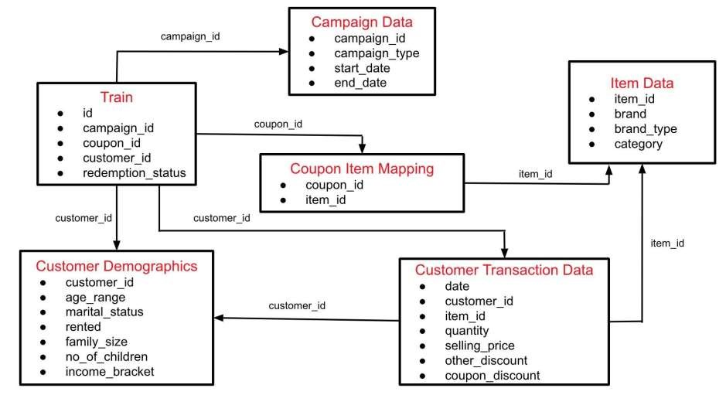

# **Implementation**

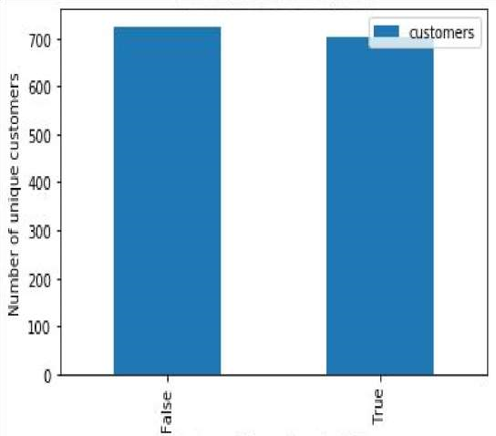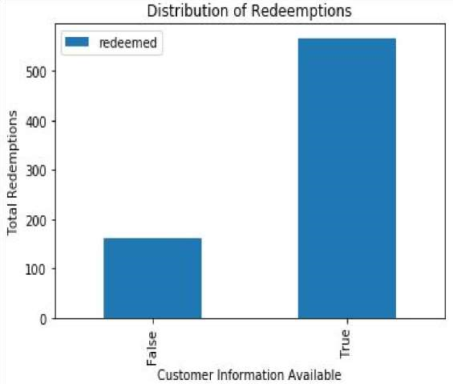

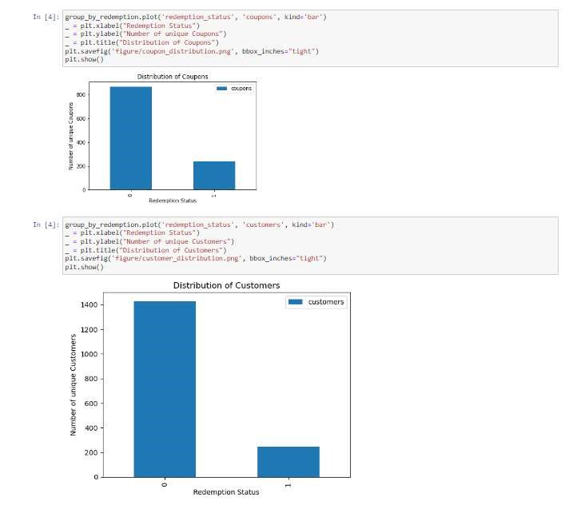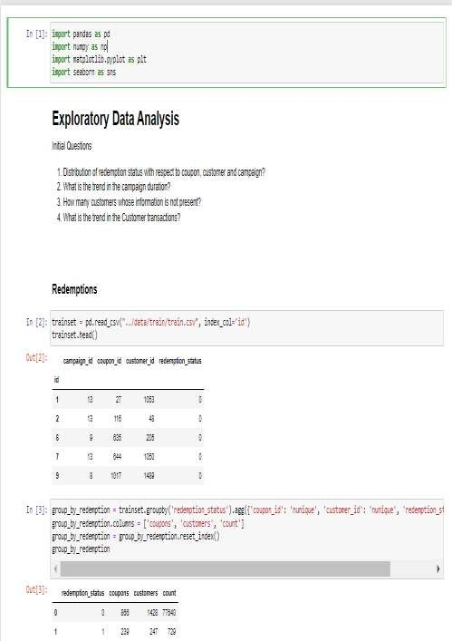

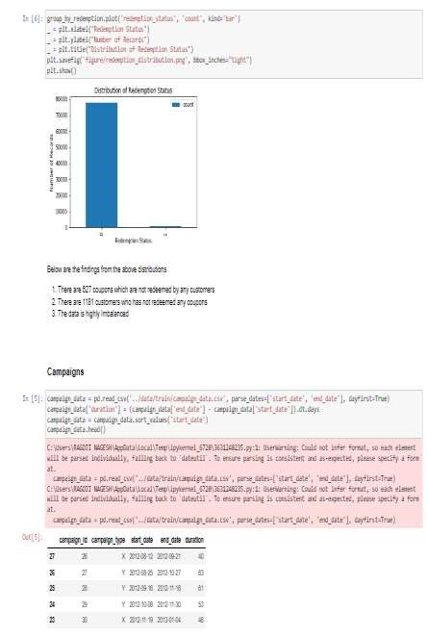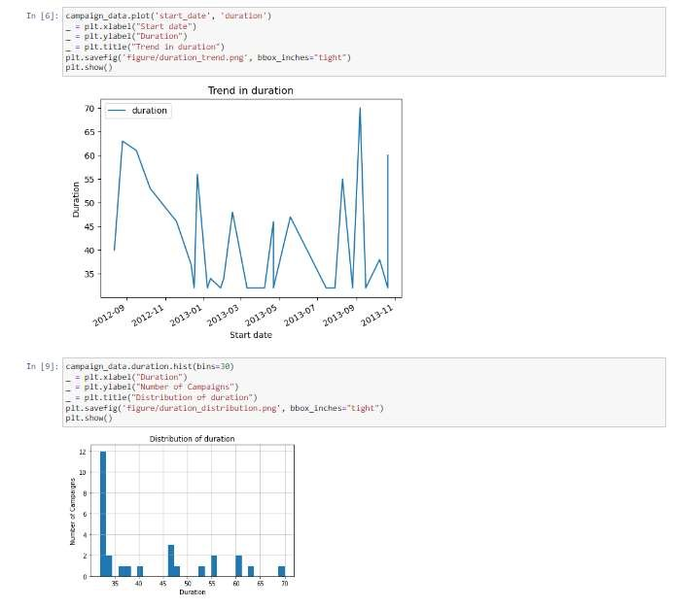

## Conclusion & Future scope

•After performing different experiments with features, missing values, parameters, etc. The ensemble of tuned lightGBM with num_leaves 15, 20 and 25 performs better than others. The evaluation metric of ***area under the ROC curve*** final model is getting the score of **0.9132**. The same model got private score of **0.8979**.

• Further Improvements can be done to improve the model. Below are some ideas that can be explored.

1. The model uses features, where each feature has a small contribution towards the model performance. Merging the features will result in better speed of model and hence, more experiments can be performed.
2. Different way of handling many-to-many relations between coupons and customer’s transactions. iii. Hyper-parameter tuning might lead to local minima, further tuning can be tried for better results. iv. Confusion matrix was not analysed. It can be analysed and fix the models for the issues.

## Conclusion & Future scope

* The future scope for forecasting coupon redemption using data analytics is promising, with advancements in technology and data analytics capabilities opening up new opportunities for businesses. Here are some potential areas of growth:
* Predictive Modeling
* Personalization
* Real-Time Analytics
* Integration with Loyalty Programs
* AI-driven Recommendations

## References

1. **Breiman, L. (2001)**. Random Forests. *Machine Learning*, 45(1), 532. Retrieved from <https://link.springer.com/article/10.1023/A:1010933404324>
2. **Chawla, N. V., Bowyer, K. W., Hall, L. O., & Kegelmeyer, W. P.**
3. **(2002)**. SMOTE: Synthetic Minority Over-sampling Technique. *Journal of Artificial Intelligence Research*, 16, 321-357. Retrieved from https://www.jair.org/index.php/jair/article/view/10302
4. **Chen, T., & Guestrin, C. (2016)**. XGBoost: A Scalable Tree
5. Boosting System. In *Proceedings of the 22nd ACM SIGKDD International Conference on Knowledge Discovery and Data Mining* (pp. 785-794). Retrieved from https://dl.acm.org/doi/10.1145/2939672.2939785
6. **GDPR (General Data Protection Regulation) (2018)**. Official
7. Legal Text. Retrieved from <https://gdpr-info.eu/>
8. **Fawcett, T. (2006)**. An introduction to ROC analysis. *Pattern Recognition Letters*, 27(8), 861-874.

Retrieved from [https://www.sciencedirect.com/science/article/pii/S0167865505003](https://www.sciencedirect.com/science/article/pii/S016786550500303X)

1. [03X](https://www.sciencedirect.com/science/article/pii/S016786550500303X)
2. **Liaw, A., & Wiener, M. (2002)**. Classification and Regression by randomForest. *R News*, 2(3), 1822. Retrieved from https://cran.rproject.org/doc/Rnews/Rnews_2002-3.pdf

### THANK YOU