GB MDM data flow
As of September 26, 2026

Overview
GB customer data moves through four zones: Mongo DB, GB DL curation, Informatica MDM SaaS (GB spoke and MDM hub) and Ops DL curation. Two paths start at the preunified customer collection. The change feed loads the unified customer Mongo collection. The UNIFICATION path runs through the GB spoke into the unified customer delta table, then through the MDM hub into three Ops DL hops that feed Salesforce and the search indexes.
Ingress and egress are named from Informatica's point of view: files sent into the spoke or hub are ingress, files it sends back are egress.

MDM side: upstream to MDM hub
The unified customer delta table is fed only by the GB spoke route: the customer profile file goes into the spoke, and its GB consolidated egress is joined with policy. The change feed loads only the unified customer Mongo collection.
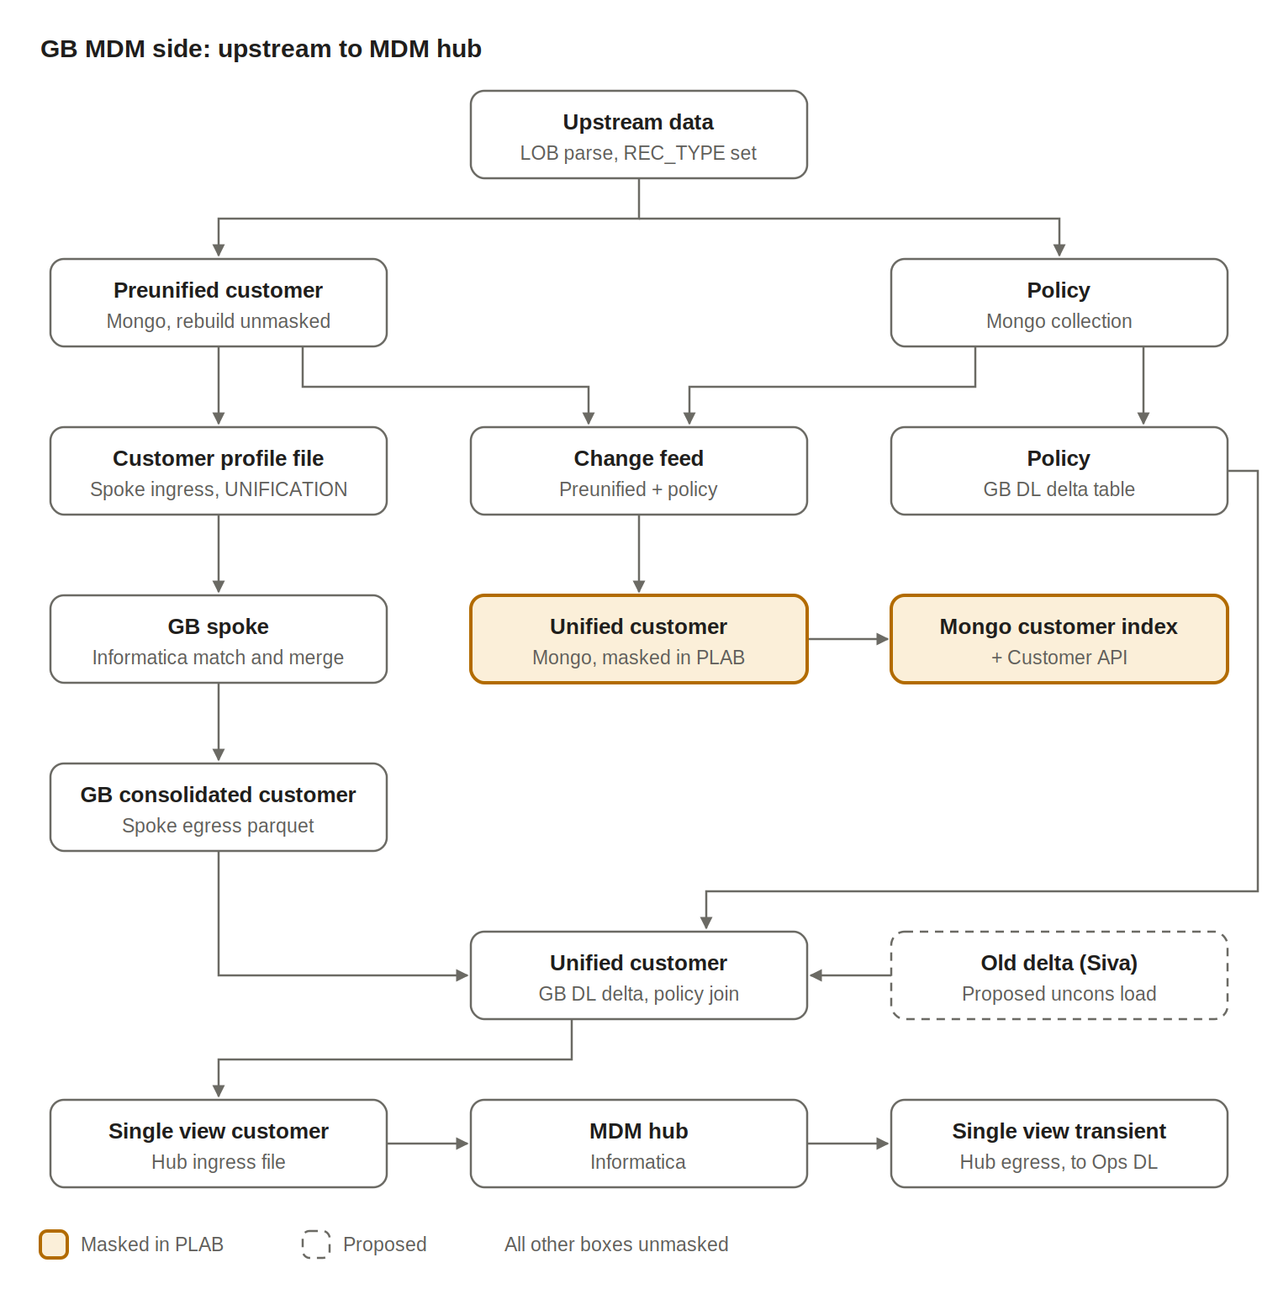
Step | What happens | Masking
1 | Upstream data loads the preunified customer and policy Mongo collections. LOB is parsed and REC_TYPE is set (UNIFICATION / NON UNIFICATION). | Unmasked
2 | Change feed joins preunified + policy and loads the unified customer Mongo collection. It does not feed the unified customer delta table. | Masked in PLAB
3 | Unified customer Mongo serves the Mongo customer index and the MDM Customer API. | Masked in PLAB
4 | Preunified UNIFICATION records are written to the customer profile parquet file (GB spoke ingress). | Unmasked
5 | Informatica MDM SaaS runs match and merge in the GB spoke and returns the GB consolidated customer parquet file (spoke egress). | Unmasked
6 | The GB consolidated egress is joined with the policy delta table and inserted into the unified customer delta table (GB DL). | Unmasked
7 | Proposed (Siva): Old Delta table applies ITF filtering, identifies uncons, enriches with policy and loads unmasked uncons into the unified customer delta table. | Unmasked
8 | The unified customer delta table generates the single view customer file (hub ingress). | Unmasked
9 | The MDM hub processes it and returns the single view transient customer file (hub egress) to Ops DL. | Unmasked

Ops DL: three hops and the search indexes
The hub egress file loads three Ops DL hops in order: single view table, consolidated customer, then consolidated customer transient. Transient pulls from consolidated customer and feeds Salesforce and the existing AI search index separately.
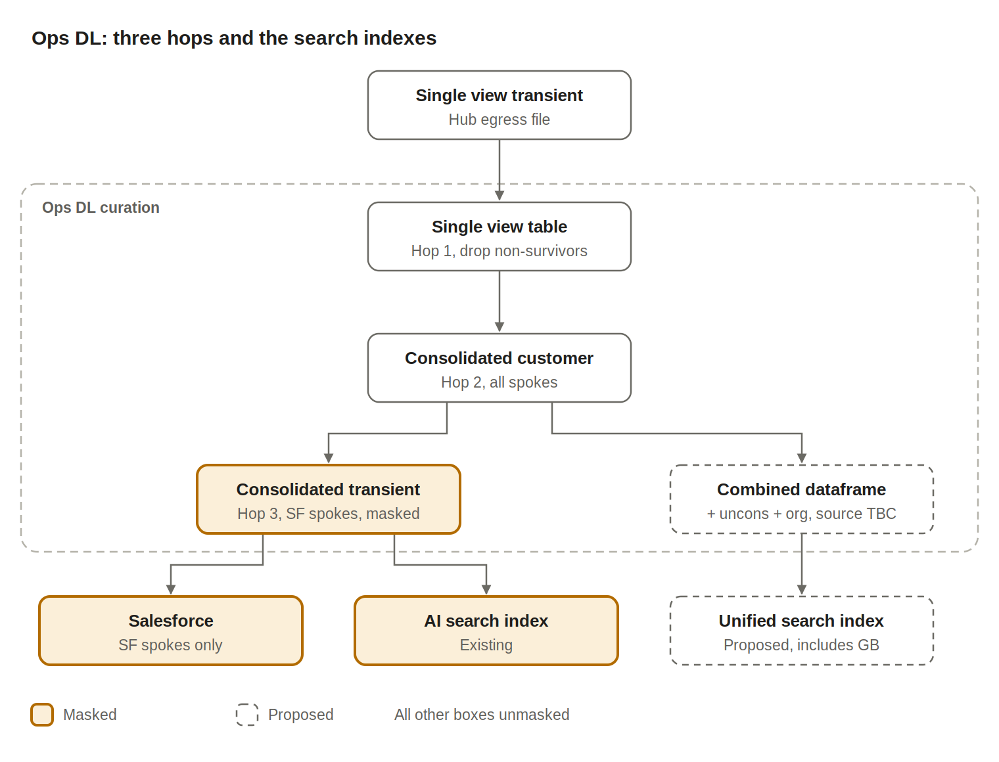
Hop | What happens | Masking
Hop 1 | Single view table: loaded from the hub egress file. Merges and deletion of non-surviving MDM customer IDs happen here. | Unmasked
Hop 2 | Consolidated customer: all spokes, consolidated data. | Unmasked
Hop 3 | Consolidated customer transient: pulls from consolidated customer, keeps only spokes sent to Salesforce. | Masked
Out | Transient feeds Salesforce and the existing AI search index as separate branches. | Masked
Proposed | Combined dataframe: consolidated customer + all uncons and org, written as JSONs for a new unified search index that includes GB. | Unmasked

Masking zones in PLAB
Masking in PLAB applies at two points: the unified customer Mongo collection, and the transient hop in Ops DL.
Object | Zone | Masking | Source
Preunified customer | Mongo DB | Masked today (release 2 load bug), to be rebuilt unmasked | Siva, Divya
Unified customer collection | Mongo DB | Masked in PLAB | Walkthrough
Mongo customer index + Customer API | Mongo DB | Masked in PLAB | Walkthrough
Unified customer delta | GB DL curation | Unmasked | Siva
Single view table | Ops DL | Unmasked | Inferred from consolidated customer
Consolidated customer | Ops DL | Unmasked, all spokes | Divya
Consolidated customer transient | Ops DL | Masked, SF spokes only | Divya
Salesforce + AI search index | Downstream | Masked | Divya
Unified search index (proposed) | Downstream | Unmasked, includes GB | Divya

Open items
- Where do the uncons and org records for the unified search index come from? (Divya)
- Is Siva's Old Delta load of unmasked uncons still planned, and is it one-time or ongoing? (Siva)
- Confirm the masking point: applied when transient pulls from consolidated customer?
- Confirm the index type for the AI search and unified search indexes (Azure AI Search?)
- Build the GB to hub pipeline for unique ID once Srinivas is back

