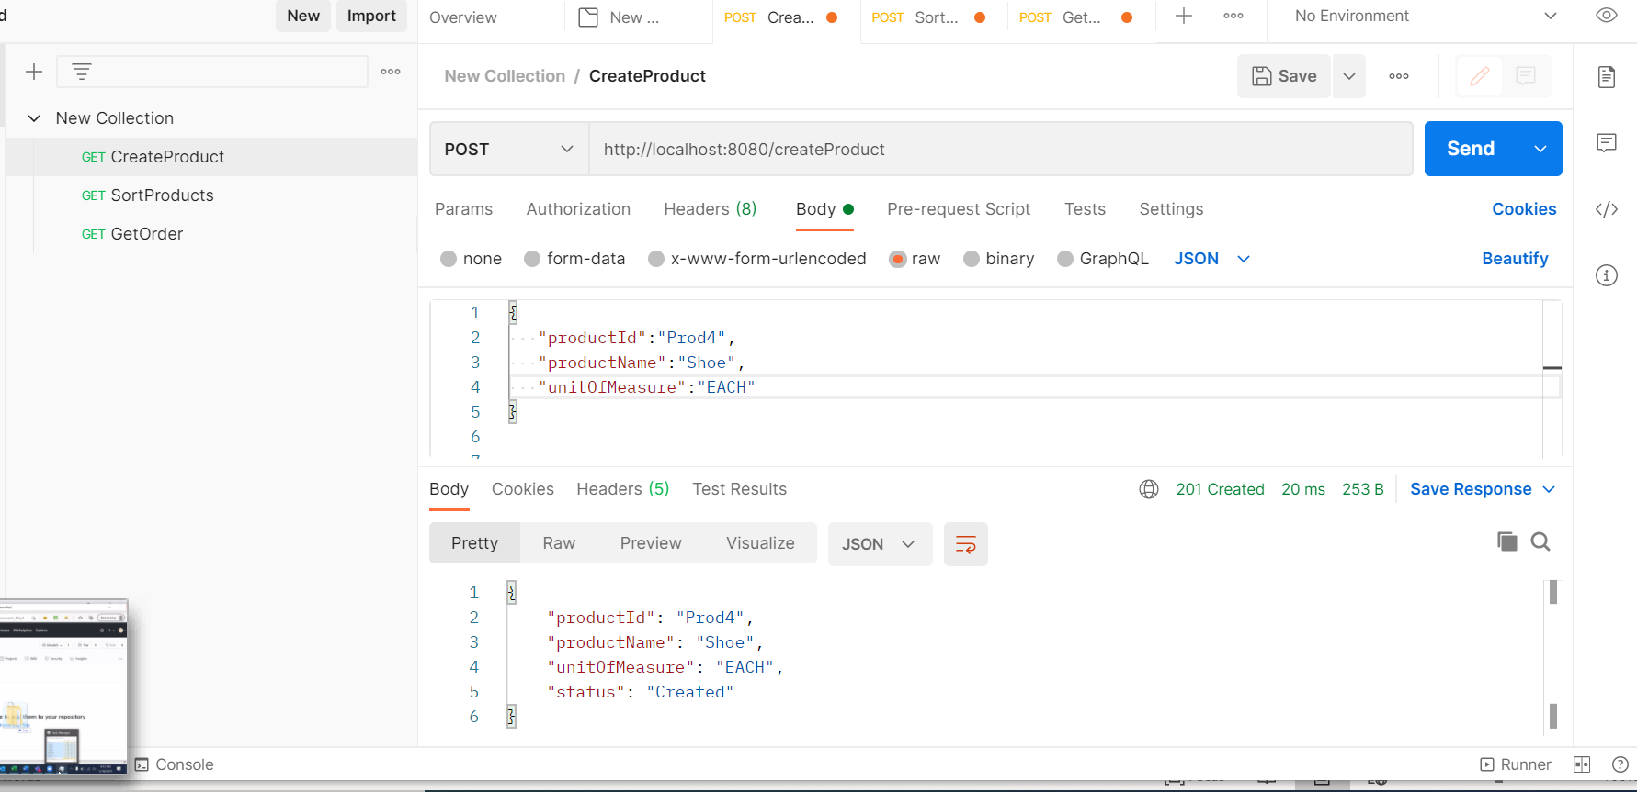

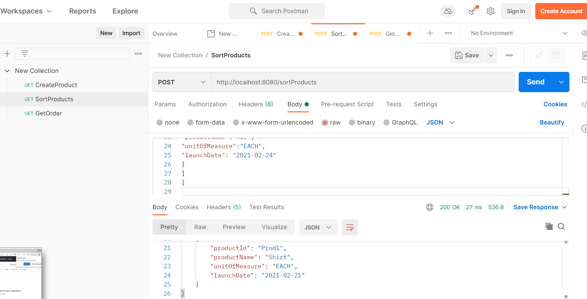

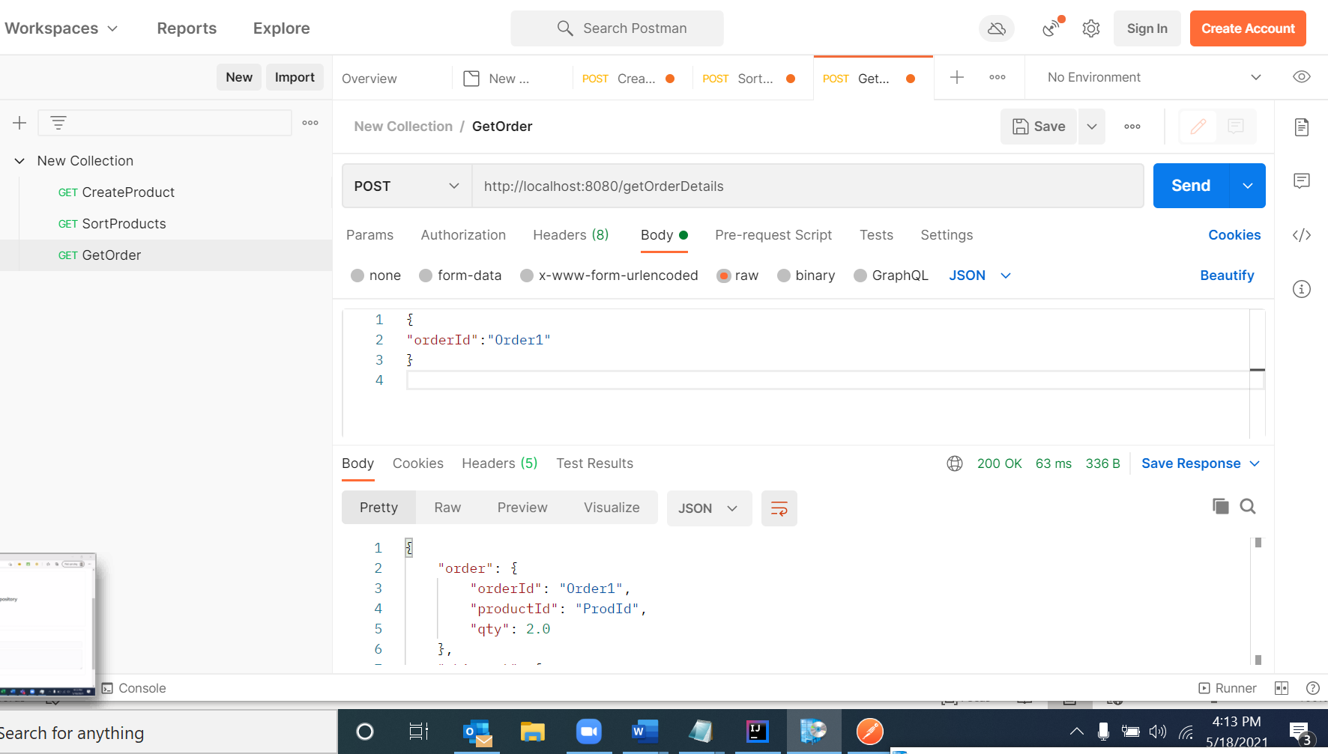

I have Created the Junit Test cases, and I have added proper loggers

I have handled the vera code issues .I tried to follow the max coding standards.