

**Analog Electronics**

**ENEE2360**

**Project Report**

**Team members:**

**Name: Nagham Maali ID: 1212312 Sec.: 2**

**Name: Akram Jaber ID: 1220872 Sec.: 2**

**Instructor: Dr. Mohammad Jehad Al Ju'Beh**

**Contents**

**Project Overview:** 2

**Completeness of the circuit (Rx and Ry):** 4

**Voltage Calculations:** 5

**Components:** 6

**Simulation using Pspice:** 11

**Physical implementation using LM324 IC:** 17

**Conclusion and Results:** 18

# **Project Overview:**

This project is about designing and testing an analog circuit that takes a sensor signal ranging from 0.2V to 2.5V and converts it into an output that ranges from 0V to 5V. The purpose of this conversion is to match the sensor's output to a full-scale range that can be read by other systems like ADCs (Analog-to-Digital Converters). The circuit uses three operational amplifiers from an LM324 IC, and each stage has a specific role.

The first op-amp stage uses a 6.2V Zener diode and a voltage divider made of a 100Ω resistor and a resistor Ry. This stage is configured as a voltage follower, meaning it copies the voltage from the divider and outputs it as a fixed reference voltage Va. The second op-amp is also a voltage follower, and its job is to copy the input voltage from the sensor, which we call Vin. Its output is called Vb and is equal to Vin. The third op-amp is a differential amplifier. It receives both Va and Vb and outputs the difference between them, scaled by a resistor Rx. By carefully choosing the values of Rx and Ry, the circuit makes sure that the output voltage Vout changes smoothly from 0V to 5V as the sensor input moves from 0.2V to 2.5V.

To find the correct resistor values, we analyzed the circuit using formulas for voltage dividers and differential amplifiers. We found that using Ry = 3kΩ and Rx ≈ 21.73913kΩ gives the correct behavior. These values make sure that Vout is 0V when Vin is 0.2V and 5V when Vin is 2.5V. After calculating the resistor values, we tested the circuit in simulation using PSpice and then built it using the LM324 chip on a breadboard. We measured and recorded the voltages at important points in the circuit for several input values between 0.1V and 3.0V. The results from the hand calculations, simulation, and real measurements were compared and showed good agreement.

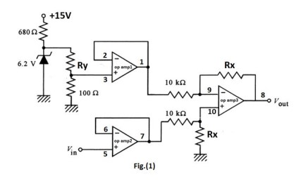

𝑉𝑎

𝑉𝑏

# **Completeness of the circuit (Rx and Ry):**

To ensure the sensor's output voltage, ranging from 0.2V to 2.5V, maps linearly to an output voltage ranging from 0V to 5V, the resistor values 𝑅𝑥 and 𝑅𝑦 were determined using standard op-amp analysis techniques.

Va = 620/(Ry+100) .......... 1

Vb = Vin .......... 2

Vout = (Rx/10K) * (Vb – Va)

Vout = (Rx/10K) * (Vin – (620/(Ry+100))) .......... 3

When Vin = 0.2v, Vout = 0v:

0 = (Rx/10K) * (0.2 – (620/(Ry+100)))

0 = 0.2Rx/10K – (620Rx/((Ry+100) * 10K))

(620Rx/((Ry+100) * 10K)) = 0.2Rx/10K

620/(Ry+100) = 0.2

620 = 0.2Ry+20

0.2Ry = 600

Ry = 3000Ω = 3KΩ

When Vin = 2.5v, Vout = 5v:

5 = (Rx/10K) * (2.5 – (620/(3K+100)))

5 = 2.3Rx/10K

50000 = 2.3Rx

Rx = 21739.13Ω = 21.73913KΩ

# **Voltage Calculations:**

Va = 620 \ (3000+100)

Va = 0.2v

Vb = Vin

Vout = (21739.13 / 10000) * (Vin – 0.2)

Vout = 2.173913(Vin – 0.2)

|  |  |  |  |
| --- | --- | --- | --- |
| Vin | Va | Vb | Vout |
| 0.1v | 0.2v | 0.1v | -0.2174v |
| 0.2v | 0.2v | 0.2v | 0v |
| 0.5v | 0.2v | 0.5v | 0.6522v |
| 1v | 0.2v | 1v | 1.74v |
| 1.5v | 0.2v | 1.5v | 2.826v |
| 2v | 0.2v | 2v | 3.913v |
| 2.5v | 0.2v | 2.5v | 5v |
| 3v | 0.2v | 3v | 6.087v |

# **Components:**

The circuit is made using a set of basic electronic components, each playing an important role in shaping and controlling the voltage signal from the sensor:

1. Resistor:

a passive two-terminal electronic component that implements electrical resistance as a circuit element.

In this circuit, there are 4 Standard resistors with the values: 680 Ω, 100 Ω, and 2 with the value 10K Ω.

In PSpice, the R element was used. In the physical circuit, fixed resistors were placed on the breadboard.

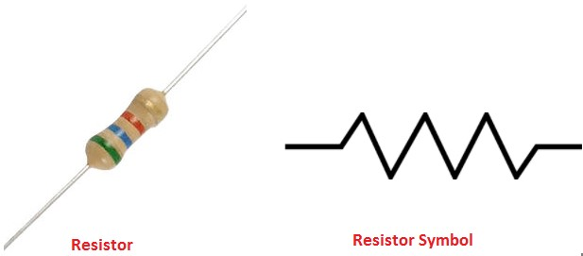

1. Zener diode:

A semiconductor device that allows current to flow in both directions.

In this circuit, it Provides a stable 6.2V reference voltage for the first op-amp stage.

In PSpice, the part D1N750 is used as the Zener diode. In real life, a 6.2V Zener diode was connected with a limiting resistor to generate the reference.

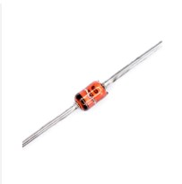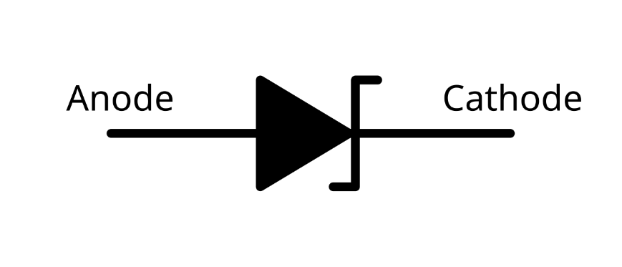

1. Rx and Ry:

These resistors control the output scaling and offset. Rx is used in the differential amplifier to set the gain, and Ry is part of the voltage divider for setting Va.

Since the calculated values (especially for Rx) are not standard, potentiometers were used for both in the physical circuit to allow fine-tuning. In PSpice, they were simulated using exact resistor values.

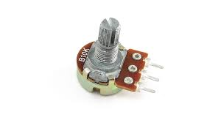

The potentiometer is a three-terminal variable resistor used to control voltage in a circuit.

1. LM324 IC:

This is a quad operational amplifier chip (four op-amps in one package), and it’s The main component in the circuit. In this project, we used three of those op-amps.

In PSpice, the LM324 part was selected. Physically, the actual LM324 IC was used on a breadboard with power supply connections (+15V and GND).

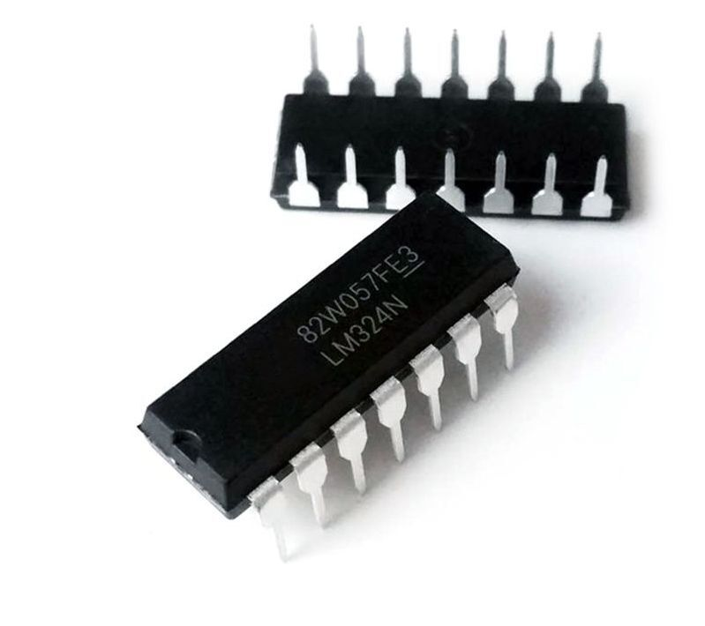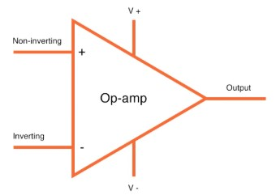

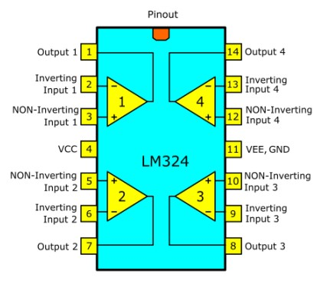

1. Breadboard:

Used in the physical implementation to build and test the circuit without soldering. All components were connected and rearranged easily for measurements.

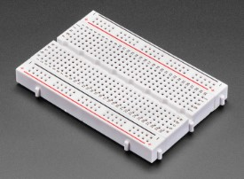

1. Wires:

Standard jumper wires were used to make connections between components on the breadboard. In PSpice, wires are just the connecting lines between parts.

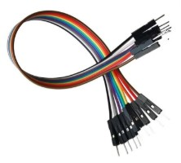

1. Vin:

This represents the signal coming from the sensor. In PSpice, the VDC component was used to simulate different input values. Physically, a DC power supply device was used to manually set Vin to specific values like 0.2V or 2.5V.

The DC power supply is an integral piece of equipment used in many applications that require the conversion of alternate current (AC) voltage into DC voltage.

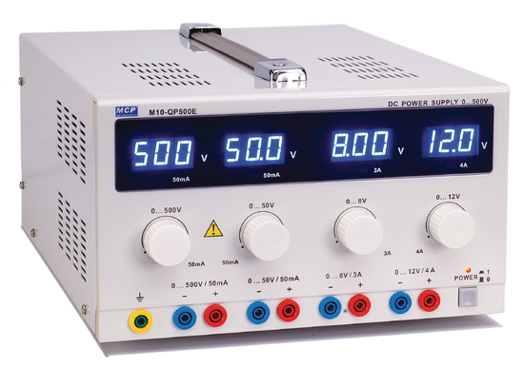

1. Vout:

This is the final output of the circuit that varies from 0V to 5V. In PSpice, a voltage marker was used to observe Vout. In the physical circuit, the multimeter (or oscilloscope) was used to measure the output voltage.

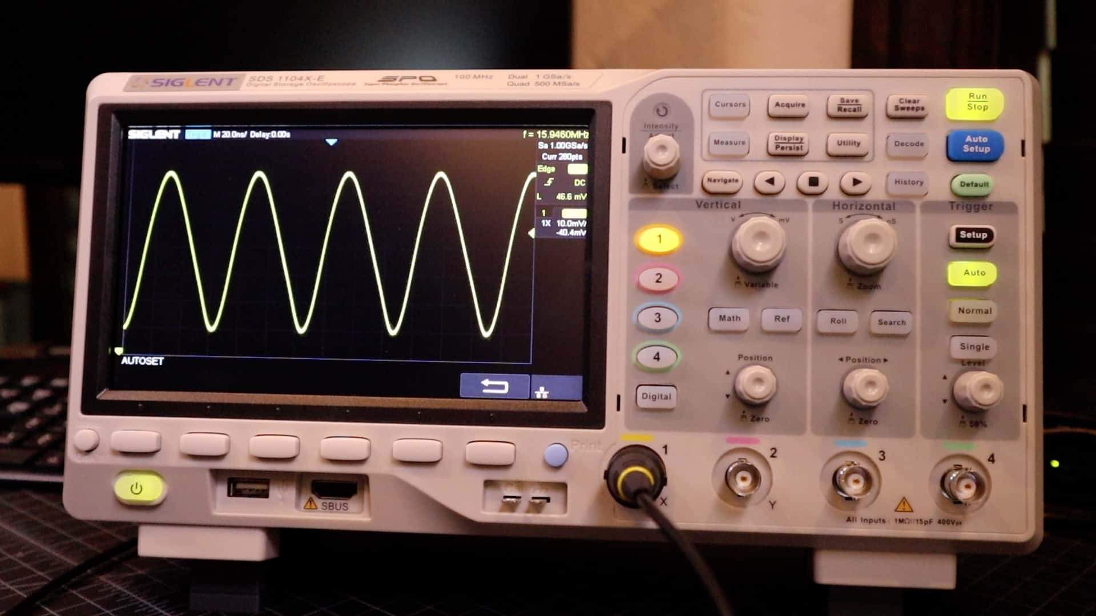

# **Simulation using Pspice:**

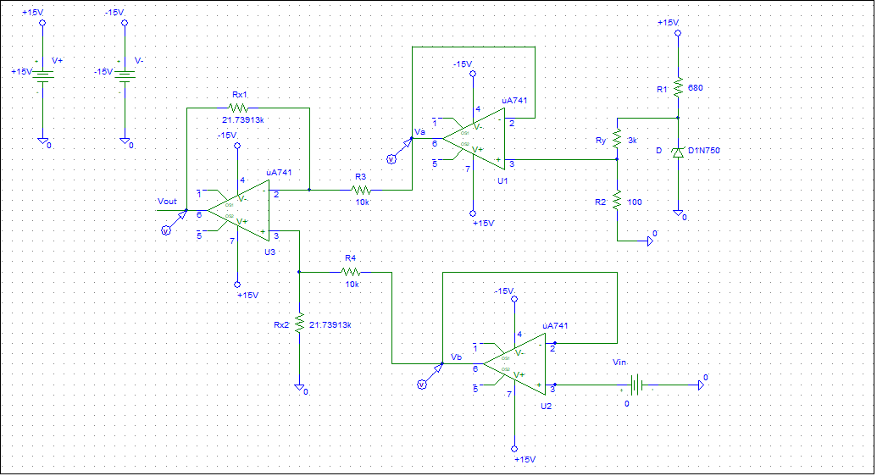

Circuit

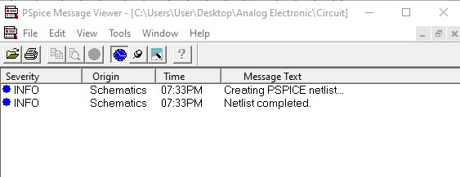

No errors

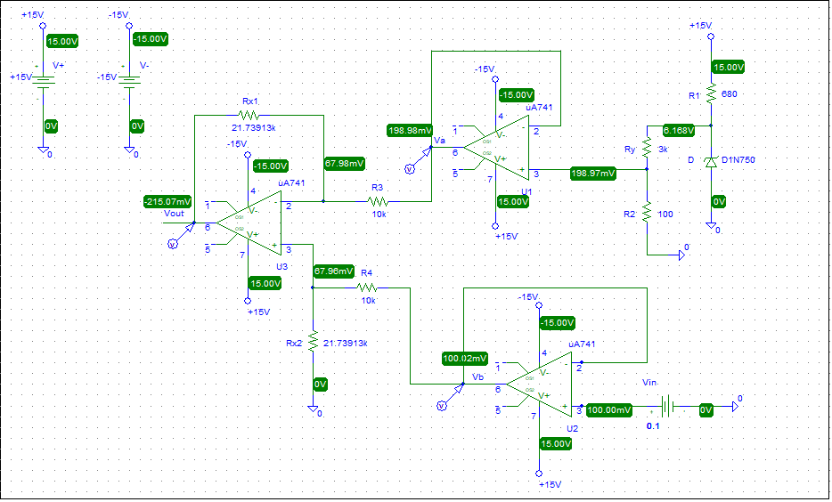Vin = 0.1v

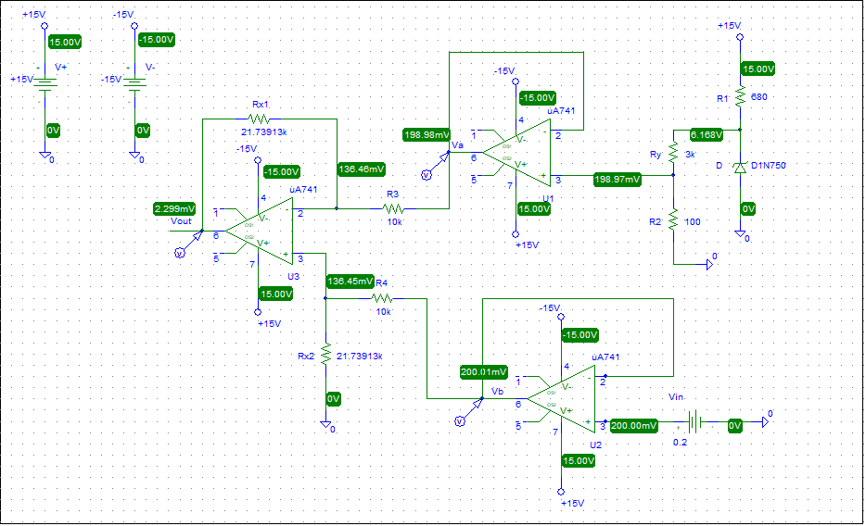Vin = 0.2v

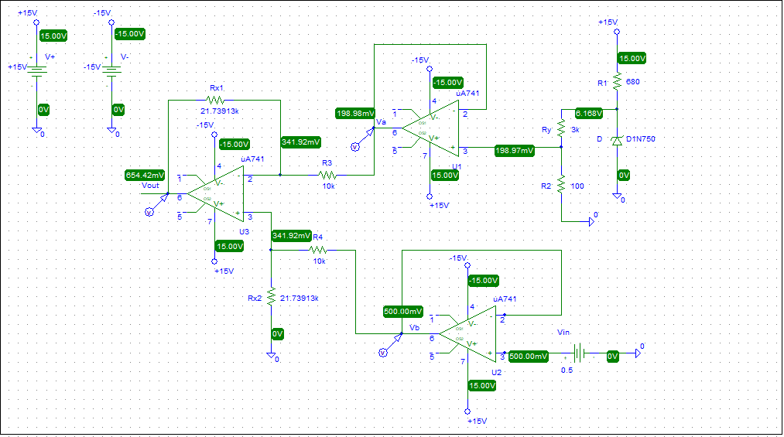

Vin = 0.5v

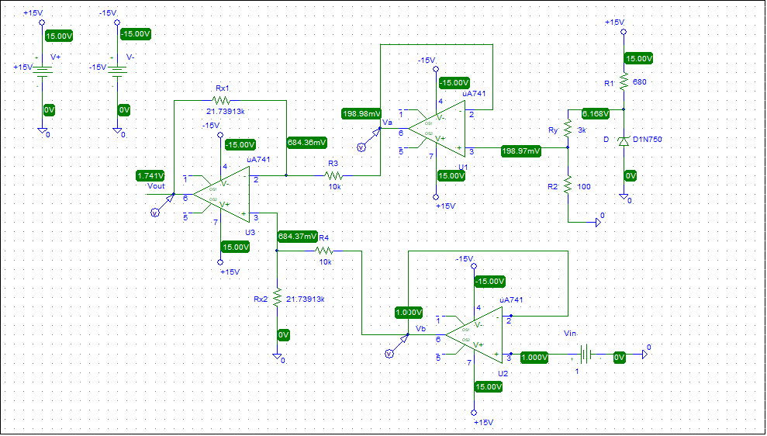

Vin = 1v

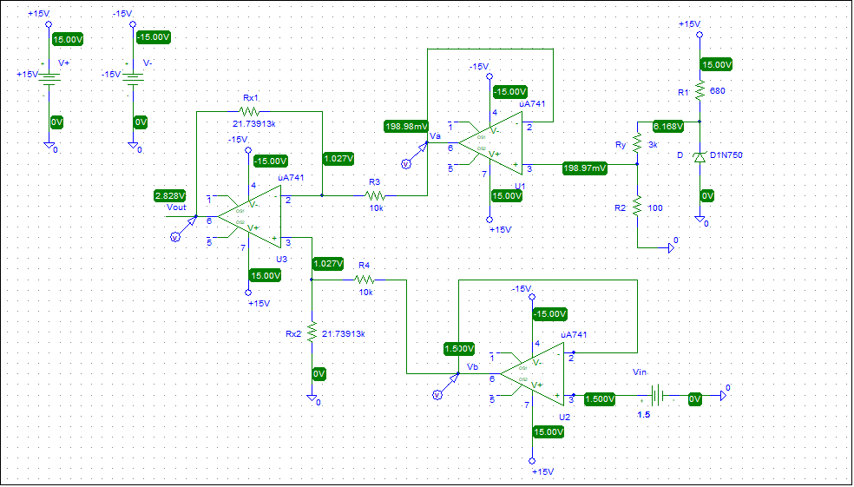

Vin = 1.5v

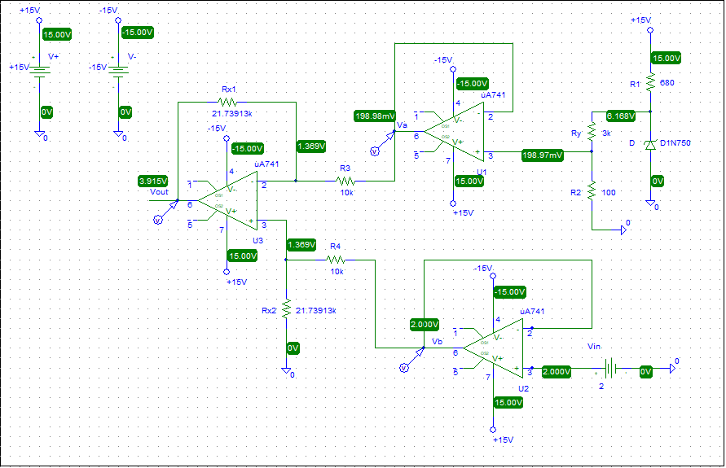Vin = 2v

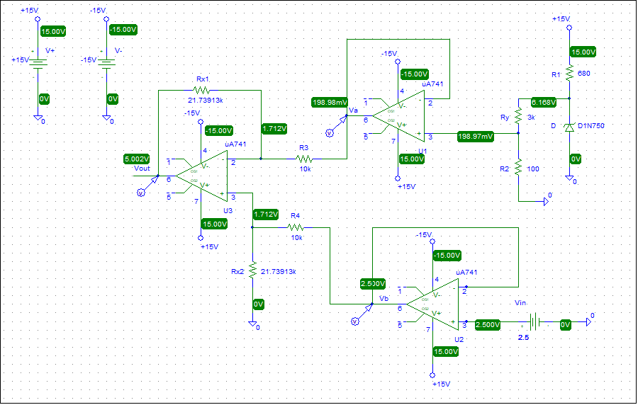Vin = 2.5v

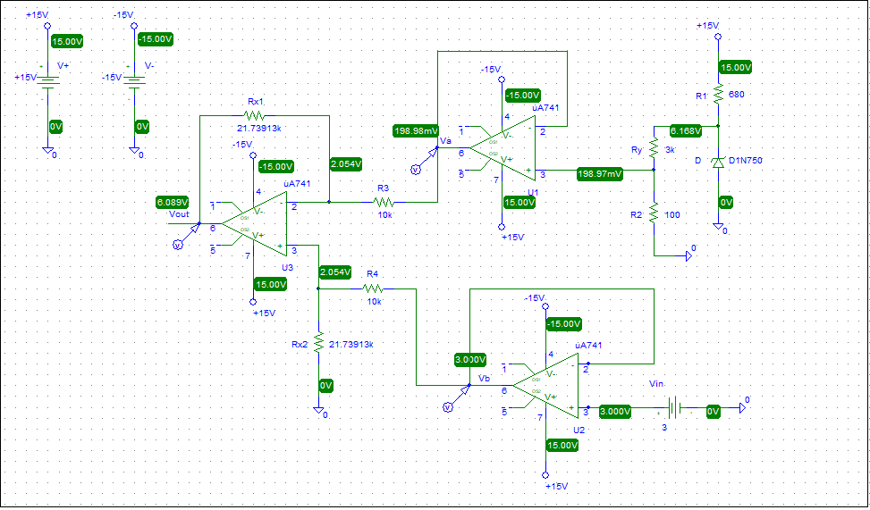

Vin = 3v



* The DC sweep simulation confirms that the output voltage Vout increases linearly as Vin increases.
* Va using Pspice is exactly like the hand calculations: Va = 0.2v.
* Vb using Pspice is exactly like the hand calculations: Vb = Vin.
* Vout values using Pspice are very close to the values using hand calculations. For example:

Vin = 3v:

using hand calculations: Vout = 6.087v

using Pspice: Vout = 6.098v

# **Physical implementation using LM324 IC:**

The circuit was physically built on a breadboard using standard components, including the LM324 quad op-amp IC. A 6.2V Zener diode was used to provide a reference voltage, and fixed resistors (including a potentiometer for fine adjustment) were used to set the values of Ry = 3kΩ and Rx ≈ 21.73913kΩ as designed. A DC power supply was used to manually vary the input voltage Vin, and a multimeter was used to measure the resulting node voltages at Va, Vb and Vout.

The physical implementation performed very well and closely matched both the PSpice simulation results and the hand calculations. The voltages Va and Vb were measured to be exactly the same as expected. The output voltage Vout was also very close, with only small differences due to practical tolerances as shown in the following table:

|  |  |  |  |
| --- | --- | --- | --- |
| Vin | Va | Vb | Vout |
| 0.1v | 0.2v | 0.1v | -0.4v |
| 0.2v | 0.2v | 0.2v | 0v |
| 0.5v | 0.2v | 0.5v | 0.4v |
| 1v | 0.2v | 1v | 1.6v |
| 1.5v | 0.2v | 1.5v | 2.6v |
| 2v | 0.2v | 2v | 3.7v |
| 2.5v | 0.2v | 2.5v | 4.8v |
| 3v | 0.2v | 3v | 6v |

# **Conclusion and Results:**

In this project, an analog signal conditioning circuit was designed, analyzed, simulated, and physically implemented to convert a sensor’s voltage output from the range of 0.2V–2.5V into a full-scale output of 0V–5V. The design used three operational amplifiers from an LM324 IC: two voltage follower stages and one differential amplifier stage.

Resistor values were calculated based on theoretical analysis. Using the voltage divider and differential amplifier formulas, the required values were found to be 𝑅𝑥 = 21.73913KΩ and 𝑅𝑦 = 3kΩ, and since these values are not standard, potentiometers were used in the physical implementation to fine-tune the exact resistance values.

The circuit was tested in three phases: hand calculations, PSpice simulation, and physical implementation using the LM324 IC on a breadboard. A DC power supply was used to provide different Vin values, and voltages at key points (Va, Vb, and Vout) were measured using a multimeter. The measured values showed excellent agreement with both the simulated and calculated results. The voltages Va and Vb matched exactly, while the output voltage Vout was very close, for example:

|  |  |  |  |
| --- | --- | --- | --- |
| Vin | Vout by hand calculations | Vout by Pspice | Vout by physical implementation |
| 3v | 6.078v | 6.089v | 6v |

Overall, the project was highly successful. The strong agreement between the theoretical calculations, PSpice simulations, and physical measurements confirms the accuracy and reliability of the design. The circuit performed exactly as intended, clearly demonstrating how op-amp configurations can be used to shift and scale voltage signals in analog systems. This project provided a complete understanding of the circuit's operation through analysis, simulation, and real-world testing, highlighting the effectiveness of combining practical implementation with theoretical design.