**WOT LAB – 1**

**ECM1004**

Name: Nagharjun M

Registration Number: 18BLC1129

Date: 10/02/2021

**Task 1**

**Temperature Monitoring**

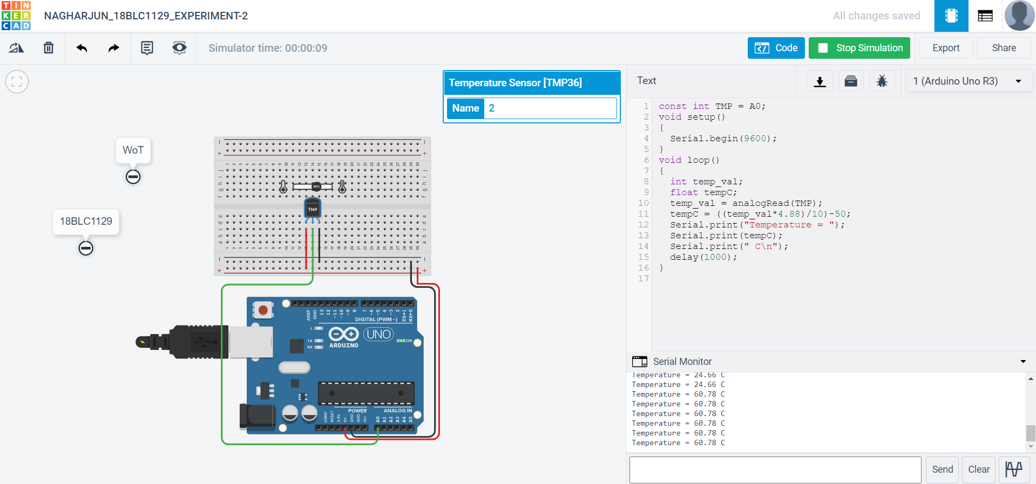

**Code:**

const int TMP = A0;

void setup()

{

Serial.begin(9600);

}

void loop()

{

int temp_val;

float tempC;

temp_val = analogRead(TMP);

tempC = ((temp_val*4.88)/10)-50;

Serial.print("Temperature = ");

Serial.print(tempC);

Serial.print(" C\n");

delay(1000);

}

**Task 2**

**PIR Sensing with LED**

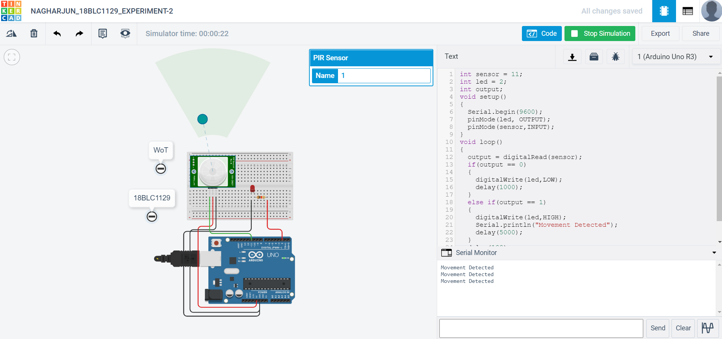

**Code:**

int sensor = 11;

int led = 2;

int output;

void setup()

{

Serial.begin(9600);

pinMode(led, OUTPUT);

pinMode(sensor,INPUT);

}

void loop()

{

output = digitalRead(sensor);

if(output == 0)

{

digitalWrite(led,LOW);

delay(1000);

}

else if(output == 1)

{

digitalWrite(led,HIGH);

Serial.println("Movement Detected");

delay(5000);

}

delay(100);

}