**WOT LAB – 2**

**ECM1004**

Name: Nagharjun M

Registration Number: 18BLC1129

Date: 17/02/2021

**TASK-1**

**ULTRASONIC DISTANCE SENSOR**:

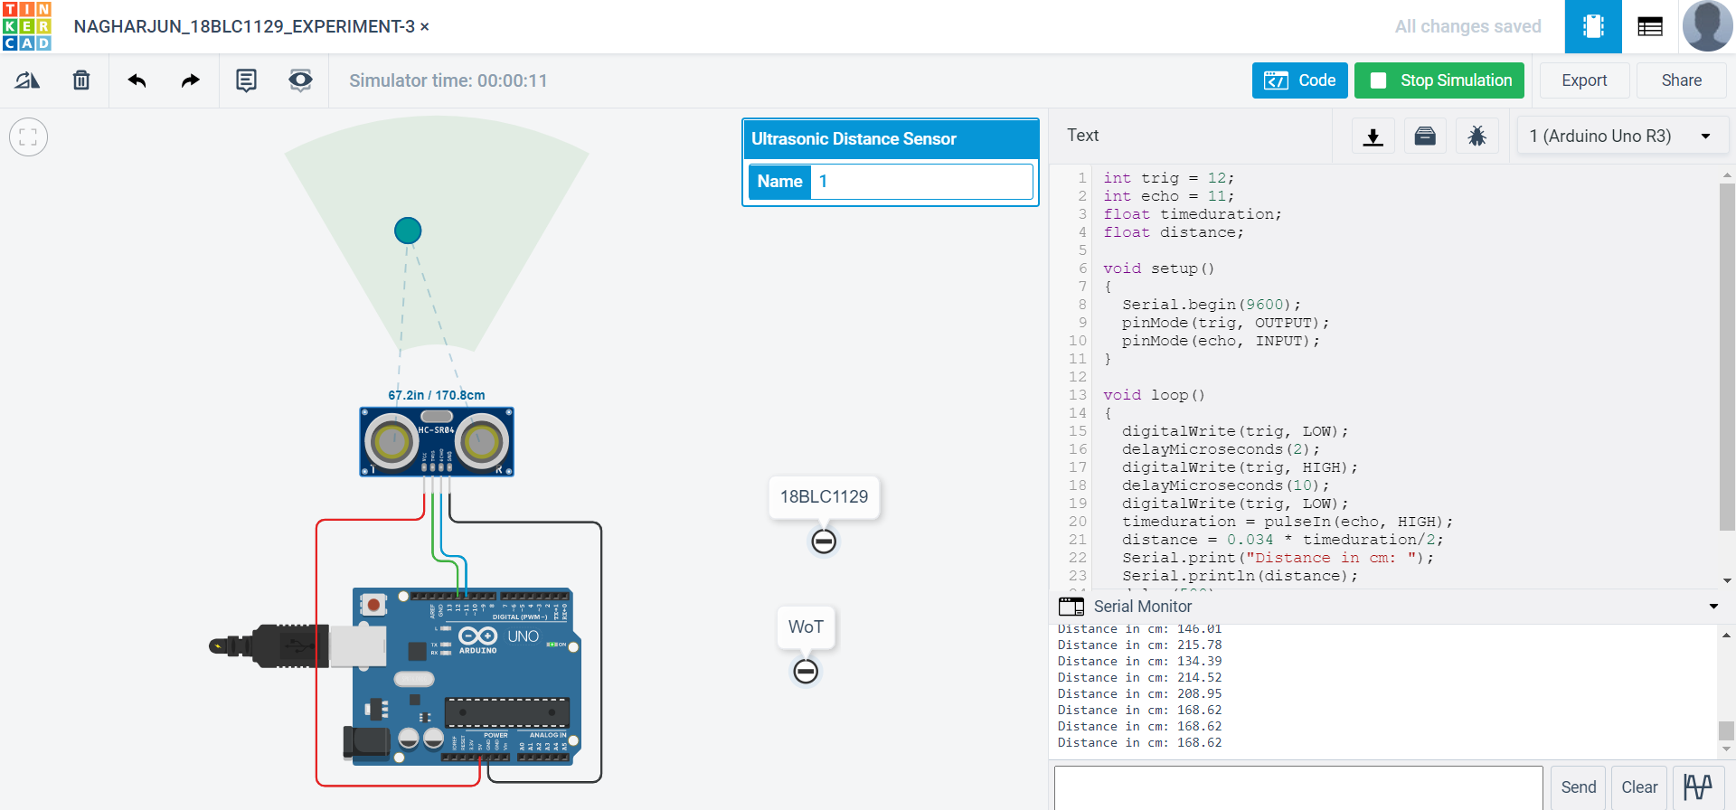

CODE:

int trig = 12;

int echo = 11;

float timeduration;

float distance;

void setup()

{

Serial.begin(9600);

pinMode(trig, OUTPUT);

pinMode(echo, INPUT);

}

void loop()

{

digitalWrite(trig, LOW);

delayMicroseconds(2);

digitalWrite(trig, HIGH);

delayMicroseconds(10);

digitalWrite(trig, LOW);

timeduration = pulseIn(echo, HIGH);

distance = 0.034 * timeduration/2;

Serial.print("Distance in cm: ");

Serial.println(distance);

delay(500);

}

**TASK-2**

**GAS SENSOR:**

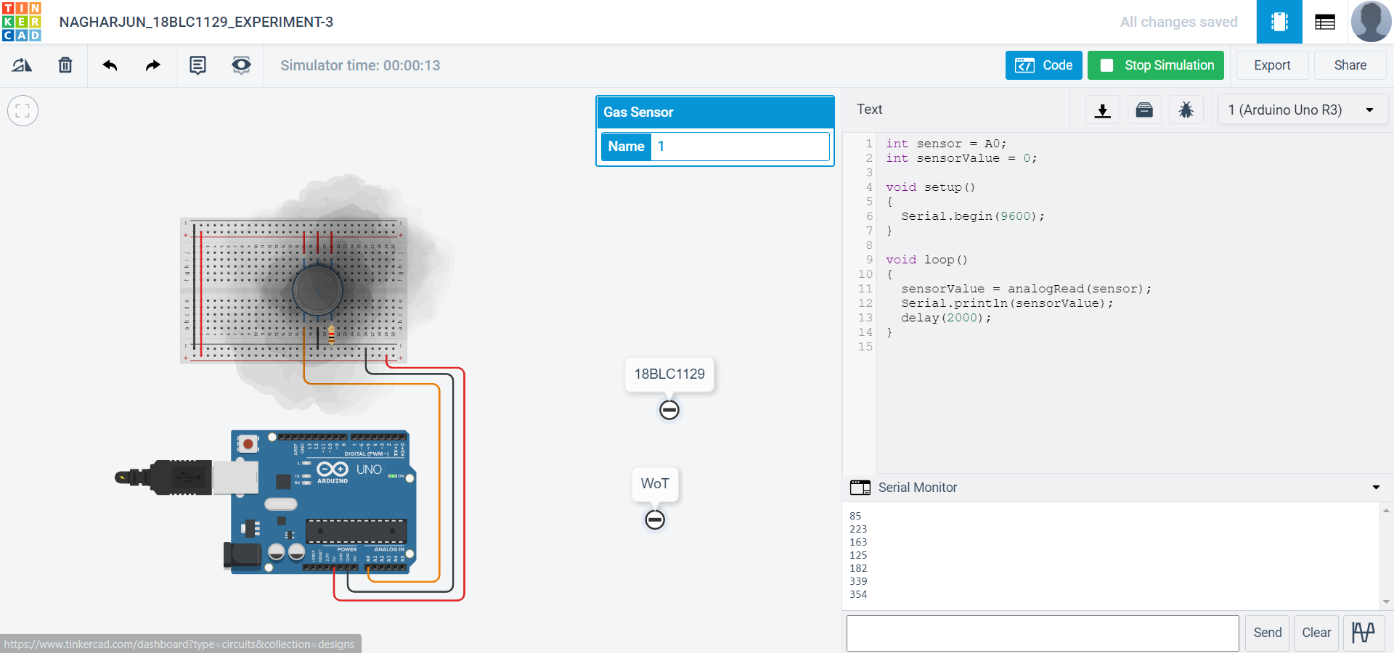

CODE:

int sensor = A0;

int sensorValue = 0;

void setup()

{

Serial.begin(9600);

}

void loop()

{

sensorValue = analogRead(sensor);

Serial.println(sensorValue);

delay(2000);

}

**TASK-3**

**BLINKING OF A LED:**

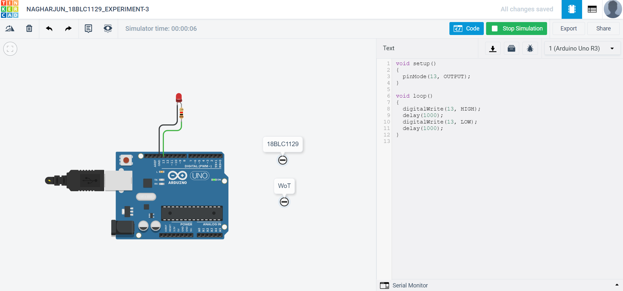

**CODE:**

void setup()

{

pinMode(13, OUTPUT);

}

void loop()

{

digitalWrite(13, HIGH);

delay(1000);

digitalWrite(13, LOW);

delay(1000);

}

**TASK-4**

**TEMPERATURE SENSOR:**

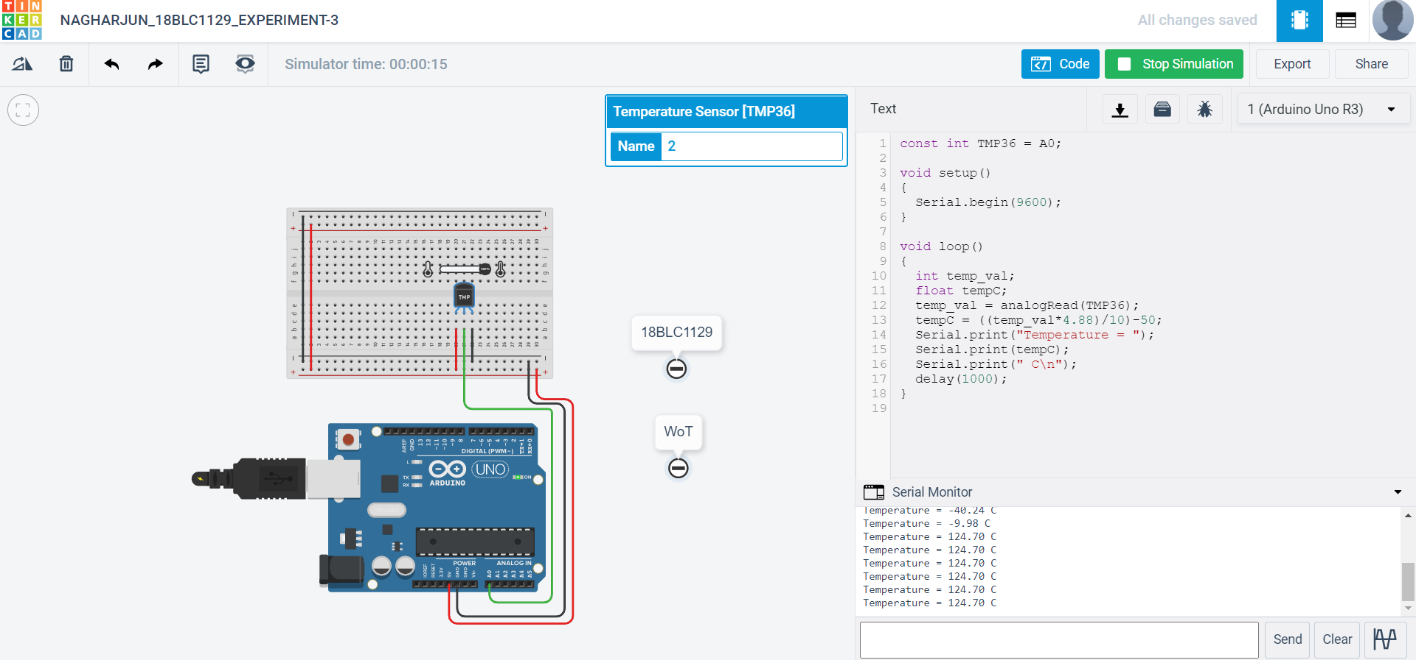

CODE:

const int TMP36 = A0;

void setup()

{

Serial.begin(9600);

}

void loop()

{

int temp_val;

float tempC;

temp_val = analogRead(TMP36);

tempC = ((temp_val*4.88)/10)-50;

Serial.print("Temperature = ");

Serial.print(tempC);

Serial.print(" C\n");

delay(1000);

}