**WOT LAB – 5**

**ECM1004**

Name: Nagharjun M

Registration Number: 18BLC1129

Date: 03/03/2021

**TASK-1**

Hello World MOTE

#include "contiki.h"

#include <stdio.h> /* For printf() */

PROCESS(hello_world_process, "Hello world process");

AUTOSTART_PROCESSES(&hello_world_process);

PROCESS_THREAD(hello_world_process, ev, data)

{

PROCESS_BEGIN();

printf("Nagharjun M \n");

PROCESS_END();

}

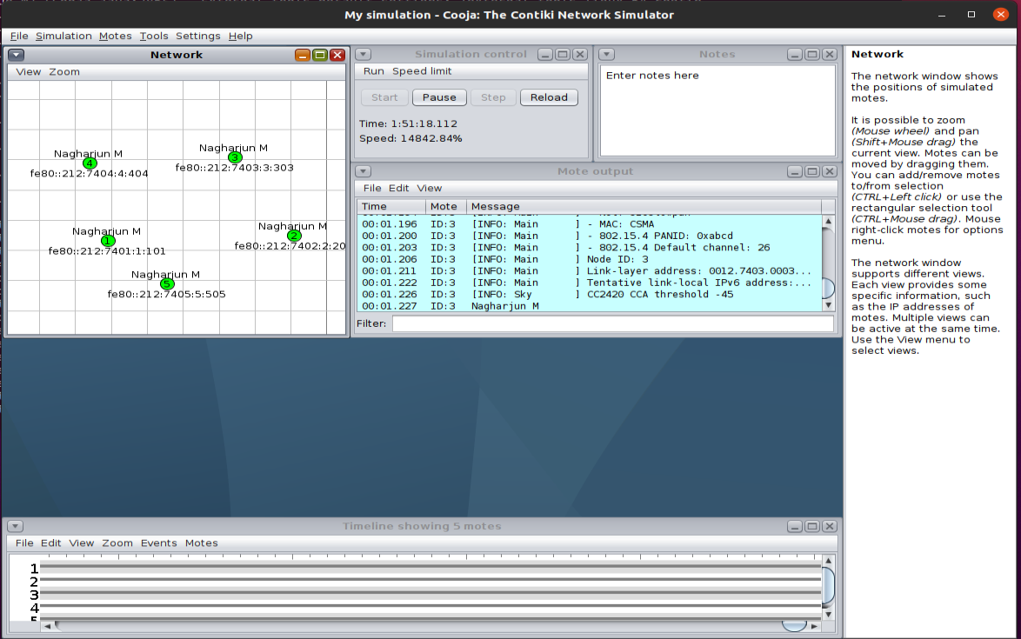

**TASK-2**

## Button LED

#include <stdio.h>

#include "contiki.h"

#include "dev/leds.h"

#include "dev/button-sensor.h"

PROCESS(button_process, "Nagharjun M");

AUTOSTART_PROCESSES(&button_process);

static uint8_t flag;

PROCESS_THREAD(button_process,ev,data)

{

PROCESS_BEGIN();

flag = 0;

SENSORS_ACTIVATE(button_sensor);

while (1)

{

PROCESS_WAIT_EVENT_UNTIL(ev == sensors_event && data == &button_sensor);

leds_toggle(LEDS_ALL);

if (!flag)

{

leds_on(LEDS_BLUE);printf("LED BLUE %d\n", leds_get());

}

else

{

printf("LED BLUE %d\n", leds_get());

leds_off(LEDS_BLUE);

}

flag ^= 1;

leds_toggle(LEDS_ALL);

}

PROCESS_END();

}

