**WOT - ECM1004**

**Module Programming using Node.js**

Name: Nagharjun M

Registration Number: 18BLC1129

Date: 4/05/2021

1. **Create a module in NodeJS and use it in your program (For e.g., Date and Time).**

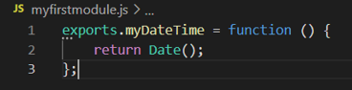

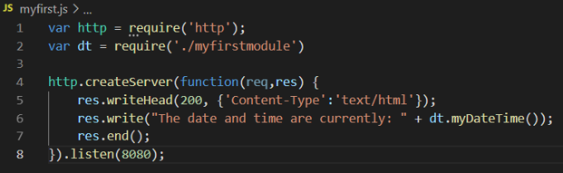

**OUTPUT**

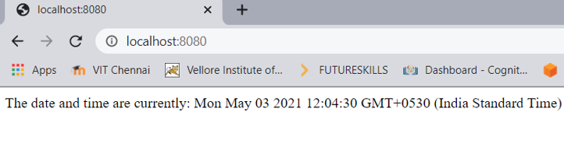

1. **Create an HTTP server using the http module that listens and gives the responses back to clients.**

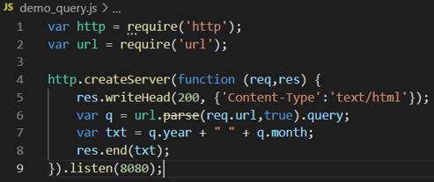

**OUTPUT**

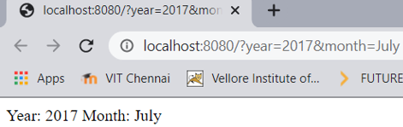

1. **Use filesystem module to create, read, update, rename and delete the file.**

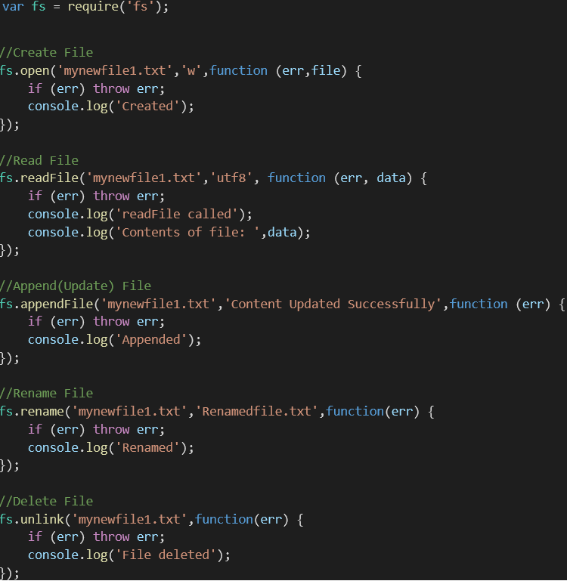

**OUTPUT**

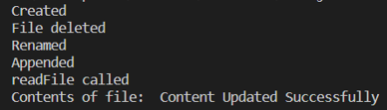

1. **Create a NodeJS file server that opens the requested file and returns the content to the client. If anything goes wrong, throw 404 error.**

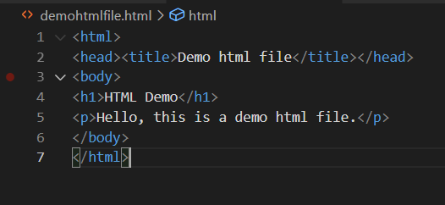 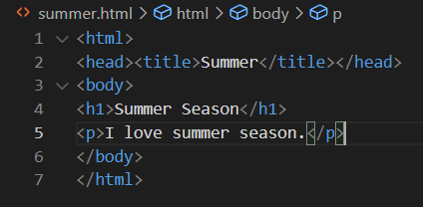

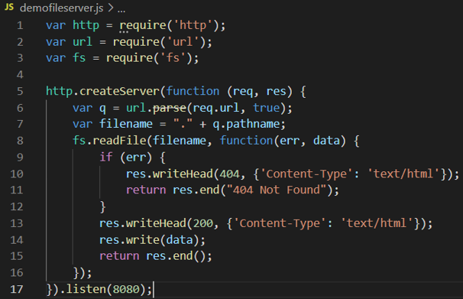

**OUTPUT**

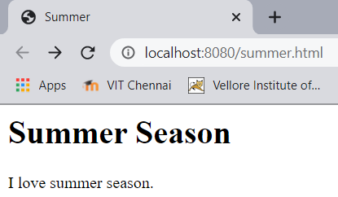 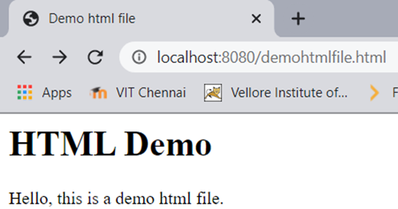

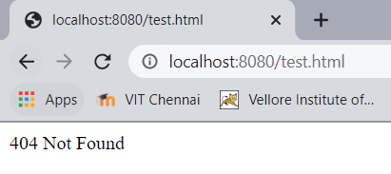

1. **Design and advanced calculator that uses different arithmetic operations as a first module and displaying the current date and time as the second module.**

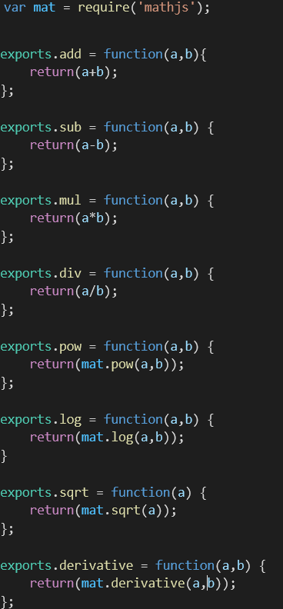

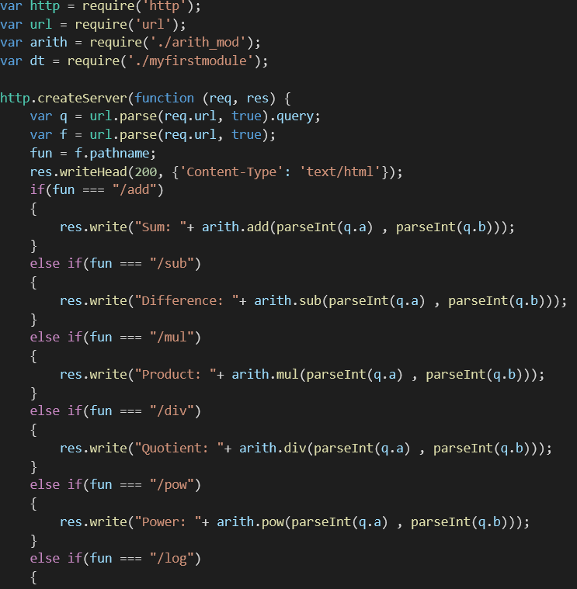

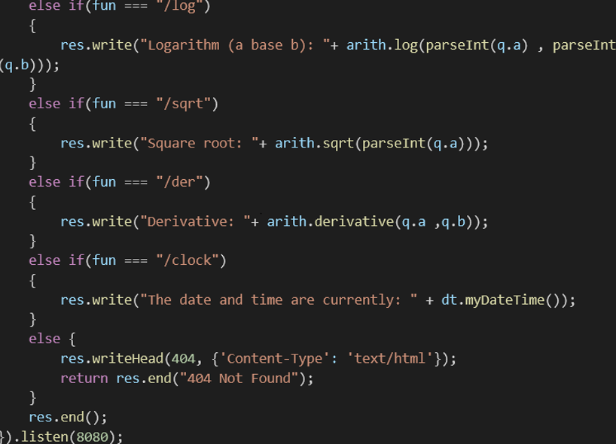

**OUTPUT**

