**WOT - ECM1004**

**MQTT using Node.js**

Name: Nagharjun M

Registration Number: 18BLC1129

Date: 4/05/2021

1. Using HiveMQ Cloud broker for Pub/Sub
2. Logging into HiveMQ cloud

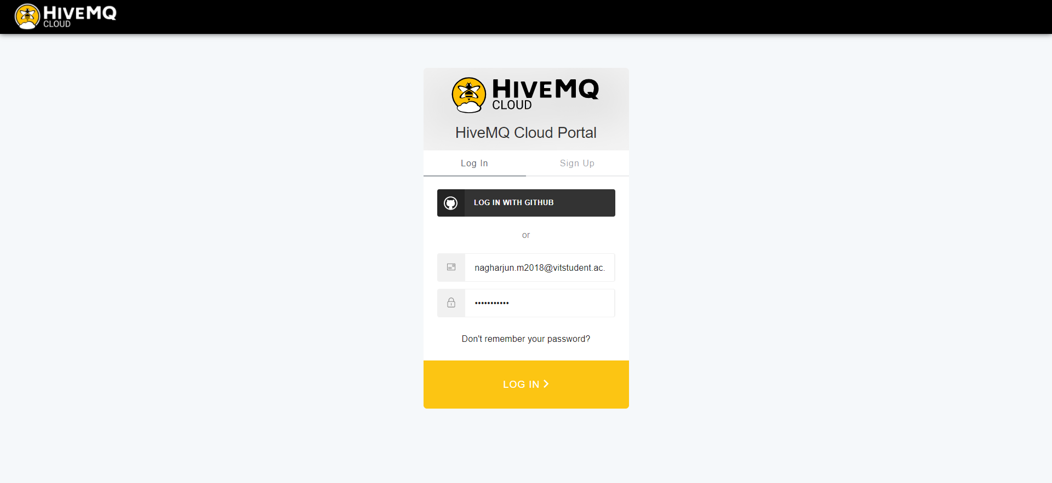

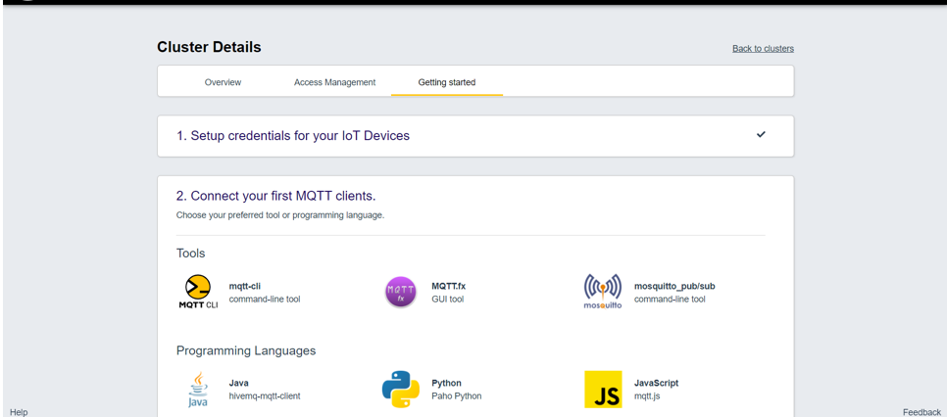

1. Select **mqtt.js** and copy the code. You can make changes in the code by adding **setInterval()** function for generating messages automatically.

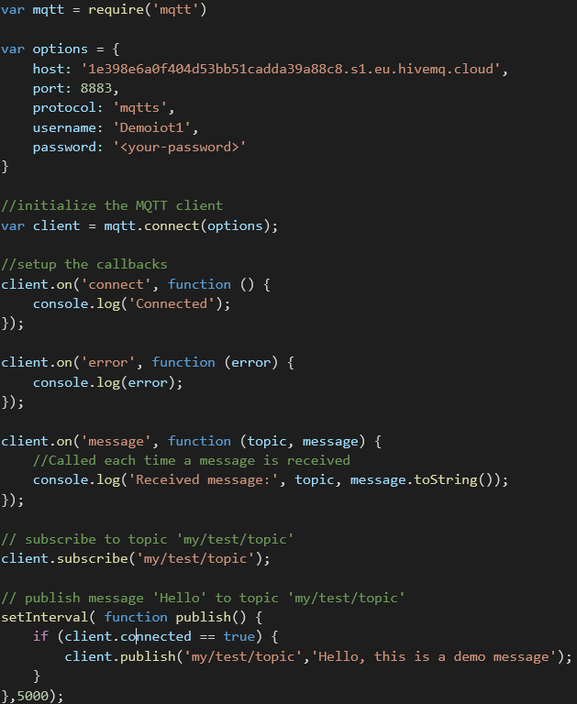

1. Now you can run this code and the code will connect to the cloud MQTT broker.

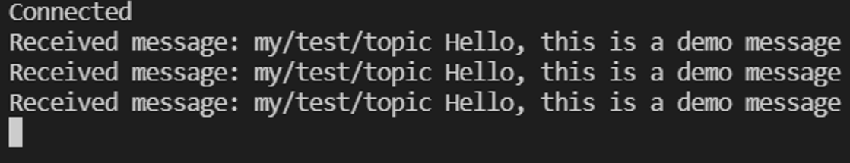

1. Using HiveMQ software for creating broker locally
2. Download HiveMQ software.
3. Use your file browser to extract the ZIP archive to the directory of your choice.
4. To start the batch file, open the bin folder and double click **run.bat**.
5. By default, the HiveMQ broker starts on localhost IP address **127.0.0.1** and listens on port **1883.**

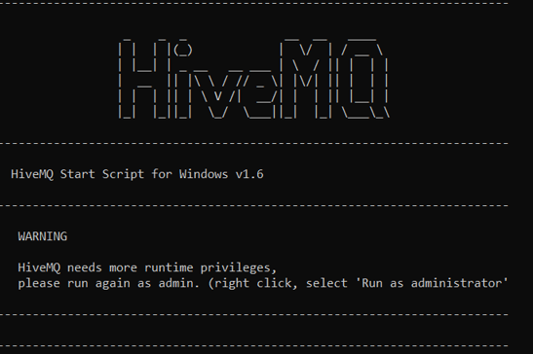

1. Navigate with your browser to **http://localhost:8080**. If you see the login dialog for the HiveMQ Control Center, you know that HiveMQ is up and running.
2. The **HiveMQ Control Center** is part of the standard HiveMQ distribution and is a web application that you can access from your browser. You do not need to install any additional software on your computer to use the control center.

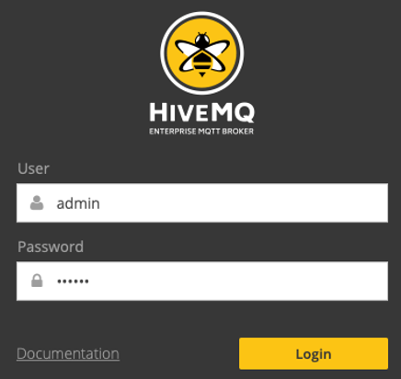

**CODE:**

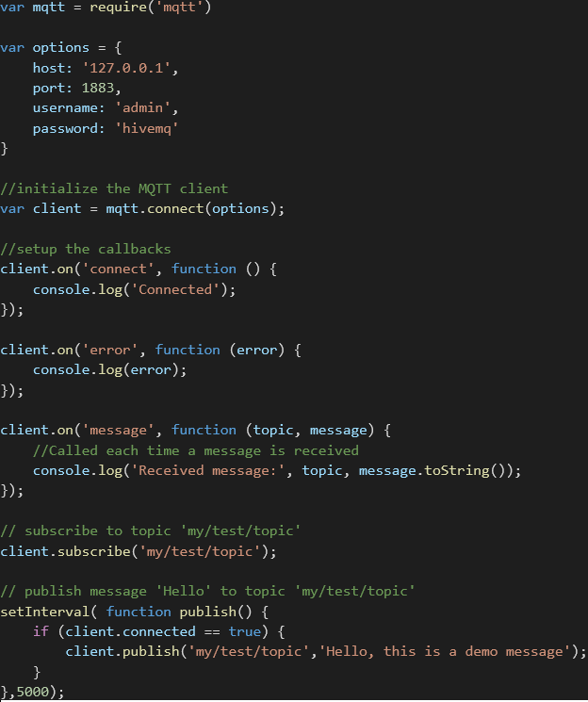

**OUTPUT**

