**WOT - ECM1004**

**Node-Red**

Name: Nagharjun M

Registration Number: 18BLC1129

Date: 19/05/2021

A simple Node-Red Application

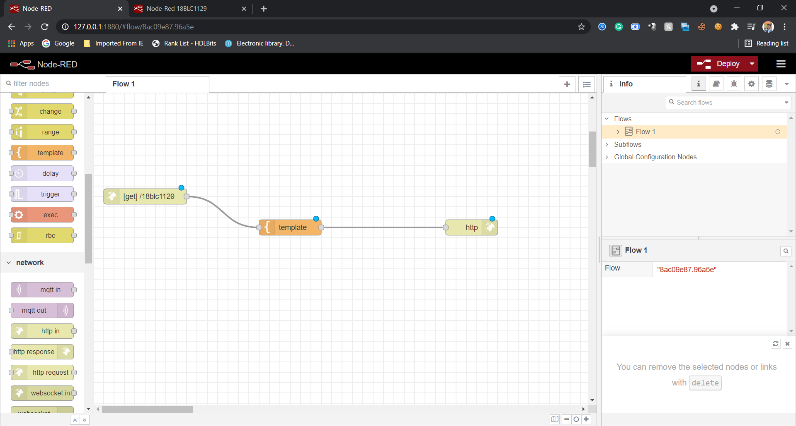

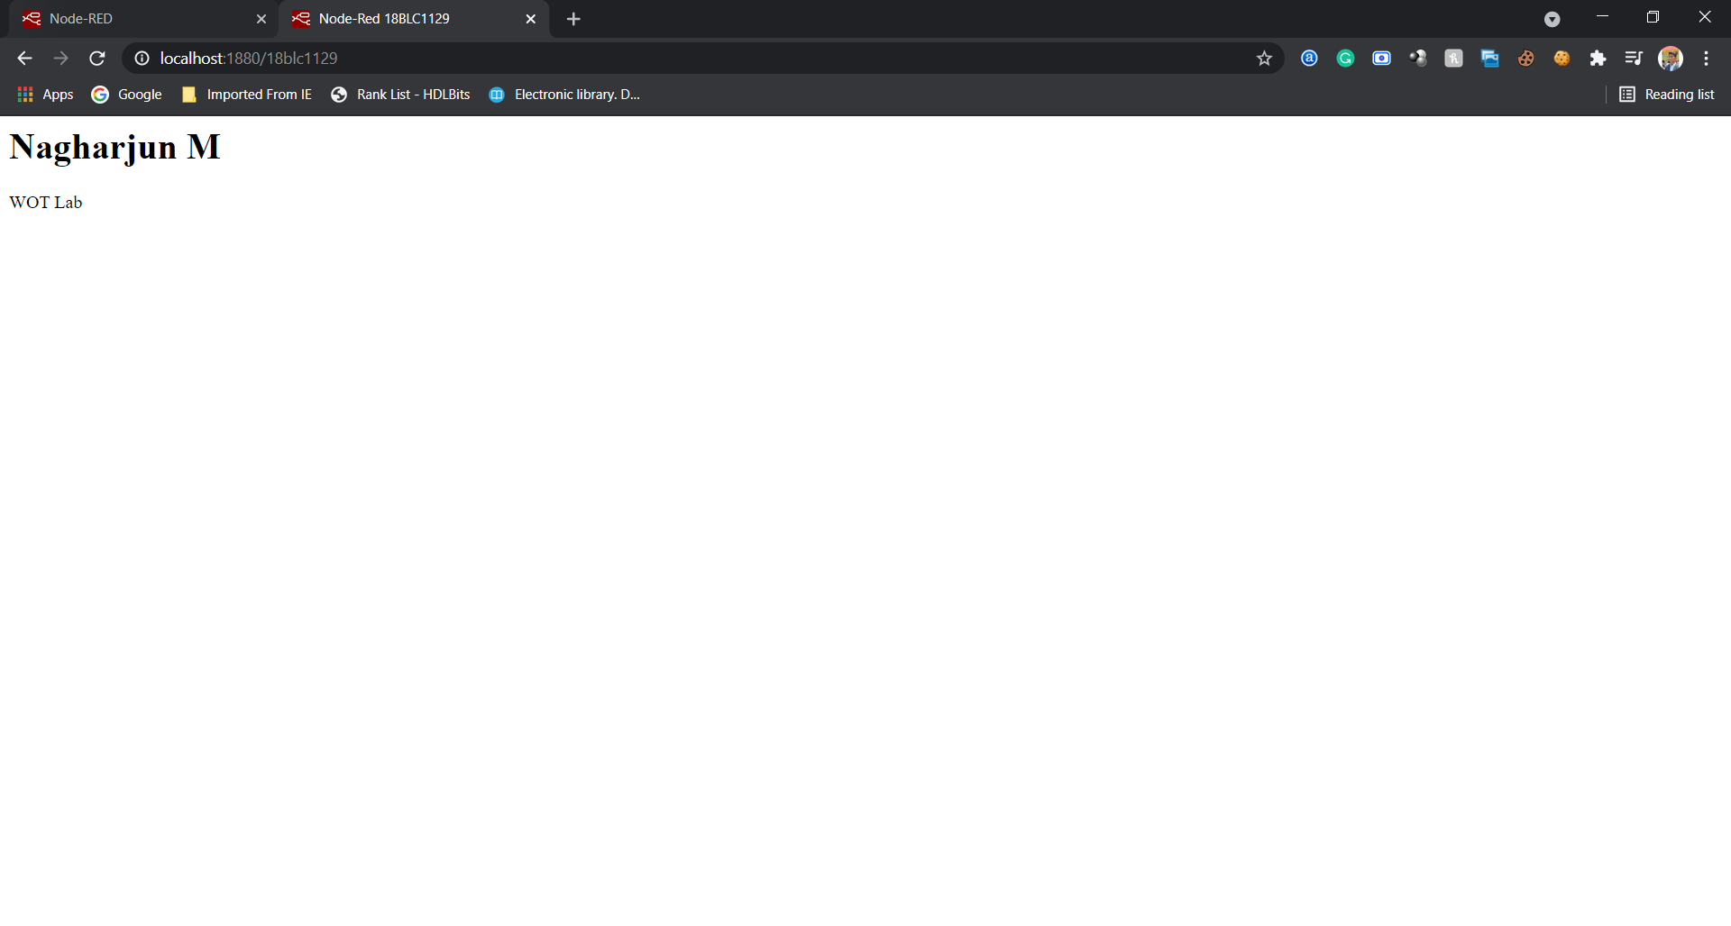

Node-Red Dashboard

