**WOT - ECM1004**

**LED and Servo Motor using Raspberry Pi in Proteus**

Name: Nagharjun M

Registration Number: 18BLC1129

Date: 24/02/2021

**TinkerCAD Servo Motor**

**Code:**

#include <Servo.h>

Servo servo_test;

int angle = 0;

void setup()

{

servo_test.attach(9);

}

void loop()

{

for(angle = 0; angle < 180; angle += 1)

{

servo_test.write(angle);

delay(100);

}

for(angle = 180; angle >= 1; angle -= 1)

{

servo_test.write(angle);

delay(100);

}

}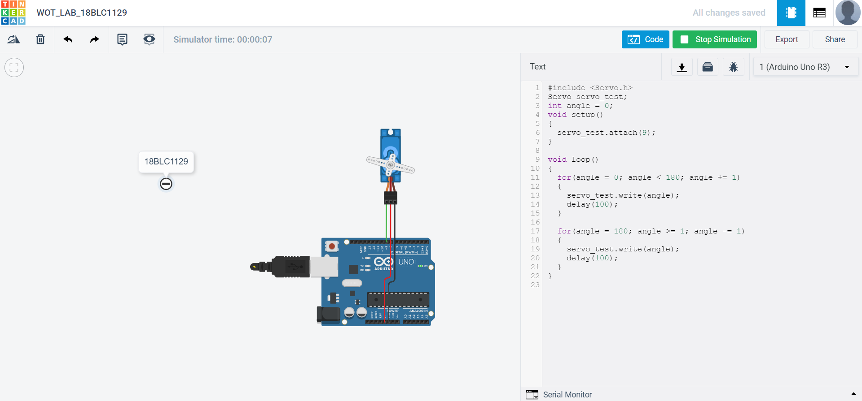

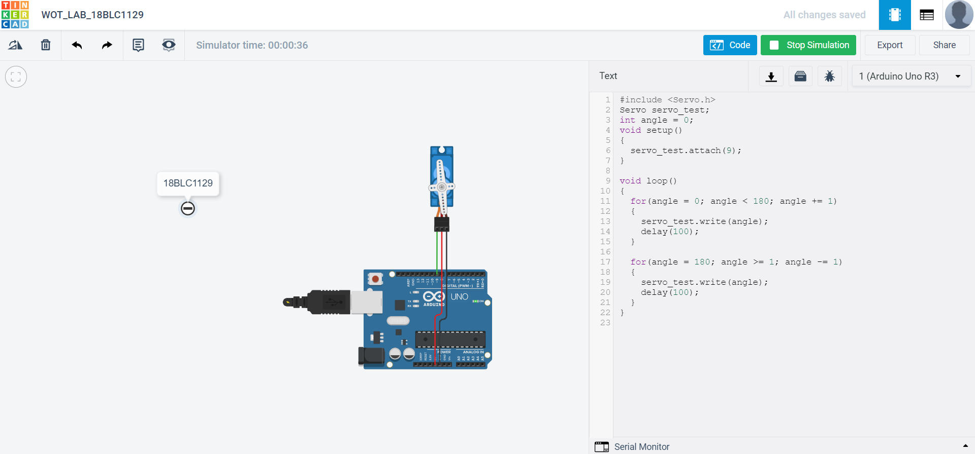

**Proteus Raspberry Pi 3 Servo Motor:**

**Code:**

import RPi.GPIO as GPIO

import time

control = [5,5.5,6,6.5,7,7.5,8,8.5,9,9.5,10]

servo = 22

GPIO.setmode(GPIO.BOARD)

GPIO.setup(servo,GPIO.OUT)

p=GPIO.PWM(servo,50)

p.start(2.5)

try:

while True:

for x in range(11):

p.ChangeDutyCycle(control[x])

time.sleep(0.03)

print x

for x in range(9,0,-1):

p.ChangeDutyCycle(control[x])

time.sleep(0.03)

print x

except KeyboardInterrupt:

GPIO.cleanup()

