**WOT LAB CoAP Protocol**

**ECM1004**

Name: Nagharjun M

Registration Number: 18BLC1129

Date: 31/03/2021

**Running CoAP server:**

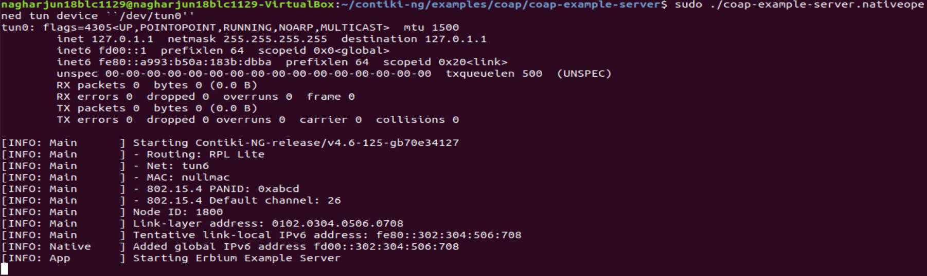

**Pinging to the server:**

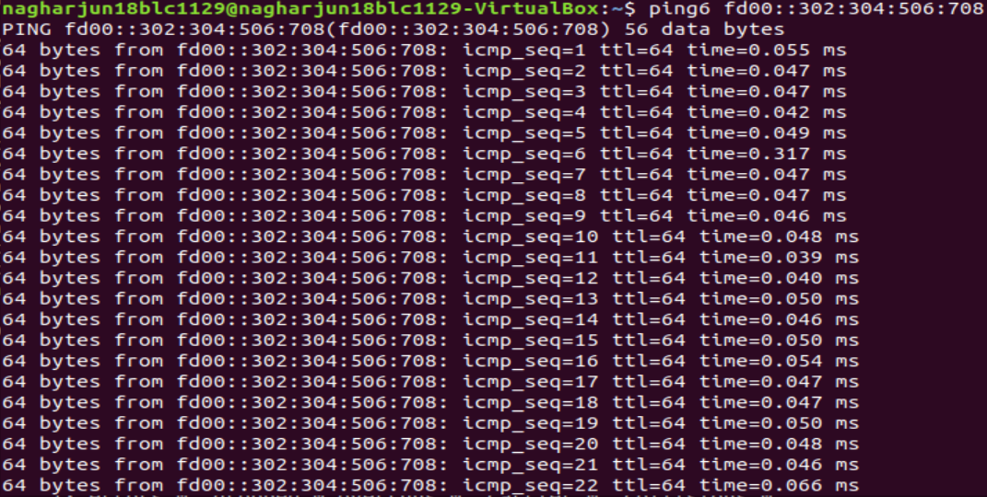

**CoAP Client:**

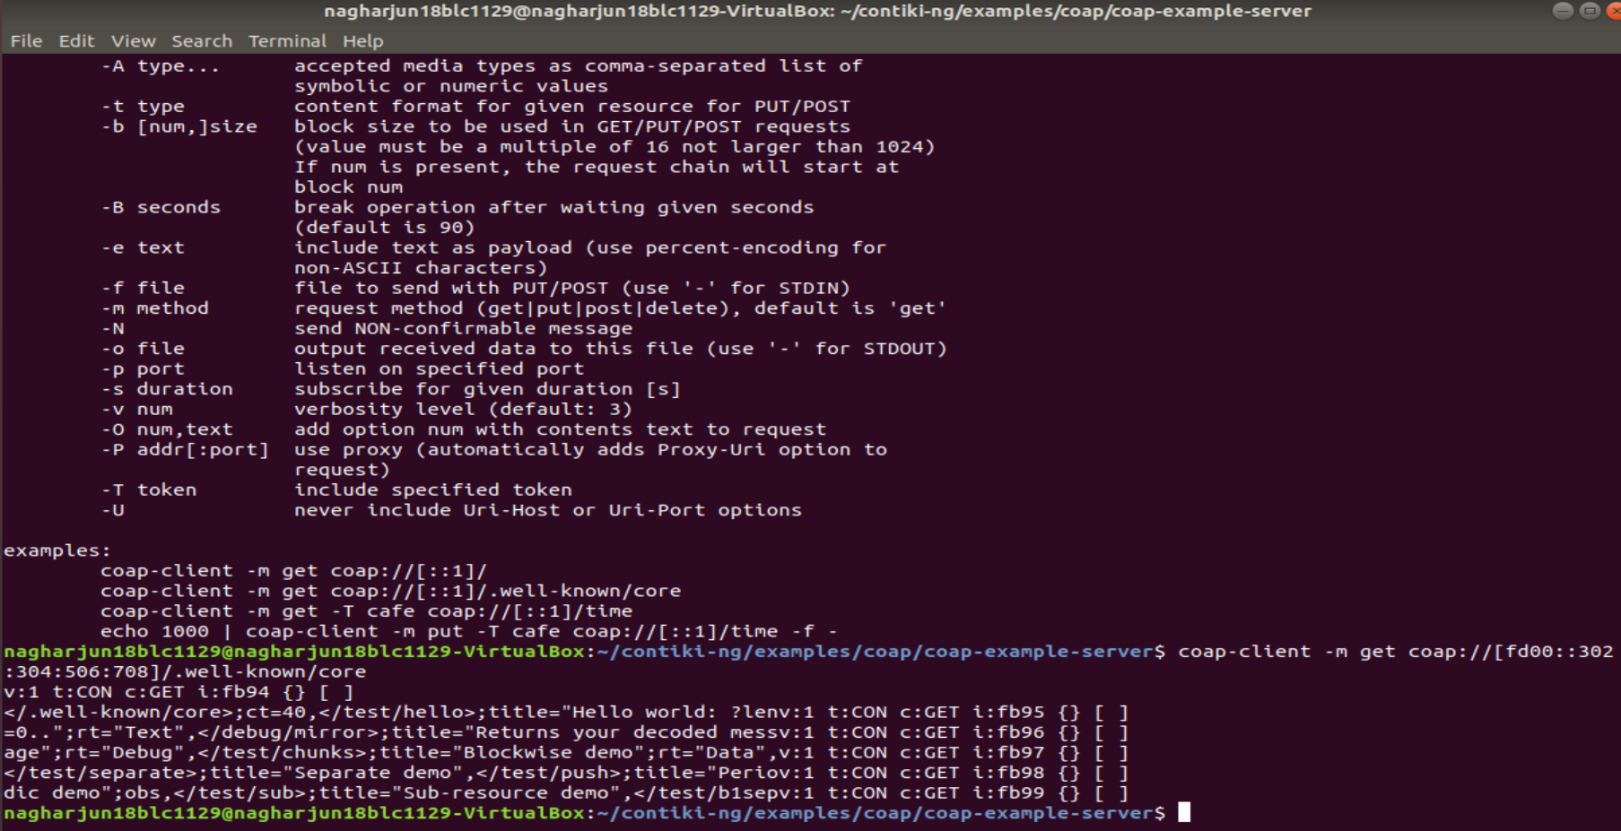

**4.04 Not found**

